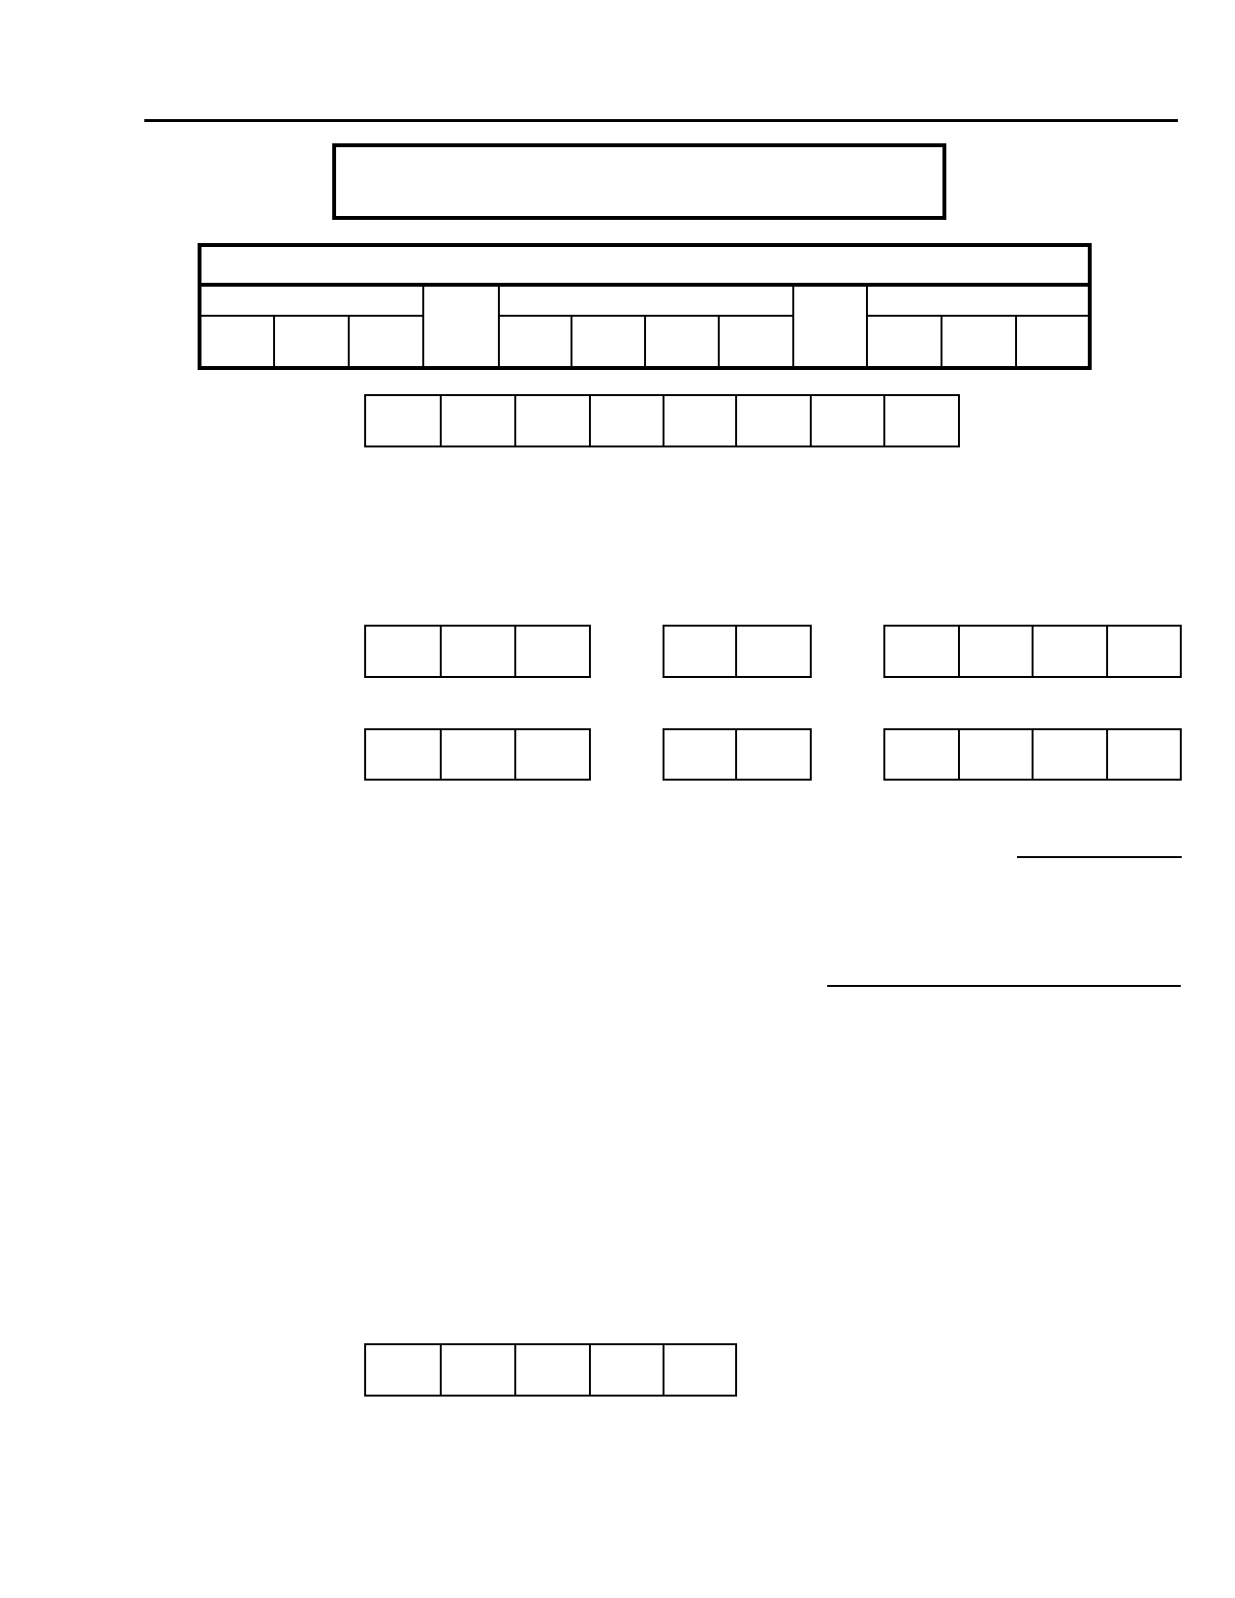
DIGS 4.0 / BP
21-Jul-2005

DIAGNOSTIC INTERVIEW FOR GENETIC STUDIES
(DIGS)

SUBJECT ID
SITE ID FAMILY ID INDIVIDUAL ID
— —

ALTERNATIVE ID:

SUBJECT NAME: ________________________ ___________ ________________________
First Middle Last

NICKNAME: __________________________________________________________

INTERVIEW DATE: — —
M O N D D Y E A R

DATE OF BIRTH: — —
M O N D D Y E A R

SELF REPORTED ETHNIC CATEGORY: Code Response
1. Hispanic or Latino 1 2 3
2. Not Hispanic or Latino
3. Unknown (Individuals not reporting ethnicity)

SELF REPORTED RACE: Code Response
1. American Indian/Alaska Native 1 2 3 4 5 6 7
2. Asian
3. Native Hawaiian or Other Pacific Islander
4. Black or African-American
5. White
6. More Than One Race
7. Unknown or not reported

IN PERSON or TELEPHONE: P T

RATER NAME: ________________________ ___________ ________________________
First MI Last

RATER NUMBER:

DIGS 4.0 / BP
21-Jul-2005

This page left intentionally blank

DIGS 4.0 / BP
21-Jul-2005

ACKNOWLEDGMENTS
Version 4.0 / BP
DIGS version 4.0 was developed between October 2003 and March 2004 with contributions from:
Laura J. Bierut, M.D., William Coryell, M.D., Caroline E. Drain, M.H.S., Elliot Gershon, M.D., Layla Kassen, Ph.D., John Kelsoe, M.D., Jennifer Khalid, R.N., William Lawson, M.D., Dean F. MacKinnon, M.D., Melvin G. McInnis, M.D., Francis J. McMahon, M.D., Eric T. Meyer, M.A., John I. Nurnberger, Jr., M.D., Ph.D., William Scheftner, M.D., Carrie Smiley, R.N.

Version 3.0
DIGS version 3.0 was developed between November 1997 and January 1999 with contributions from:
Laura J. Bierut, M.D., William Coryell, M.D., Raymond DePaulo, M.D., Caroline E. Drain, M.H.S., Tyler C. Hightower, Douglas F. Levinson, M.D., Dean F. MacKinnon, M.D., Melvin G. McInnis, M.D., Francis J.
McMahon, M.D., Eric T. Meyer, M.A., John I. Nurnberger, Jr., M.D., Ph.D., Theodore Reich, M.D., William
Scheftner, M.D., Sylvia G. Simpson, M.D., Carrie Smiley, R.N., C.J.M. Thomas

Version 2.0
Development of the DIGS 2.0 instrument and training manual was supported by the NIMH Diagnostic Centers for
Psychiatric Linkage Studies (extramural grant numbers U01 MH 46276, 46289, 46318, 46274, 46282, 46280, and the Clinical Neurogenetics Branch, Intramural Research Program, NIMH).
Members of the NIMH Diagnostic Centers for Psychiatric Linkage Studies Cooperative Agreement who
participated in the development of the DIGS 2.0 include:
Sandra Barton, Kate Berg, Ph.D., Mary Blehar, Ph.D., Elizabeth Bowman, M.D., C. Robert Cloninger, M.D., J.
Raymond Depaulo, Jr., M.D., Stephen Faraone, Ph.D., Jill Harkavy Friedman, Ph.D., Elliot Gershon, M.D.,
Juliet Guroff, M.S.W., Charles Kaufmann, M.D., Darrell Kirch, M.D., Dolores Malaspina, M.D., Mary Elizabeth
Maxwell, M.S.W., Aimee Mayeda, M.D., Martin McElhiney, M.S., Francis J. McMahon, M.D., Marvin Miller,
M.D., John Nurnberger, Jr., M.D., Ph.D., Beth O'Dell, B.S., John Pepple, Ph.D., H. Matthew Quitkin, A.B., Leela
Rau, M.D., Theodore Reich, M.D., A. Louise Ritz, M.B.A., Joanne Severe, M.S., Sylvia Simpson, M.D., Carrie
Smiley, R.N., Ming T. Tsuang, M.D., Ph.D., D.Sc., Debra Wynne, M.S.W., Scott Yale, M.S.W., and Carolyn York, R.N.
A complete list of references for the DIGS instrument is included in the training manual.
We gratefully acknowledge the assistance of Jean Endicott, Ph.D., Kenneth Kendler, M.D., Philip Lavori, Ph.D., and Lee Robins, Ph.D., for critical review of the instrument.

Address comments, correspondence, and reprint requests to:

Steven O. Moldin, Ph.D., Chief, Genetics Research Branch
Division of Basic and Clinical Neuroscience Research
National Institutes of Mental Health
5600 Fishers Lane
Rockville, Maryland 20857

A blank copy of the DIGS, DIGS code manual, DIGS training manual, and DIGS software are available on the
World Wide Web at http://zork.wustl.edu/nimh/
DIGS 4.0 / BP
21-Jul-2005

This page left intentionally blank
DIGS 4.0 / BP
21-Jul-2005

CONTENTS
SECTION NAME PAGE

A. Demographics ................................................................................................................................. 1
B. Medical History .............................................................................................................................. 5
C1. Modified Mini-Mental Status Examination .................................................................................... 9C2. Telephone Interview for Cognitive Status ...................................................................................... 11

D. E. F.
G. H. I. J.
K. N. O. P.
Q. R. S.
Somatization ................................................................................................................................... Overview of Psychiatric Disturbance ............................................................................................. Major Depression............................................................................................................................ Mania/Hypomania .......................................................................................................................... Dysthymia/Cyclothymia ................................................................................................................. Alcohol Abuse and Dependence..................................................................................................... Tobacco, Drug Abuse and Dependence.......................................................................................... Psychosis......................................................................................................................................... Comorbidity Assessment ................................................................................................................ Suicidal Behavior............................................................................................................................ Anxiety Disorders ........................................................................................................................... Eating Disorders ............................................................................................................................. Pathological Gambling ................................................................................................................... Antisocial Personality .....................................................................................................................
13 15 25 43 63 67 71 81 99
101 107 115 119 121

AA. Attention Deficit / Hyperactivity Disorder ..................................................................................... 125

T. U. V. X. Y. Z.
Global Assessment Scale (GAS) .................................................................................................... Scale for the Assessment of Negative Symptoms (SANS)............................................................. Scale for the Assessment of Positive Symptoms (SAPS) ............................................................... Interviewer's Reliability Assessment ............................................................................................. Narrative Summary......................................................................................................................... Medical Records Information .........................................................................................................
129 131 135 139 141 143

In reference section:
Ethnicity Card
Modified MMS Card
Depression Tally Sheet
Mania Tally Sheet
Drug Use Card
Comorbidity Card

DIGS 4.0 / BP
21-Jul-2005

This page left intentionally blank

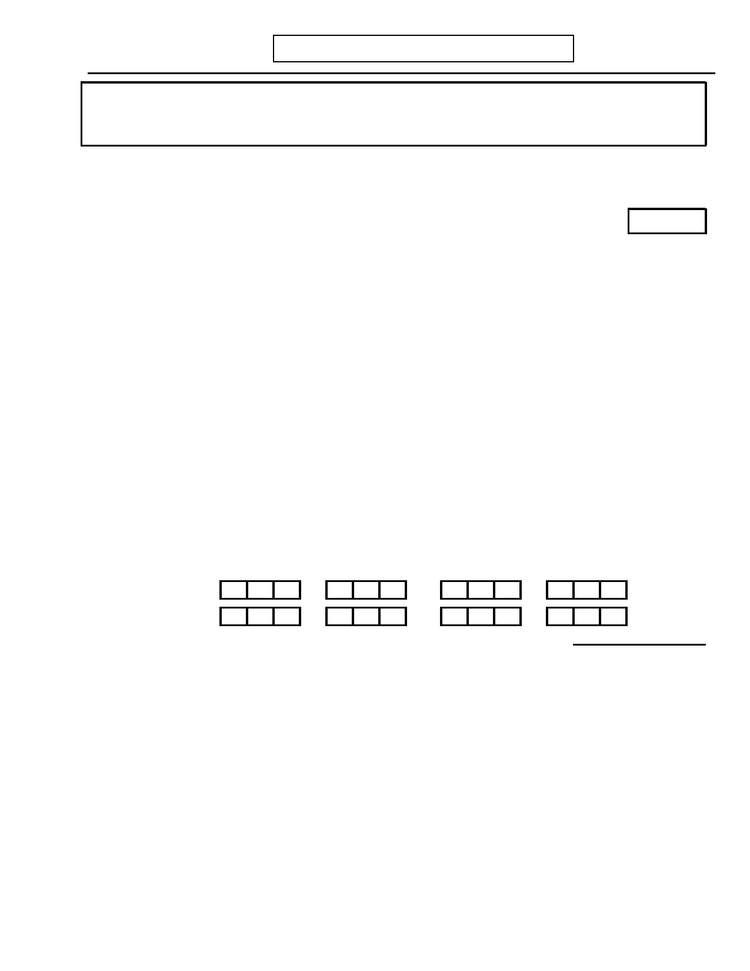
DIGS 4.0 / BP
21-Jul-2005
A. DEMOGRAPHICS
Page 1

INTERVIEWER: If it appears that the subject's mental status is interfering with his/her ability to
provide accurate information, skip to C1. Modified Mini-Mental Status Examination (page 9).

Male Female

1. INTERVIEWER: Circle sex code. 0 1
Age
2. How old are you?
No Yes Unk

3. Were you adopted? 0 1 9

If yes: Clarify nature of adoption. (See manual for further information.)

____________________________________________________

4. In which country were you born?

Record response: ___________________________________________________

5. What is the ethnic background of your biological parents?

INTERVIEWER: Code up to four ethnicities on maternal and paternal sides if
possible.
Record response:
Mother: ______________ ______________ ______________ ______________

Father: ______________ ______________ ______________ ______________

INTERVIEWER: Code using Ethnicity Card.
Mother: Father:
Code Response

6. What was your childhood religious affiliation? 1 2 3 4 5 6
1. Catholic
2. Protestant
3. Jewish
4. Moslem
5. Not Affiliated
6. Other, Specify: _______________________________________________


Page 2
A. DEMOGRAPHICS
DIGS 4.0 / BP
21-Jul-2005

Code Response

7. What is your current marital status? 1 2 3 4 5
1. Married
2. Separated 3. Divorced 4. Widowed
5. Never Married
Marriages
7.a) If ever married: How many times have you been legally married?
Children
8. How many living children do you have?
Code Response

9. Are you living alone or with others? 1 2 3 4 5 6 7 8
1. Alone
2. With partner (for at least one year), but not legally married
3. In own home with spouse and/or children
4. In home of parents or children
5. In home of siblings or other non-lineal relatives
6. In shared home with other relatives or friends
7. In Residential Treatment Facility
8. Other, Specify: _________________________________________


DIGS 4.0 / BP
21-Jul-2005
A. DEMOGRAPHICS
Page 3

10.

What is your present occupation? Code occupation using chart below.
Record response: ________________________________________________________

10.a) What is the most responsible job you have ever held? Code using chart below.
Record response: ________________________________________________________

10.b) If subject not Head of Household: What is/was the occupation of the head of
household during most of their working career? Code using chart below.
Record response: ________________________________________________________

Present

Most Resp.

HoH

Occupations
Managerial and Professional Specialty Occupations
01. Executive, Administrative, and Managerial Occupations
02. Professional Specialty Occupations
03. Writers, Artists, Entertainers, and Athletes
Technical, Sales, and Administrative Support Occupations
04. Technicians and Related Support Occupations
05. Sales Occupations
06. Administrative Support Occupations, Including Clerical
Service Occupations
07. Private Household Occupations
08. Protective Service Occupations
09. Service Occupations, Except Protective and Private Household
Farming, Forestry, and Fishing Occupations
10. Farm Operators and Managers
11. Other Farming, Forestry, and Fishing Occupations
Precision Production, Craft, and Repair Occupations
12. Mechanics and Repairers, Construction Trades, Extractive Occupations, Precision Production
Occupations
Operators, Fabricators, and Laborers
13. Machine Operators, Assemblers, and Inspectors
14. Transportation and Material-Moving Occupations
15. Handlers, Equipment Cleaners, Helpers, and Laborers
Other

16.
17. 18. 19. 20. 21.
Armed Services
Disabled
Housewife/Homemaker
Never worked
Full time student
Unemployed/Retired

99. Unknown/No Answer


Page 4
A. DEMOGRAPHICS
DIGS 4.0 / BP
21-Jul-2005

11. How many years of school did you complete? Years
Record response: ________________________________________________________

No Yes Unk

12. Have you ever been in the Military? 0 1 9

Code Response

12.a) If no: Were you ever rejected for Military Service? Why? 1 2 3 4 5 6
1. Never called up or never rejected (include females). 2. Rejected for physical defect. 3. Rejected for low IQ.
4. Rejected for delinquency or criminal record. 5. Rejected for other psychiatric reasons. 6. Rejected for reasons uncertain.

13. If yes to question 12: What kind of discharge did you receive? 1 2 3 4 5 6 7
1. Honorable
2. General 3. Medical
4. Without Honor
5. Undesirable
6. Dishonorable
7. Not Discharged, Currently in Active or Reserve Military


DIGS 4.0 / BP
21-Jul-2005
B. MEDICAL HISTORY
Page 5

1. Has a doctor ever told you that you had:

Condition
(information to include in details on right)
How old were you
when you were first
told you had (condition)?

Additional Details
(Example: types of cancer, loss of
consciousness, other items
indicated in parentheses at left)

Allergies (Specify)
Alzheimer Disease Anemia/low blood
Arthritis Asthma
Cancer/malignancy
(Type, location)
Chronic bronchitis
Congestive heart
failure
Diabetes
Emphysema
Epilepsy/Seizures/
Convulsions
Goiter/thyroid disease
(Specify)
Head injury (Indicate
if lost consciousness
and for how long)
Heart attack/angina
High blood pressure
Liver condition
(Specify)
Migraine headaches
(Aura?)
Osteoporosis/brittle
bones

Overweight

Skin Condition
(Specify)
Stroke
Ulcer
Other neurological
problems
Fibromyalgia
No
0
0000

0

0

0

0
0

0

0

0

0
0

0

0

0

0

0

0
0

0

0
Yes
1
1111

1

1

1

1
1

1

1

1

1
1

1

1

1

1

1

1
1

1

1
Unk
9
9999

9

9

9

9
9

9

9

9

9
9

9

9

9

9

9

9
9

9

9
Age (in Years)


Page 6
B. MEDICAL HISTORY
DIGS 4.0 / BP
21-Jul-2005

2. If yes to any: How do(es) this (these) condition(s) affect your daily life?

INTERVIEWER: The goal is to get an impression of the total impact of all conditions on daily living.
Additional Details (Include details included
No Yes Unk in parentheses at left)

2.a) Frequent symptoms (Specify) 0 1 9

2.b)

Sees doctor regularly

0

1

9

2.c) Hospitalized, or takes 0 1 9
medication regularly

2.d) Occupational disability (Able 0 1 9
to work at all?)

No Yes Unk

3. Do you have any other medical problem or condition we haven't discussed? 0 1 9
If yes: Specify. ____________________________________________________

____________________________________________________

4. Current height (in): ______ Maximum lifetime body weight (lbs): _______

5. Have you ever had any of the following tests:
Year of
Most Recent
No Yes Test Notes

5.a) EEG/"Brain Wave" tests? 0 1 _______ _________________________

5.b) Head CAT scan? 0 1 _______ _________________________

5.c) Head MRI? 0 1 _______ _________________________

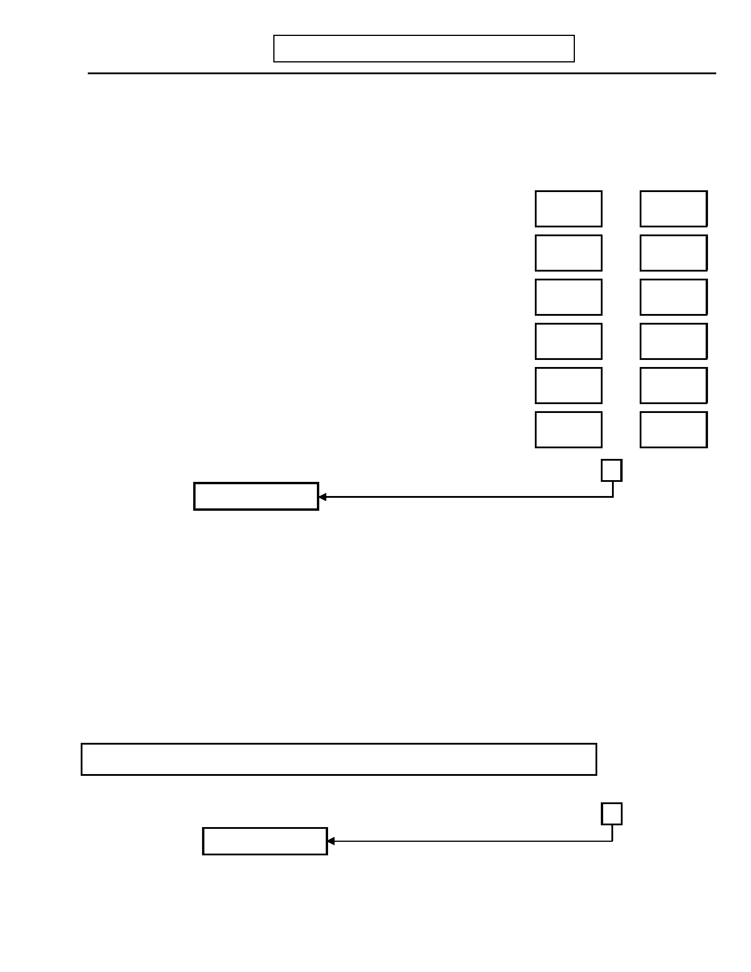
DIGS 4.0 / BP
21-Jul-2005
B. MEDICAL HISTORY

No

Yes
Page 7

Unk

6. Are you taking any medications regularly (include aspirin and oral contraceptives)? 0 1 9

Medication Dosage per day Duration of Dosage
Weeks OR Months
OR
______________________________ _________________________________
OR
______________________________ _________________________________
OR
______________________________ _________________________________
OR
______________________________ _________________________________
OR
______________________________ _________________________________
OR
______________________________ _________________________________

7. Was your own birth or early development abnormal in any way? 0 1 9
Skip to question 8

7.a) Were there any problems with your mother's health while she was pregnant 0 1 9
with you, or with your birth, such as prematurity or birth complications?

If yes: Specify. ________________________________________________

_____________________________________________________________

7.b) Was your development abnormal in any way, for example did you walk or talk 0 1 9
later than other children?

If yes: Specify. ________________________________________________

_____________________________________________________________

INTERVIEWER: For MALES, skip to C1. Modified Mini-Mental Status (page 9).
No Yes Unk

8. Have you ever been pregnant? 0 1 9
Skip to question 9


Page 8
B. MEDICAL HISTORY
DIGS 4.0 / BP
21-Jul-2005

No Yes Unk

8.a)

8.b)

How many times have you been pregnant including miscarriages, abortions, and still
births?
Record response: ________________________________________________

________________________________________________________________

How many live births?

Pregnancies

Live Births

Code Response

8.c) Have you ever had any severe emotional problems during a pregnancy or 0 1 2 3 9
within a month of childbirth?
0. No
1. Yes, during pregnancy only
2. Yes, post natal only
3. Yes, both during pregnancy and post natal
9. Unknown

If yes: Specify: ________________________________________________

________________________________________________________
No Yes Unk

9. Have you ever noticed regular mood changes in the premenstrual or menstrual 0 1 9
period?

If yes: Specify. ____________________________________________________

_________________________________________________________________

10. Have you gone through menopause? 0 1 9

10.a) If yes: Have you ever had any severe emotional problems associated with 0 1 9
menopause?
If yes: Specify. _________________________________________________

____________________________________________________________


DIGS 4.0 / BP
21-Jul-2005
C1. MODIFIED MINI-MENTAL STATUS
EXAMINATION

No

Yes
Page 9

Unk

INTERVIEWER: Do you have reasonable suspicion from any source (e.g., behavior or
appearance during interview, information from relatives, medical 0 1 9
records) that subject may have a questionable mental status? Complete this section only if the subject's mental status is questionable.
Skip to D. Somatization (page 13)

INTERVIEWER: If this is a telephone interview, skip to C2. Telephone Interview for Cognitive Status (page 11).
Now I am going to ask you to perform some quick tasks.
Maximum
Score Subject Score 1. Orientation

1.a) What is the: (Year) (Season) (Date) (Day) (Month)? 5

1.b) Where are we: (Country) (State) (Town) (Hospital/Bldg) 5
(Floor/Street)?

2. Registration

Name three objects or concepts for the subject (e.g., fish hook, shoe, 3
green) taking one second to say each. Tell subject s/he will be asked to
recall them. Ask the subject to repeat all three after you have said them. Give one point for each correct answer. Repeat them until subject learns all three (up to six trials).

3. Attention and Calculation

Serial 7's. Count backward from 100 by 7. Score one point for each 5
correct. Stop after five answers.
-and-
Spell "world" (or some other 5-letter word) backward. Score one point 5
for each letter in correct order.

4. Recall

Ask the subject to name the three objects repeated above. Score one point 3
for each correct.

5. Language

5.a) Point to a pencil and watch. Ask the subject "What is this 2
called?" for each. Score two points.

5.b) Ask the subject to repeat the following "No ifs, ands, or buts." 1
Score one point.

5.c) Ask the subject to follow a three-stage command. (E.g., "Take a 3
paper in your right hand, fold it in half, and put it on the floor.") Score three points.


Page 10 C1. MODIFIED MINI-MENTAL STATUS DIGS 4.0 / BP
EXAMINATION 21-Jul-2005

Maximum
Score Subject Score

*6. Cognitive State

6.a) Hand the subject the MMS Card that reads "Close Your Eyes". 1
Score one point.

6.b) Write a sentence. Score one point. 1

6.c) Copy the design below. Score one point. 1

7. Record Total Score 35

Code
Response

8. INTERVIEWER: Assess level of consciousness. 1 2 3
1. Alert
2. Drowsy 3. Stupor

INTERVIEWER: If Total Score is 15 or less, discontinue interview at this time. If total score is between
15 and 23, interviewer may need to consider whether proceeding through the interview will yield reliable information.

Otherwise, skip to D. Somatization (page 13)

* Adapted, with permission, from Folstein, M.F., Folstein, S.E., McHugh, P., "Mini Mental State: A practical
method for grading the cognitive state of patients for the clinician", Journal of Psychiatric Research 12:189-198, 1975.

DIGS 4.0 / BP C2. TELEPHONE INTERVIEW FOR Page 11
21-Jul-2005 COGNITIVE STATUS

INTERVIEWER: Directions: 1) Explain exam to subject. 2) Get address. 3) Be sure distractions are minimal
(e.g., no T.V. or radio on, remove pens and pencils from reach.) 4) Be sure sources of orientation (e.g.,
newspapers, calendars) are not in subject's view. 5) Care-givers may offer reassurance, but not assistance. 6) Single repetitions permitted, except for items 5 and 8.
Maximum

1.

2.

3.

4.

5.

6.

7.

8.

Please tell me your name.
Score one point for first name, and one point for last name.

What is today's date?
Score one point for month, date, year, day of week, and season. If
incomplete ask specifics (e.g., "What is the month?" "What
season are we in?")

Where are you right now?
Score one point each for house number, street, city state and zip.
If incomplete ask specifics (e.g., "What street are you on right
now?")

Count backwards from 20 to 1.
Score two points if completely correct on the first trial; one point
if the completely correct on second trial; no points for anything else.

I am going to read you a list of ten words. Please listen carefully and try to remember them. When I am done, tell me as many words as you can, in any order. Ready? The words are cabin, pipe, elephant, chest, silk, theater, watch, whip, pillow, giant. Now tell me all the words you remember.
Score one point for each correct response. No penalty for repetitions or intrusions.

100 minus 7 equals what? And 7 from that? Etc.
Stop at 5 serial subtractions. Score one point for each correct
subtraction. Do not inform the subject of incorrect responses, but allow subtractions to be made from his/her last response (e.g., 93-
85-78-71-65 would get 3 points.)

What do people use to cut paper?
Score one point for scissors or shears only.

How many things in a dozen?
Score one point for 12.

What do you call the prickly green plant that lives in the desert?
Score one point for cactus only.

What animal does wool come from?
Score one point for sheep or lamb only.

Say this: "No ifs ands or buts."
Say this: "Methodist Episcopal."
Score one point for each complete repetition on the first trial. Repeat only if poorly presented.
Score

2

5

5

2

10

5

1

1

1

1

2
Subject Score


Page 12 C2. TELEPHONE INTERVIEW FOR DIGS 4.0 / BP
COGNITIVE STATUS 21-Jul-2005

Maximum
Score Subject Score

9.

10.

11.

12.

Who is the President of the United States right now?
Who is the Vice-President?
Score one point each for correct first and last name.

With your finger, tap 5 times on the part of the phone you speak into.
Score two points if 5 taps are heard; one point if subject taps more or less than 5 times.

I am going to give you a word and I want you to give me the opposite.
For example, the opposite of hot is cold. What is the opposite of
"west"?
Score one point for "east".

What is the opposite of "generous"?
Score one point for "selfish", "greedy", "stingy", "tight",
"cheap", "mean", "meager", "skimpy", or other good antonym.

Record Total Score

2

2

1

1

41

INTERVIEWER: If Total Score is 20 or less, discontinue interview at this time. If total score is between
20 and 28, interviewer may need to consider whether proceeding through the interview will yield reliable information.

Otherwise, continue with D. Somatization (page 13)

Adapted, with permission, from Brandt J, Spencer M, Folstein M, "The Telephone Interview for Cognitive Status", Neuropsychiatry, Neuropsychology and Behavioral Neurology, Vol 1, No. 2, pp. 111-117, 1988.

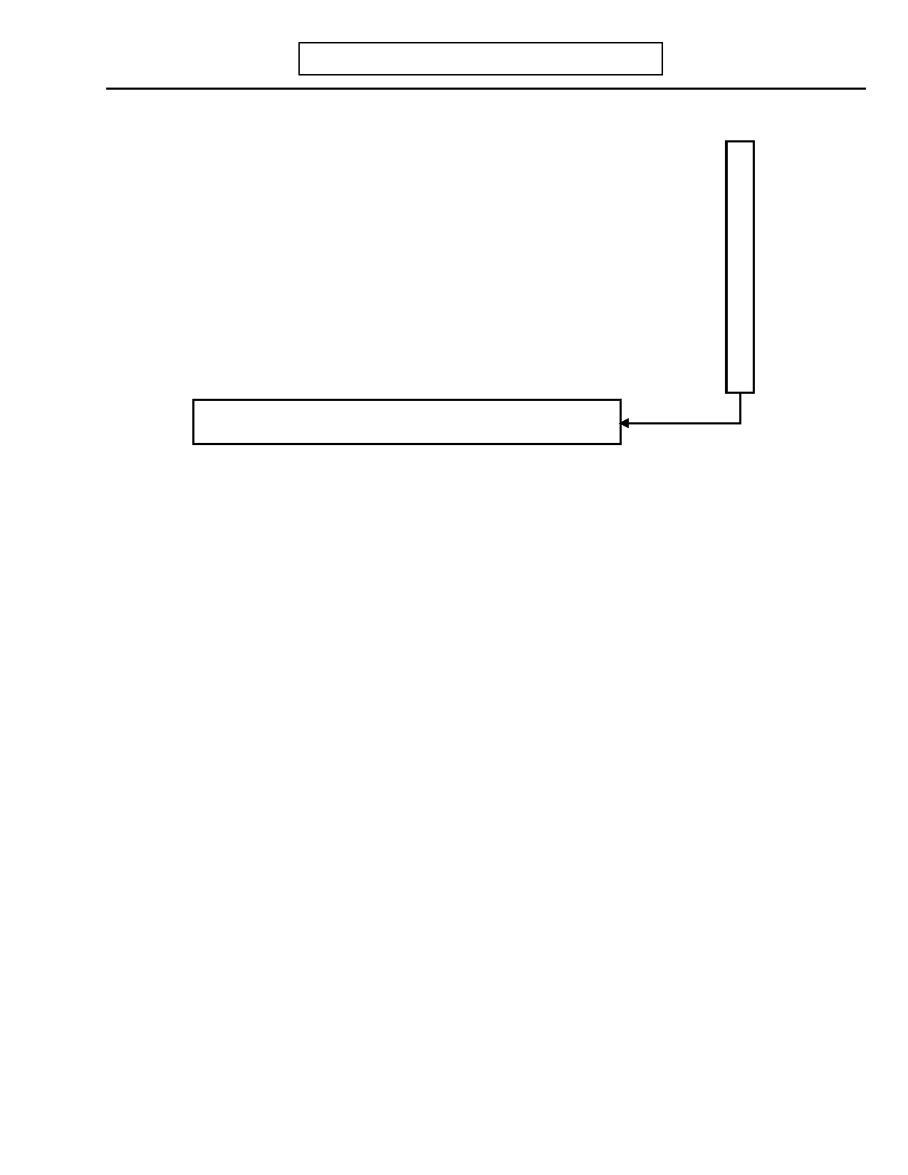
DIGS 4.0 / BP
21-Jul-2005
D. SOMATIZATION
Page 13

I am going to ask you a few more questions about your health.

1.a) Before age 30, (or currently, if subject is <30 years old) did/do you have a lot of
physical health problems or medical problems?
Probe: Was treatment sought, how often? How impairing?
Record response: ___________________________________________________

___________________________________________________________________

___________________________________________________________________

___________________________________________________________________

1.b) Have you missed work or school more than twice because of headaches?

No

0

0

Yes

1

1

Unk

9

9

Skip to E. Overview of Psychiatric Disturbance (page 15)


Page 14
D. SOMATIZATION
DIGS 4.0 / BP
21-Jul-2005

Impairment Code

2. Have you ever had any neurological problems such as…:

2.a)

2.b)

2.c)

2.d)

2.e)

2.f)

2.g)

2.h)

2.i)

2.j)

2.k)

2.l)
…temporary blindness in one or both eyes lasting several seconds or more?

…double vision?

…completely losing your hearing for a few seconds or longer?

…being paralyzed, where you could not move a part of your body for at least a
few minutes?
…periods of weakness where you could not lift or move things you could
normally lift or move?
…trouble walking? (balance or coordination problems)

…being unable to urinate or having difficulty urinating for 24 hours or longer
or having to be catheterized (other than after childbirth or surgery)?
…having a lump in your throat that made it difficult to swallow (other than
when you feel like crying)?
…having a seizure or convulsion (where you had staring spells or were
unconscious and your body jerked)?
…being unconscious or fainting (not seizures)?

…amnesia for a period of several hours or days where you could not remember
afterwards anything that happened?
…other similar symptoms, such as loss of speech, or numbness in a part of the
body?
Specify: _________________________________________________________

0

0

0

0

0

0

0

0

0

0

0

0

1

1

1

1

1

1

1

1

1

1

1

1

2

2

2

2

2

2

2

2

2

2

2

2

3

3

3

3

3

3

3

3

3

3

3

3

4

4

4

4

4

4

4

4

4

4

4

4

_____________________________________________________________

IMPAIRMENT CODES 0. None
1. Yes, mild (never saw physician/never took medication/did not interfere with usual activities) 2. Yes, always secondary to alcohol or drug use.
3. Yes, always part of medically explained physical disorder. 4. Yes, medically unexplained.


DIGS 4.0 / BP
21-Jul-2005
E. OVERVIEW OF PSYCHIATRIC DISTURBANCE
Page 15

No Yes Unk

1. Have you ever had any emotional problems or a period when you were not feeling or 0 1 9
behaving like your normal self?

2. Have you ever seen any professional for emotional problems, your nerves, or the way 0 1 9
you were feeling or acting?

2.a) Have you been in psychotherapy or in counseling? 0 1 9

If yes to question 2 or 2.a:
Age
2.b) How old were you when you first saw someone for (Emotional problem)?

2.c) Were you employed at the time or a full-time student or homemaker? 0 1 9

3. Has there ever been a period of time when you were unable to work, go to school, or 0 1 9
take care of other responsibilities because of psychiatric or emotional reasons?

4. Have you ever been admitted to a hospital or day hospital because of problems with 0 1 9
your mood, emotions, or how you were acting?
Inpatient
If yes: Hospitalizations
4.a) How many times were you admitted to an inpatient unit?
Day
Hospitalizations
4.b) How many times were you admitted to a day hospital?
If any in 4a-b:
0 1 9
4.c) Were any primarily for alcohol and/or drug treatment?
Alc/Drug
Hospitalizations
4.c.1) If yes: How many?
Age
4.d) How old were you at the time of your first psychiatric hospitalization?

5. Have you ever received electro-convulsive treatment (ECT, shock treatments)? 0 1 9
# of courses
5.a) If yes: How many courses of ECT have you received?


Page 16
E. OVERVIEW OF PSYCHIATRIC DISTURBANCE
DIGS 4.0 / BP
21-Jul-2005

No Yes Unk

6. Have you ever taken medications for your nerves or any emotional or mental 0 1 9
problems?
INTERVIEWER: Place a single CHECK mark in column 1 next to all medications the person can recall taking.
Place a second CHECK mark in column 2 by all medications that were taken for at least 3 consecutive months on a daily basis. For other drugs not listed in a category, write in the
name of the drug in the blank(s) at the end of the category and check as above. If the category is unknown, put at the end in "Other Medications".

Antidepressants

Mood Stabilizers

Sedatives / Hypnotics /
Minor Tranquilizers
12

Anafranil (clomipramine
hydrochloride)
Asendin (amoxapine)
Celexa (citalopram
hydrobromide)
Desyrel (trazodone)
Effexor (venlafaxine) Elavil (amitriptyline)
Lexapro (escitalopram oxalate)
Ludiomil (maprotiline)
Luvox (fluvoxamine)
Marplan (isocarboxazid)
Nardil (phenelzine sulfate)
Norpramin (desipramine)
Pamelor/Aventyl (nortriptyline)

Lamictal (lamotrigine)
Lithium
Tegretol (carbamazepine)

Ambien (zolpidem)
Atarax (hydroxyzine)
Ativan (lorazepam)
Benadryl (diphenhydramine)
Buspar (buspirone)
Dalmane (flurazepam
hydrochloride)
Halcion (triazolam)
Klonopin (clonazepam)
Librium (chlordiazepoxide)
Miltown/Equanil (meprobamate)
12

Parnate (tranylcypromine)
Paxil (paroxetine) Prozac (fluoxetine)
Remeron (mirtazapine)
Serzone (nefazodone)
Sinequan/Adapin (doxepine)
Surmontil (trimipramine)
Tofranil (imipramine) Vivactil (protriptyline) Wellbutrin (bupropion)
Zoloft (sertraline)

___________________________

Valproic Acid (depakene,
depakote)

___________________________

Noctec (chloral hydrate) Placidyl (ethchlorvynol)
Restoril (temazepam) Seconal (secobarbital)
Serax (oxazepam)
Tranzene (chlorazepate)
Valium (diazepam) Xanax (alprazolam) Versed (midzolam)

___________________________


DIGS 4.0 / BP
21-Jul-2005
E. OVERVIEW OF PSYCHIATRIC DISTURBANCE
Page 17

Antipsychotics

Stimulants

Other

1

2

Abilify (ariprapizole)
Clozaril (clozapine)
Geodon (ziprasidone) Haldol (haloperidol) Loxitane (loxapine)
Mellaril (thioridazine)
Moban (molindone) Navane (thiothixene)
Prolixin (fluphenazine)

Adderall (amphetamine /
dextroamphetamine)
Concerta (methylphenidate
hydrochloride)
Cylert (pemoline)
Dexedrine (dextroamphetamine)

Neurontin (gabapentin)
Trileptal (oxycarbazepine [anti-
epileptic])
Topamax (Topiramate ([anti-
epileptic])

1

2

Risperdal (risperidone) Serentil (mesoridazine)
Seroquel (sertindole)
Stelazine (trifluoperazine)
Thorazine (chlorpromazine)
Trilafon (perphenazine)
Zyprexa (olanzapine)

___________________________

Metadate (methylphenidate
hydrochloride)
Provigil (modafinil)
Ritalin (methylphenidate)

___________________________

Strattera (Atomoxetine
[norepinephrine reuptake
blocker])
Symbyax (olanzapine and
fluoxetine hydrochloride)

___________________________

Page 18
E. OVERVIEW OF PSYCHIATRIC DISTURBANCE

This page left intentionally blank
DIGS 4.0 / BP
21-Jul-2005


DIGS 4.0 / BP
21-Jul-2005

Antidepressants
E. OVERVIEW OF PSYCHIATRIC DISTURBANCE

MEDICATIONS CARD
Page 19

Anafranil (clomipramine
hydrochloride)
Asendin (amoxapine)
Celexa (citalopram hydrobromide)
Desyrel (trazodone)
Effexor (venlafaxine) Elavil (amitriptyline)
Lexapro (escitalopram oxalate)
Ludiomil (maprotiline)

Mood Stabilizers
Lamictal (lamotrigine)
Luvox (fluvoxamine)
Marplan (isocarboxazid)
Nardil (phenelzine sulfate)
Norpramin (desipramine)
Pamelor/Aventyl (nortriptyline)
Parnate (tranylcypromine)
Paxil (paroxetine) Prozac (fluoxetine)
Remeron (mirtazapine)

Lithium
Tegretol (carbamazepine)
Serzone (nefazodone)
Sinequan (doxepine)
Surmontil (trimipramine)
Tofranil (imipramine) Vivactil (protriptyline) Wellbutrin (bupropion)
Zoloft (sertraline)

Valproic Acid (depakene,
depakote)

Sedatives / Hypnotics / Minor Tranquilizers

Ambien (zolpidem, midzolam)
Atarax (hydroxyzine)
Ativan (lorazepam)
Benadryl (diphenhydramine)
Buspar (buspirone)
Halcion (triazolam)
Klonopin (clonazepam)
Librium (chlordiazepoxide)
Miltown/Equanil (meprobamate)
Noctec (chloral hydrate)
Restoril (temazepam)
Seconal (secobarbital)
Serax (oxazepam)
Tranzene (chlorazepate)
Valium (diazepam)

Dalmane (flurazepam hydrochloride) Placidyl (ethchlorvynol) Xanax (alprazolam)

Antipsychotics

Abilify (ariprapizole)
Clozaril (clozapine)
Geodon (ziprasidone) Haldol (haloperidol) Loxitane (loxapine)
Mellaril (thioridazine)

Stimulants
Adderall (amphetamine /
dextroamphetamine)
Concerta (methylphenidate
hydrochloride)

Other
Neurontin (gabapentin)
Trileptal (oxycarbazepine [anti-
epileptic])
Moban (molindone)
Navane (thiothixene)
Prolixin (fluphenazine) Risperdal (risperidone) Serentil (mesoridazine)

Cylert (pemoline)
Dexedrine (amphetamine)
Metadate (methylphenidate
hydrochloride)

Topamax (Topiramate ([anti-
epileptic])
Strattera (Atomoxetine
[norepinephrine reuptake
blocker])
Seroquel (sertindole)
Stelazine (trifluoperazine)
Thorazine (chlorpromazine)
Trilafon (perphenazine)
Zyprexa (olanzapine)

Provigil (modafinil)
Ritalin (methylphenidate)

Symbyax (olanzapine and
fluoxetine hydrochloride)

Page 20
E. OVERVIEW OF PSYCHIATRIC DISTURBANCE

This page left intentionally blank
DIGS 4.0 / BP
21-Jul-2005


DIGS 4.0 / BP
21-Jul-2005
E. OVERVIEW OF PSYCHIATRIC DISTURBANCE
Page 21

INTERVIEWER: If subject reported any emotional problems in questions 1-6 skip to
question 8.
No Yes Unk

7. Was there ever a time when you or someone else thought you needed professional 0 1 9
help because of your feelings or the way you were acting?
Skip to F. Major Depression (page 25)

8. Please tell me more about these periods we've just discussed.


Page 22
E. OVERVIEW OF PSYCHIATRIC DISTURBANCE
DIGS 4.0 / BP
21-Jul-2005

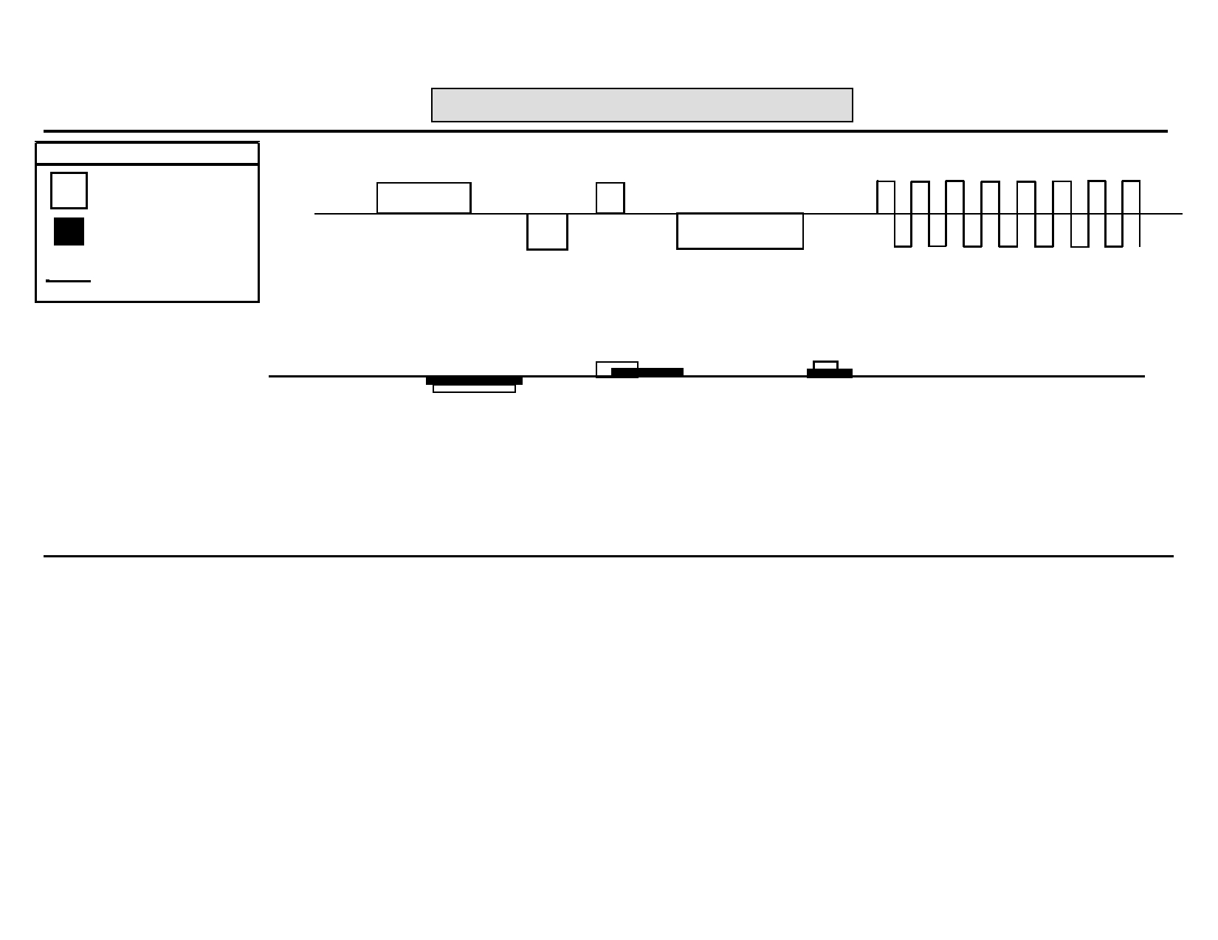
DIGS 4.0 / BP
21-Jul-2005
E. OVERVIEW OF PSYCHIATRIC DISTURBANCE
Page 23

KEY SAMPLE: Affective Illness Only

Affective Illness MANIA

Active Psychosis DEPRESSION

Prodromal & Residual 1962 1966 1970 1975 <-- 1978 to present -->

SAMPLE: Psychosis and Affective Illness

1950 1954 1956

PATIENT:


Page 24
E. OVERVIEW OF PSYCHIATRIC DISTURBANCE

Duration
DIGS 4.0 / BP
21-Jul-2005

Age Type of Episode or Symptoms (weeks) Treatment

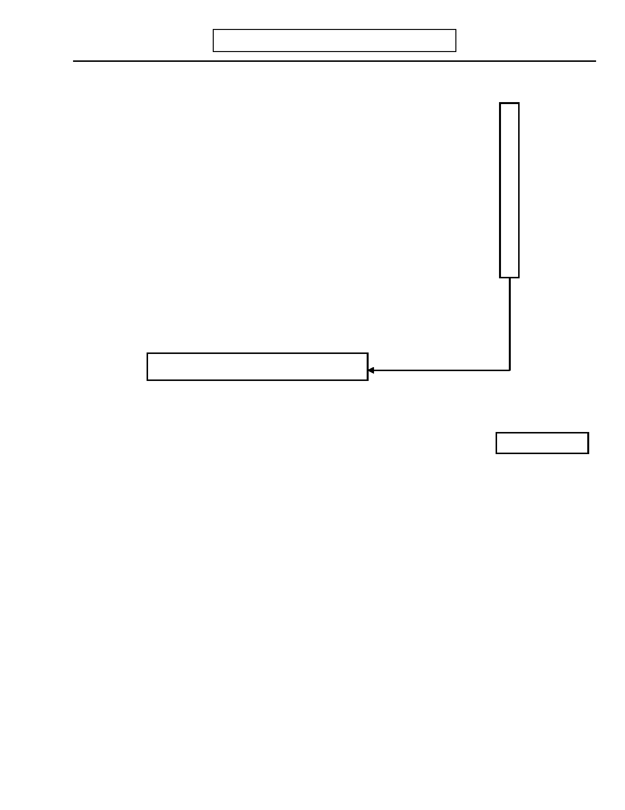
DIGS 4.0 / BP
21-Jul-2005
F. MAJOR DEPRESSION
Page 25

Now I'm going to ask you some questions about your mood.
No Yes Unk

1. Have you ever had a period of at least one week when you were bothered most of the 0 1 9
day, nearly every day, by feeling depressed, sad, down, low?

1.a) By feeling irritable? 0 1 9

1.b) By feeling anxious? 0 1 9

1.c) Have you ever had a period of at least one week when you did not enjoy most 0 1 9
things, even things you usually like to do?

2. If 1-1.c are all NO:

INTERVIEWER: Do you suspect a past or current episode from subject's responses, 0 1 9
behavior, or other information?

If yes: Specify: ____________________________________________________

_________________________________________________________________

Skip to G. Mania/Hypomania (page 43)

3. Have you been feeling that way recently (i.e., for at least one week during the past 30 0 1 9
days)?
Weeks
3.a) If yes: How long have you felt this way?


Page 26
F. MAJOR DEPRESSION
Most Severe Episode
DIGS 4.0 / BP
21-Jul-2005

4. Think about the most severe period in your life when you were feeling this way.

When did it begin?

Month
-

Year

Age

4.a) INTERVIEWER: Compute age.
Weeks
4.b) How long did that period last?
No Yes Unk

4.c) Did you feel depressed, sad, down, or low? 0 1 9

4.d) Did you feel irritable? 0 1 9

4.e) Did you feel anxious? 0 1 9

5. INTERVIEWER: Is the most severe episode also the current episode? 0 1


DIGS 4.0 / BP
21-Jul-2005

During the most severe episode…:
F. MAJOR DEPRESSION
Most Severe Episode
Page 27

Code Response

6. Did you have a loss of appetite or did your appetite greatly increase? 0 1 2 3 9

0.
1. 2. 3. 9.
No
Yes, decreased Yes, increased
Yes, mixture
Unknown/No information

6.a) Did you lose/gain weight when you were not trying to? 0 1 2 9

0.
1. 2. 9.
If yes:
No
Loss Gain
Unknown

Pounds
6.b)What was your weight before the loss/gain?
Pounds
6.c) What was your weight after the loss/gain?
Weeks
6.d)Over what period of time did you lose/gain this amount of weight?

No Yes Unk

7. Did you have trouble sleeping or were you sleeping more than usual? 0 1 9

If yes:

7.a) Were you unable to fall asleep? 0 1 9

7.b)If yes: Was this for at least one hour? 0 1 9

7.c) Were you waking up in the middle of the night and having trouble going back to 0 1 9
sleep?

7.d) Were you waking up too early in the morning? 0 1 9

7.e) If yes: Was this at least one hour earlier than usual? 0 1 9

7.f) Were you sleeping much more than usual? 0 1 9

8. Were you so fidgety or restless that other people could have noticed (e.g., pacing or 0 1 9
wringing hands)?

9. Were you moving or speaking so slowly that other people could have noticed? 0 1 9

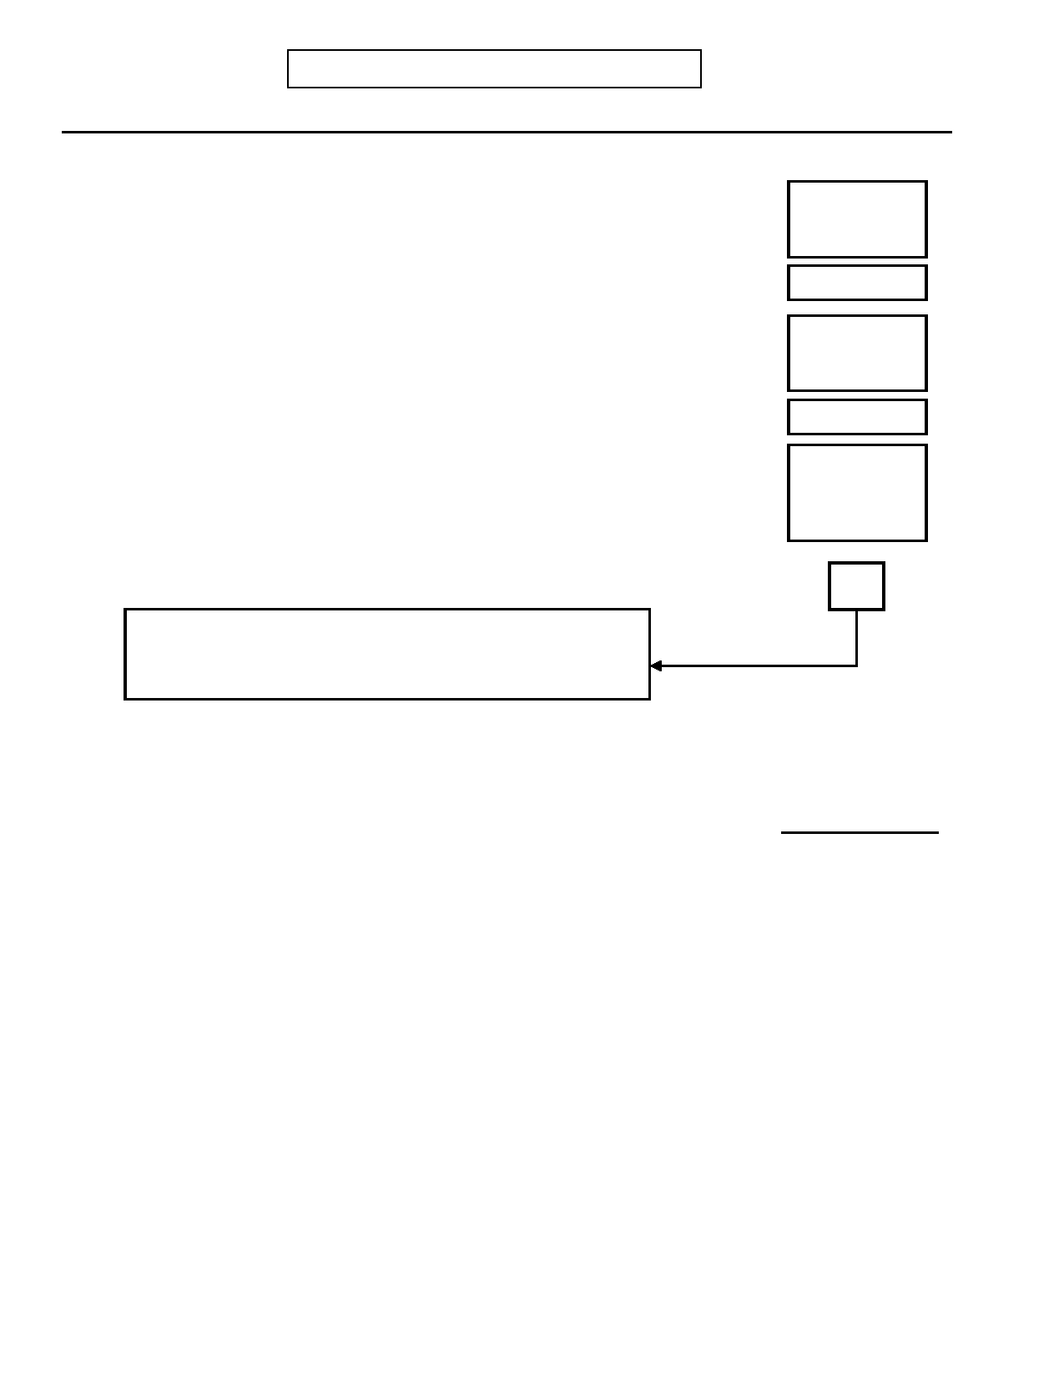
Page 28
F. MAJOR DEPRESSION
Most Severe Episode
DIGS 4.0 / BP
21-Jul-2005

No Yes Unk

10. Were you much less able to enjoy sex and other pleasurable activities? 0 1 9

10a. Did you lose interest in nearly all of your usual activities? 0 1 9

11. Were you feeling a loss of energy or more tired than usual? 0 1 9

12. Were you feeling guilty or that you were a bad person? 0 1 9

13. Were you feeling that you were a failure or worthless? 0 1 9

14. Were you having difficulty thinking, concentrating, or making decisions? 0 1 9

15. Were you frequently thinking about death, or wishing you were dead, or thinking 0 1 9
about taking your life?

16. Did you actually try to harm yourself? 0 1 9

17. INTERVIEWER: Enter number of boxes with at least one YES response in questions 6-
16 TOTAL BOXES
INTERVIEWER: If less than three, probe for other potentially
severe episodes. If necessary, recode questions 6-16. If still less than three, skip to G. Mania/Hypomania (page 43).

18. (INTERVIEWER: Review symptoms in questions 6-16 plus depressed mood or 0 1 9
hand subject Depression Tally Sheet to review): During this episode was there a
two-week period when these symptoms were present nearly every day (at least four
symptoms plus depressed mood)?
Code Response
19. Did you tend to feel worse in the morning or in the evening or was there no difference?
0 1 2
0. A.M.
1. P.M.
2. No difference
No Yes Unk

20. During this episode, did you have beliefs or ideas that you later found out were not 0 1 9
true? Probe: Like believing you had committed a crime or sin? Or that God was
punishing you? Or that some terrible thing was going to happen? Or that someone
was trying to harm you, or was talking about you? Or that something had gone wrong
with your body? How certain were you?
INTERVIEWER: If delusions are suspected, probe further to determine the content
and whether the beliefs were held with certainty. Code on the basis of this
information and describe below:

__________________________________________________________________

__________________________________________________________________

20.1) If yes: Were you convinced of these beliefs at the time? 0 1 9


DIGS 4.0 / BP
21-Jul-2005
F. MAJOR DEPRESSION
Most Severe Episode
Page 29

No Yes Unk
If yes to question 20:

20.a) Did these beliefs occur either just before this depression or after it cleared? 0 1 9
Days
20.b) If yes: How long were they present before the depression began?
Days
20.c) If yes: How long did they last after your mood returned to normal?

20.d) INTERVIEWER: Does this total more than 14 days? 0 1 9

21. Did you see or hear things that other people could not see or hear? 0 1 9
Probe: Like voices talking or noises, or visions? Or have unusual tastes, smells, or
physical sensations?
If yes: Specify: ____________________________________________________

_________________________________________________________________

_________________________________________________________________

21.1) If yes: Were you using any street drugs at the times that you experienced these 0 1 9
(refer to experiences)?

If yes: What were they? (INTERVIEWER: List the drugs used and describe the
frequency of use and doses, if possible.) ____________________________

_________________________________________________________________

_________________________________________________________________

21.2) If voices: Did these voices usually seem to originate:

21.2.a) ...from within your head? 0 1 9

21.2.b) ...from outside your head? 0 1 9

21.2.c) ...from some particular place outside your head? 0 1 9

21.2.d) Were these voices definitely different from your own thoughts? 0 1 9

If yes to question 21:
0 1 9
21.a) Did these (refer to experiences) occur either just before this depression or
after it cleared?
Days
21.b) If yes: How long were they present before the depression began?
Days
21.c) If yes: How long did they last after your mood returned to normal?

21.d) INTERVIEWER: Does this total more than 14 days? 0 1 9


Page 30
F. MAJOR DEPRESSION
Most Severe Episode
DIGS 4.0 / BP
21-Jul-2005

No Yes Unk

22. If yes to questions 20 or 21: 0 1 9
INTERVIEWER: Did psychotic symptoms have content that was inconsistent with
depressive themes such as poverty, guilt, illness, personal inadequacy or catastrophe?

22.a) If yes: INTERVIEWER: Was the subject preoccupied with psychotic 0 1 9
symptoms to the exclusion of other symptoms or concerns?

23. Did you seek or receive help from a doctor or other professional for this period of 0 1 9
depression?

24. Were you prescribed medication for depression or was there a change in your 0 1 9
dosage?

If yes: Specify: ____________________________________________________

_________________________________________________________________

25. During this episode were you admitted to the hospital for depression (including day 0 1 9
hospital)?
Days
25.a) If yes: For how long (inpatient)?
Days
25.b) If yes: For how long (day hospital) ?

26. Did you receive ECT (shock treatments)? 0 1 9
INTERVIEWER: If the patient was hospitalized two days or more, had ECT, or had
psychotic symptoms, skip to question 29 and code incapacitation.

Code Response
27. Was your major responsibility during this episode job, home, school, or
something else? 1 2 3 4
1. Job
2. Home 3. School
4. Other
If other: Specify: __________________________________________

______________________________________________________________
No Yes Unk

28. Was your functioning (in this role) affected? 0 1 9

If yes: Specify: ____________________________________________________

_________________________________________________________________


DIGS 4.0 / BP
21-Jul-2005
F. MAJOR DEPRESSION
Most Severe Episode
Page 31

28.a) Did something happen as a result of this (such as marital separation, absence 0 1 9
from work or school, loss of a job, or lower grades)?

If yes: Specify: _____________________________________________________

_______________________________________________________________

_______________________________________________________________

28.b) Did someone notice a change in your functioning? 0 1 9

Code Response

29. INTERVIEWER: Code based on answers to questions 20, 21 and 25-28 0 1 2 9
0. No change
1. Impairment
2. Incapacitation 9. Unknown

Modified RDC Impairment: A decrease in quality of the most important
role performance (noticeable to others). This usually requires a
decrease in the amount of performance; it may be manifested by a
person taking ten hours to do what normally may require five hours.

Modified RDC Incapacitation: Includes complete inability to carry out
principal role at home, school or work for 2 days in a row OR Hospitalization for 2 days. OR ECT treatment.
OR Presence of hallucinations or delusions.

If impaired or incapacitated: Specify: _____________________________

___________________________________________________________

___________________________________________________________

30. RDC Minor Role Dysfunction 0 1 9
If no change in question 29: Was your functioning in any other area of your life
affected?

If yes: Specify: ____________________________________________________

______________________________________________________________

30.a) INTERVIEWER: If no to questions 25-30, is there any other evidence of 0 1 9
clinically significant distress?

If yes: Specify: ____________________________________________________

______________________________________________________________
INTERVIEWER: If MALE or NEVER PREGNANT, skip to question 32, page 32.


Page 32
F. MAJOR DEPRESSION
Most Severe Episode
DIGS 4.0 / BP
21-Jul-2005

No Yes Unk

31. Did this episode occur during pregnancy (code 1) or just after childbirth (code 2)? 0 12 9

31.a)

If yes: What was the date of childbirth?

Month

-

Year

32. Did this episode occur during or shortly after a serious physical illness? 0 1 9

INTERVIEWER: The following illnesses, among others, may be relevant:
Hypothyroidism, CVA, MS, Mono, Hepatitis, Cancer, Parkinson's, HIV, Cushing's or other endocrine illnesses.

If yes: Specify: ____________________________________________________

_________________________________________________________________

33. Did this episode begin shortly after you started taking any prescribed medication? 0 1 9

INTERVIEWER: Aldomet, Inderal (propranolol), reserpine, interferon, and steroid
medications (Prednisone, etc.) are important precipitants. Probe to
distinguish precipitants from drugs actually prescribed to treat early symptoms of depression, such as hypnotics given for insomnia.

If yes: Specify medications: ______________________________________

_________________________________________________________________

34. Did this episode begin while you were using street drugs? 0 1 9

INTERVIEWER: The following drugs, among others, may be relevant: Amphetamines,
Barbiturates, Cocaine, "Downers", Tranquilizers

If yes: Specify drug and quantity: ______________________________________

_________________________________________________________________

35. Did this episode follow increased use of alcohol? 0 1 9

If yes: Specify: _____________________________________________________

_________________________________________________________________

35.a) Did this episode follow decreased use of alcohol? 0 1 9

If yes: Specify: _____________________________________________________

________________________________________________________________

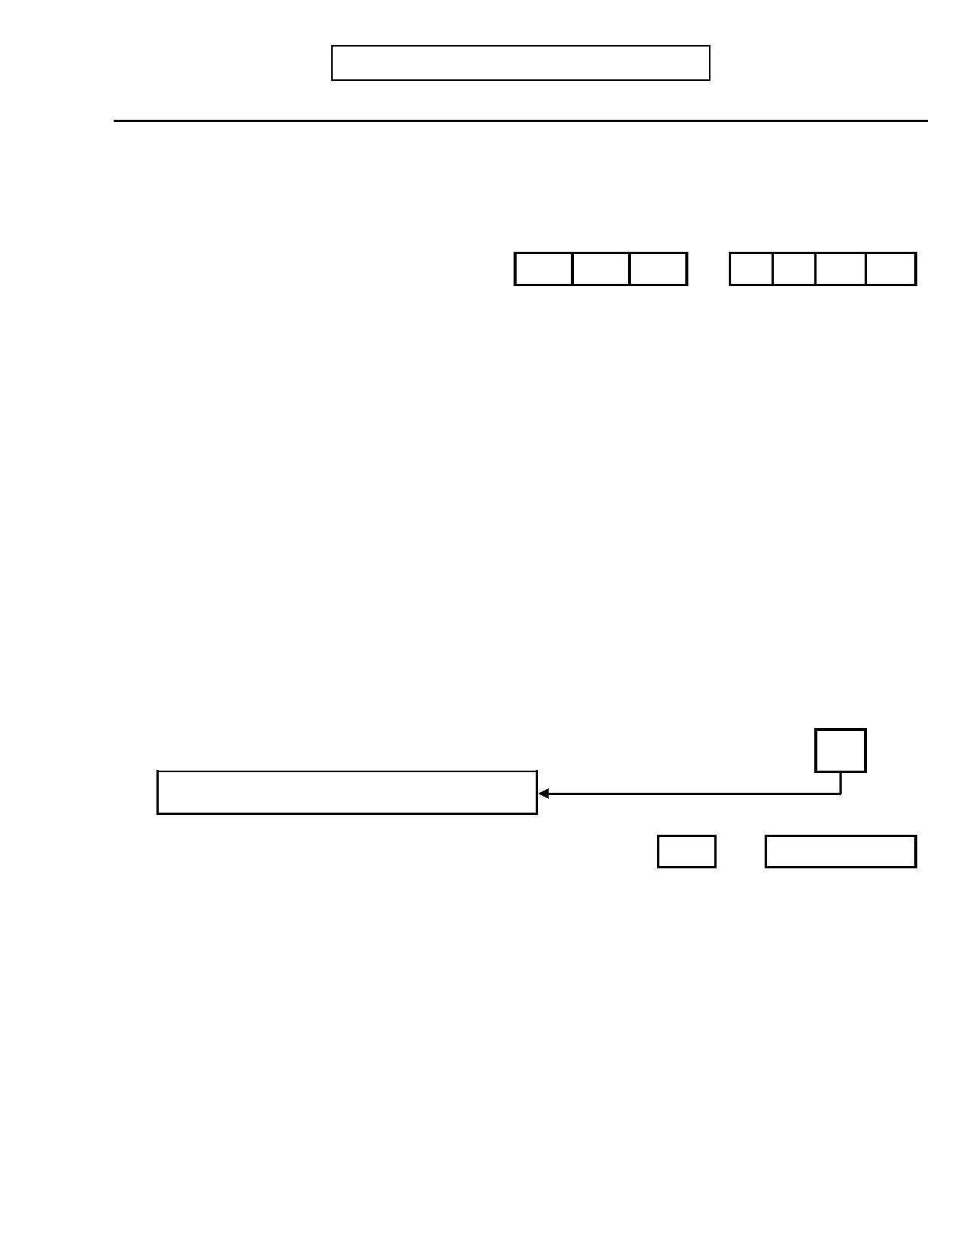
DIGS 4.0 / BP
21-Jul-2005
F. MAJOR DEPRESSION
Most Severe Episode
Page 33

No Yes Unk

36. Did this episode follow the death of someone close to you? 0 1 9

36.a) If yes: Specify relationship: _________________________________________

36.b)

Date of death

Month

-

Year

37. During this episode of depression did you have a week or more during which your 0 1 9
mood frequently changed between sadness and irritability or even elation?

If yes:
37.a) During this episode of depression did you also experience any of these
symptoms?

37.a.1) Overactivity—Running around, many projects, or physically agitated? 0 1 9

37.a.2) More talkative than usual, speech pressured? 0 1 9

37.a.3) Thoughts racing, jumping from topic to topic? 0 1 9

37.a.4) Feeling grandiose - more important, special, powerful? 0 1 9

37.a.5) Needing less sleep - energetic after little or no sleep? 0 1 9

37.a.6) Attention distracted by unimportant things? 0 1 9

37.a.7) Doing risky things for pleasure - spending, sex, reckless driving, etc.? 0 1 9
37.a.8) INTERVIEWER: Enter number of YES responses in 37.a.1-7: TOTAL

If total in 37.a.8 is less than 3, skip to question 38
Days Weeks
37.a.9) How long were these symptoms present? OR

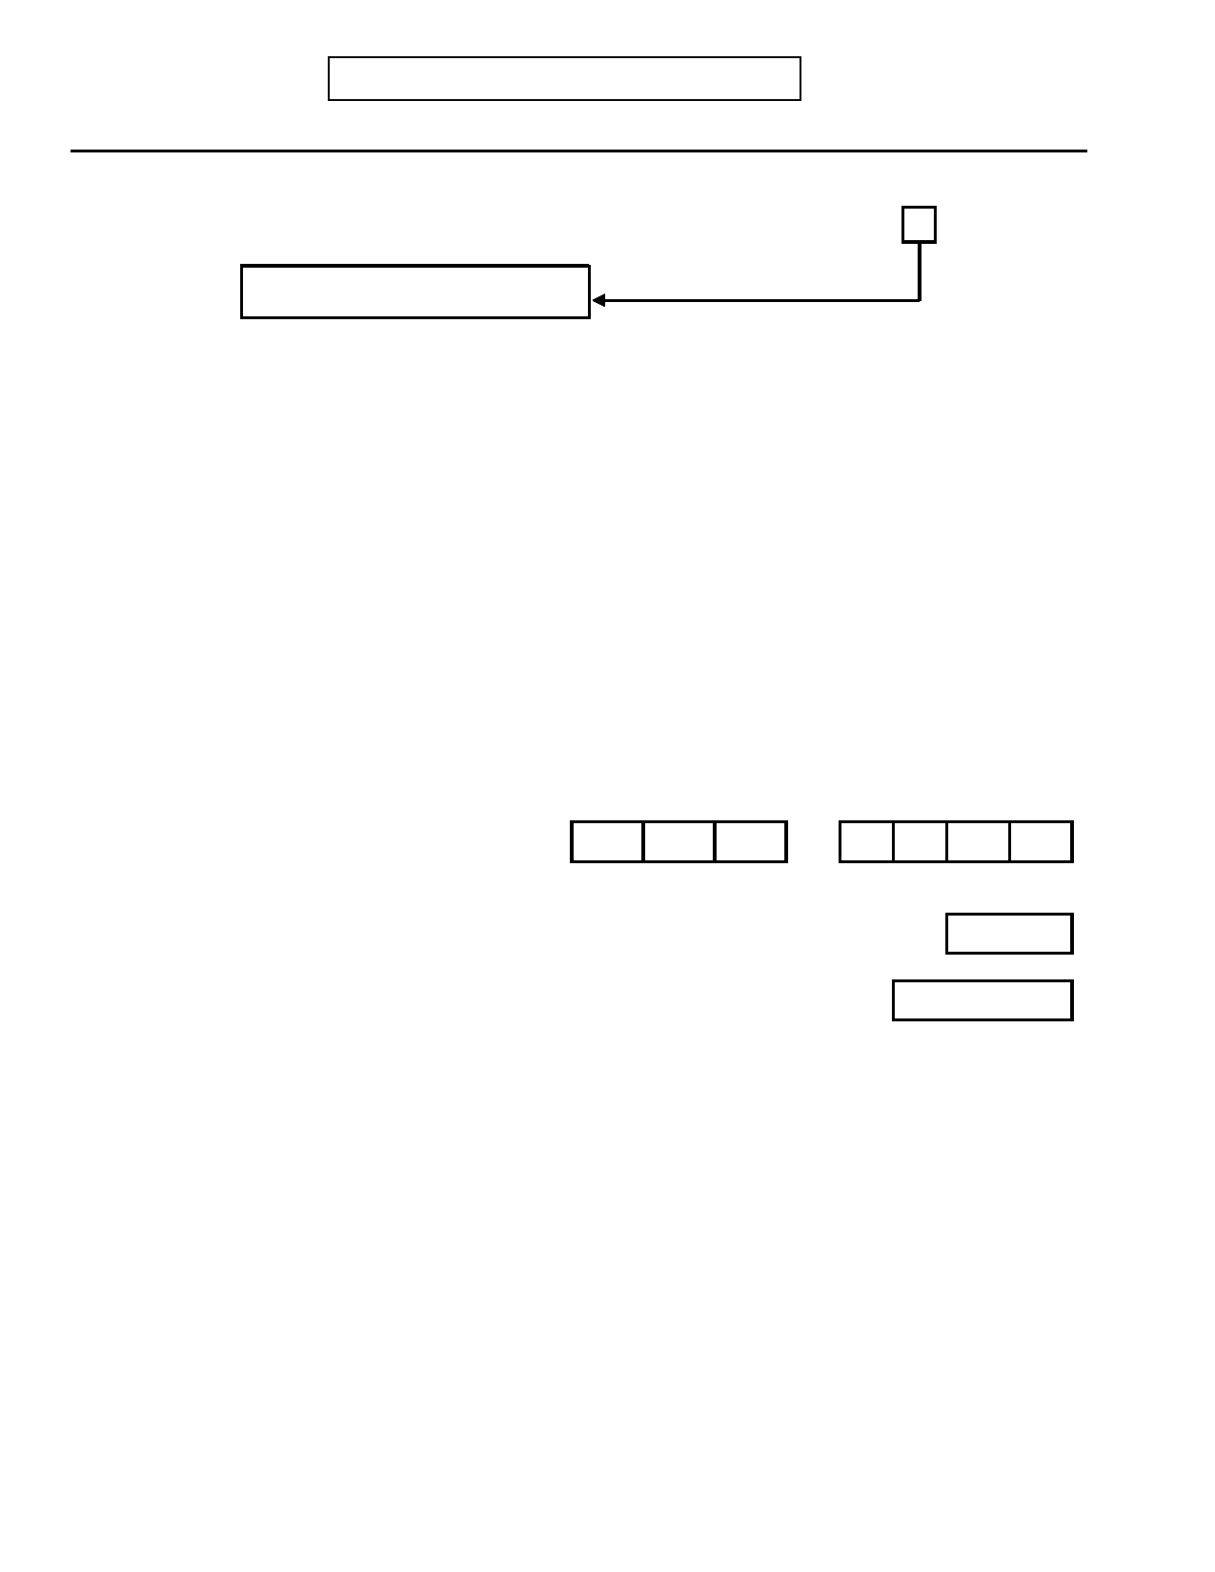
Page 34
F. MAJOR DEPRESSION
Other Episode
DIGS 4.0 / BP
21-Jul-2005

No Yes Unk

38. Did you have at least one other episode when you were depressed for at least one 0 1 9
week and had several of the symptoms you described?
Skip to question 71, page 42
If yes: When was the most recent time that you had depression that was almost as
severe as the time we just talked about?

INTERVIEWER: Based on the overview or additional probing, identify the most
recent severe episode that the subject remembers well. Avoid
episodes with probable organic precipitants and episodes that
occurred less than 2 months before or after the Most Severe
Episode. A Current Episode should be rated here if it meets these criteria.

Briefly describe the subject's response: ___________________________________

_________________________________________________________________

_________________________________________________________________

_________________________________________________________________

38.a)

38.b)

38.c)

Is the selected episode also the current episode (in the past 30 days)?

When did it begin?
Month

INTERVIEWER: Compute age.

-

0

1

Year

Age

Weeks
38.d) How long (did that period last/has it lasted)?
No Yes Unk

38.e) Did you feel depressed, sad, down, or low? 0 1 9

38.f) Did you feel irritable? 0 1 9

38.g) Did you feel anxious? 0 1 9


DIGS 4.0 / BP
21-Jul-2005

During the selected episode…:
F. MAJOR DEPRESSION
Other Episode
Page 35

Code Response

39. Did you have a loss of appetite or did your appetite greatly increase? 0 1 2 3 9

0.
1. 2. 3. 9.
No
Yes, decreased Yes, increased
Yes, mixture
Unknown/No information

39.a) Did you lose/gain weight when you were not trying to? 0 1 2 9

0.
1. 2. 9.
If yes:
No
Loss Gain
Unknown

Pounds
39.b) What was your weight before the loss/gain?
Pounds
39.c) What was your weight after the loss/gain?
Weeks
39.d) Over what period of time did you lose/gain this amount of weight?

No Yes Unk

40. Did you have trouble sleeping or were you sleeping more than usual? 0 1 9

If yes:

40.a) Were you unable to fall asleep? 0 1 9

40.b) If yes: Was this for at least one hour? 0 1 9

40.c) Were you waking up in the middle of the night and having trouble going back to 0 1 9
sleep?

40.d) Were you waking up too early in the morning? 0 1 9

40.e) If yes: Was this at least one hour earlier than usual? 0 1 9

40.f) Were you sleeping much more than usual? 0 1 9

41. Were you so fidgety or restless that other people could have noticed (e.g., pacing or 0 1 9
wringing hands)?

42. Were you moving or speaking so slowly that other people could have noticed? 0 1 9

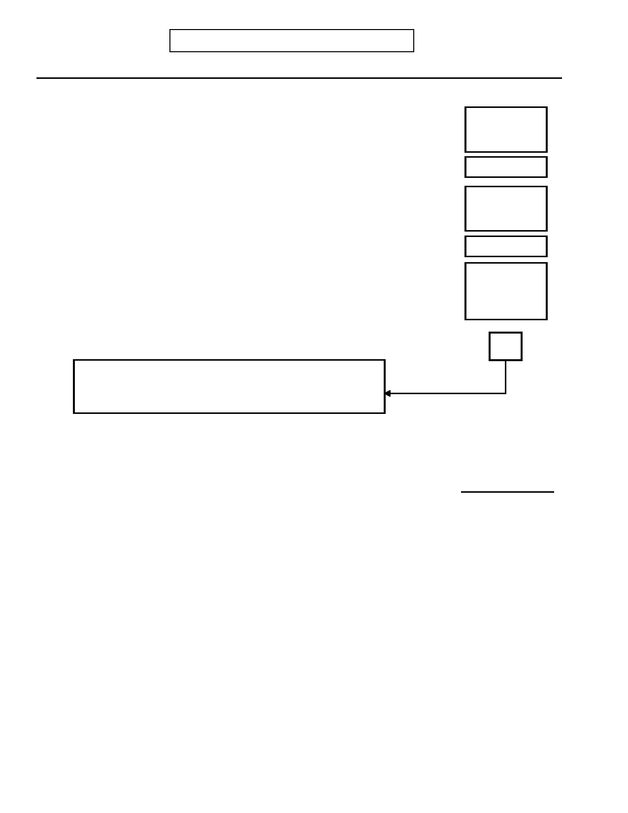
Page 36
F. MAJOR DEPRESSION
Other Episode
DIGS 4.0 / BP
21-Jul-2005

No Yes Unk

43. Were you much less able to enjoy sex and other pleasurable activities? 0 1 9

43.a) Did you lose interest in nearly all of your usual activities? 0 1 9

44. Were you feeling a loss of energy or more tired than usual? 0 1 9

45. Were you feeling guilty or that you were a bad person? 0 1 9

46. Were you feeling that you were a failure or worthless? 0 1 9

47. Were you having difficulty thinking, concentrating, or making decisions? 0 1 9

48. Were you frequently thinking about death, or wishing you were dead, or thinking 0 1 9
about taking your life?

49. Did you actually try to harm yourself? 0 1 9

50. INTERVIEWER: Enter number of boxes with at least one YES response in questions 39-
49 TOTAL BOXES
INTERVIEWER: If less than three, probe for other potentially
severe episodes. If necessary, recode questions 39-49. If still less than three, skip to question 71, page 42.

51. (INTERVIEWER: Review symptoms in questions 39-49 plus depressed mood or 0 1 9
hand subject Depression Tally Sheet to review): During this episode was there a
two-week period when these symptoms were present nearly every day (at least four
symptoms plus depressed mood)?
Code Response
52. Did you tend to feel worse in the morning or in the evening or was there no difference?
0 1 2
0. A.M.
1. P.M.
2. No difference
No Yes Unk

53. During this episode, did you have beliefs or ideas that you later found out were not 0 1 9
true? Probe: Like believing you had committed a crime or sin? Or that God was
punishing you? Or that some terrible thing was going to happen? Or that someone
was trying to harm you, or was talking about you? Or that something had gone wrong
with your body? How certain were you?
INTERVIEWER: If delusions are suspected, probe further to determine the content
and whether the beliefs were held with certainty. Code on the basis of this
information and describe below:

__________________________________________________________________

__________________________________________________________________

53.1) If yes: Were you convinced of these beliefs at the time? 0 1 9

DIGS 4.0 / BP
21-Jul-2005
F. MAJOR DEPRESSION
Other Episode
Page 37

No Yes Unk
If yes to question 53:

53.a) Did these beliefs occur either just before this depression or after it cleared? 0 1 9
Days
53.b) If yes: How long were they present before the depression began?
Days
53.c) If yes: How long did they last after your mood returned to normal?

53.d) INTERVIEWER: Does this total more than 14 days? 0 1 9

54. Did you see or hear things that other people could not see or hear? 0 1 9
Probe: Like voices talking or noises, or visions? Or have unusual tastes, smells, or
physical sensations?
If yes: Specify: ____________________________________________________

_________________________________________________________________

_________________________________________________________________

54.1) If yes: Were you using any street drugs at the times that you experienced these 0 1 9
(refer to experiences)?

If yes: What were they? (INTERVIEWER: List the drugs used and describe the
frequency of use and doses, if possible.) ____________________________

_________________________________________________________________

_________________________________________________________________

54.2) If voices: Did these voices usually seem to originate:

54.2.a) ...from within your head? 0 1 9

54.2.b) ...from outside your head? 0 1 9

54.2.c) ...from some particular place outside your head? 0 1 9

54.2.d) Were these voices definitely different from your own thoughts? 0 1 9

If yes to 54:
0 1 9
54.a) Did these (refer to experiences) occur either just before this depression or
after it cleared?
Days
54.b) If yes: How long were they present before the depression began?
Days
54.c) If yes: How long did they last after your mood returned to normal?

54.d) INTERVIEWER: Does this total more than 14 days? 0 1 9

Page 38
F. MAJOR DEPRESSION
Other Episode
DIGS 4.0 / BP
21-Jul-2005

No Yes Unk

55. If yes to questions 53 or 54: 0 1 9
INTERVIEWER: Did psychotic symptoms have content that was inconsistent with
depressive themes such as poverty, guilt, illness, personal inadequacy or catastrophe?

55.a) If yes: INTERVIEWER: Was the subject preoccupied with psychotic 0 1 9
symptoms to the exclusion of other symptoms or concerns?

56. Did you seek or receive help from a doctor or other professional for this period of 0 1 9
depression?

57. Were you prescribed medication for depression or was there a change in your 0 1 9
dosage?

If yes: Specify: ____________________________________________________

_________________________________________________________________

58. During this episode were you admitted to the hospital for depression (including day 0 1 9
hospital)?
Days
58.a) If yes: For how long (inpatient)?
Days
58.b) If yes: For how long (day hospital) ?

59. Did you receive ECT (shock treatments)? 0 1 9
INTERVIEWER: If the patient was hospitalized two days or more, had ECT, or had
psychotic symptoms, skip to question 62 and code incapacitation.

Code Response
60. Was your major responsibility during this episode job, home, school, or
something else? 1 2 3 4
1. Job
2. Home 3. School
4. Other
If other: Specify: __________________________________________

______________________________________________________________
No Yes Unk

61. Was your functioning (in this role) affected? 0 1 9

If yes: Specify: ____________________________________________________

_________________________________________________________________


DIGS 4.0 / BP
21-Jul-2005
F. MAJOR DEPRESSION
Other Episode
Page 39

61.a) Did something happen as a result of this (such as marital separation, absence 0 1 9
from work or school, loss of a job, or lower grades)?

If yes: Specify: ____________________________________________________

________________________________________________________________

________________________________________________________________

61.b) Did someone notice a change in your functioning? 0 1 9

Code Response

62. INTERVIEWER: Code based on answers to questions 53, 54 and 58-61 0 1 2 9
0. No change
1. Impairment
2. Incapacitation 9. Unknown

Modified RDC Impairment: A decrease in quality of the most important
role performance (noticeable to others). This usually requires a
decrease in the amount of performance; it may be manifested by a
person taking ten hours to do what normally may require five hours.

Modified RDC Incapacitation: Includes complete inability to carry out
principal role at home, school or work for 2 days in a row OR Hospitalization for 2 days. OR ECT treatment.
OR Presence of hallucinations or delusions.

If impaired or incapacitated: Specify: ______________________________

_____________________________________________________________

______________________________________________________________

63. RDC Minor Role Dysfunction 0 1 9
If no change in question 62: Was your functioning in any other area of your life
affected?

If yes: Specify: ____________________________________________________

______________________________________________________________

63.a) INTERVIEWER: If no to questions 58-63, is there any other evidence of 0 1 9
clinically significant distress?

If yes: Specify: ____________________________________________________

_______________________________________________________________


Page 40
F. MAJOR DEPRESSION
Other Episode
DIGS 4.0 / BP
21-Jul-2005

INTERVIEWER: If MALE or NEVER PREGNANT, skip to question 65, page 40.
No Yes Unk

64. Did this episode occur during pregnancy (code 1) or just after childbirth (code 2)? 0 12 9

64.a)

If yes: What was the date of childbirth?

Month

-

Year

65. Did this episode occur during or shortly after a serious physical illness? 0 1 9

INTERVIEWER: The following illnesses, among others, may be relevant:
Hypothyroidism, CVA, MS, Mono, Hepatitis, Cancer, Parkinson's, HIV, Cushing's or other endocrine illnesses.

If yes: Specify: ____________________________________________________

_________________________________________________________________

66. Did this episode begin shortly after you started taking any prescribed medication? 0 1 9

INTERVIEWER: Aldomet, Inderal (propranolol), reserpine, interferon, and steroid
medications (Prednisone, etc.) are important precipitants. Probe to
distinguish precipitants from drugs actually prescribed to treat early symptoms of depression, such as hypnotics given for insomnia.

If yes: Specify medications: ______________________________________

_________________________________________________________________

67. Did this episode begin while you were using street drugs? 0 1 9

INTERVIEWER: The following drugs, among others, may be relevant: Amphetamines,
Barbiturates, Cocaine, "Downers", Tranquilizers

If yes: Specify drug and quantity: ______________________________________

_________________________________________________________________

68. Did this episode follow increased use of alcohol? 0 1 9

If yes: Specify: _____________________________________________________

_________________________________________________________________

68.a) Did this episode follow decreased use of alcohol? 0 1 9

If yes: Specify: _____________________________________________________

_________________________________________________________________

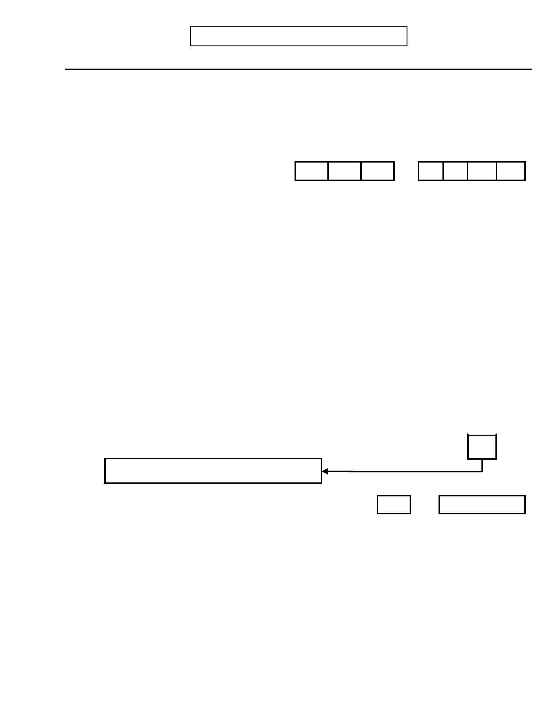
DIGS 4.0 / BP
21-Jul-2005
F. MAJOR DEPRESSION
Other Episode
Page 41

No Yes Unk

69. Did this episode follow the death of someone close to you? 0 1 9

69.a) If yes: Specify relationship: _________________________________________

_________________________________________________________________

69.b)
Date of death

Month

-

Year

70. During this episode of depression did you have a week or more during which your 0 1 9
mood frequently changed between sadness and irritability or even elation?

If yes:
70.a) During this episode of depression did you also experience any of these
symptoms?

70.a.1) Overactivity—Running around, many projects, or physically agitated? 0 1 9

70.a.2) More talkative than usual, speech pressured? 0 1 9

70.a.3) Thoughts racing, jumping from topic to topic? 0 1 9

70.a.4) Feeling grandiose - more important, special, powerful? 0 1 9

70.a.5) Needing less sleep - energetic after little or no sleep? 0 1 9

70.a.6) Attention distracted by unimportant things? 0 1 9

70.a.7) Doing risky things for pleasure - spending, sex, reckless driving, etc.? 0 1 9
70.a.8) INTERVIEWER: Enter number of YES responses in 70.a.1-7: TOTAL

If total in 70.a.8 is less than 3, skip to question 71
Days Weeks
70.a.9) How long were these symptoms present? OR


Page 42
F. MAJOR DEPRESSION
DIGS 4.0 / BP
21-Jul-2005

No Yes Unk

71. INTERVIEWER: Has there been at least one "clean" episode? A "clean" episode is 0 1 9
one WITHOUT prior physical illness, drug or alcohol abuse, organic precipitants, or bereavement.

If yes: Clean
Episodes
72. How many episodes like this have you had?

72a. How old were you the first time you had an episode of depression like this? (Review Ons Age
requirements for clean episode above)

72b. How old were you the last time you had an episode of depression like this? (Review Rec Age
requirements for clean episode above)
Unclean
73. If no clean episodes: Episodes
73.a) How many episodes like this have you had?
Ons Age
73.b) How old were you the first time you had an episode like this?
Rec Age
73.c) How old were you the last time you had an episode like this?
Weeks
74. What was the duration of your longest episode of depression in weeks?
Hospitalized
75. How many times were you hospitalized for an episode of depression? (inpatient)
Hospitalized
75.a) How many times were you hospitalized for an episode of depression? (day hospital)
# of courses
76. How many courses of ECT have you had for depression?
No Yes Unk
77. Did you ever feel high or were you overactive following medical treatment for
depression? 0 1 9

If yes: Describe: ___________________________________________________

_________________________________________________________________
Code Response
78. Do your depressions tend to begin in any particular season?
0 1 2 3 4 9
0. No pattern
1. Winter 2. Spring
3. Summer 4. Fall
9. Unknown

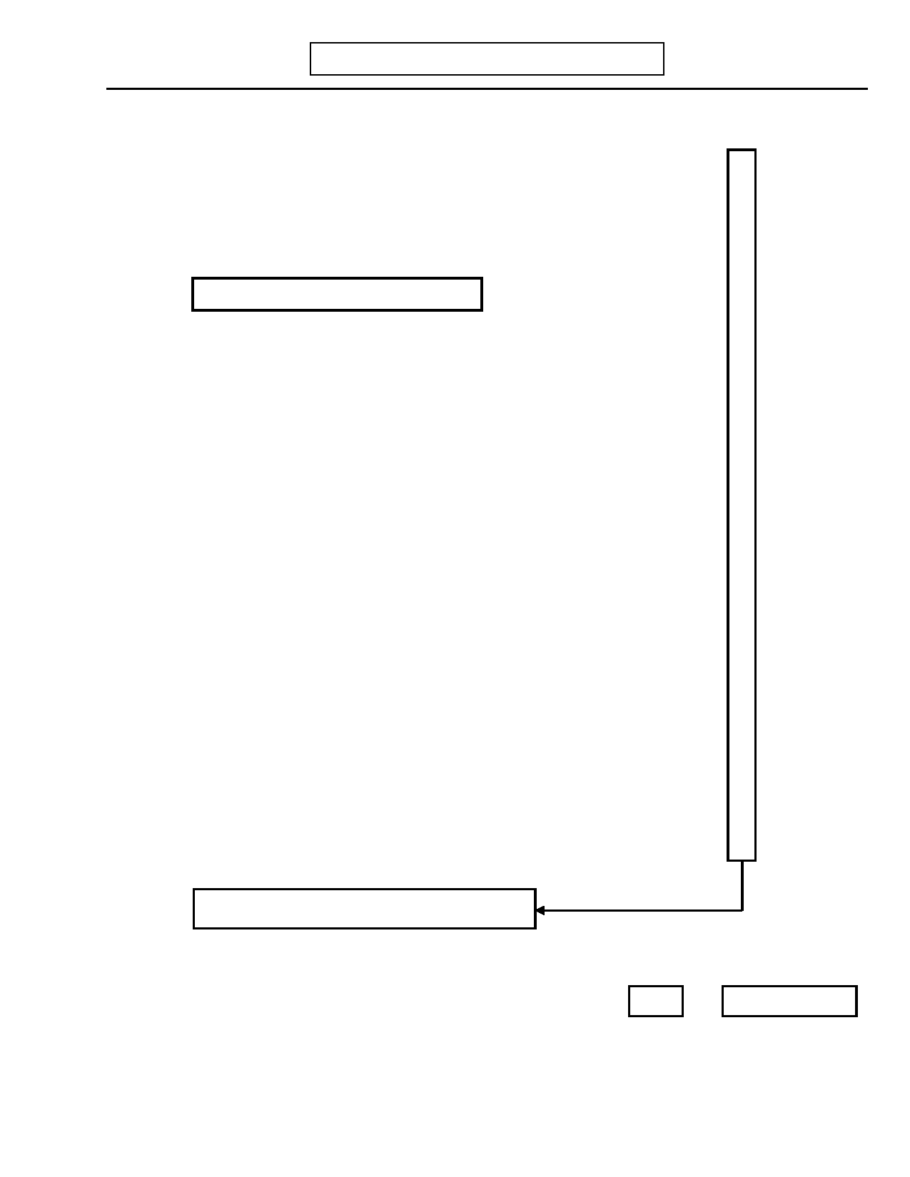
DIGS 4.0 / BP
21-Jul-2005
G. MANIA/HYPOMANIA
Page 43

Now I'm going to ask you some other questions about your mood.
No Yes Unk

1.a)

1.b)

1.c)

1.d)

Did you ever have a period when you felt extremely good or high, clearly different from your normal self? (Was this more than just feeling good?)

Did you ever have a period when you were unusually irritable, clearly different
from your normal self so that you would shout at people or start fights or
arguments?

If yes to 1.a or 1.b, skip to question 1.e

Have you ever had periods lasting even a day or two when you felt unusually
cheerful, irritable, energetic, or hyper?

Have there been times when you felt much more energetic than usual and
needed less sleep than usual?

0

0

0

0

1

1

1

1

9

9

9

9

INTERVIEWER: Probe for additional symptoms if necessary, using additional probes
(e.g., Did you experience racing thoughts or pressure to keep talking? Were you over-confident? Did you make unrealistic
plans? Were you uncharacteristically impulsive? Did you
experience increased activity or increased talkativeness?) Gather and record information on any (even mild) mood states that seem qualitatively different from a normal good mood and that indicate
hypomania. Record response including subject's description of the
mood below:

_________________________________________________________________

_________________________________________________________________

_________________________________________________________________

_________________________________________________________________

1.e) If any yes to questions 1a-d: Did this last persistently throughout the day or 0 1 9
intermittently for two days or more?

1.f) INTERVIEWER: Do you suspect a past or current episode from subject's 0 1 9
responses, behavior, or other information?

Skip to H. Dysthymia/Cyclothymia (page 63)

2. Have you been feeling that way recently (i.e., during the past 30 days)? 0 1 9
Days Weeks
2.a) If yes: How long have you felt this way? OR


Page 44
G. MANIA/HYPOMANIA
Most Severe Episode
DIGS 4.0 / BP
21-Jul-2005

3. Think about the most extreme period in your life when you were feeling unusually
good, high, or irritable.

When did it begin?

Month
-

Year

Age

3.a) INTERVIEWER: Compute age.
Days Weeks
3.b) How long did that period last? OR
No Yes

4. INTERVIEWER: Is the most severe episode also the current episode? 0 1

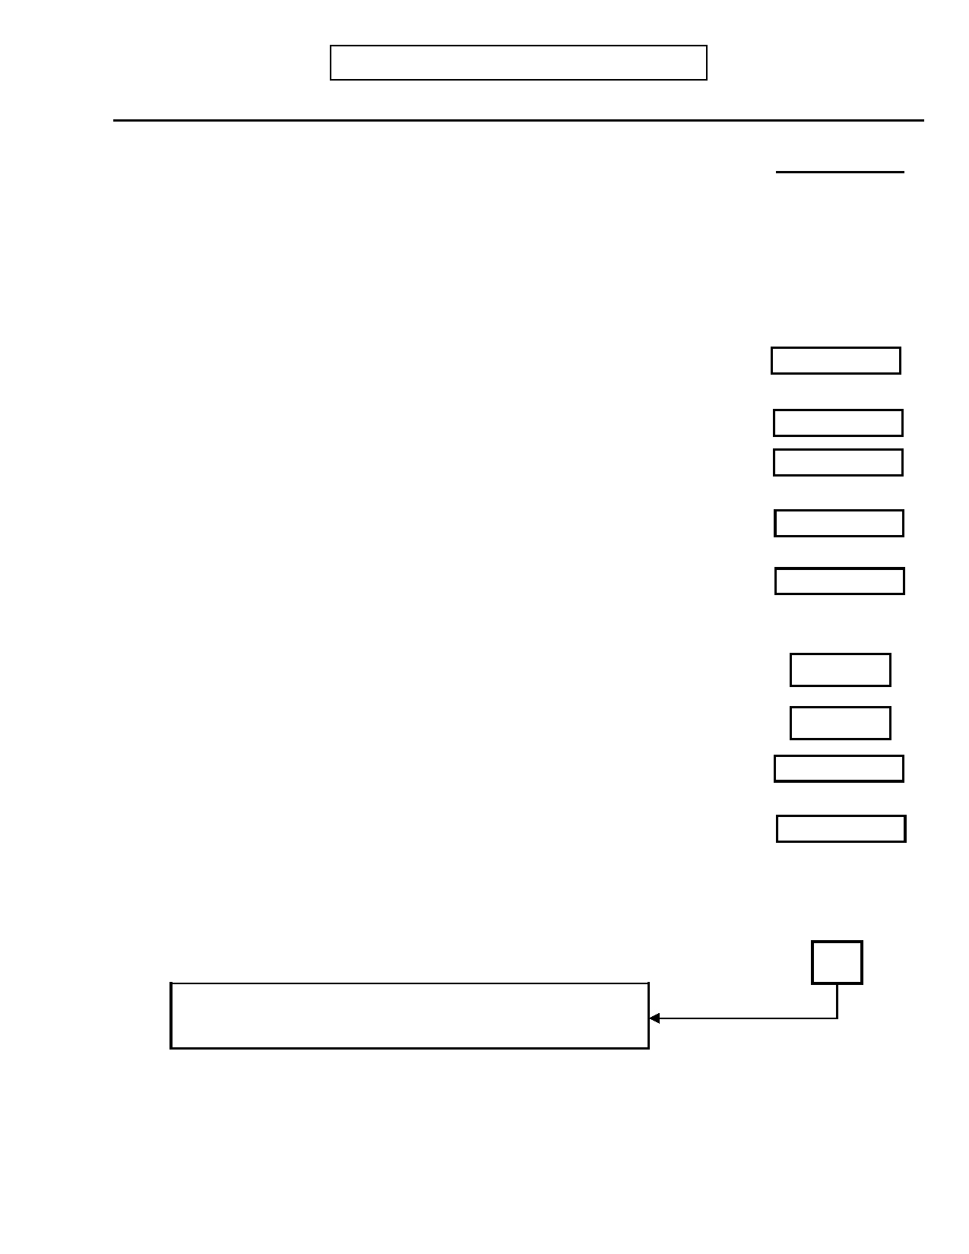
DIGS 4.0 / BP
21-Jul-2005

During the most severe episode…:
G. MANIA/HYPOMANIA
Most Severe Episode
Page 45

Code Response

5. INTERVIEWER: Specify and code whether subject's mood was: 1 2 3

1. Irritable
2. Elated/expansive
3. Both irritable and elated

No Yes Unk

6. Were you more active than usual either sexually, socially, or at work, or were you 0 1 9
physically restless?

7. Were you more talkative than usual or did you feel pressure to keep on talking? 0 1 9

8. Did your thoughts race or did you talk so fast that it was difficult for people to follow 0 1 9
what you were saying?

9. Did you feel you were a very important person, or that you had special powers, plans, 0 1 9
talents, or abilities?

10. Did you need less sleep than usual? 0 1 9

If yes:
Hours
10.a) How many hours of sleep did you get per night?
Hours
10.b) How many hours of sleep do you usually get per night?

11. Did you have more trouble than usual concentrating because your attention kept 0 1 9
jumping from one thing to another?

12. Did you do anything that could have gotten you into trouble—like buy things, make 0 1 9
business investments, have sexual indiscretions, drive recklessly?

If yes: Specify: ____________________________________________________

13.

_________________________________________________________________ INTERVIEWER: Enter number of boxes with YES responses in questions 6-12
TOTAL BOXES
INTERVIEWER: If only one or none, skip to H.
Dysthymia/Cyclothymia (page 63).

13.a) During this episode was there at least a week when these symptoms 0 1 9
(INTERVIEWER: Review symptoms in questions 6-12 plus elated/irritable
mood or hand subject Mania Tally Sheet to review) were present most of the
time?


Page 46
G. MANIA/HYPOMANIA
Most Severe Episode
DIGS 4.0 / BP
21-Jul-2005

No Yes Unk

14. Would you say your behavior was provocative, obnoxious, arrogant, or manipulative 0 1 9
enough to cause problems for your family, friends, or co-workers?
If yes: Specify: ____________________________________________________

_________________________________________________________________

15. Were you so excited that it was almost impossible to hold a conversation with you? 0 1 9

16. During this episode, did you have beliefs or ideas that you later found out were not 0 1 9
true? Probe: Like believing that you had powers and abilities others did not have?
Or that you had a special mission, perhaps from God? Or that someone was trying to
harm you? How certain were you?
INTERVIEWER: If delusions are suspected, probe further to determine the content
and whether the beliefs were held with certainty. Code on the basis of this
information and describe below:

__________________________________________________________________

__________________________________________________________________

16.1) If yes: Were you convinced of these beliefs at the time? 0 1 9
If yes:

16.a) Did these beliefs occur either just before this episode or after it cleared? 0 1 9
Days
16.b) If yes: How long were they present before the episode began?
Days
16.c) If yes: How long did they last after your mood returned to normal?

16.d) INTERVIEWER: Does this total more than 14 days? 0 1 9

17. Did you see or hear things that other people could not see or hear? 0 1 9
If yes: Specify: ____________________________________________________

_________________________________________________________________

_________________________________________________________________

17.1) If yes: Were you using any street drugs at the times that you experienced these 0 1 9
(refer to experiences)?

If yes: What were they? (INTERVIEWER: List the drugs used and describe the
frequency of use and doses, if possible.) ____________________________

_________________________________________________________________

_________________________________________________________________


DIGS 4.0 / BP
21-Jul-2005
G. MANIA/HYPOMANIA
Most Severe Episode
Page 47

No Yes Unk

17.2) If voices: Did these voices usually seem to originate:

17.2.a) ...from within your head? 0 1 9

17.2.b) ...from outside your head? 0 1 9

17.2.c) ...from some particular place outside your head? 0 1 9

17.2.d) Were these voices definitely different from your own thoughts? 0 1 9

If yes to question 17:

17.a) Did these (refer to experiences) occur either just before this episode or after it 0 1 9
cleared?
Days
17.b) If yes: How long were they present before the episode began?
Days
17.c) If yes: How long did they last after your mood returned to normal?

17.d) INTERVIEWER: Does this total more than 14 days? 0 1 9

18. If yes to questions 16 or 17: 0 1 9
INTERVIEWER: Did psychotic symptoms have content that was inconsistent with
manic themes such as inflated worth, power, knowledge, identity, or special
relationship to a deity or a famous person?

18.a) If yes: INTERVIEWER: Was the subject preoccupied with psychotic 0 1 9
symptoms to the exclusion of other symptoms or concerns?

19. Did you seek or receive help from a doctor or other professional? 0 1 9

20. Were you prescribed medication or was there a change in your dosage? 0 1 9

If yes: Specify: ____________________________________________________

_________________________________________________________________

21. During this episode were you admitted to the hospital (including day hospital)? 0 1 9
Days
21.a) If yes: For how long (inpatient)?
Days
21.b) If yes: For how long (day hospital) ?

22. Did you receive ECT (shock treatments)? 0 1 9

INTERVIEWER: If the patient was hospitalized two days or more, had ECT, or had
psychotic symptoms, skip to question 25 and code incapacitation.


Page 48
G. MANIA/HYPOMANIA
Most Severe Episode
DIGS 4.0 / BP
21-Jul-2005

Code Response

23. Was your major responsibility during this episode job, home, school, or
something else? 1 2 3 4
1. Job
2. Home 3. School 4. Other

If other: Specify: __________________________________________

______________________________________________________________
No Yes Unk

24. Was your functioning (in this role) affected? 0 1 9

If yes: Specify: ____________________________________________________

_________________________________________________________________

If yes:

24.a) Did something negative happen as a result of this (such as marital separation, 0 1 9
absence from work or school, loss of a job, or lower grades)?

If yes: Specify: ____________________________________________________

_______________________________________________________________

_______________________________________________________________

24.b) Did someone notice a change in your functioning? 0 1 9


DIGS 4.0 / BP
21-Jul-2005
G. MANIA/HYPOMANIA
Most Severe Episode
Page 49

Code Response

25. INTERVIEWER: Code based on answers to questions 15-24 0 1 2 3 9

0.
1. 2. 3. 9.
No change
Impairment
Incapacitation Improvement
Unknown

Modified RDC Impairment: Decreased functioning not severe enough
to meet incapacitation.

Modified RDC Incapacitation: Includes complete inability to carry
out principal role at home, school or work for 2 days in a row OR Hospitalization for 2 days. OR ECT treatment.
OR Presence of hallucinations or delusions.
OR Complete inability to carry on a conversation.

Improvement: Improvement in function.

Specify: __________________________________________________

_____________________________________________________

_____________________________________________________

No Yes Unk
26. RDC Impairment
If no change or improvement in question 25: Was your functioning in any other area 0 1 9
of your life affected or did you get into trouble in any way?

If yes: Specify: ____________________________________________________

______________________________________________________________

27. Did this episode occur during or shortly after a serious physical illness? 0 1 9

INTERVIEWER: The following illnesses, among others, may be relevant:
MS, HIV, Hyperthyroidism, Lupus, Cushing's, Brain Tumors, Encephalitis.

If yes: Specify: ____________________________________________________

_________________________________________________________________


Page 50
G. MANIA/HYPOMANIA
Most Severe Episode
DIGS 4.0 / BP
21-Jul-2005

No Yes Unk

28. Did this episode begin shortly after you started using decongestants, steroids, or some 0 1 9
other medication?

INTERVIEWER: L-DOPA, among others, may be relevant. Antidepressants are not
considered an organic precipitant for DSM-III-R and RDC.

If yes: Specify medications: ______________________________________

_________________________________________________________________

29. Did this episode begin shortly after you began taking an antidepressant, shortly after 0 1 9
you started a course of ECT, or after beginning a course of light therapy?

If yes: Specify: ____________________________________________________

_________________________________________________________________

30. Were you using cocaine or other street drugs or were you drinking more than usual 0 1 9
just before this episode began?

INTERVIEWER: Amphetamines, among others, may be relevant.
If yes:

30.a) Cocaine? 0 1 9

If yes: Specify: ___________________________________________________

30.b) Other street drugs? 0 1 9

If yes: Specify drug and quantity: ______________________________________

_________________________________________________________________

30.c) Increased use of alcohol? 0 1 9

If yes: Specify: ___________________________________________________


DIGS 4.0 / BP
21-Jul-2005
G. MANIA/HYPOMANIA
Most Severe Episode
Page 51

No Yes Unk

31. During this episode did you have a week or more during which your mood frequently 0 1 9
changed between irritability or elation and sadness or depression?

If yes:
31.a) During this episode did you also experience any of these symptoms?

31.a.1) Diminished desire for food, or marked overeating? 0 1 9

31.a.2) Inability to sleep when sleep was desired, or excessive sleep? 0 1 9

31.a.3) Feeling slowed down? 0 1 9

31.a.4) Having fatigue or a loss of energy? 0 1 9

31.a.5) Losing interest in pleasurable activities? 0 1 9

31.a.6) Feeling guilty or worthless? 0 1 9

31.a.7) Being unable to think or retain written information? 0 1 9

31.a.8) Feeling suicidal or thinking a lot about death? 0 1 9
31.a.9) INTERVIEWER: Enter number of YES responses in 31.a.1-8: TOTAL

If total in 31.a.9 is less than 4, skip to question 32
Days Weeks
31.a.10) How long were these symptoms present? OR

Episodes
31.b) How many episodes like this have you had?


Page 52
G. MANIA/HYPOMANIA
Other Episode

No
DIGS 4.0 / BP
21-Jul-2005

Yes

32. INTERVIEWER: Refer to the instructions below, and indicate here whether a 0 1
second episode of mania/hypomania will be rated.
Skip to question 60, page 60
Another episode of mania SHOULD be rated if there is a Current Episode that was not
coded under Most Severe OR the Most Severe episode was mixed, related to an organic factor or to antidepressant treatment, or in any way questionable, atypical, or marginal.

Based on the overview or additional probing, identify the most recent severe episode that the subject remembers well.

Briefly describe how the Other Episode was selected:

_________________________________________________________________

_________________________________________________________________

_________________________________________________________________

32.a) Is the selected episode also a current episode (in the past 30 days)? 0 1

32.b) When did it begin? -
Month Year
Age
32.c) INTERVIEWER: Compute age.
Days Weeks
32.d) How long did that period last? OR

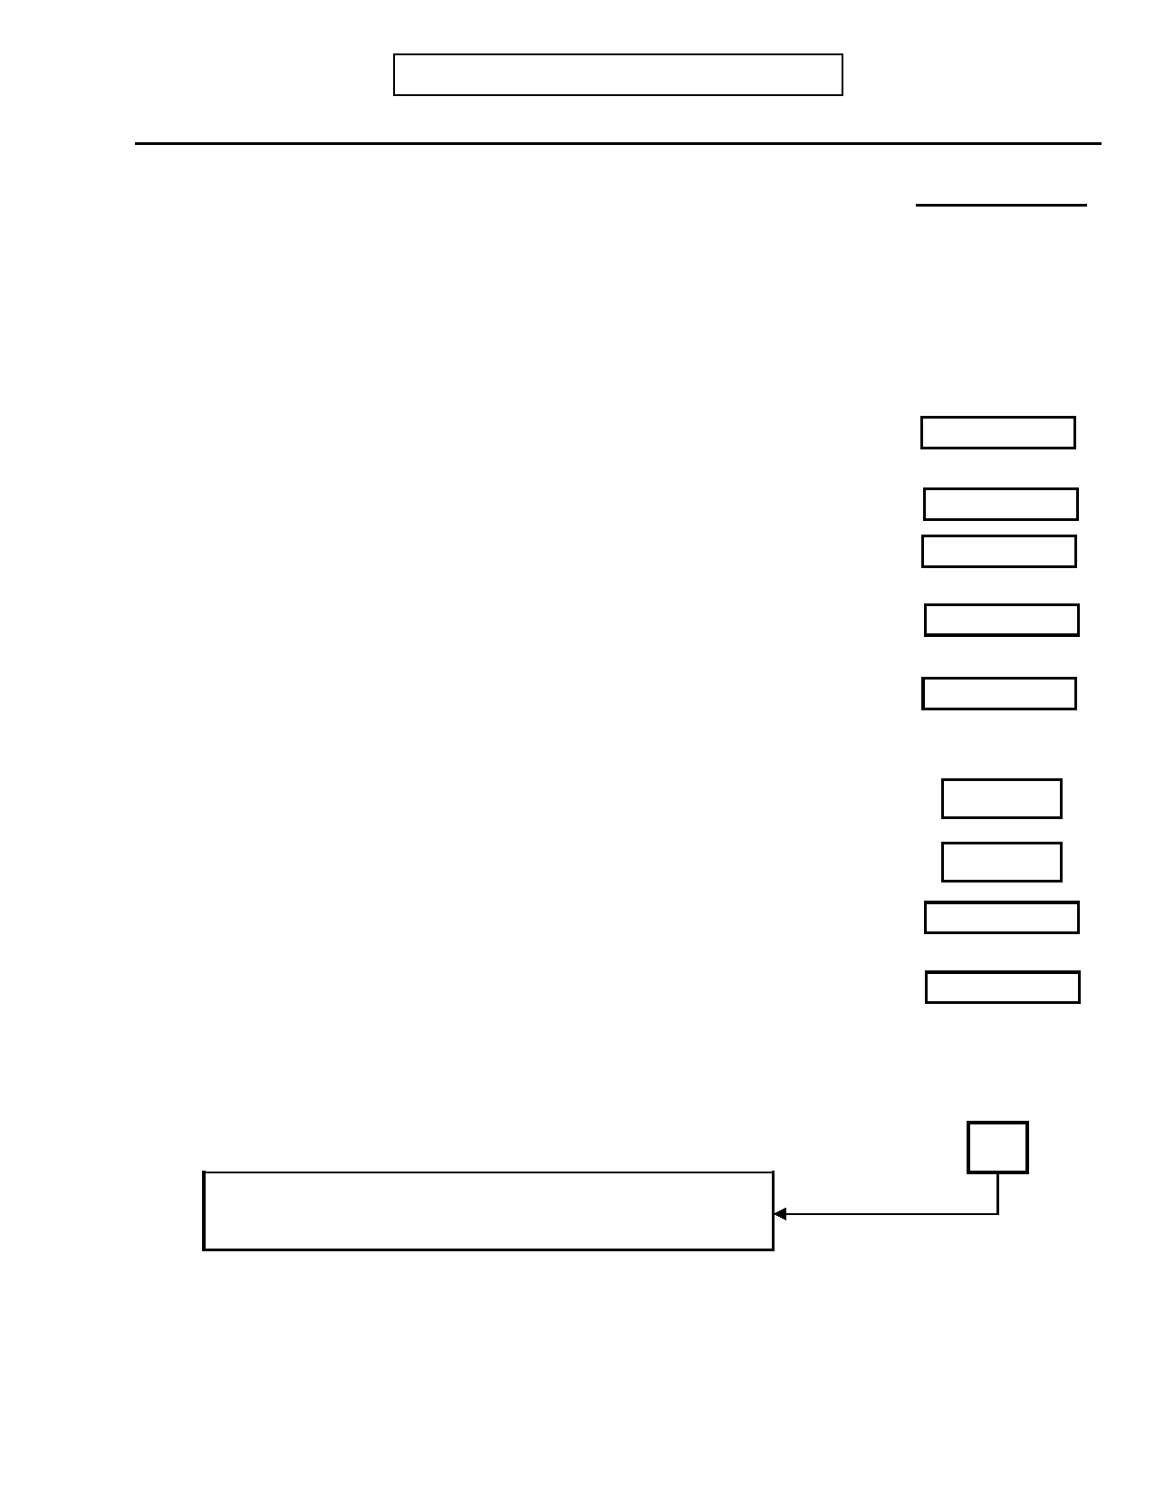
DIGS 4.0 / BP
21-Jul-2005

During this episode…:
G. MANIA/HYPOMANIA
Other Episode
Page 53

Code

33. INTERVIEWER: Specify and code whether subject's mood was: 1 2 3

1. Irritable
2. Elated/expansive
3. Both irritable and elated

No Yes Unk

34. Were you more active than usual either sexually, socially, or at work, or were you 0 1 9
physically restless?

35. Were you more talkative than usual or did you feel pressure to keep on talking? 0 1 9

36. Did your thoughts race or did you talk so fast that it was difficult for people to follow 0 1 9
what you were saying?

37. Did you feel you were a very important person, or that you had special powers, plans, 0 1 9
talents, or abilities?

38. Did you need less sleep than usual? 0 1 9

If yes:
Hours
38.a) How many hours of sleep did you get per night?
Hours
38.b) How many hours of sleep do you usually get per night?

39. Did you have more trouble than usual concentrating because your attention kept 0 1 9
jumping from one thing to another?

40. Did you do anything that could have gotten you into trouble—like buy things, make 0 1 9
business investments, have sexual indiscretions, drive recklessly?

If yes: Specify: ____________________________________________________

41.

_________________________________________________________________ INTERVIEWER: Enter number of boxes with YES responses in questions 34-40
TOTAL BOXES
INTERVIEWER: If only one or none, skip to question 60
(page 60).

41.a) During this episode was there at least a week when these symptoms 0 1 9
(INTERVIEWER: Review symptoms in questions 34-40 plus
elated/irritable mood or hand subject Mania Tally Sheet to review) were
present most of the time?


Page 54
G. MANIA/HYPOMANIA
Other Episode
DIGS 4.0 / BP
21-Jul-2005

No Yes Unk

42. Would you say your behavior was provocative, obnoxious, arrogant, or manipulative 0 1 9
enough to cause problems for your family, friends, or co-workers?
If yes: Specify: ____________________________________________________

_________________________________________________________________

43. Were you so excited that it was almost impossible to hold a conversation with you? 0 1 9

44. During this episode, did you have beliefs or ideas that you later found out were not 0 1 9
true? Probe: Like believing that you had powers and abilities others did not have?
Or that you had a special mission, perhaps from God? Or that someone was trying to
harm you? How certain were you?
INTERVIEWER: If delusions are suspected, probe further to determine the content
and whether the beliefs were held with certainty. Code on the basis on this
information and describe below:

__________________________________________________________________

__________________________________________________________________

44.1) If yes: Were you convinced of these beliefs at the time? 0 1 9
If yes:
44.a) Did these beliefs occur either just before this episode or after it cleared? 0 1 9
Days
44.b) If yes: How long were they present before the episode began?
Days
44.c) If yes: How long did they last after your mood returned to normal?

44.d) INTERVIEWER: Does this total more than 14 days? 0 1 9

45. Did you see or hear things that other people could not see or hear? 0 1 9
If yes: Specify: ____________________________________________________

_________________________________________________________________

_________________________________________________________________

45.1) If yes: Were you using any street drugs at the times that you experienced these 0 1 9
(refer to experiences)?

If yes: What were they? (INTERVIEWER: List the drugs used and describe the
frequency of use and doses, if possible.) ____________________________

_________________________________________________________________

_________________________________________________________________

45.2) If voices: Did these voices usually seem to originate:


DIGS 4.0 / BP
21-Jul-2005
G. MANIA/HYPOMANIA
Other Episode
Page 55

45.2.a) ...from within your head?

45.2.b) ...from outside your head?

45.2.c) ...from some particular place outside your head?

45.2.d) Were these voices definitely different from your own thoughts?

If yes to question 45:

No

0

0

0

0

0

Yes

1

1

1

1

1

Unk

9

9

9

9

9

45.a) Did these (refer to experiences) occur either just before this episode or after it
cleared?
Days
45.b) If yes: How long were they present before the episode began?
Days
45.c) If yes: How long did they last after your mood returned to normal?

45.d) INTERVIEWER: Does this total more than 14 days? 0 1 9

46. If yes to questions 44 or 45: 0 1 9
INTERVIEWER: Did psychotic symptoms have content that was inconsistent with
manic themes such as inflated worth, power, knowledge, identity, or special
relationship to a deity or a famous person?

46.a) If yes: INTERVIEWER: Was the subject preoccupied with psychotic 0 1 9
symptoms to the exclusion of other symptoms or concerns?

47. Did you seek or receive help from a doctor or other professional? 0 1 9

48. Were you prescribed medication or was there a change in your dosage? 0 1 9

If yes: Specify: ____________________________________________________

_________________________________________________________________

49. During this episode were you admitted to the hospital (including day hospital)? 0 1 9
Days
49.a) If yes: For how long (inpatient)?
Days
49.b) If yes: For how long (day hospital) ?

50. Did you receive ECT (shock treatments)? 0 1 9

INTERVIEWER: If the patient was hospitalized two days or more, had ECT, or had
psychotic symptoms, skip to question 53 and code incapacitation.


Page 56
G. MANIA/HYPOMANIA
Other Episode
DIGS 4.0 / BP
21-Jul-2005

Code Response

51. Was your major responsibility during this episode job, home, school, or
something else? 1 2 3 4
1. Job
2. Home 3. School 4. Other

If other: Specify: __________________________________________

______________________________________________________________
No Yes Unk

52. Was your functioning (in this role) affected? 0 1 9

If yes: Specify: ____________________________________________________

_________________________________________________________________

If yes:

52.a) Did something negative happen as a result of this (such as marital separation, 0 1 9
absence from work or school, loss of a job, or lower grades)?

If yes: Specify: ____________________________________________________

_______________________________________________________________

_______________________________________________________________

52.b) Did someone notice a change in your functioning? 0 1 9

DIGS 4.0 / BP
21-Jul-2005
G. MANIA/HYPOMANIA
Other Episode
Page 57

Code Response

53. INTERVIEWER: Code based on answers to questions 43-52 0 1 2 3 9

0.
1. 2. 3. 9.
No change
Impairment
Incapacitation Improvement
Unknown

Modified RDC Impairment: Decreased functioning not severe enough
to meet incapacitation.

Modified RDC Incapacitation: Includes complete inability to carry
out principal role at home, school or work for 2 days in a row OR Hospitalization for 2 days. OR ECT treatment.
OR Presence of hallucinations or delusions.
OR Complete inability to carry on a conversation.

Improvement: Improvement in function.

Specify: _________________________________________________

_____________________________________________________

_____________________________________________________

No Yes Unk

54. RDC Impairment 0 1 9
If no change in question 53: Was your functioning in any other area of your life
affected or did you get into trouble in any way?

If yes: Specify: ____________________________________________________

______________________________________________________________

55. Did this episode occur during or shortly after a serious physical illness? 0 1 9

INTERVIEWER: The following illnesses, among others, may be relevant:
MS, HIV, Hyperthyroidism, Lupus, Cushing's, Brain Tumors, Encephalitis.

If yes: Specify: ____________________________________________________

_________________________________________________________________

Page 58
G. MANIA/HYPOMANIA
Other Episode
DIGS 4.0 / BP
21-Jul-2005

No Yes Unk

56. Did this episode begin shortly after you started using decongestants, steroids, or some 0 1 9
other medication?

INTERVIEWER: L-DOPA, among others, may be relevant. Antidepressants are not
considered an organic precipitant for DSM-III-R and RDC.

If yes: Specify medications: ______________________________________

_________________________________________________________________

57. Did this episode begin shortly after you began taking an antidepressant, shortly after 0 1 9
a course of ECT, or after beginning a course of light therapy?

If yes: Specify: ____________________________________________________

_________________________________________________________________

58. Were you using cocaine or other street drugs or were you drinking more than usual 0 1 9
just before this episode began?

INTERVIEWER: Amphetamines, among others, may be relevant.

If yes:

58.a) Cocaine? 0 1 9

If yes: Specify: ______________________________________________________

58.b) Other street drugs? 0 1 9

If yes: Specify drug and quantity: ______________________________________

_________________________________________________________________

58.c) Increased use of alcohol? 0 1 9

If yes: Specify: ______________________________________________________

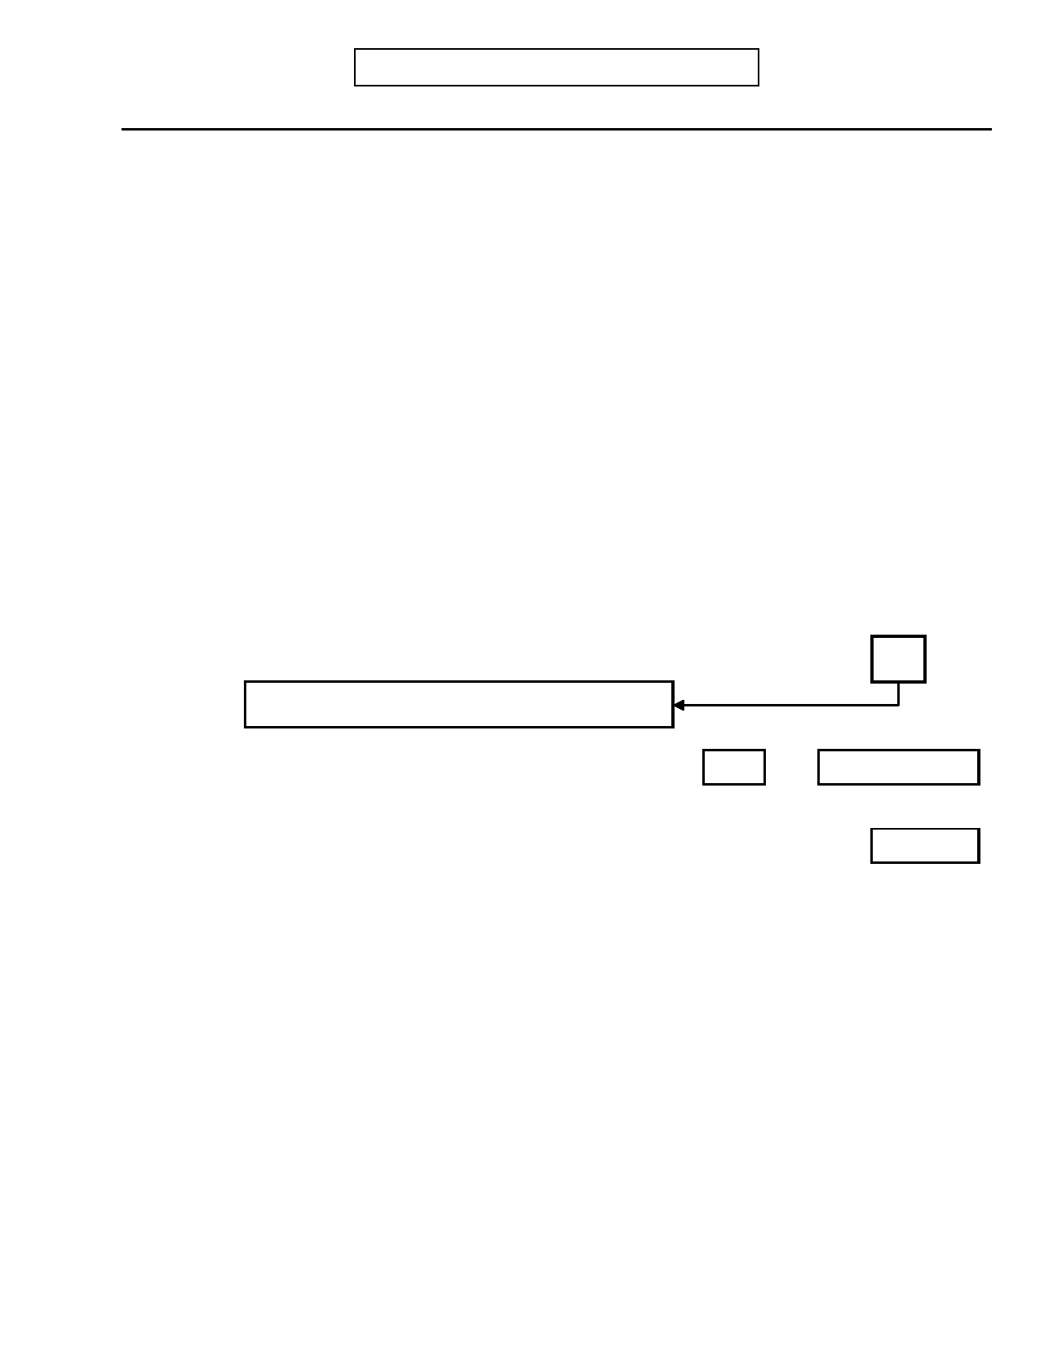
DIGS 4.0 / BP
21-Jul-2005
G. MANIA/HYPOMANIA
Other Episode
Page 59

No Yes Unk

59. During this episode did you have a week or more during which your mood frequently 0 1 9
changed between irritability or elation and sadness or depression?

If yes:
59.a) During this episode did you also experience any of these symptoms?

59.a.1) Diminished desire for food, or marked overeating? 0 1 9

59.a.2) Inability to sleep when sleep was desired, or excessive sleep? 0 1 9

59.a.3) Feeling slowed down? 0 1 9

59.a.4) Having fatigue or a loss of energy? 0 1 9

59.a.5) Losing interest in pleasurable activities? 0 1 9

59.a.6) Feeling guilty or worthless? 0 1 9

59.a.7) Being unable to think or retain written information? 0 1 9

59.a.8) Feeling suicidal or thinking a lot about death? 0 1 9
59.a.9) INTERVIEWER: Enter number of YES responses in 59.a.1-8: TOTAL

If total in 59.a.9 is less than 4, skip to question 60
Days Weeks
59.a.10) How long were these symptoms present? OR

Episodes
59.b) How many episodes like this have you had?

INTERVIEWER: Were the Most Severe Episode and/or the Other Episode mixed episodes? If both were
mixed, try to establish a non-mixed episode for which mania criteria were met, and recode Other Episode from question 32, page 52.


Page 60
G. MANIA/HYPOMANIA
DIGS 4.0 / BP
21-Jul-2005

No Yes Unk
60. INTERVIEWER: Has there been at least one "clean" episode of mania/hypomania?
A "clean" episode is one WITHOUT prior physical illness, drug or 0 1 9
alcohol abuse, or organic precipitants.

If yes, estimate the number of clean DSM-IV manias (≥ 7 days with significant role impairment,
or < 7 days with hospitalization or psychosis) and hypomanias (≥ 4 days without
significant impairment).
"Clean" periods with significant role impairment (mania):
61.a/b) Number of "clean" manias (include mixed periods):
Ons Age
61.c/d) Age at first and last "clean" manic periods:

"Clean" periods without significant role impairment (hypomania):
62.a/b) Number of "clean" hypomanias (include mixed periods):
Ons Age
62.c/d) Age at first and last "clean" hypomanic periods:

# Periods

Rec Age

# Periods

Rec Age

63. If no clean episodes:

"Unclean" periods with significant role impairment (mania):
63.a/b) Number of "unclean" manias (include mixed periods):

63.c/d) Age at first and last "unclean" manic periods:

"Unclean" periods without significant role impairment (hypomania):
64.a/b) Number of "unclean" hypomanias (include mixed periods):

64.c/d) Age at first and last "unclean" hypomanic periods:

Ons Age

Ons Age

# Periods

Rec Age

# Periods

Rec Age

# Times

65. How many times were you hospitalized for an episode of mania? (inpatient)
Hospitalized
65.a) How many times were you hospitalized for an episode of mania? (day hospital)
Code Response
66. Do your episodes tend to begin in any particular season? (Up to 3 seasons may
be coded) 0 1 2 3 4 9
0. No pattern
1. Winter 2. Spring
3. Summer
4. Fall
9. Unknown


DIGS 4.0 / BP
21-Jul-2005
G. MANIA/HYPOMANIA
Page 61

No Yes Unk
67. Think about your first manic episode. Did it begin with a period of time when you
didn't sleep (or slept very little) for several nights? 0 1 9

If yes: # Nights
67.a) How many nights?
Hours
67.b) How many hours did you sleep each night?

68.

69.

SITE OPTIONAL

How about your most recent manic episode? Did it begin with a period like that?

How about your most severe manic episode? Did it begin with a period like that?

No

0

0

Yes

1

1

Unk

9

9

[If not clear]:
70. Did most of your manic episodes begin with a period of sleeplessness? 0 1 9

71. Have you ever switched back and forth quickly from feeling high to feeling normal, or 0 1 9
from feeling high to feeling depressed without a normal mood in between?

Code Response

71.a) If yes: Did this switch in your mood happen 1 2 3
1. every few hours
2. every few days, or 3. every few weeks?
No Yes Unk

72. Have you ever had a year when you had several different manic, hypomanic, 0 1 9
depressive, or mixed episodes?

If yes:

72.a) Altogether, how many different manic, hypomanic, depressive, or mixed episodes did Episodes
you have during that year?
Describe: ____________________________________________________

______________________________________________________________

INTERVIEWER: Distinct episodes are separated either by a partial or full remission for at
least 2 months or a switch to a mood state of opposite polarity (e.g.,
Major Depressive Episode to Manic Episode). DSM-IV Rapid Cycling requires at least four distinct episodes of mood disturbance in one year that meet criteria for a Major Depressive, Manic, Mixed or Hypomanic Episode.


Page 62
G. MANIA/HYPOMANIA
DIGS 4.0 / BP
21-Jul-2005

No Yes Unk
(If subject describes multiple episodes of similar polarity)
Ask:
72.b) Are you sure you got better between episodes? 0 1 9

If yes:
Weeks
72.b.1) For how long?

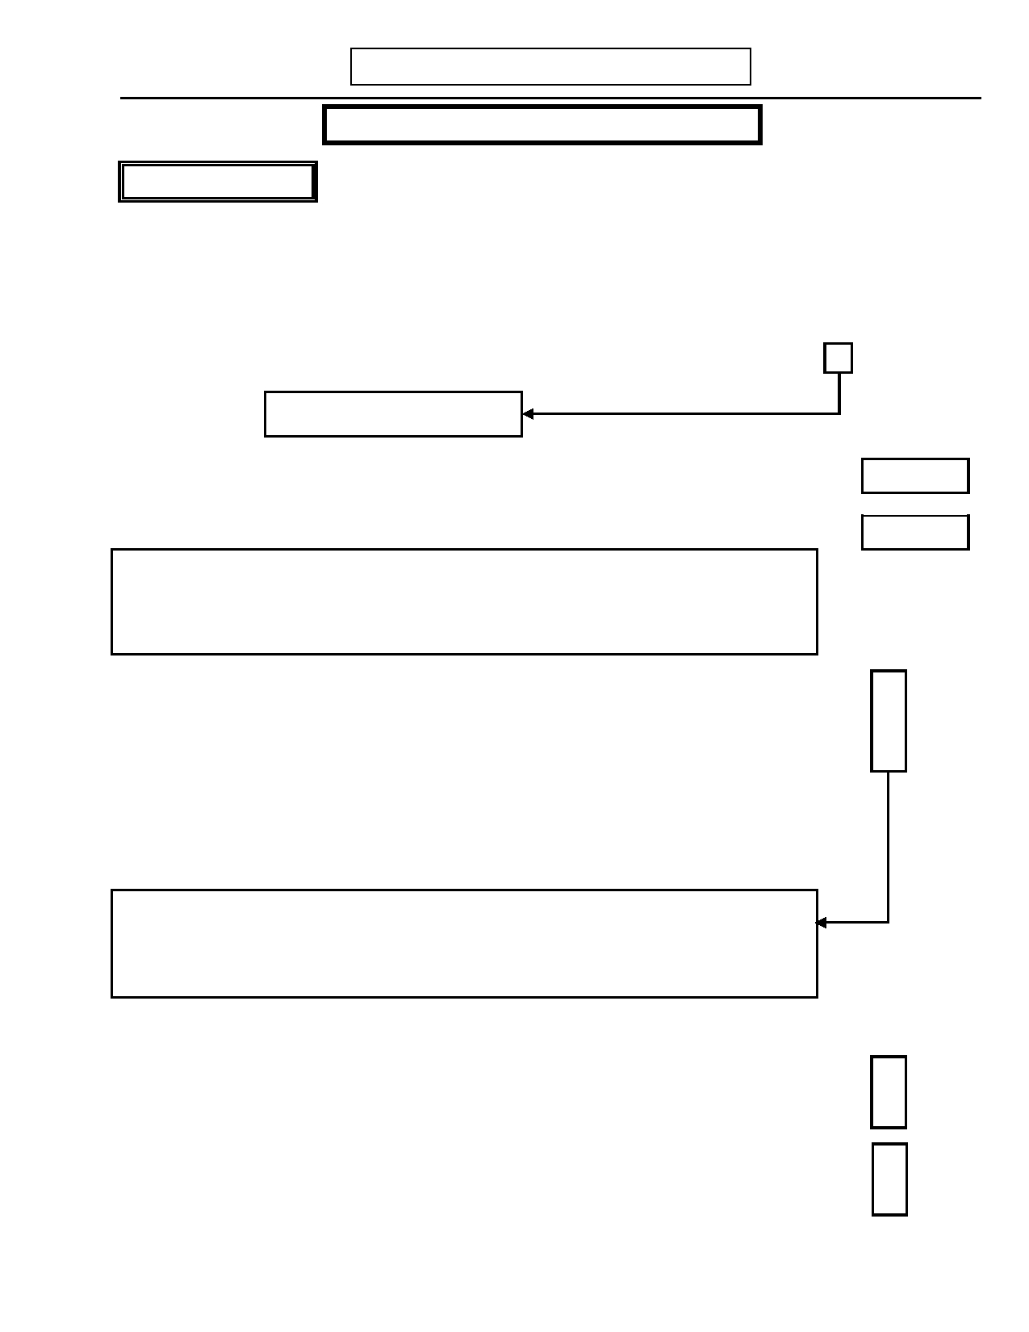
DIGS 4.0 / BP
21-Jul-2005

DYSTHYMIA
H. DYSTHYMIA/CYCLOTHYMIA

SITE OPTIONAL
Page 63

INTERVIEWER: Bipolar patients cannot meet DSM-IIIR/DSM-IV criteria for Dysthymia. However, it is Site
Optional to continue through this section. Otherwise, for bipolar patients skip to Cyclothymia (question 7, page 64).
I have asked about episodes of depression that were severe. Some people have less severe periods of depression that go on for years at a time. Now we want to talk about times like that.
No Yes Unk

1. Have you ever had a period of a year or more when you felt sad, down, or blue most 0 1 9
of the day, more days than not?
Skip to question 7, page 64
Ons Age
1.a) How old were when this first began?
End Age
1.b) How old were when it ended?

INTERVIEWER: For adolescents or children, skip to Cyclothymia (question 7) if the
period in questions 1.a-b is less than 1 year.
For adults, skip to Cyclothymia (question 7) if the period in questions 1.a-b is less than 2 years.

2. Did you have a severe episode of depression either during the first two years of this 0 1 9
period or in the six months before this period began?

3. Just before and during this period was there a change in your use of street drugs, 0 1 9
alcohol, or prescription medications, or did you have a serious physical illness?

If yes: Specify: ____________________________________________________

_________________________________________________________________

INTERVIEWER: If YES to question 2 or 3, can you identify another period?
If YES, recode questions 1.a and 1.b.
If NOT, skip to Cyclothymia (question 7).
Site Optional: Interviewer may continue to specify dysthymic symptoms.

4. During that period did you…

4.a) …overeat? 0 1 9

4.b) …have a poor appetite? 0 1 9

4.c) …have trouble sleeping? 0 1 9

4.d) …sleep too much? 0 1 9

4.e) …feel tired easily? 0 1 9

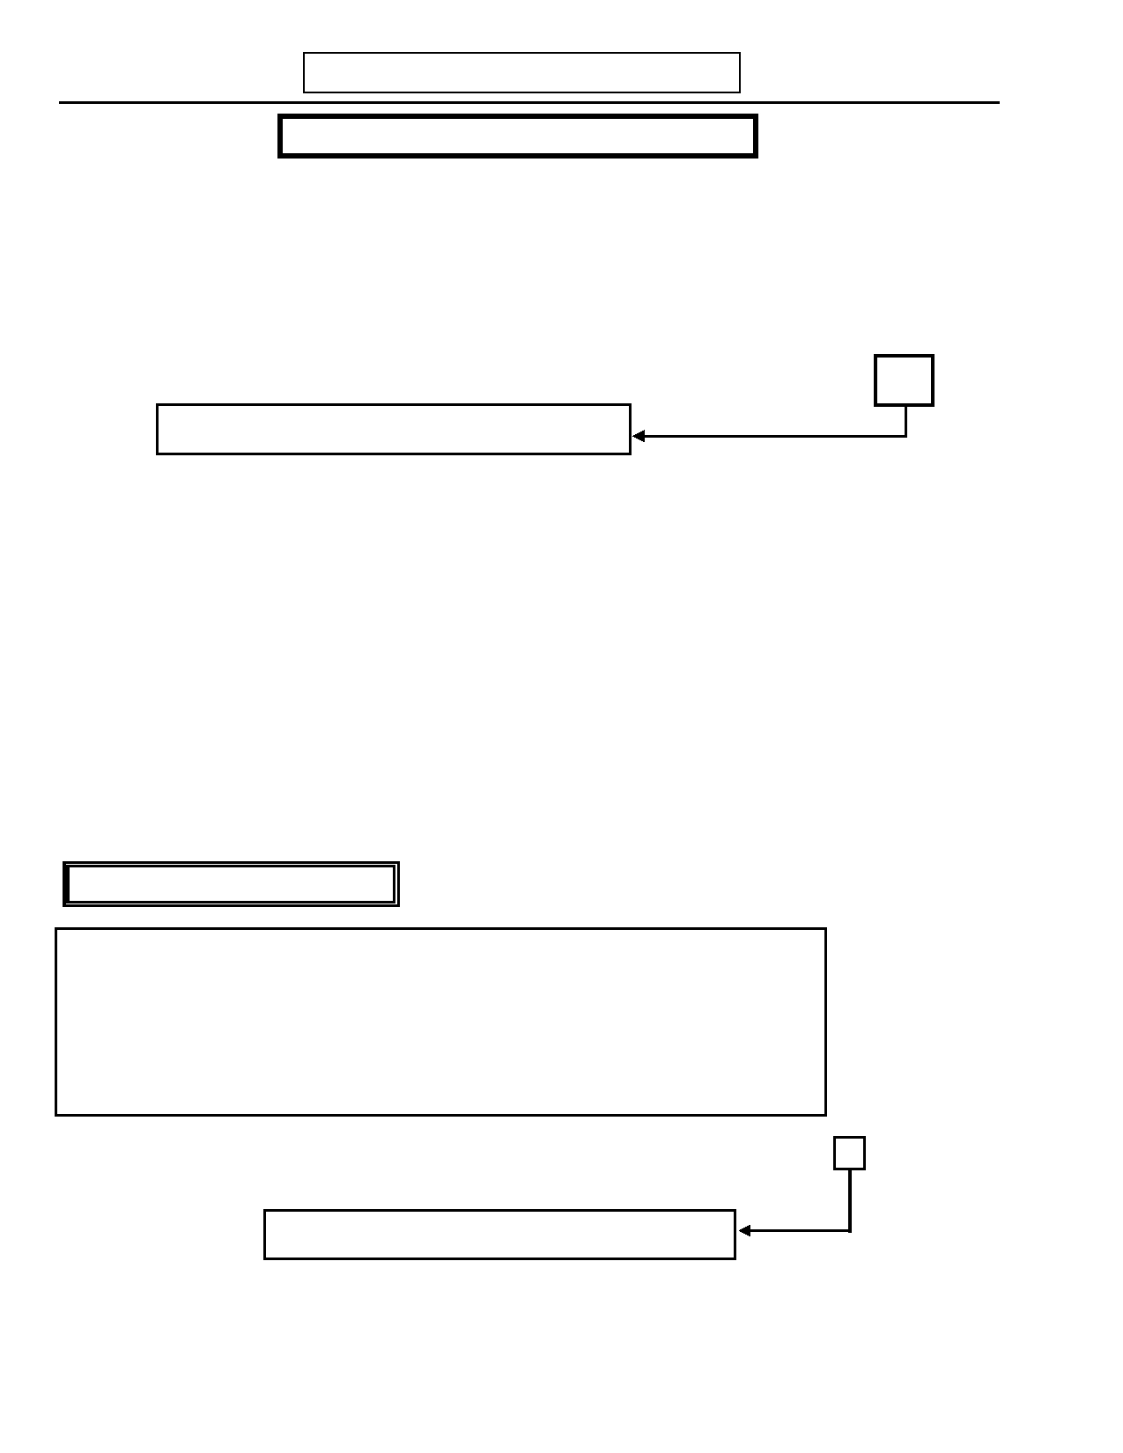
Page 64
H. DYSTHYMIA/CYCLOTHYMIA

SITE OPTIONAL
DIGS 4.0 / BP
21-Jul-2005

No Yes Unk

4.f) …feel inadequate or worthless? 0 1 9

4.g) …find it hard to concentrate or make decisions? 0 1 9

4.h) …feel hopeless? 0 1 9

4.i) INTERVIEWER: Enter number YES responses in questions 4a-h. Note: Boxed
items count as only one YES response if yes to either. TOTAL
INTERVIEWER: If less than two, skip to question 7.

5. During that period was your mood ever normal for more than two months in a row— 0 1 9
that is, two months when you were not sad, blue or down?

6. During that two-year period was there a difference in the way you managed your 0 1 9
work, school, or household tasks or was any other area of your life affected?

If yes: Specify: ____________________________________________________

_________________________________________________________________

6.a) INTERVIEWER: If no to question 6, is there any other evidence of clinically 0 1 9
significant distress?

If yes: Specify: ____________________________________________________

______________________________________________________________

CYCLOTHYMIC DISORDER

INTERVIEWER: If subject reported episodes of major depression or mania, distinguish
these from the less severe, fluctuating mood changes typical of
Cyclothymia by beginning the questions with: "Other than the severe
episodes you mentioned..."

Many subjects with cyclothymia will have already reported numerous
hypomanias. In this case, interviewer must look for periods of depressive symptoms and establish chronicity.

7. Have you had a year or more when you have been a very moody person—someone 0 1 9
who often had a few hours or days when you felt better than normal or high and other
times when you felt down or depressed?
Skip to I. Alcohol Abuse and Dependence (page 67)

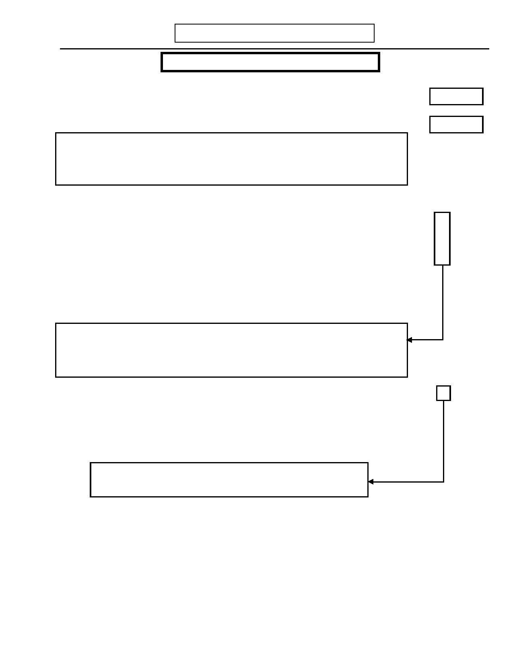
DIGS 4.0 / BP
21-Jul-2005
H. DYSTHYMIA/CYCLOTHYMIA

SITE OPTIONAL
Page 65

Ons Age

7.a) How old were when this first began?
End Age
7.b) How old were when it ended?

INTERVIEWER: For adolescents or children, skip to I. Alcohol Abuse and Dependence
(page 67) if the period in questions 7.a-b is less than 1 year.
For adults, skip to I. Alcohol Abuse and Dependence (page 67) if the period in questions 7.a-b is less than 2 years.

No Yes Unk

8. Did you have an episode of depression or mania during the first two years of this 0 1 9
period?

9. Just before and during this period was there a change in your use of street drugs, 0 1 9
alcohol, or prescription medications, or did you have a serious physical illness?

If yes: Specify: ____________________________________________________

_________________________________________________________________

INTERVIEWER: If YES to question 8 or 9, can you identify another period?
If YES, recode questions 7.a and 7.b.
If NOT, skip to I. Alcohol Abuse and Dependence (page 67).
Site Optional: Interviewer may continue to specify cyclothymic symptoms.

10.a) During this period, did you have at least two of the following symptoms…: 0 1 9
Elated:
…more active or energetic than usual?
…more talkative than usual?
…needing less sleep than usual?
…thoughts racing?
…feeling very important?
INTERVIEWER: If yes, consider returning to mania section (page
43) if not completed previously.
10.b) During this period, did you have at least two of the following symptoms…:
Depressed: 0 1 9
…trouble sleeping or sleeping too much?
…loss of appetite of overeating?
…trouble concentrating?
…loss of energy?
…feeling guilty or worthless?
…being unable to enjoy things?
…thinking about death?


Page 66
H. DYSTHYMIA/CYCLOTHYMIA

SITE OPTIONAL
DIGS 4.0 / BP
21-Jul-2005

No Yes Unk

11. During that period was your mood ever normal for more than two months in a row— 0 1 9
that is, two months when you were not sad, blue or down?

12. During that period was there a difference in the way you managed your work, school, 0 1 9
or household tasks or was any other area of your life affected?

If yes: Specify: ____________________________________________________

_________________________________________________________________

12.a) INTERVIEWER: If no to question 12, is there any other evidence of 0 1 9
clinically significant distress?

If yes: Specify: ____________________________________________________

______________________________________________________________
Age
13. How old were you the first time you had a year or more like this?
Months
14. How long did that period last?

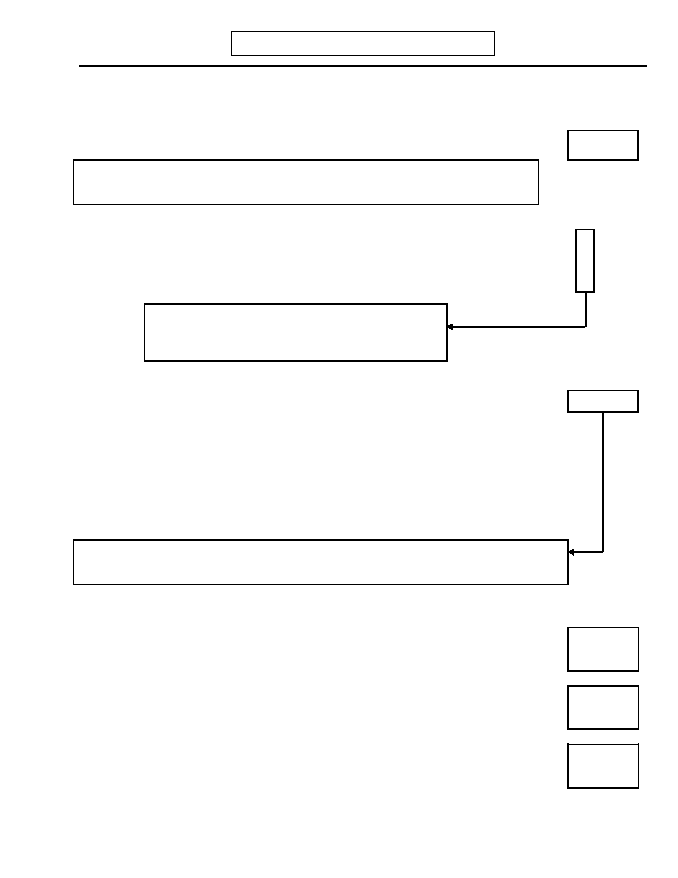
DIGS 4.0 / BP
21-Jul-2005
I. ALCOHOL ABUSE AND DEPENDENCE
Page 67

I am going to ask you a series of questions about alcohol and drug use. I will use the word "often" in some of
these questions; by often, we mean three or more times. Now, I would like to ask you some questions about
alcoholic beverages like beer, wine, wine coolers, champagne, or hard liquor like vodka, gin, or whiskey.
Age

1. How old were you when you had your first drink of alcohol?
INTERVIEWER: If never had a drink of alcohol, code 00 for age and skip to J.
Tobacco, Marijuana and Other Drug Abuse and Dependence (page 71)
No Yes

2. Did you ever drink regularly—that is, at least once a week, for six months or more? 0 1

3. Did you ever get drunk—that is, when your speech was slurred or you were unsteady on 0 1
your feet?
If NO to BOTH question 2 and 3, skip to J. Tobacco,
Marijuana, and Other Drug Abuse and
Dependence (page 71)
Drinks

4. What is the largest number of drinks you have ever had in a 24-hour period?
Record response: __________________________________________________________

Hard liquor drink equivalents Wine drink equivalents
1 shot glass/highball = 1 1 bottle = 6
½ pint = 6 1 wine cooler = 1
1 pint = 12
1 fifth = 20 Beer drink equivalents
1 quart = 24 1 bottle/can = 1
1 case = 24
If 3 drinks or fewer, skip to J. Tobacco, Marijuana and Other Drug Abuse and Dependence
(page 71)

No Yes
Alcohol Abuse (criteria in boxed questions 5-8)
5. Has your drinking or being hung over often kept you from working or taking care of
household responsibilities? 0 1

6. Have you often been high from drinking in a situation where it increased your chances of
getting hurt-for instance, when driving, using machinery or guns, or during sports? 0 1

7. Did your alcohol use more than once cause you to have legal problems, such as arrests for 0 1
drunk driving or disorderly conduct or drunken behavior?

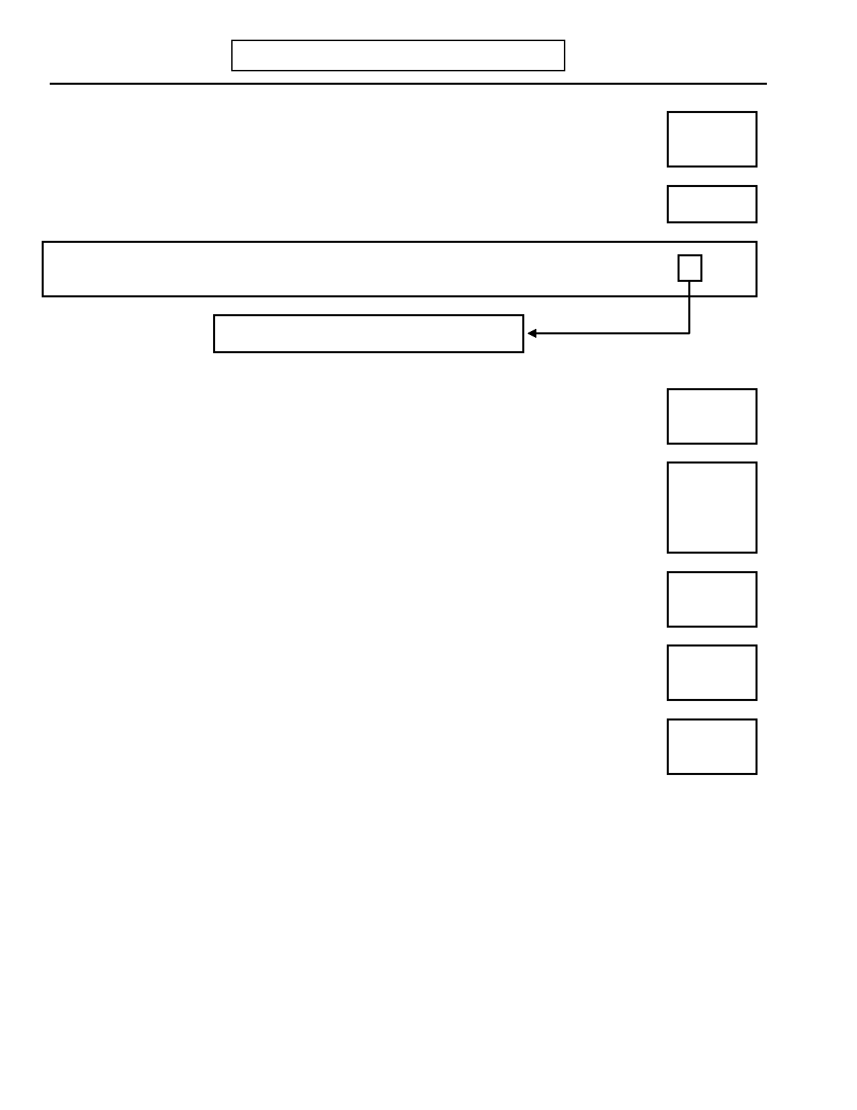
Page 68
I. ALCOHOL ABUSE AND DEPENDENCE
DIGS 4.0 / BP
21-Jul-2005

No Yes

8. Did your drinking often cause you to have problems at work, school or at home? 0 1

Age
9. How old were you the first time any of these things happened?
If questions 5-8 are all NO: No Yes

10.
INTERVIEWER: Do you have any suspicion of alcohol abuse or dependence (based on all
available history and data gathered so far)?

Skip to J. Tobacco, Marijuana and Other
Drug Abuse and Dependence (page 71)

0

1

Alcohol Dependence (criteria in boxed questions 11 - 21a)
Loss of Control / Compulsive Use
11. Have you often kept on drinking when you promised yourself that you would not, or have 0 1
you often drunk more than you intended to?

12. Have you often wanted or tried to stop or cut down on drinking? 0 1

13. Did you ever try to stop or cut down on drinking and find you could not? 0 1

14. Has there ever been a period when you spent so much time drinking or recovering from the 0 1
effects of alcohol that you had little time for anything else?

15. Have you often given up or greatly reduced important activities because of your drinking- 0 1
like sports, work, or associating with friends or relatives?

Tolerance
16. Did you ever need to drink a lot more in order to get an effect, or find that you could no 0 1
longer get high or drunk on the amount you used to drink?


DIGS 4.0 / BP
21-Jul-2005
I. ALCOHOL ABUSE AND DEPENDENCE
Page 69

Psychological and Physical problems No Yes
No Yes
17. Have you more than once had blackouts, when you did not pass out,
but you drank enough so that the next day you could not remember 0 1
things you said or did?

17.a) If yes: Did you continue to drink after you knew it caused you any of these problems? 0 1

No Yes
18. While drinking, did you more than once have psychological problems
start or get worse such as feeling depressed, feeling paranoid, trouble 0 1
thinking clearly, hearing, smelling or seeing things, or feeling jumpy?

18.a) If yes: Did you continue to drink after you knew it caused you any of these problems? 0 1

No Yes
19. There are several other health problems that can result from long
stretches of heavy drinking. Did you more than once have a serious 0 1
health problem such as liver disease, pancreatitis, or stomach disease
from drinking?

19.a) If yes: Did you continue to drink knowing that drinking caused you to have health 0 1
problems?

20. Have you ever continued to drink when you knew you had any (other) serious physical 0 1
illness that might be made worse by drinking?

Withdrawal

21. Did you ever have times when you stopped or cut down on drinking and had withdrawal
problems such as shaking hands, nausea and vomiting, sweating, anxiety, or trouble 0 1
sleeping?

21.a) If yes: Have you more than once taken a drink to keep from having any of these 0 1
symptoms or to make them go away?

22. Have you ever attended AA or had treatment for a drinking problem? 0 1

If yes: Was this…

22.a) …discussion with a professional? 0 1

22.b) …AA or other self-help? 0 1

22.c) …outpatient alcohol program? 0 1

22.d) …inpatient alcohol program? 0 1

22.e) …other? 0 1


Page 70
I. ALCOHOL ABUSE AND DEPENDENCE
DIGS 4.0 / BP
21-Jul-2005

INTERVIEWER: Check responses to questions 11-21a. If all coded NO or less than 3 positive
responses in separate boxes, skip to J. Tobacco, Marijuana and Other
Drug Abuse and Dependence (page 71)

DSM-IV

No

Yes

23. You told me you had these experiences such as (Review boxed positive symptoms in 0 1
questions 11-21a). While you were drinking, did you ever have at least three of these
experiences occur at any time in the same 12-month period?
INTERVIEWER: Criteria require items from three separate boxes above.

If yes:

23.a) How old were you the first time at least three of these experiences occurred within the Ons Age
same 12 months?

23.b) How old were you the last time at least three of these experiences occurred within the Rec Age
same 12 months?

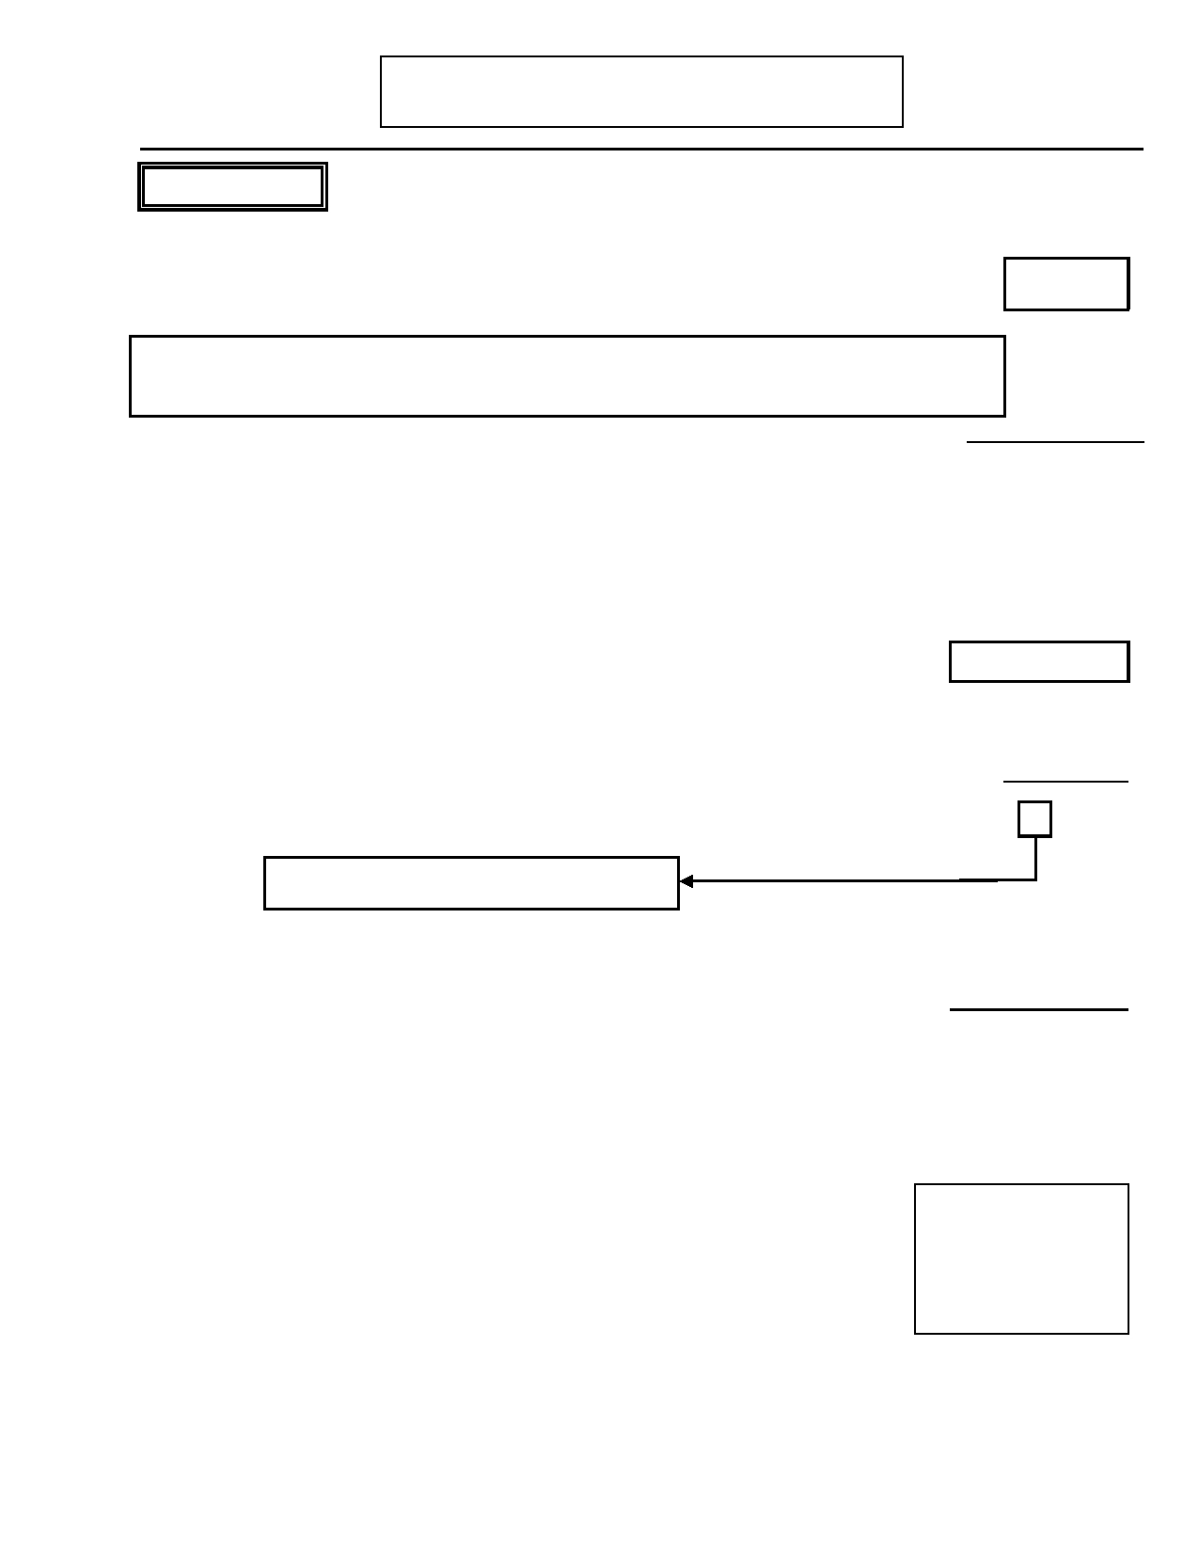
DIGS 4.0 / BP
21-Jul-2005

TOBACCO
J. TOBACCO, MARIJUANA, AND OTHER DRUG
ABUSE AND DEPENDENCE
Page 71

Now I'm going to ask you some questions about using tobacco. Age

1. How old were you when you first tried any form of tobacco?

INTERVIEWER: If never used tobacco, code 00 for age, then code question 2.b NO and skip
to Marijuana (question 22, page 74)
Code Response

2.a) Have you ever smoked cigarettes on a daily basis for a month or more? 0 1 2
If yes: Are you currently smoking?

0. No
1. Yes, currently smoking 2. Yes, smoked in the past
Pack years
2.a.1) If yes to question 2.a: Estimate number of "pack-years".
Record: ______________ X _________________
# of packs per day # years

No Yes

2.b) Over your lifetime, have you smoked a total of 100 cigarettes? 0 1

Skip to Marijuana (question 22, page 74)
FAGERSTROM questions 3 - 8

Think about the period lasting a month or more when you were smoking the most.
Code Response
3. How many cigarettes per day did you smoke?
IF unknown, ASK: Would you say….
INTERVIEWER INSTRUCTION: ON AVERAGE.
(If R says Unknown or a range of values, rephrase with "Can you give us your best
estimate of the average number of cigarettes you smoke per day?". If R still is
unable to provide a number, read response categories and ask to select. "Would
you say…"
0. 0-5 0 1 2 3 4 5
1. 6-10 2. 11-15 3. 16-20 4. 21-30
5. 31 or more

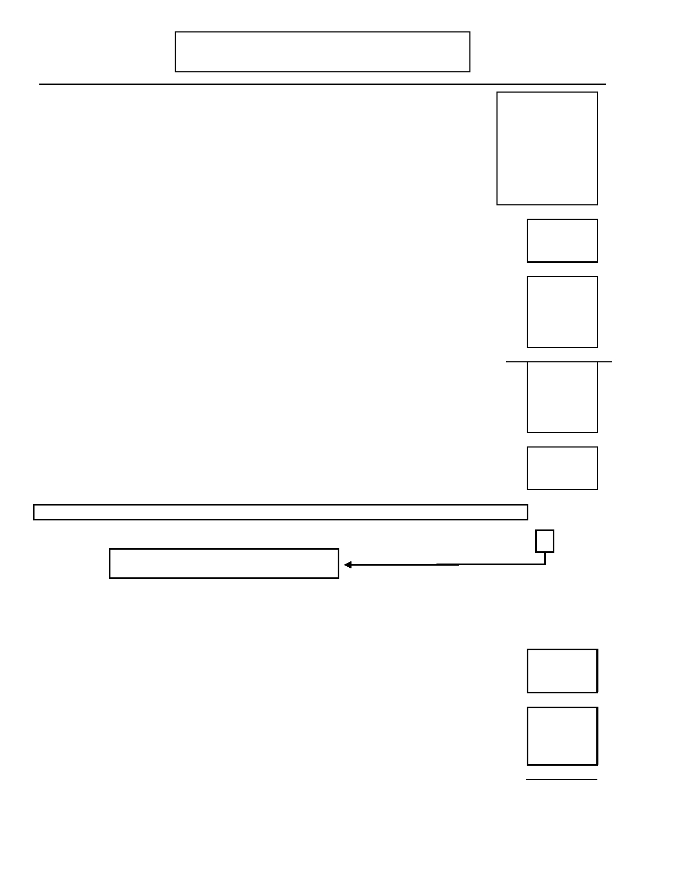
Page 72
J. TOBACCO, MARIJUANA, AND OTHER DRUG
ABUSE AND DEPENDENCE
DIGS 4.0 / BP
21-Jul-2005

4. During this period when you were smoking the most, about how many minutes after
you woke up did you smoke your first cigarette? 1 2 3 4 9

1. 2. 3. 4. 9.
Within 5 minutes
Within 6-30 minutes Within 31-60 minutes
More than 1 hour
Unknown

5.

6.

During the period when you were smoking the most, did you usually smoke more frequently
during the first hours after waking than during the rest of the day?

During the period when you were smoking the most, did you usually find it difficult to keep
from smoking in places where it was forbidden; for example, on airplanes, in movie
theaters, in "no smoking" sections of restaurants or office buildings, or perhaps in situations
where someone asked you not to?
No

0

0
Yes

1

1

Code Response
7. During the period when you were smoking the most, which cigarette would you have hated
most to give up: 0 1

0. the first one in the morning,
1. after eating, while watching television, or some other one?
No Yes
8. During the period when you were smoking the most, were there times you smoked even
when you were so ill that you had to be in bed most of the day? 0 1

Fagerstrom Score will be calculated by computer

The Following section on tobacco dependence is site optional. Will you continue? 0 1
Skip to Marijuana (question 22, page 74)

Tobacco Dependence
Now I'd like you to think about your cigarette smoking throughout your life as I ask you more
questions about experiences people sometimes have when they smoke cigarettes. (Since you don't
smoke now, I'd like to ask you about the times when you used to smoke cigarettes.)

9. Did you ever chain smoke; that is, where you smoked several cigarettes, one right after 0 1
another?

10. Have you often given up or spent much less time in activities important to you such as work, 0 1
sports, going to movies, or seeing friends or relatives because you would not be able to
smoke?


DIGS 4.0 / BP
21-Jul-2005
J. TOBACCO, MARIJUANA, AND OTHER DRUG
ABUSE AND DEPENDENCE
Page 73

11.

12.

13.

14.

15.

Have you often smoked a lot more than you intended or for more days in a row than you
intended? For example, smoking half a pack or more when trying to limit yourself to only 1
or 2 cigarettes?

Have you often wanted to quit or tried to cut down on smoking?

Did you ever have times when you stopped or cut down on smoking and had withdrawal
problems such as irritability, depression, anxiety, and difficulty concentrating?

Have you continued to smoke when you had any health problem such as a problem with your heart, a problem with your blood pressure, lung trouble, a cough that wouldn't go
away; or another serious illness that you knew was made worse by smoking, for example:
asthma or bronchitis?

After you had been smoking for some time, did you find that cigarettes had less effect on you
than before?

No

0

0

0

0

0

Yes

1

1

1

1

1

INTERVIEWER: If less than 3 boxes from tobacco dependence (9-15) are marked yes above,
Skip to Marijuana (question 17, page 74)

16. I'd like to review the experiences you've told me you had with smoking cigarettes. You've
said that: (Read positive symptoms from boxes above) 0 1
Did you ever have 3 or more of these experiences in the same year?
Ons Age
16.a) How old were you the first time?
Rec Age
16.b) How old were you the last time?

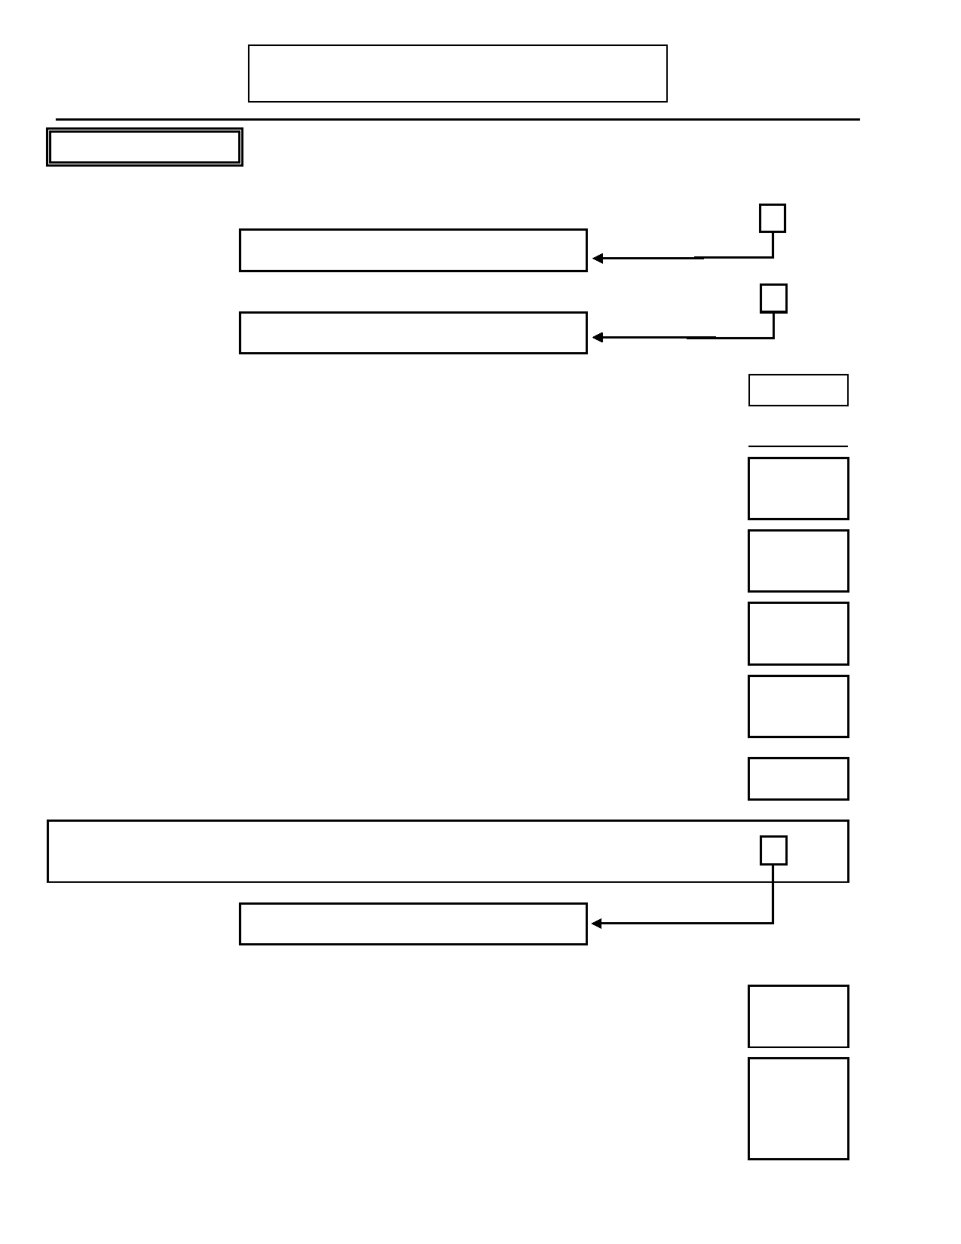
Page 74
J. TOBACCO, MARIJUANA, AND OTHER DRUG
ABUSE AND DEPENDENCE
DIGS 4.0 / BP
21-Jul-2005

MARIJUANA
No Yes

17. Have you ever used marijuana? 0 1
Skip to Other Drugs (question 34, page 76)

17.a) If yes: Have you used marijuana at least 21 times in a single year? 0 1
Skip to Other Drugs (question 34, page 76)
Ons Age
17.b) How old were you when you used marijuana for the first time?

Marijuana abuse (criteria in boxed questions 18-21) No Yes

18. Have you often been high on marijuana or suffering its after-effects while in school, 0 1
working, or taking care of household responsibilities?
19. Have you often been under the effects of marijuana in a situation where it increased your
chances of getting hurt—for instance, when driving, using knives or machinery or guns, or 0 1
during sports?
20. Did your marijuana use more than once cause you to have legal problems, such as arrests
for disorderly conduct, possession or selling? 0 1

21. Did your marijuana use often cause you to have problems at work, school, or at home? 0 1

Age
22. How old were you the first time any of these things happened?
If questions 18-21 are all NO:

23.
INTERVIEWER: Do you have any suspicion of marijuana abuse or dependence (based on
all available history and data gathered so far)?

Skip to Other Drugs (question 34, page 76)

0

1

Marijuana Dependence
Loss of Control / Compulsive Use
24. Have you often used marijuana over a longer period or in larger amounts than you intended 0 1
to?

25. Have you often wanted to or tried to cut down on marijuana? 0 1

26. Did you ever try to stop or cut down on marijuana and find you could not? 0 1


DIGS 4.0 / BP
21-Jul-2005
J. TOBACCO, MARIJUANA, AND OTHER DRUG
ABUSE AND DEPENDENCE
Page 75

No Yes

27. Has there ever been a period of a month or more when a great deal of your time was spent 0 1
using marijuana, getting marijuana, or getting over its effects?

28. Have you often given up or greatly reduced important activities with friends or relatives or 0 1
at work while using marijuana?
Tolerance
29. Did you ever need larger amounts of marijuana to get an effect, or did you ever find that 0 1
you could no longer get high on the amount you used to use?
Psychological / Physical
30. While using marijuana, did you more than once have a psychological problem start or get 0 1
worse such as feeling depressed, feeling paranoid, trouble thinking clearly, hearing,
smelling or seeing things, or feeling jumpy? Or any physical problems (e.g. asthma) become
worse using marijuana?

30.b) If yes: Did you continue to use marijuana after you knew it caused you any of 0 1
these problems?
Withdrawal
31. Did stopping or cutting down ever cause you to feel bad physically? (Co-occurrence of 0 1
symptoms such as nervousness, insomnia, sweating, nausea, diarrhea.)

32. If yes: Did you use marijuana to prevent these symptoms? 0 1

INTERVIEWER: If questions 24-32 are all NO or if there are less than 3 positive boxed
symptoms, skip to Other Drugs (question 34, page 76).

DSM-IV
33. You told me you had these experiences such as (Review positive symptoms in questions 0 1
24-32). While you were using marijuana, did you ever have at least three of these
experiences occur at any time in the same 12 month period?

If yes:

33.a)

33.b)

33.c)

33.d)

How old were you the first time at least three of these experiences occurred within the
same 12 months?
How old were you the last time at least three of these experiences occurred within the
same 12 months?

What was the longest period that you used marijuana almost every day?

How old were you at that time?

Ons Age

Rec Age

Days

Age

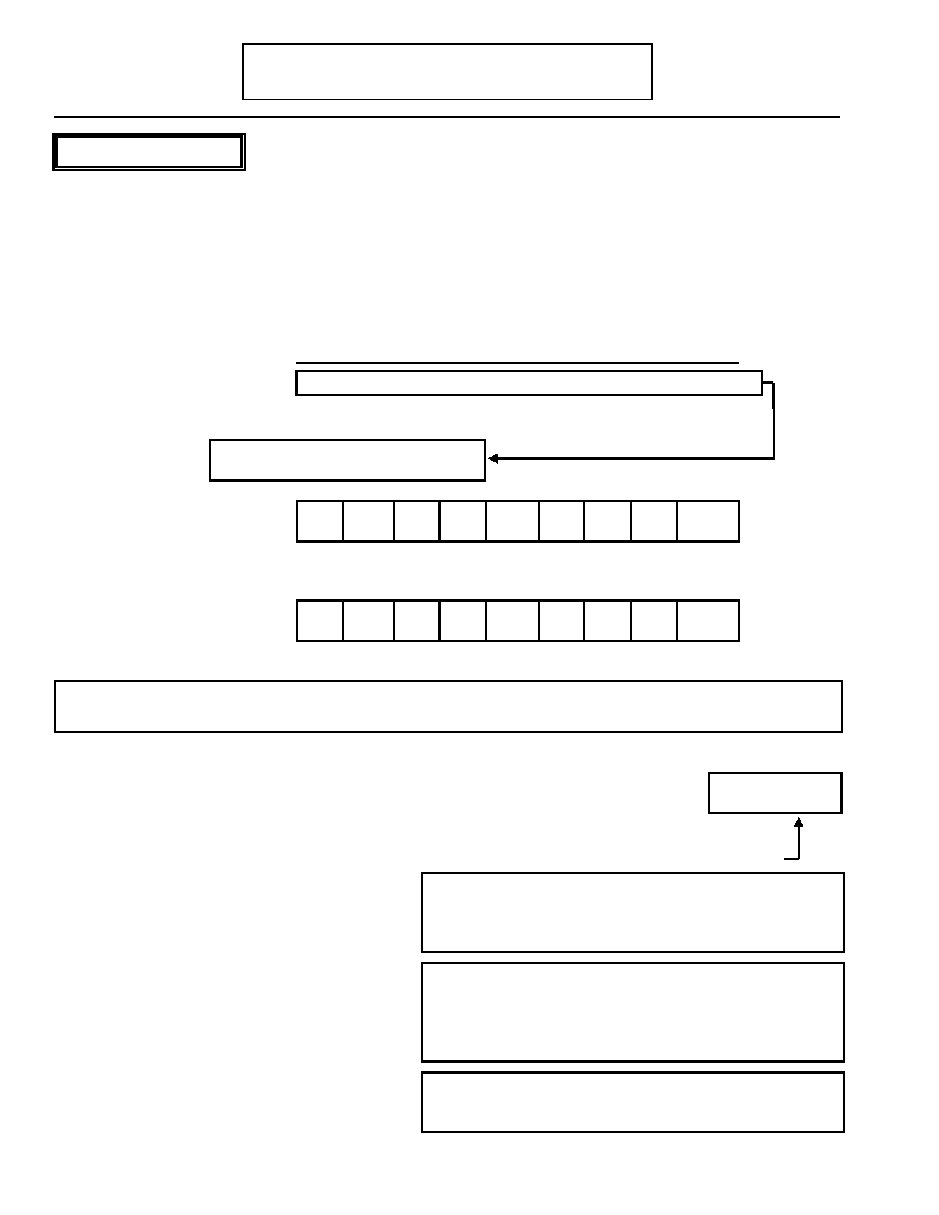
Page 76
J. TOBACCO, MARIJUANA, AND OTHER DRUG
ABUSE AND DEPENDENCE
DIGS 4.0 / BP
21-Jul-2005

OTHER DRUGS

INTERVIEWER: Hand Drug Use Card "A" to subject.

34. Have you ever used any of these drugs to feel good or high, or to feel more
active or alert, or when they were not prescribed for you? Or have you ever used a prescribed drug in larger quantities or for longer than prescribed?

34.a) If yes: Which ones?
A B C D E F G H I
Coc Stim Sed Op PCP Hal Sol Oth Comb
0 0 0 0 0 0 0 0 0 No

1 1 1 1 1 1 1 1 1 Yes

Skip to K. Psychosis (page 81)

34.b) For each drug, ask:
How old were you
when you first used
(Drug)?

34.c) For each drug, ask:
How many times
have you used
(Drug) in your life?

Age

Times

INTERVIEWER: If all drugs in question 34.c were used less than 11 times, skip to K. Psychosis (page 81).

If Other, specify
the drug:

Drug abuse (criteria in boxed questions 35-38)

35.

36.

37.

Have you often been high on (Drug) or
suffering its after-effects while in school,
working, or taking care of household
responsibilities?
Have you often been under the effects of
(Drug) in a situation where it increased your
chances of getting hurt-for instance, when driving, using knives or machinery or guns,
or during sports?
Did your use of (Drug) more than once cause
you to have legal problems such as arrests
for disorderly conduct, possession or selling?
A
Coc

01

01

01
B
Stim

01

01

01
C
Sed

01

01

01
D
Op

01

01

01
E
Oth

01

01

01

No
Yes

No
Yes

No
Yes

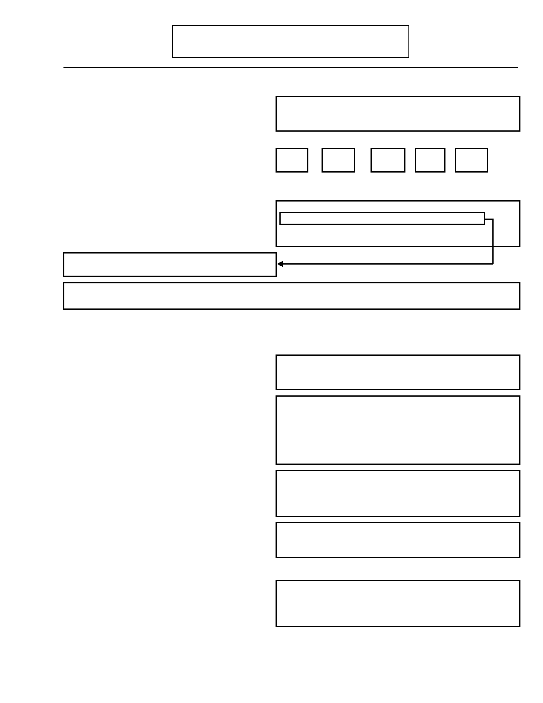
DIGS 4.0 / BP
21-Jul-2005
J. TOBACCO, MARIJUANA, AND OTHER DRUG
ABUSE AND DEPENDENCE
Page 77

A B C D E
If questions 35-38 are all NO: Coc Stim Sed Op Oth

38.

39.
Did your (Drug) use often cause you to have
problems at work, school, or at home?

How old were you the first time any of these
things happened?
0
1

A

A
0
1

B

B
0
1

C

C
0
1

D

D
0
1

E

E
No
Yes

Age

If questions 35-38 are all NO: Coc Stim Sed Op Oth
40. Interviewer: Do you have any suspicion of
(Drug) abuse or dependence (based on all 0 0 0 0 0 No available history and data gathered so far)? 1 1 1 1 1 Yes

If all are NO, skip to question 53 (page 79).

INTERVIEWER: If evidence of drug abuse, select two drugs with the most symptoms of abuse (questions 35-
38).

Drug Dependence
Loss of Control / Compulsive Use A B C D E
Coc Stim Sed Op Oth

41.

42.

43.

44.

45.
Have you often used (Drug) more days or in
larger amounts than you intended to?

Have you often wanted to or tried to cut
down on (Drug)?

Did you ever try to cut down on (Drug) and
find that you could not?

Has there ever been a period of a month or
more when a great deal of your time was
spent using (Drug), getting (Drug), or
getting over effects?
Have you often given up or greatly reduced
important activities with friends or relatives
or at work in order to use (Drug)?
0
1

01

01

01

01
0
1

01

01

01

01
0
1

01

01

01

01
0
1

01

01

01

01
0
1

01

01

01

01
No
Yes

No
Yes

No
Yes

No
Yes

No
Yes

Tolerance
46. Did you ever need larger amounts of (Drug)
to get an effect, or find that you could no 0 0 0 0 0 No longer get high on the amount you used to 1 1 1 1 1 Yes
use?


Page 78
J. TOBACCO, MARIJUANA, AND OTHER DRUG
ABUSE AND DEPENDENCE
DIGS 4.0 / BP
21-Jul-2005

Psychological / Physical
47. While using (Drug), did you more than once
have psychological problems start or get worse, such as feeling depressed, feeling
paranoid, trouble thinking clearly, hearing, smelling, or seeing things, or feeling jumpy?

47.b) If yes: Did you continue to use
(Drug) after you knew it caused these
problems?

A
Coc

01

01

B
Stim

01

01

C
Sed

01

01

D
Op

01

01

E
Oth

01

01

No
Yes

No
Yes

48.
Did using (Drug) cause you more than once
to have any physical health problem (other
than withdrawal)?
48.b) If yes: Did you continue to use
(Drug) after you knew it caused these
problems?

01

01

01

01

01

01

01

01

01

01

No
Yes

No
Yes

Withdrawal
49. Did you ever have times when you stopped or
cut down on your (Drug) use and had 0 0 0 0 0 No withdrawal problems such as irritability, 1 1 1 1 1 Yes
depression, fatigue, or trouble sleeping?
50. If yes: Did you use (Drug) to prevent these 0 0 0 0 0 No
symptoms? 1 1 1 1 1 Yes

INTERVIEWER: If questions 41-50 are all NO or if there are less than 3 positive boxed
symptoms, skip to question 53 (page 79).

DSM-IV
51. You told me you had these experiences such 0 0 0 0 0 No
as (Review positive symptoms in boxes 1 1 1 1 1 Yes
above Q. 41-50). While you were using
(Drug) did you ever have at least three of
these occur at any time in the same 12 month period? INTERVIEWER: Criteria require items from three separate boxes .

51.a) How old were you the first time at least
three of these experiences occurred
within the same 12 months?

51.b) How old were you the last time at least
three of these experiences occurred
within the same 12 months?

Ons Age

Rec Age


DIGS 4.0 / BP
21-Jul-2005
J. TOBACCO, MARIJUANA, AND OTHER DRUG
ABUSE AND DEPENDENCE
Page 79

No Yes

52. Have you ever been treated for a drug problem? 0 1

If yes: Was this treatment…:

52.a) …discussion with a professional? 0 1

52.b) …NA or other self-help? 0 1

52.c) …outpatient drug-free program? 0 1

52.d) …inpatient drug-free program? 0 1

52.e) …other? 0 1
If yes: Specify: _______________________________________________________

53. When was the last time you used…: Year
53.a) …cocaine?
53.b) …stimulants?
53.c) …sedatives, hypnotics, or tranquilizers?
53.d) …opiates?
53.e) …other drugs?


Page 80 DIGS 4.0 / BP
21-Jul-2005

This page left intentionally blank

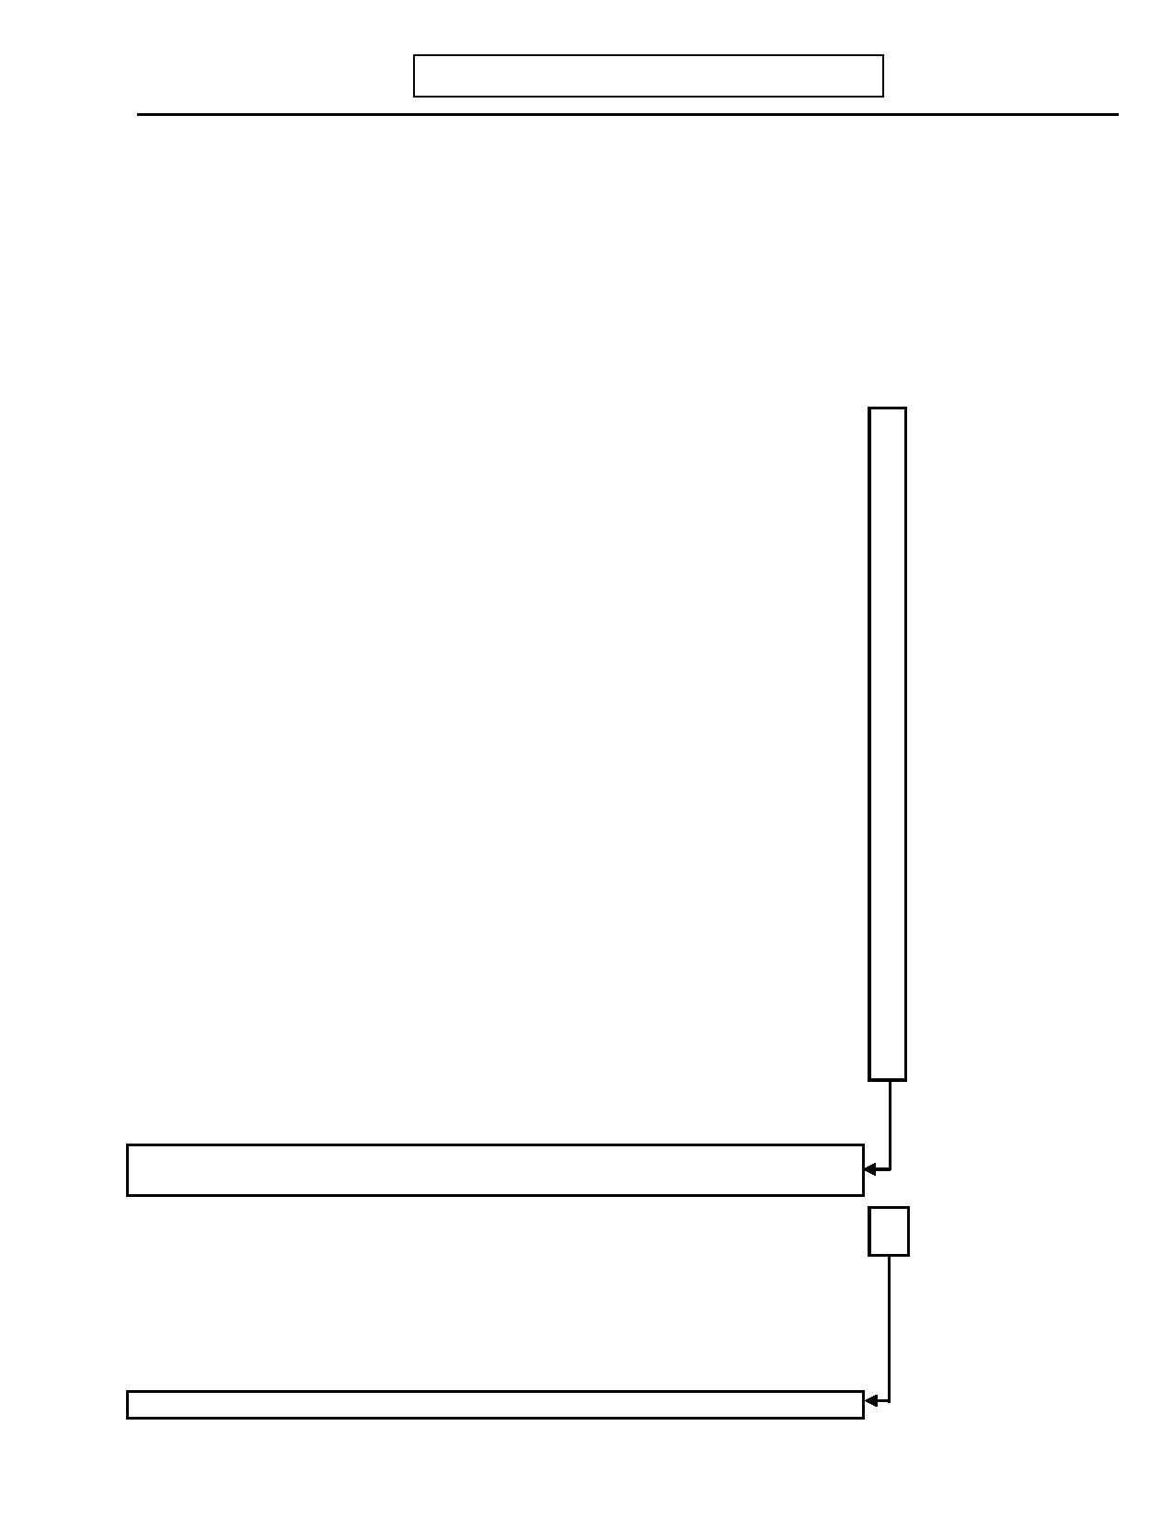
DIGS 4.0 / BP
21-Jul-2005
K. PSYCHOSIS
Page 81

Now I would like to read you a list of experiences that other people have reported. Tell me which ones you have had.
INTERVIEWER: For each positive response, ask the following standard probes:
Were you convinced?
How did you explain it?
Did you change your behavior?
How often did this happen?
How long did it last?
Record an example of each positive response in the margins Susp-
1. Has there been a time when . . . . No Yes ected Unk
1.a) you heard voices? For example, some people have had the experience
of hearing people's voices whispering or talking to them, even when no 0 1 2 9
one was actually present.

1.b) you had visions or saw things that were not visible to others? 0 1 2 9

1.c) you had beliefs or ideas that others did not share or later found out
were not true—like people being against you, people trying to harm 0 1 2 9
you, or people talking about you, or believing you were being given
special messages (e.g., through the TV or the radio)?

1.d) you have ever engaged in any unusual behavior, had speech that was
mixed up or did not make sense [aside from mania and/or 0 1 2 9depression], or had your body stuck in one position so that you could
not move?

1.e) you have had many days in a row when you did not get dressed, or have
felt you had nothing to say, or appeared to have no emotions or have 0 1 2 9
inappropriate emotions? [aside from mania and/or depression]

1.f) Interviewer: Does the subject manifest or describe disorganized 0 1 2 9
speech?

1.g) Interviewer: Does the subject manifest or describe bizarre behavior? 0 1 2 9

1.h) Interviewer: Does the subject manifest gross flattening of affect (e.g.,
unchanging facial expression, decreased spontaneous movements, poor 0 1 2 9
eye contact, lack of vocal inflection) or poverty of content of speech
(e.g., the patient's replies are adequate in amount but tend to be vague,
over concrete or over generalized, and convey little in information)?

INTERVIEWER: If there is NO EVIDENCE, from any source, of any psychosis
skip to N. Comorbidity Assessment (page 99).

1.i) If any yes to questions 1a-e: Did any of these symptoms last 0 1 2 9
persistently throughout the day for one day or intermittently for a
period of three days?

(If yes to any in 1a-i:) Describe: ________________________________________

_______________________________________
INTERVIEWER: If NO, skip to N. Comorbidity Assessment (page 99).

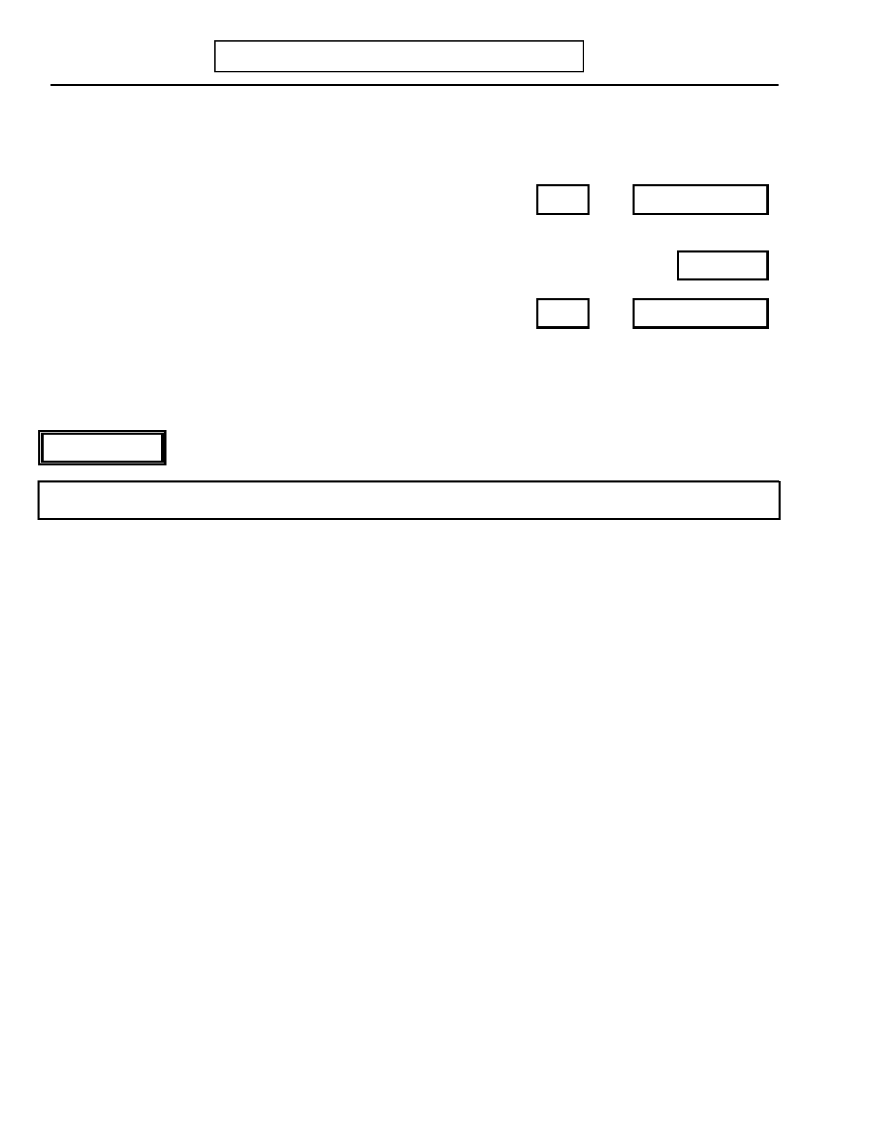
Page 82
K. PSYCHOSIS
DIGS 4.0 / BP
21-Jul-2005

No Yes Unk

2. Are you currently experiencing (Psychotic symptoms)? 0 1 9

Days Weeks
2.a) If yes: How long ago did this begin? OR
Record response: _________________________________
Age
3. If no: How old were you the last time you had (Psychotic symptoms)?
Days Weeks
3.a) How long did these symptoms last? OR

No Yes Unk
4. Since you first began experiencing (Psychotic symptoms) have you ever returned to
your normal self for at least two months? 0 1 9

DELUSIONS

INTERVIEWER: If no delusions (question 1.c) skip to Hallucinations (question 22, page 86).

INTERVIEWER: For each positive response use the standard probes and record examples in space below this section.
No Yes Unk
5. Persecutory Delusions
Have you ever felt that people were out to get you or deliberately trying to harm 0 1 9
you?

If yes: Specify. ____________________________________________________

_________________________________________________________________

6. Jealousy Delusions
Have you ever been convinced that your (husband/wife/boyfriend/girlfriend) was 0 1 9
being unfaithful to you? What made you think so? _________________________

_________________________________________________________________

7. Guilt or Sin Delusions
Have you ever been convinced that you committed a crime, sinned greatly, or 0 1 9
deserved punishment?

8. Grandiose Delusions
Have you ever felt you had any special powers, talents, or abilities much more than 0 1 9
other people?
(Probes: having a special purpose, mission or identity?)


DIGS 4.0 / BP
21-Jul-2005
K. PSYCHOSIS
Page 83

No Yes Unk
9. Religious Delusions
Have you had any religious beliefs or experiences that other people didn't share? 0 1 9

If yes: Specify. ____________________________________________________

_________________________________________________________________

10. Somatic Delusions
Have you ever had a change in your body or the way it was working for which the 0 1 9
doctor could find no cause?
If yes: Specify. ____________________________________________________

_________________________________________________________________
(Probe: like incurable cancer, bowels stopped up, insides rotting?)

11. Erotomanic Delusions
Have you ever believed that another person was in love with you when there was no 0 1 9real reason to think so?

12. Delusions of Reference
Have you ever seen things in magazines or on TV that seem to refer specifically to 0 1 9
you or contain a special message for you? Have you ever been sure that people were
talking about you, laughing at you, or watching you?

13. Being Controlled
Have you ever felt you were being controlled or possessed by some outside force or 0 1 9
person?

14. Thought Broadcasting
Have you ever felt your thoughts were broadcast so other people could hear them? 0 1 9

15. Thought Insertion
Have you ever felt that thoughts that were not your own were being put into your 0 1 9
head by some outside force?

16. Thought Withdrawal
Have you ever felt your thoughts were taken out of your head by some outside force? 0 1 9

Days Weeks
17. How long did your longest period of (Delusions) last? OR

17.a) Were you convinced of these beliefs at the time? 0 1 9


Page 84
K. PSYCHOSIS
DIGS 4.0 / BP
21-Jul-2005

INTERVIEWER: This space may be used to describe positive responses to questions 5-29:


DIGS 4.0 / BP
21-Jul-2005
K. PSYCHOSIS
Page 85

Code Response

18. When you believed any (Delusion)…,
…were you at all confused about where you were or the time of day? 0 1 2 3 9
…did you have trouble with your memory?

INTERVIEWER: Rate Sensorium While Delusional.
0. None: No distortion of subject's sensorium during delusional beliefs.
1. Questionable
2. Definite: Sensorium is clouded, due to medication, substance use, or general
medical condition.
3. Definite: Clouded sensorium, but not due to medication, substance use, or
general medical condition.
9. Unknown: No information.

19. INTERVIEWER: Rate Fragmentary Nature of Delusions. 0 1 2 9
0. Not at all: All delusions are around a single theme, such as persecution.
1. Somewhat fragmentary: Several different, but possibly related themes. 2. Definitely fragmentary: Unrelated themes.
9. Unknown

20. INTERVIEWER: Rate Widespread Delusions. 0 1 9
0. Not widespread.
1. Widespread: Delusions intrude into most aspects of patient's life and/or
preoccupy patient most of the time.
9. Unknown

21. INTERVIEWER: Rate Bizarre Quality of Delusions. 0 1 2 9
0. Not at all: (e.g., wife is unfaithful).
1. Somewhat bizarre: (e.g., subject is being persecuted by witches).
2. Definitely bizarre: (e.g., little green men from Mars have been recording his
dreams and broadcasting them back home).
9. Unknown


Page 86

HALLUCINATIONS
K. PSYCHOSIS
DIGS 4.0 / BP
21-Jul-2005

INTERVIEWER: If no hallucinations (questions 1.a-b) skip to question 32, page 87).

INTERVIEWER: For each positive response use the standard probes and record examples in the margins.

No Yes Unk
22. Auditory - Voices, Noises, Music
Have you ever heard sounds or voices other people could not hear? 0 1 9

22.a) If yes: Did they say bad things about you or threaten you? 0 1 9

23. Auditory - Running Commentary
Have you ever heard voices that described or commented on what you were doing or 0 1 9
thinking?

24. Auditory - Two or More Voices
Have you ever heard two or more voices talking with each other? 0 1 9

25. Thought Echo
Have you ever experienced hearing your thoughts repeated or echoed? 0 1 9

26. Somatic or Tactile
Have you ever had unusual sensations or other strange feelings in your body when 0 1 9
there was nothing to account for them?
(Probe: like electricity shooting through your body or your body parts moving
around or growing, or that something was being inserted into your body
against your will?)

27. Olfactory
Have you ever experienced any strange smells you couldn't account for or smells 0 1 9
that others didn't notice?

28. Visual
Have you ever had visions or seen things that other people could not? 0 1 9

28.b) If yes: Did this only occur when you were falling asleep or waking up? 0 1 9

29. Gustatory
Have you ever had a strange taste in your mouth that you couldn't account for? 0 1 9

Days Weeks
30. How long did your longest period of (Hallucinations) last? OR
No Yes Unk

30.b) INTERVIEWER: Did the subject experience prominent hallucinations
(throughout the day for several days or several times a week for several weeks, 0 1 9each hallucination experience not being limited to a few brief moments)?


DIGS 4.0 / BP
21-Jul-2005
K. PSYCHOSIS
Page 87

Code Response

31. When you were (Hallucinating)… 0 1 2 3 9
…were you at all confused about where you were or the time of day?
…did you have trouble with your memory?

INTERVIEWER: Rate Sensorium While Hallucinating.
0. None: No distortion of subject's sensorium during hallucination.
1. Questionable
2. Definite: Sensorium is clouded, due to medication, substance use, or general
medical condition.
3. Definite: Clouded sensorium, but not due to medication, substance use, or
general medical condition.
9. Unknown: No information.

SCHIZOPHRENIA CRITERION A

32. INTERVIEWER: Check if subject has reported symptoms in each of the following categories:
No Yes
32.a) Delusions (questions 5-21) 0 1
If yes: 32.b) Definitely bizarre delusions (question 21 coded 2) 0 132.c) Hallucinations (questions 22-29) 0 1
If yes: 32.d) Two or more voices (question 24) or a voice that commented on what you 0 1
were doing or thinking (question 23)
32.e) Disorganized speech (e.g. frequent derailment or incoherence) (question 1.f) 0 1
32.f) Grossly disorganized or catatonic behavior (question 1.g) 0 132.g) Negative symptoms, i.e., affective flattening, alogia or avolition (question 1.h) 0 1

TOTAL

If TOTAL is less than 2, skip to question 34.

33. INTERVIEWER: Has the subject ever had symptoms from two or more of the above
categories (32.a, c, e, f or g) most of the time for at least one month, or been treated 0 1
successfully for symptoms occurring together from two or more of these categories?
(Probe symptom by symptom if necessary from positive responses to questions 5-29)

33.a) Has the subject ever had (32.b or 32.d) most of the time for a month or been treated 0 1
successfully for either of these?


Page 88
K. PSYCHOSIS
DIGS 4.0 / BP
21-Jul-2005

No Yes
34. Was there ever a period of time when you had (Psychotic symptoms) when you were not
feeling (depressed/high or excited)? 0 1

34a. If yes: Did these symptoms ever last as long as one week while you were not
(depressed/high)? 0 1

How long did you have these symptoms when you Days Weeks
were not (depressed/high)? OR
34b. (IF NO TO question 34 or 34.a) INTERVIEWER: Review all psychotic symptoms
coded present during depression and code YES if mood incongruent psychotic 0 1
symptoms were present during major depression.
Skip to N. Comorbidity Assessment (page 99)

INTERVIEWER: Do not skip out of the Psychosis section if the subject has a chronic psychiatric disorder with
psychotic features.

ONSET OF FIRST SYMPTOMS/EPISODE

35. How old were you the first time that you were experiencing (describe delusions, Age
hallucinations, or other criteria for schizophrenia noted by the subject previously)?
Days Weeks
36. How long did those (Psychotic symptoms) last? OR

No Yes Unk

37. Did you return to feeling like your normal self for at least two months? 0 1 9

38. How many episodes have you had? (By episodes I mean spells separated by periods Episodes
of being your normal self for at least two months.)
INTERVIEWER: Record total (minimum) number of episodes or periods of psychosis
(separated from each other by at least two months). If subject never
returned to pre-morbid state for at least two months, count as one period of illness.

38.a) INTERVIEWER: Do you suspect autism on the basis of the medical history section 0 1 9
or other information?

38.b) INTERVIEWER: Do you suspect another Pervasive Developmental Disorder on the
basis of the medical history section or other information? 0 1 9

DELINEATION OF CURRENT OR MOST RECENT EPISODE
No Yes Unk
39. During the current/most recent episode, have you also been experiencing. . .

39.a) a low/depressive episode? 0 1 9

39.b) a high/manic episode? 0 1 9


DIGS 4.0 / BP
21-Jul-2005
K. PSYCHOSIS
Page 89

No Yes Unk

40. Did the current/most recent episode follow increased or excessive use of alcohol? 0 1 9

If yes: Specify: _____________________________________________________

____________________________________________________________

41. Did the current/most recent episode follow use of street drugs? 0 1 9

If yes: Specify: _____________________________________________________

____________________________________________________________

42. Did the current/most recent episode follow serious medical illness? 0 1 9

If yes: Specify: _____________________________________________________

____________________________________________________________

43. Did the current/most recent episode follow use of prescription medications? 0 1 9

If yes: Specify: _____________________________________________________

____________________________________________________________

44. Did the current/most recent episode follow an extremely stressful life event (such as 0 1 9
your house burning down or a violent death of a family member or friend)?

If yes: Specify: _____________________________________________________

____________________________________________________________

44.a) During the current/most recent episode, was there a change in your ability to 0 1 9
function at work or with family and friends? (That is, were you unable to do
your job, go to school, do your work at home, or perform self-care activities?) Was there a decrease in your ability to have relationships with family and/or
friends?

INTERVIEWER: Code for deterioration of function: during the course of the disturbance,
functioning in such areas as work, social relations, and self care is
markedly below the highest level achieved before onset of the
disturbance (or when the onset is in childhood or adolescence, failure to achieve expected level of social development).

44.b) If yes: Has this change in your functioning continued for much of the time since 0 1 9
this episode began?

45. DSM III-R Brief Reactive Psychosis
During the current/most recent episode, did you experience unpredictable, intense 0 1 9mood changes or did you feel baffled?

46. If FEMALE: Did the current/most recent episode begin within four weeks of 0 1 9
childbirth?


Page 90
K. PSYCHOSIS
DIGS 4.0 / BP
21-Jul-2005

PRODROMAL AND RESIDUAL SYMPTOMS

INTERVIEWER: Complete the Prodromal Period first then complete the Residual Period. If the subject is
actively psychotic, complete the Prodromal Period only, then skip to question 48, page 92.

Do not count as positive symptoms that are due to a disturbance in mood or a psychoactive substance disorder.
(Ask after completing question 47.a-n for the Prodromal period:)
Establishing the Prodromal Period: Establishing the Residual Period:

47. Now I would like to ask you about the year Now I would like to ask you about the year after your (Active
before your (Active psychotic symptoms) psychotic symptoms) stopped. During that time did you. . . . started. During that time did you. . . .

Prodromal Residual
Period Period
No Yes Unk No Yes Unk

47.a) stay away from family and friends, become socially isolated? 0 1 9 0 1 9

47.b) have trouble doing your job, going to school, or doing your 0 1 9 0 1 9
work at home?

47.c) do anything unusual, like collecting garbage, talking to yourself 0 1 9 0 1 9
in public, hoarding food?

47.d) neglect grooming, bathing, and keeping your clothes cleaned? 0 1 9 0 1 9

47.e) appear to have no emotions or show emotions that did not fit 0 1 9 0 1 9
with what was going on (for example, giggle or cry at the wrong
time)?

47.f) speak in a way that was hard to understand, have a hard time 0 1 9 0 1 9
getting to the point, or were you at a loss for words (not due to a
speech impediment)?

47.g) have unusual beliefs or magical thinking (e.g., 0 1 9 0 1 9
superstitiousness, belief in clairvoyance, telepathy, sixth sense,
feeling that "others can feel my feelings"), have ideas that were
not quite true, think others were referring to you when they
really were not?

47.h) have unusual visual experiences or experiences of hearing (e.g., 0 1 9 0 1 9
whispers, crackling), sense the presence of a force or person
not actually there, or feel the world is unreal?

47.i) have trouble getting going, or have no interests or energy? 0 1 9 0 1 9


DIGS 4.0 / BP
21-Jul-2005
K. PSYCHOSIS

Prodromal
Period
No Yes Unk
Page 91

Residual
Period
No Yes Unk

47.j) think that things around you, such as TV programs or 0 1 9 0 1 9
newspaper articles, had some special meaning just for you, or
think people were talking about you or laughing at you, or think
you were receiving special messages in other ways?

47.k) get nervous about being around other people, or about going to 0 1 9 0 1 9
parties or other social events, or take criticism badly?

47.l) worry that people had it in for you, or feel that most people were 0 1 9 0 1 9
your enemies, or think people were making fun of you?

PRODROMAL ONLY
Weeks
47.m) How long did you have these experiences before you had
(Active psychotic features)?

47.n) Was this year typical of your usual self (that is, as subject was 0 1 9
prior to onset of earliest symptoms)?

INTERVIEWER: Return to top of question 47 to establish the Residual period and code
in Residual Column.

RESIDUAL ONLY
Weeks
47.o) How long did you have these experiences after your (Active
psychotic features) stopped?

47.p) Did you return to your usual self (as subject was prior to age of 0 1 9
onset of earliest symptoms)?

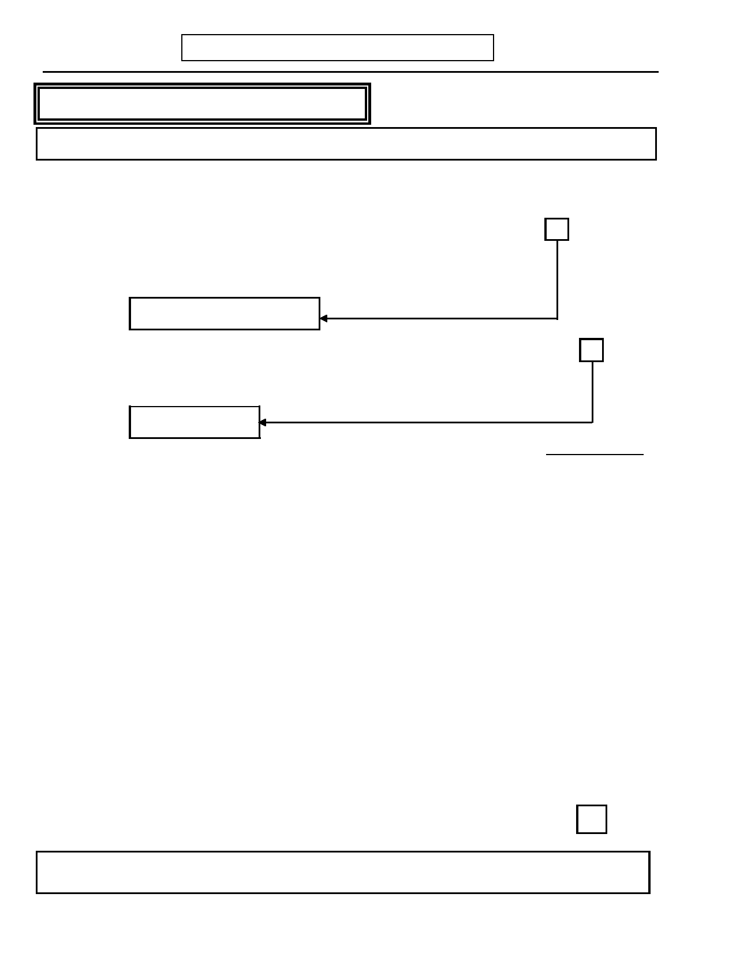
Page 92
K. PSYCHOSIS
DIGS 4.0 / BP
21-Jul-2005

SCHIZOAFFECTIVE DISORDER, MANIC TYPE

INTERVIEWER: If subject has never had a period of mania or hypomania, skip to question 58, page 94.

You mentioned before that you have had periods when you felt (Manic moods).
No Yes Unk

48. Did (Delusions or Hallucinations) ever occur when you were feeling extremely good 0 1
or high, or when you were feeling unusually irritable?
If yes: Record response: _____________________________________________

____________________________________________________________
Skip to question 58, page 94

49. Did the (Delusions or Hallucinations) correspond to either of the manic episodes 0 1 9
described previously?
INTERVIEWER: Indicate if manic episode corresponds to manic periods described in
the MANIA section.
Skip to question 52
Code Response
50. INTERVIEWER: Specify and code whether subject's mood was:
1 2
1. Only irritable
2. Euphoric (with or without irritability)
No Yes Unk
50.a) During the period of feeling especially good or high when you were also having
(Psychotic symptoms) were you also experiencing any of these symptoms?

50.a.1) Overactivity—Running around, many projects, or physically agitated? 0 1 9

50.a.2) More talkative than usual, speech pressured? 0 1 9

50.a.3) Thoughts racing, jumping from topic to topic? 0 1 9

50.a.4) Feeling grandiose - more important, special, powerful? 0 1 9

50.a.5) Needing less sleep - energetic after little or no sleep? 0 1 9

50.a.6) Attention distracted by unimportant things? 0 1 9

50.a.7) Doing risky things for pleasure - spending, sex, reckless driving, etc.? 0 1 9

51. INTERVIEWER: Enter number of definite symptoms. SX
[If Euphoric, criterion = 3]
[If Irritable only, criterion = 4]

INTERVIEWER: If this episode does not meet criteria for mania (i.e., no evidence of delusions or
hallucinations during a mania), skip to question 58, page 94.


DIGS 4.0 / BP
21-Jul-2005
K. PSYCHOSIS
Page 93

No Yes Unk

52. Did these episodes only follow alcohol or drug intake or withdrawal? 0 1 9

53. INTERVIEWER: Has the subject ever met Criterion A for schizophrenia (i.e., was 0 1
the response to question 33 or 33.a yes)?

53a. If yes: Did subject ever meet Criterion A for schizophrenia during an episode of 0 1 9
mania?

53b. (IF 53.a is UNKNOWN:) Ask if subject has reported symptoms in each of the
following categories during the episode of mania referred to in question 49 or
50:

53.b.1) Delusions
53.b.1.a) If yes: Bizarre delusions
53.b.2) Hallucinations
53.b.2.a) If yes: Two or more voices or a voice commenting on the
subject's behavior or thoughts
53.b.3) Disorganized speech (e.g. frequent derailment or incoherence)
53.b.4) Grossly disorganized or catatonic behavior
53.b.5) Negative symptoms, i.e., affective flattening, alogia or avolition

0
000

0
00

1
111

1
11

54. Presence of Mood-Incongruent Psychotic Symptoms 0 1 9
Code YES if psychotic symptoms occurring during any manic episode had content
that was not consistent with themes of inflated worth, power, knowledge, identity, or special relationship to a deity or a famous person.

55. Persistence of Psychotic Symptoms with Affective Clearing 0 1 9
Did the (Hallucinations/delusions) ever continue after your mood returned to
normal?
Weeks
55.a) If yes: What is the longest time they lasted after your mood became normal?
56. Did the (Other psychotic symptoms such as formal thought disorder, bizarre
behavior, catatonia) ever continue after your mood returned to normal? 0 1 9
Weeks
56.a) If yes: What is the longest time they lasted after your mood became normal?
57. INTERVIEWER: Were the Affective syndromes brief relative to the Psychotic
symptoms? 0 1 9

INTERVIEWER NOTE: Brief = < 30%. Code question 57 "yes" if the total duration of their affective
episodes equals less than 30% of the time relative to the total duration of psychosis. If needed, use the
following questions to clarify the overlap: "Since you first began experiencing (delusions/hallucinations) what
percent of the time were you manic? What percent of time was your mood normal?"

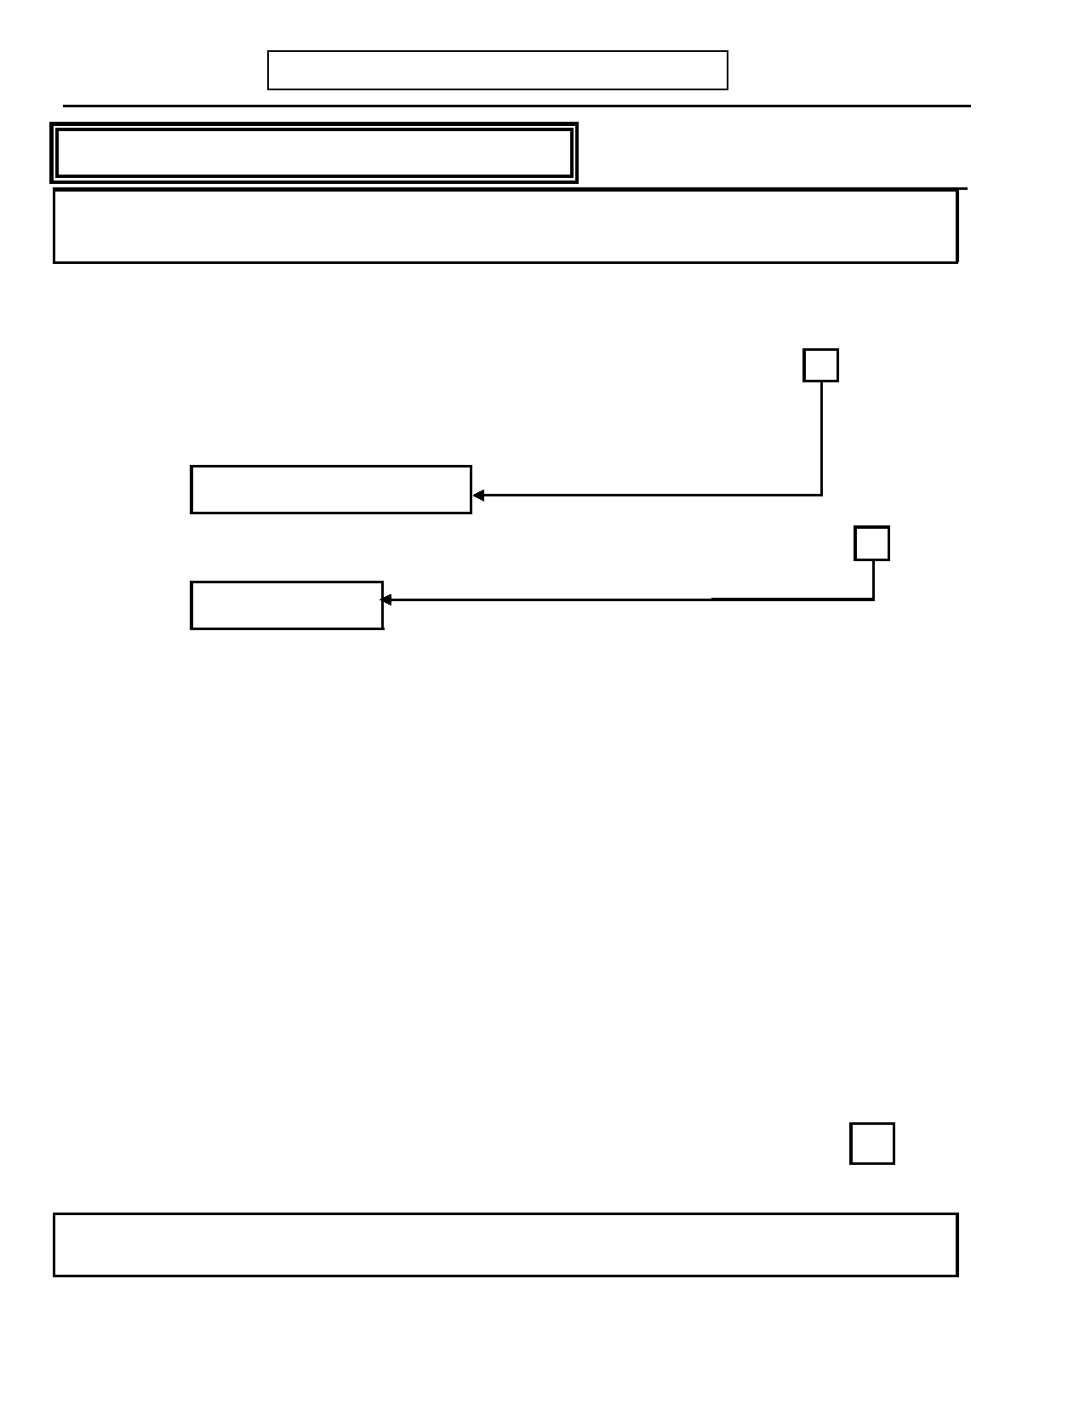
Page 94
K. PSYCHOSIS
DIGS 4.0 / BP
21-Jul-2005

SCHIZOAFFECTIVE DISORDER, DEPRESSED TYPE

INTERVIEWER: If subject has never had a period of depression lasting at least one week, skip to
question 68, page 95.

You mentioned before that you have had periods when you felt (Depressed mood) lasting at
least one week. No Yes Unk

58. Did (Delusions or Hallucinations) ever occur when you were feeling especially 0 1
depressed?
If yes: Record response: ______________________________________________

_____________________________________________________________
Skip to question 68, page 95

59. Did the (Delusions or Hallucinations) correspond to either of the depressive 0 1 9
episodes described previously?
Skip to question 62

60. During the period of feeling especially depressed when you were also having
(Psychotic symptoms) were you also experiencing any of these symptoms?

60.a) Diminished desire for food, or marked overeating? 0 1 9

60.b) Inability to sleep when sleep was desired, or excessive sleep? 0 1 9

60.c) Feeling slowed down? 0 1 9

60.d) Having fatigue or a loss of energy? 0 1 9

60.e) Losing interest in pleasurable activities? 0 1 9

60.f) Feeling guilty or worthless? 0 1 9

60.g) Being unable to think or retain written information? 0 1 9

60.h) Feeling suicidal or thinking a lot about death? 0 1 9

61. INTERVIEWER: Enter number of definite symptoms. SX

61.a) Is this a current episode? 0 1
INTERVIEWER: If this episode does not meet criteria for depression (i.e., no evidence of delusions or
hallucinations during a depression), skip to question 68, page 95.

62. Did these episodes only follow alcohol or drug intake or withdrawal? 0 1 9

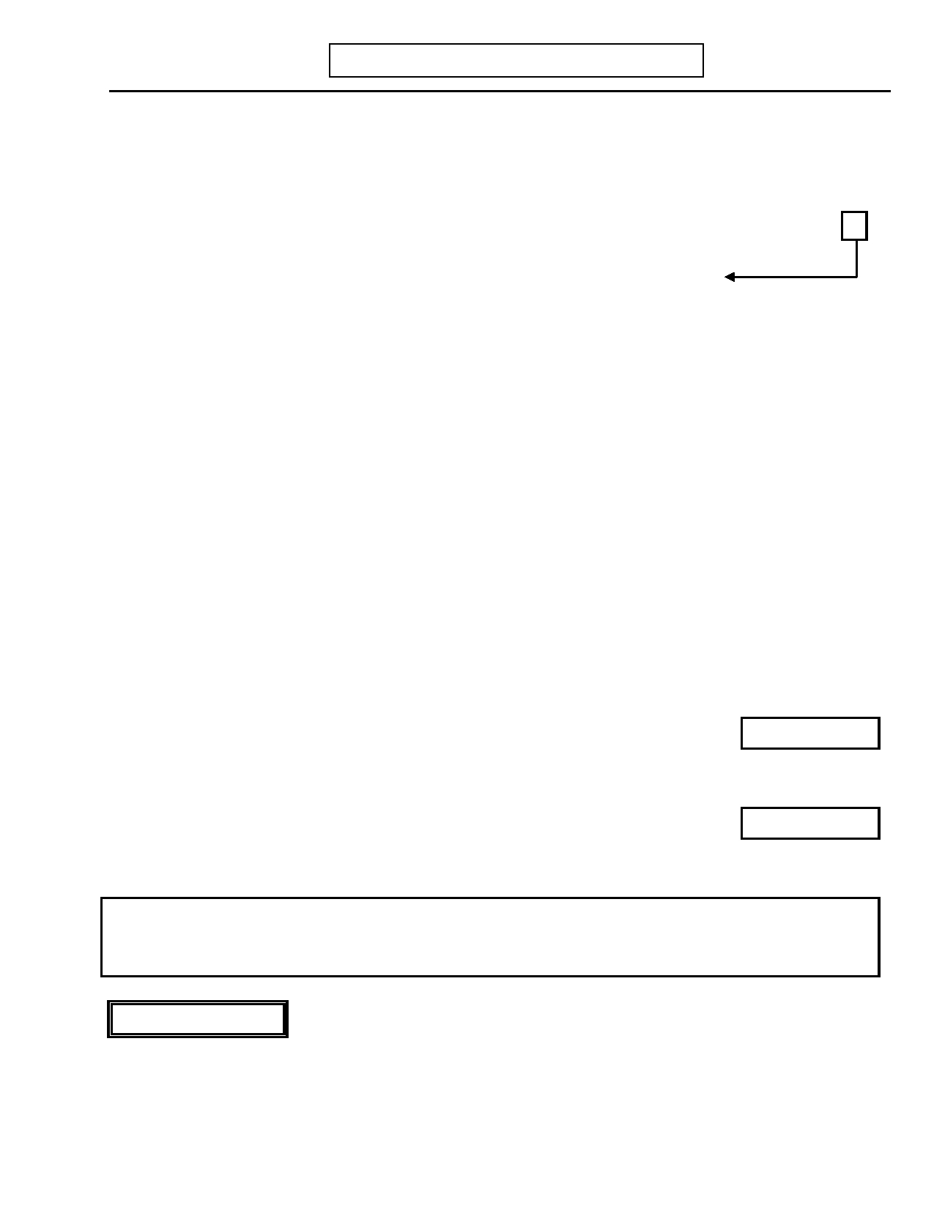
DIGS 4.0 / BP
21-Jul-2005
K. PSYCHOSIS
Page 95

No Yes Unk

63. INTERVIEWER: Has the subject ever met Criterion A for schizophrenia (i.e., was the 0 1
response to question 33 or 33.a yes)?

63.a) If yes: Did subject ever meet Criterion A for schizophrenia during an episode of 0 1 9
depression?

63.b) (IF 63.a is UNKNOWN:) Ask if subject has reported symptoms in each of the
following categories during the episode of depression referred to in question 59
or 60:

63.b.1) Delusions 0 1
63.b.1.a) If yes: Bizarre delusions 0 163.b.2) Hallucinations 0 1
63.b.2.a) If yes: Two or more voices or a voice commenting on the 0 1
subject's behavior or thoughts
63.b.3) Disorganized speech (e.g. frequent derailment or incoherence) 0 1
63.b.4) Grossly disorganized or catatonic behavior 0 163.b.5) Negative symptoms, i.e., affective flattening, alogia or avolition 0 1

64. Presence of Mood-Incongruent Psychotic Symptoms 0 1 9
Code YES if psychotic symptoms occurring during any depressed episode had content that was not consistent with themes of personal inadequacy, guilt, etc.

65. Persistence of Psychotic Symptoms with Affective Clearing 0 1 9
Did the (Hallucinations/delusions) ever continue after your mood returned to
normal?
Weeks
65.a) If yes: What is the longest time they lasted after your mood became normal?
66. Did the (Other psychotic symptoms such as formal thought disorder, bizarre
behavior, catatonia) ever continue after your mood returned to normal? 0 1 9
Weeks
66.a) If yes: What is the longest time they lasted after your mood became normal?
67. INTERVIEWER: Were the Affective syndromes brief relative to the Psychotic
symptoms? 0 1 9

INTERVIEWER NOTE: Brief = < 30%. Code question 67 "yes" if the total duration of their affective
episodes equals less than 30% of the time relative to the total duration of psychosis. If needed, use the
following questions to clarify the overlap: "Since you first began experiencing (delusions/hallucinations) what
percent of the time were you depressed? What percent of time was your mood normal?"

POLYDYPSIA

68. Have you ever consumed excess fluids over an extended period of time such that you 0 1 9
had problems of low sodium, seizures, confusion, urinary tract difficulties, or other
medical complications?


Page 96
K. PSYCHOSIS
DIGS 4.0 / BP
21-Jul-2005

PATTERN OF SYMPTOMS
This rating can be made only for people with psychotic episodes.
Code Response

69. INTERVIEWER: Circle appropriate pattern from descriptions below: 1 2 3 4 5

1. Continuously Positive: The subject has predominantly positive symptoms when ill.
During periods of remission, he/she may have mild negative symptoms or be relatively asymptomatic.

2. Predominantly Negative: The subject may have periods of mild psychosis with
some delusions and hallucinations, but the predominant clinical features during
most of his/her illness are negative symptoms. Thus, he/she is in a chronic deficit
state most of the time with occasional flickers of delusions, hallucinations, or social disorganization.

3. Predominantly Positive Converting to Predominantly Negative: The subject
begins with a number of episodes characterized by positive symptoms, but these
become more widely spaced, and the subject passes into a deficit state in between.
Eventually, he/she remains in a deficit state for a prolonged period of time (e.g., two
or three years), during which he/she may have occasional mild flickerings of positive symptoms.

4. Negative Converting to Positive: The subject begins in a deficit state with a history
of poor premorbid functioning. He/she then develops a florid psychotic picture that is relatively prominent and persistent and thereafter does not spend much time in the
deficit state. It is likely that this pattern will be quite uncommon. Subjects who
have an adolescent history of poor premorbid adjustment and who simply return to
this level of functioning between episodes should be classified as Pattern 1 described above rather than as Pattern 4.

5. Continuous Mixture of Positive and Negative Symptoms: Pattern is one of
concurrent and continuous active psychosis and negative symptoms.


DIGS 4.0 / BP
21-Jul-2005

CLASSIFICATION OF LONGITUDINAL
COURSE FOR SCHIZOPHRENIA
K. PSYCHOSIS
Page 97

Code Response

70. These specifiers can be applied only after at least 1 year has elapsed since the
initial onset of active-phase symptoms. 1 2 3 4 5 6

1. Episodic With Interepisode Residual Symptoms: When the course is
characterized by episodes in which Criterion A for Schizophrenia is met and
there are clinically significant residual symptoms between the episodes. With
Prominent Negative Symptoms can be added if prominent negative symptoms are present during these residual periods.

2. Episodic With No Interepisode Residual Symptoms: When the course is
characterized by episodes in which Criterion A for Schizophrenia is met and
there are no clinically significant residual symptoms between the episodes.

3. Continuous: When characteristic symptoms of Criterion A are met throughout
all (or most) of the course. With Prominent Negative Symptoms can be added if prominent negative symptoms are also present.

4. Single Episode in Partial Remission: When there has been a single episode in
which Criterion A for Schizophrenia is met and some clinically significant residual symptoms remain. With Prominent Negative Symptoms can be
added if these residual symptoms include prominent negative symptoms.

5. Single Episode in Full Remission: When there has been a single episode in
which Criterion A for Schizophrenia has been met and no clinically significant residual symptoms remain.

6. Other or Unspecified Pattern: If another or an unspecified course pattern has
been present.

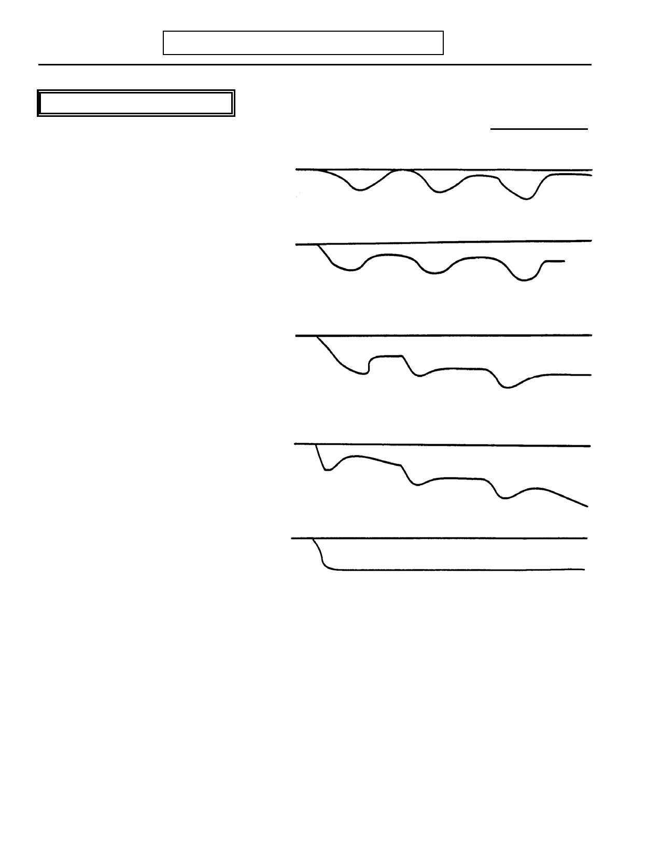
Page 98
K. PSYCHOSIS
DIGS 4.0 / BP
21-Jul-2005

PATTERN OF SEVERITY
Code Response
71. INTERVIEWER: Circle appropriate pattern from descriptions below:
1 2 3 4 5
1. Episodic Shift: Episodes of illness are
interspersed between periods of health or near normality.

2. Mild Deterioration: Periods of illness
occur, but there are also extended periods
of return to near normality, with some ability to work at a job and near normal or normal social functioning.

3. Moderate Deterioration: The subject
may occasionally experience some
resolution of symptoms, but overall the
course is downhill culminating in a
relatively severe degree of social and occupational incapacitation.

4. Severe Deterioration: The subject's
illness has become chronic resulting in
inability to maintain employment
(outside of sheltered workshop) and social impairment.

5. Relatively Stable: The subject's illness
has not changed significantly.


DIGS 4.0 / BP
21-Jul-2005
N. COMORBIDITY ASSESSMENT
Page 99

INTERVIEWER: Subjects who have significant history of alcohol, marijuana, or other drug abuse and evidence of depression, mania, hypomania, dysthymia, or psychosis should be asked this section.
No Yes Unk

INTERVIEWER: Does this section apply to subject.? 0 1 9
Skip to O. Suicidal Behavior (page 101)

INTERVIEWER: Rate first occurrence at right. Code
Response

1. You mentioned earlier your (mood changes/psychotic symptoms), and also that 1 2 3 4
you were using (alcohol/drugs) heavily. Think about the first time you had any of
these problems. Which came first (mood changes/psychotic symptoms) or
(alcohol/drugs)?
1. Mood changes/psychotic symptoms occurred first.
2. Alcohol/drug abuse occurred first.
3. Mood changes/psychotic symptoms and alcohol/drug abuse occurred at the
same time.
4. Not clear.
SITE OPTIONAL No Yes Unk
1.a) If 1. Mood changes/psychotic symptoms occurred first:
Did you have (mood changes/psychotic symptoms) right before you started 0 1 9
using (alcohol/drugs) heavily?

If yes:

1.a.1) For how long did you have (mood changes/psychotic
symptoms) right before you started using Days Weeks
(alcohol/drugs) heavily? OR
No Yes Unk
1.b) If 2. Alcohol/drugs occurred first:
Were you using (alcohol/drugs) heavily right before you had (mood 0 1 9
changes/psychotic symptoms)?

If yes:

1.b.1) For how long were you using (alcohol/drugs) heavily
right before your (mood changes/psychotic symptoms) Days Weeks
began? OR

INTERVIEWER: If only one episode (total) of mood changes/psychotic symptoms,
skip to O. Suicidal Behavior (page 101).

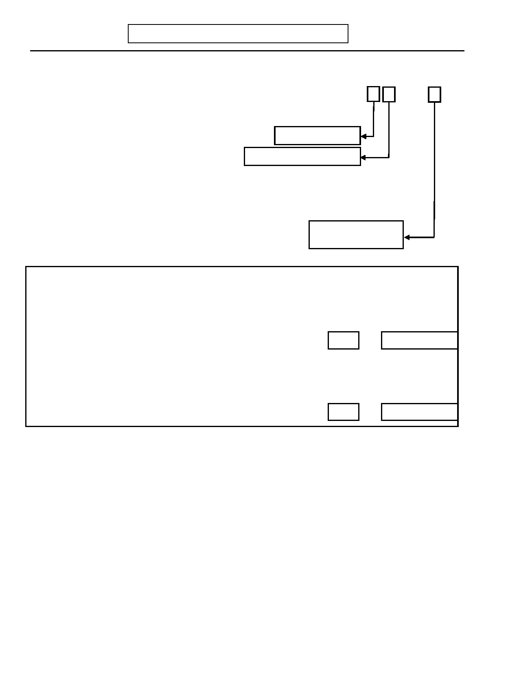
Page 100
N. COMORBIDITY ASSESSMENT
DIGS 4.0 / BP
21-Jul-2005

INTERVIEWER: Hand Comorbidity Card to subject.

2. Now I would like you to think about other episodes of (Mood changes/Psychotic 1 2 3 4 5 6
symptoms) and tell me which statement on the card best characterizes these episodes.

1. Emotional/thinking difficulties always occurred first Skip to question 4

2. Alcohol/drug abuse always occurred first Ask question 3, but skip 4
3. Emotional/thinking difficulties and alcohol/drug abuse always occurred at the
same time
4. No strict pattern (sometimes emotional/thinking difficulties first, sometimes
alcohol drugs first)

5. Emotional/thinking difficulties and alcohol/drug abuse always
occurred independently
6. Not Clear
SITE OPTIONAL

Skip to O. Suicidal
Behavior (page 101)

No

Yes

Unk

3. Have your (Mood/Psychotic) episodes ever continued after you stopped using 0 1 9
(Alcohol/Drugs) heavily?

3.a) If yes: What was the longest time a (Mood/Psychotic) episode Days Weeks
ever continued after you stopped using (Alcohol/Drugs)? OR

4. Did you ever continue to use (Alcohol/Drugs) heavily after your (Mood/Psychotic) 0 1 9
episode stopped?

4.a) If yes: What was the longest you used (Alcohol/Drugs) heavily Days Weeks
after a (Mood/Psychotic) episode stopped? OR

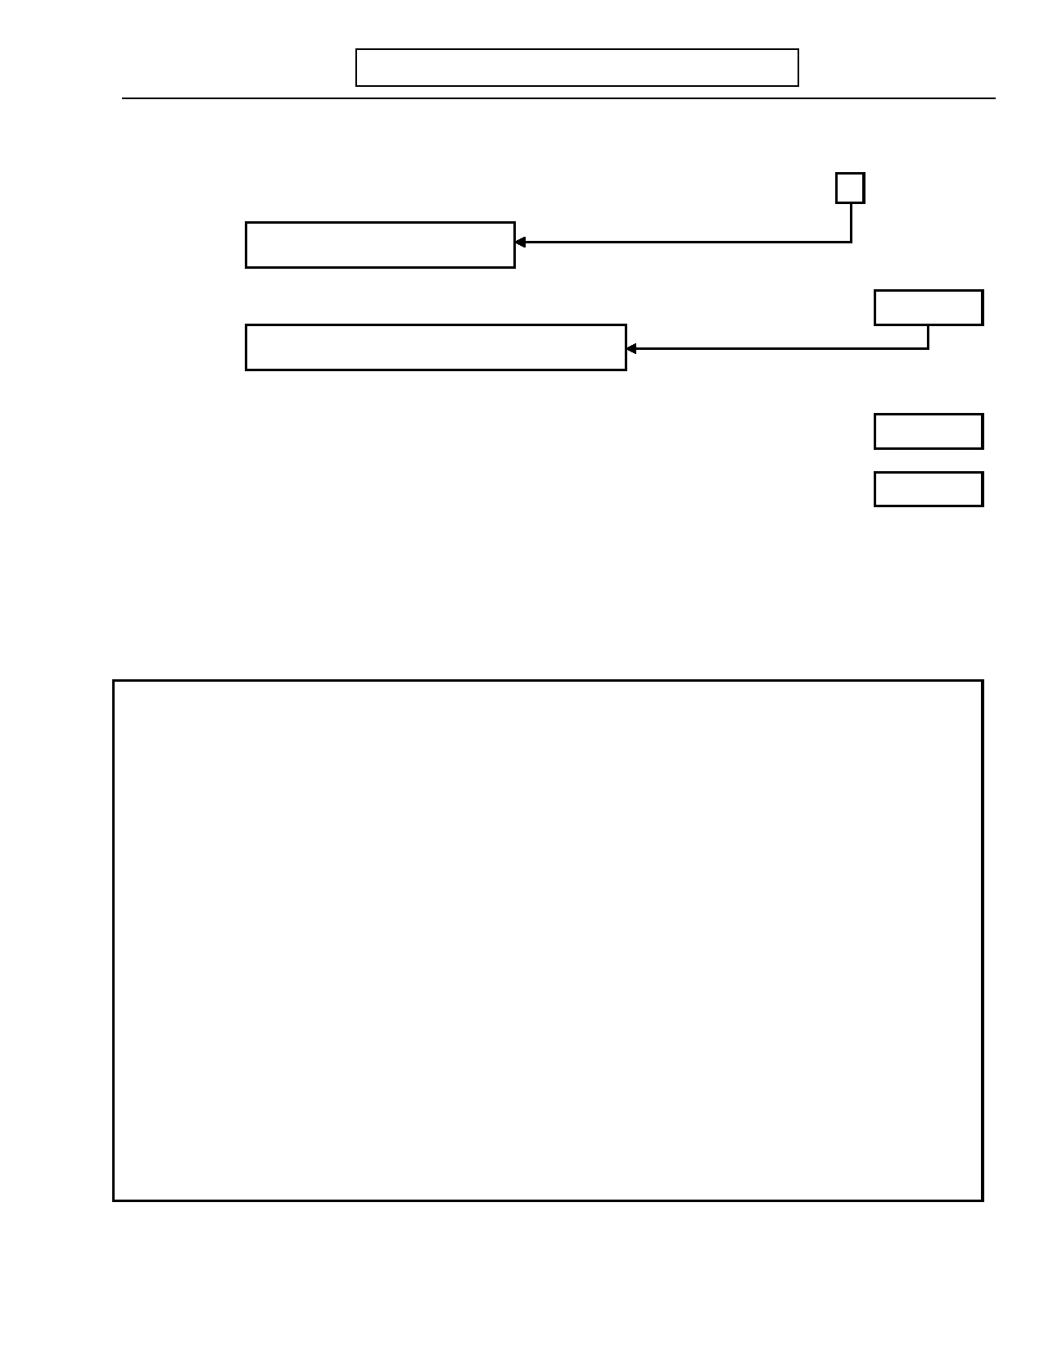
DIGS 4.0 / BP
21-Jul-2005
O. SUICIDAL BEHAVIOR
Page 101

Now I'm going to ask you some questions about suicidal behavior.
No Yes Unk

1. Have you ever tried to kill yourself? 0 1 9

Skip to question 13, page 104

1.a) If yes: How many times have you tried to kill yourself?

If only one time, skip to question 2, page 102

1.b) How many of those attempts led to medical care (i.e., stitches, "stomach pumped",
intubation, etc.)

1.c) How old were you the first time you tried to kill yourself?

1.d) Please tell me more about the time/times you tried to kill yourself.

INTERVIEWER: Probe for means, intent, whether other persons were present at
the time of the suicide attempt, and what medical or psychiatric intervention resulted.
Data Entry: Do not code.
Times

Times

Age


Page 102
O. SUICIDAL BEHAVIOR
DIGS 4.0 / BP
21-Jul-2005

Now I'm going to ask about your most serious episode of suicidal behavior.

INTERVIEWER: For the following questions, ask about the most serious attempt.
2. How did you try to kill yourself?

Record response: ___________________________________________________

___________________________________________________________________

___________________________________________________________________
Age
3. How old were you?
No Yes Unk

4. Did you require medical treatment after this attempt? 0 1 9

5. Were you admitted to a hospital after the attempt? 0 1 9

If yes:
Code Response

5.a) Medical hospital? 0 1 2 9

0. No
1. Yes, Emergency Room 2. Yes, Inpatient 9. Unknown

5.b) Psychiatric hospital? 0 1 2 9
If yes: Note whether voluntary or involuntary.

0. No
1. Yes, voluntary 2. Yes, involuntary 9. Unknown
No Yes Unk

6. Did you want to die? 0 1 9

7. Did you think you would die from what you had done? 0 1 9

Code Response

8. INTERVIEWER: Rate intent of most serious attempt. 1 2 3 9

1. No intent or minimal intent, manipulative gesture. 2. Definite intent, but ambivalent. 3. Serious intent, expected to die. 9. No information, not sure.


DIGS 4.0 / BP
21-Jul-2005
O. SUICIDAL BEHAVIOR
Page 103

Code Response

9. INTERVIEWER: Rate lethality of most serious attempt. 1 2 3 4 5 6 9

1. No danger (no effects, held pills in hand). 2. Minimal (scratch on wrist).
3. Mild (10 aspirin, mild gastritis).
4. Moderate (10 Seconals, briefly unconscious). 5. Severe (cut throat).
6. Extreme (respiratory arrest or prolonged coma). 9. No information, not sure.

10. INTERVIEWER: Rate premeditation of most serious attempt. 1 2 3 9

1. Impulsive (less than 1 hour forethought, used materials immediately at
hand).
2. Somewhat premeditated (had suicidal ideation over hours or days, or
intermittently throughout an episode, prior to making an attempt). 3. Thoroughly premeditated (persistent suicidal ideation over weeks,
months, or longer prior to the attempt) 9. No information, not sure.

11. Did the suicidal behavior described occur during an episode of… No Yes Unk
(Circle all that apply)

…depression? 0 1 9

…bipolar (mixed state)? 0 1 9

…alcohol abuse? 0 1 9

…drug abuse? 0 1 9

…psychosis? 0 1 9

…other? 0 1 9
If yes: Specify: _______________________________________________

__________________________________________________________________

12. INTERVIEWER: Did any suicide attempt occur by violent means? (Violent suicide 0 1 9
attempts include those by gunshot, stabbing, hanging, or jumping from a high place.)

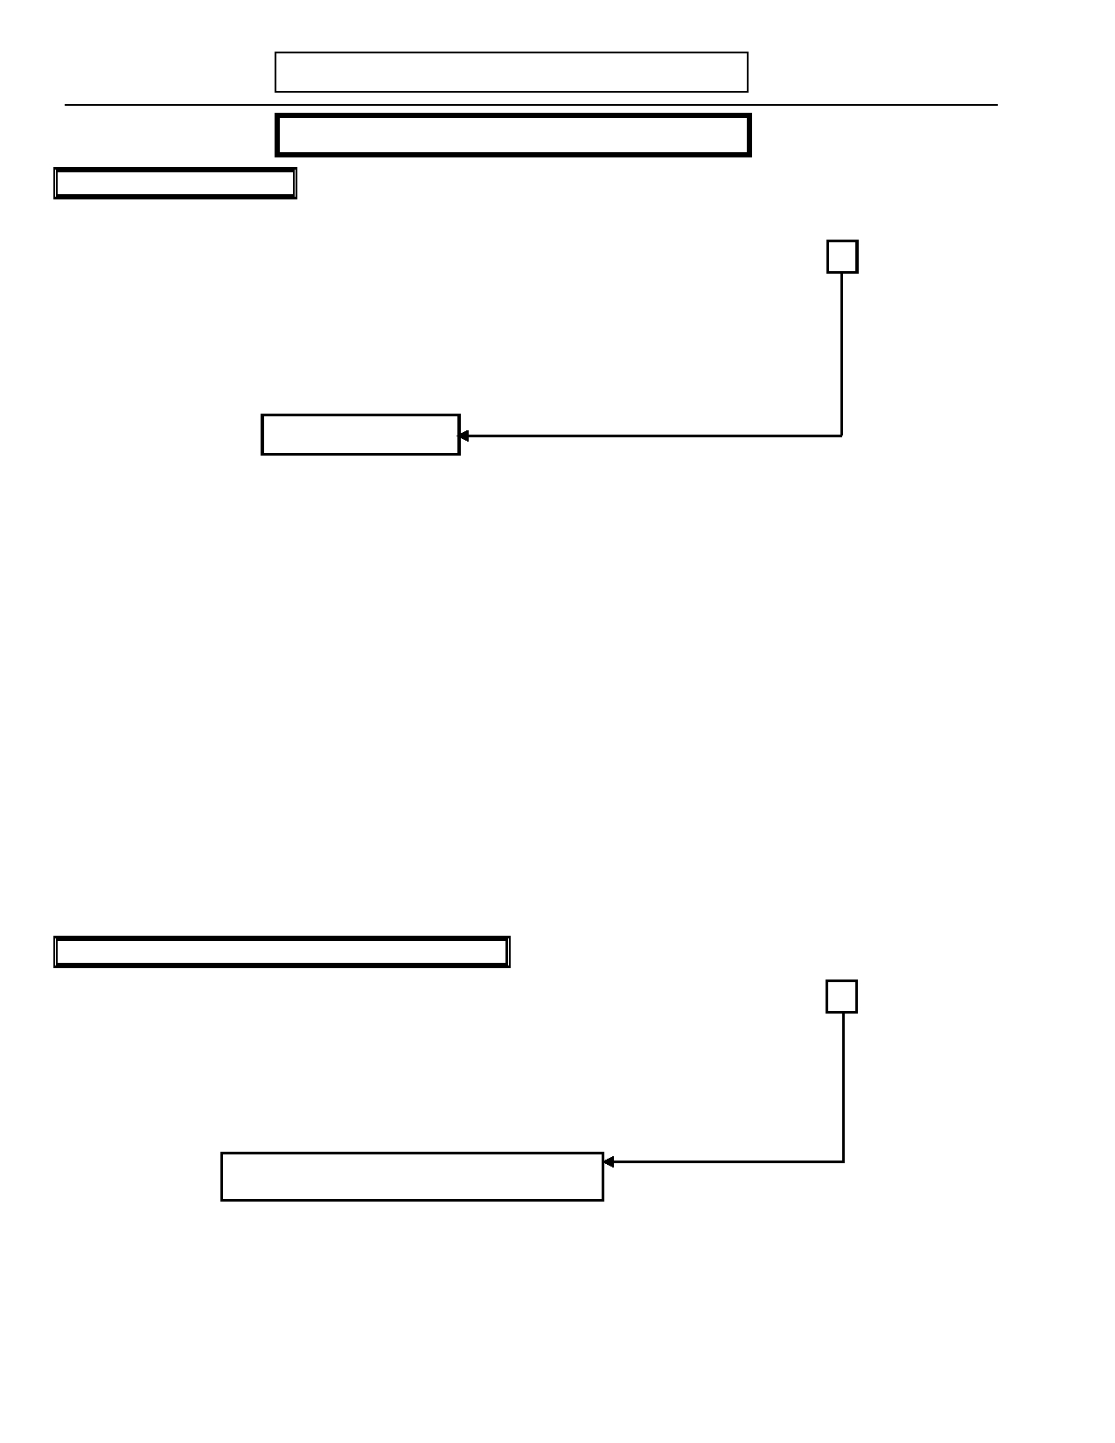
Page 104

VIOLENT BEHAVIOR
O. SUICIDAL BEHAVIOR

SITE OPTIONAL
DIGS 4.0 / BP
21-Jul-2005

No Yes Unk

13. When angry or irritable, were there times when you hurt someone so they required 0 1 9
medical attention?
If yes: Describe: ____________________________________________________

_________________________________________________________________

_________________________________________________________________

Skip to question 15

14. Did this behavior occur during an episode of…
(Circle all that apply)

…depression? 0 1 9

…bipolar (mixed state)? 0 1 9

…alcohol abuse? 0 1 9

…drug abuse? 0 1 9

…psychosis? 0 1 9

…other? 0 1 9
If yes: Specify: _______________________________________________

__________________________________________________________________

__________________________________________________________________

SELF-HARM WITHOUT SUICIDAL INTENT

15. Have you ever intentionally harmed yourself when you were upset but you had no 0 1 9
intention to commit suicide?

INTERVIEWER: You may ask "Did you ever cut (or burn, or scratch, or hit)
yourself, when no one was around, when the intent was to
cause pain or disfigurement, or to relieve emotional distress?"

Skip to P. Anxiety Disorders (page 107)
If yes: Describe: __________________________________________________

_________________________________________________________________

_________________________________________________________________


DIGS 4.0 / BP
21-Jul-2005
O. SUICIDAL BEHAVIOR

SITE OPTIONAL
Page 105

16. Why did you do that?
Describe: _________________________________________________________

_________________________________________________________________

17. INTERVIEWER: Circle YES in the ever column for any of the
following reasons offered; ask if these reasons
applied during most episodes of self-injury and Ever Most Episodes
code in the second column.
No Yes Unk No Yes Unk

17.a) As a cry for help 0 1 9 0 1 9

17.b) To relieve emotional distress 0 1 9 0 1 9

17.c) To demonstrate inner pain 0 1 9 0 1 9

17.d) To get back at someone else 0 1 9 0 1 9

17.e) To keep from feeling numb 0 1 9 0 1 9

17.f) Other 0 1 9 0 1 9
Describe: ____________________________________

____________________________________________

18. Did this behavior occur during an episode of…
(Circle all that apply)

…depression? 0 1 9

…bipolar (mixed state)? 0 1 9

…alcohol abuse? 0 1 9

…drug abuse? 0 1 9

…psychosis? 0 1 9

…other? 0 1 9
If yes: Specify: _______________________________________________

__________________________________________________________________

__________________________________________________________________


Page 106 DIGS 4.0 / BP
21-Jul-2005

This page left intentionally blank

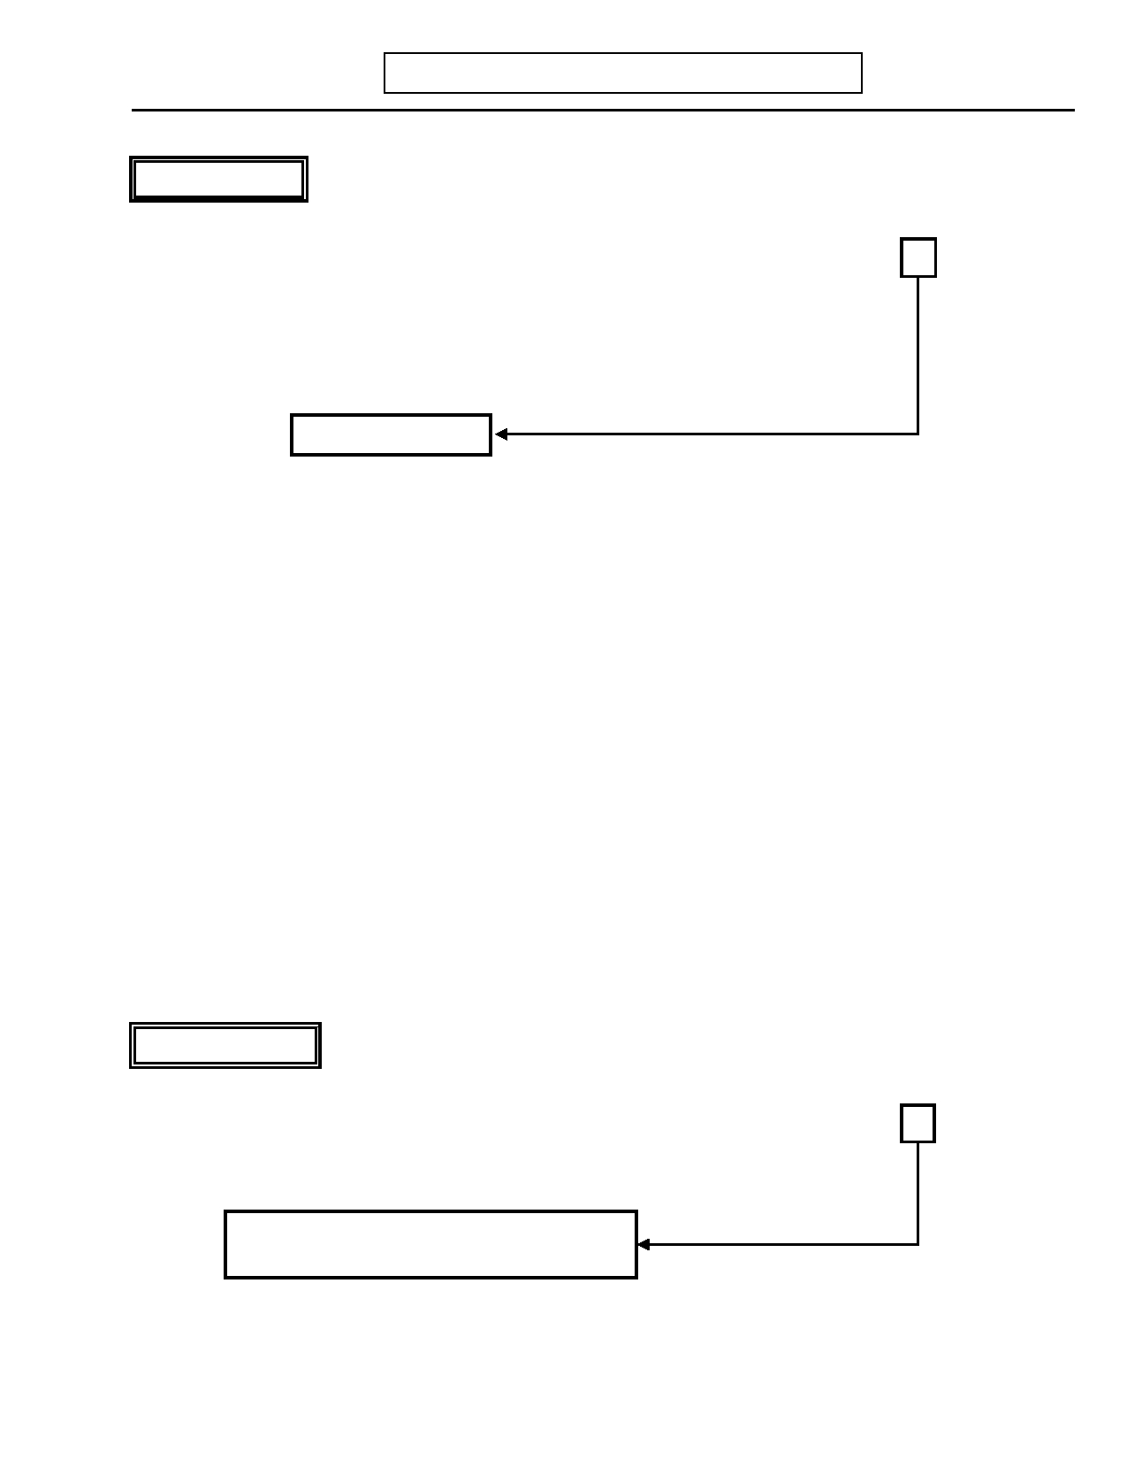
DIGS 4.0 / BP
21-Jul-2005
P. ANXIETY DISORDERS
Page 107

Now I would like to ask you some questions about certain situations and reactions you may have experienced.

OBSESSIONS
No Yes Unk

1. Have you ever been bothered by thoughts that did not make any sense, that kept 0 1 9
coming back to you even when you tried not to have them?
If unclear: Did these thoughts continue to bother you no matter how hard you tried
to get rid of them or ignore them?
(Probe: Examples might be like thinking your hands are dirty no matter how often
you wash them, or the repeated urge to curse in church, or feeling sure
many times that you have run someone over with your car.)
Skip to question 2
If yes:
1.a) What were they? _________________________________________________

_______________________________________________________________

1.b) What did you do about them? _______________________________________

_______________________________________________________________

1.c) INTERVIEWER: Code NO if thoughts, impulses, or images are simply 0 1 9
excessive worries about real-life problems.

1.d) INTERVIEWER: Code YES if the person tries to ignore or suppress such 0 1 9
thoughts or to neutralize them with some other thought or action.

1.e) INTERVIEWER: Does the person recognize that the obsessions are imposed 0 1 9
from within (not from without as in thought insertion)?

1.f) INTERVIEWER: Code YES if the thoughts appear to be unrelated to other 0 1 9
AXIS I disorders which are present (e.g., Major Depression,
Mania, Eating Disorders, Substance Abuse Disorder) or a general medical condition.

COMPULSIONS
No Yes Unk
2. Have you ever had to repeat some act over and over which you could not resist
repeating in order to feel less anxious-like washing your hands, counting things, or 0 1 9
checking things?
(Probe: Another example might be doing things in a certain order and having to
start over again if you get the order wrong.)
If No to questions 1 and 2, skip to question 11.
If No to question 2 only, skip to question 4.
If yes:
2.a) What was it you did over and over? __________________________________

_______________________________________________________________


Page 108
P. ANXIETY DISORDERS
DIGS 4.0 / BP
21-Jul-2005

No Yes Unk

2.b) What were you afraid would happen if you did not do it? _________________

_______________________________________________________________

2.c) INTERVIEWER: Code YES if the behavior is designed to neutralize or 0 1 9
prevent something unwanted, yet is not realistically
connected with what it is meant to neutralize or prevent.

2.d) INTERVIEWER: Code YES if the thoughts appear to be unrelated to other 0 1 9
AXIS I disorders which are present (e.g., Major Depression,
Mania, Eating Disorders, Substance Abuse Disorder) or a general medical condition.

3. Did you ever feel that these behaviors were excessive or unreasonable? 0 1 9

4. How much time did you spend doing (Compulsion) and or thinking about Minutes
(Obsession) each day?

5. Did you seek help from anyone, like a doctor or other professional? 0 1 9

6. Did you take any medication? 0 1 9
If yes: Specify. ____________________________________________________

_________________________________________________________________

7. What effect did these (Obsessions and/or Compulsions) have on your life?

___________________________________________________________________

___________________________________________________________________

___________________________________________________________________

7.a) Did these (Obsessions and/or Compulsions) bother you a lot? 0 1 9

7.b) Did they significantly interfere with how you managed your work, school, 0 1 9
household tasks, or social relationships?

7.c) Did these (Obsessions and/or Compulsions) cause you a lot of anxiety or 0 1 9
distress?

8. How old were you the first time you were bothered by (Obsession and/or Ons Age
Compulsion)?
9. How old were you the last time you were bothered by (Obsession and/or Rec Age
Compulsion)?

10. Did you ever have (Obsession and/or Compulsion) at some time other than within 0 1 9
two months of having (Depression/Psychosis)?

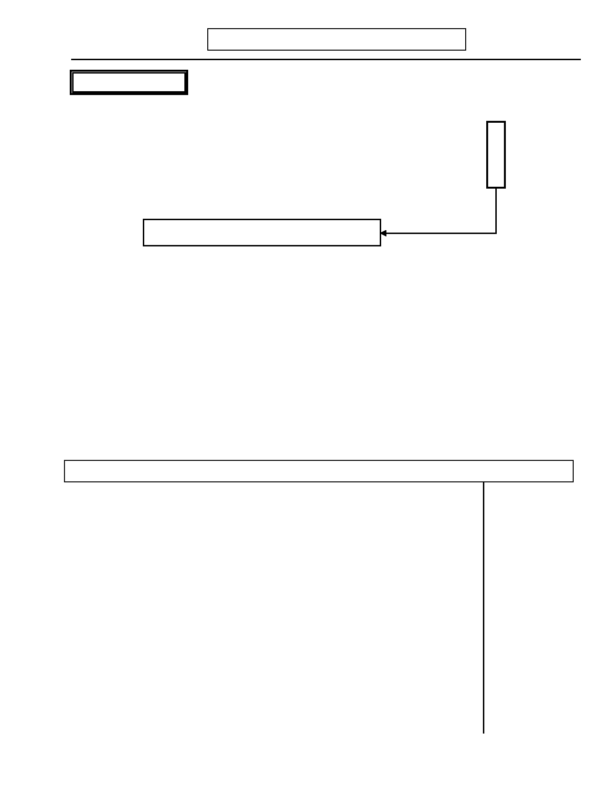
DIGS 4.0 / BP
21-Jul-2005

PANIC DISORDER
P. ANXIETY DISORDERS
Page 109

No Yes Unk

11. Have you ever had panic attacks or anxiety attacks when you suddenly felt very 0 1 9
frightened in situations that are usually not considered threatening?

11.a) If no: Have you ever had sudden, unexplained episodes of physical symptoms 0 1 9
such as rapid or loud heartbeat, feeling faint or lightheaded, sweating,
trembling? How about sudden, unexplained episodes of chest tightness or a
feeling of smothering?
Skip to Phobic disorder (question 28, page 112)

12. Describe spells and situations in which (Symptoms indicated above) happen: (Are
the attacks predictable?)
___________________________________________________________________

___________________________________________________________________

___________________________________________________________________

12.a) INTERVIEWER: Code NO if the attacks were always predictable. Code YES 0 1 9
if attacks were at least initially unexpected and seemed to be coming out of the blue even if they later became triggered by one particular stimulus.

12.b) INTERVIEWER: Code NO if the attacks were associated exclusively with 0 1 9
physical exertion or life-threatening situations.

INTERVIEWER: Complete the Ever column first then complete the Most Attacks column.
Ever Most Attacks
No Yes Unk No Yes Unk
13. During the attacks, did you experience any of the following
symptoms:

13.a) sudden rapid heartbeat, your heart pounding loudly? 0 1 9 0 1 9

13.b) choking? 0 1 9 0 1 9

13.c) sudden sweating? 0 1 9 0 1 9

13.d) sudden trembling or shaking? 0 1 9 0 1 9

13.e) hot flashes or chills? 0 1 9 0 1 9

13.f) chest tightness or pain? 0 1 9 0 1 9

13.g) shortness of breath, or a feeling of smothering? 0 1 9 0 1 9

13.h) dizziness, lightheadedness, feeling unsteady, or faint? 0 1 9 0 1 9

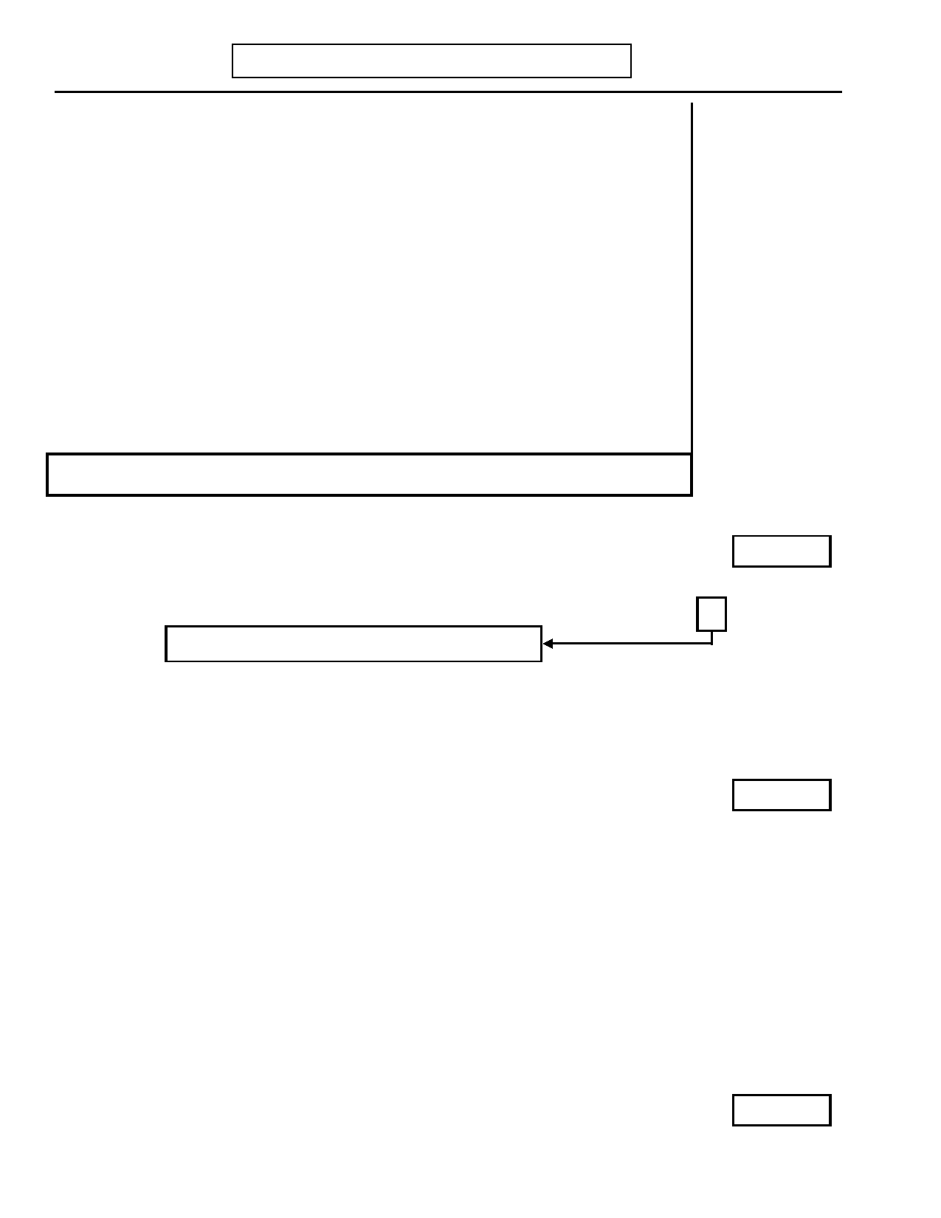
Page 110
P. ANXIETY DISORDERS

No

Ever
Yes Unk
DIGS 4.0 / BP
21-Jul-2005

Most Attacks
No Yes Unk

13.i) numbness or tingling? 0 1 9 0 1 9

13.j) fear of dying during the attack? 0 1 9 0 1 9

13.k) nausea or abdominal distress? 0 1 9 0 1 9

13.l) feeling that you or the world around you was strange or 0 1 9 0 1 9
unreal?

13.m) fear of going crazy or doing something uncontrolled? 0 1 9 0 1 9

EVER ONLY

INTERVIEWER: If less than two symptoms, skip to Phobic disorder (question 28, page 112).

INTERVIEWER: Return to top of question 13 to ask Which symptoms occurred during
most attacks?

MOST ATTACKS ONLY
14. Count positive symptoms from Most Attacks and enter here.

No

Yes

SX

Unk

15. Was there ever a time when four of these symptoms occurred together? 0 1 9
Skip to Phobic disorder (question 28, page 112)
If yes:

15.a) Did these symptoms develop and become intense within 10 minutes? 0 1 9

15.a.1) If yes: Did this happen more than once? 0 1 9
Attacks
16. How many panic attacks like this have you had?

No Yes Unk

17. Have you ever had at least four of these attacks within a four-week period? 0 1 9

18.a) After having an attack, have you been afraid of having another one? 0 1 9

18.b) Have you been worried about the implications or consequences of the attack? 0 1 9

18.c) Have you changed your behavior because of the attack? 0 1 9
If yes: Specify. ____________________________________________________

_________________________________________________________________

18.c.1) If Yes to question 18a, b, or c: How long did the fear, worry or change in your Weeks
behavior last?


DIGS 4.0 / BP
21-Jul-2005
P. ANXIETY DISORDERS
Page 111

No Yes Unk

19. Did you seek help from anyone, like a doctor or other professional? 0 1 9

20. Did you take any medications for these attacks? 0 1 9
If yes: Specify. ____________________________________________________

_________________________________________________________________

21. Did you only have the attacks when you were consuming a lot of caffeine or alcohol 0 1 9
or taking drugs like amphetamines?
If yes: Specify. ____________________________________________________

_________________________________________________________________

22.a) Did a doctor ever tell you that you had a medical condition (e.g., overactive thyroid?) 0 1 9
that might have been responsible for these attacks?

22.b) Did a doctor ever tell you that you had a psychiatric condition (e.g., phobias, 0 1 9
OCD, PTSD) that might have been responsible for these attacks?
Ons Age
23. How old were you the first time you had a panic attack?
Rec Age
24. How old were you the last time you had a panic attack?

None Some Most All Unk

25. What proportion of panic attacks have occurred during 0 1 2 3 9
depression?

26. What proportion of panic attacks have occurred during mania? 0 1 2 3 9

27. What proportion of panic attacks have occurred at other times? 0 1 2 3 9

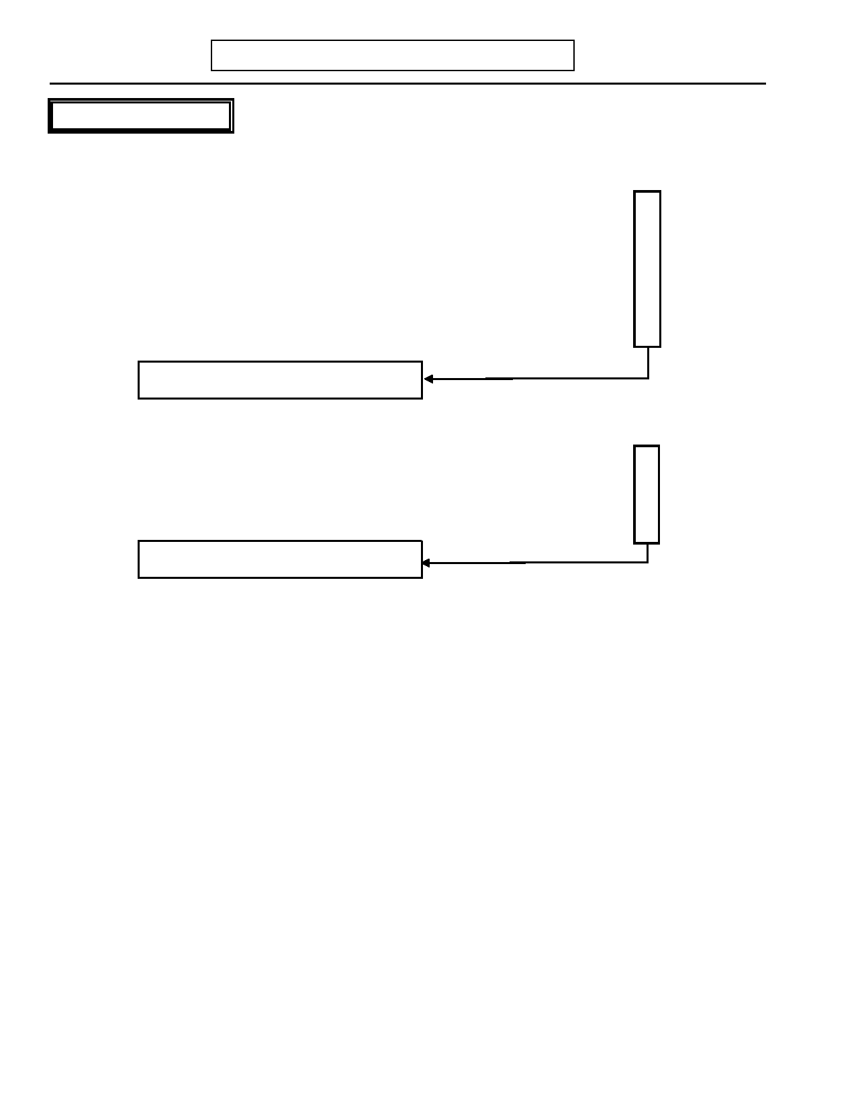
Page 112

PHOBIC DISORDER
P. ANXIETY DISORDERS
DIGS 4.0 / BP
21-Jul-2005

No Yes Unk
28. Have you ever been excessively afraid of…

28.a) Agoraphobic 0 1 9
…going out alone, being alone in a crowd or in stores, or being in places where
you feel you cannot escape or get help?

28.b) Social 0 1 9
…doing certain things in front of people like speaking, eating, or writing?

28.c) Simple/Specific 0 1 9
…certain animals, heights, or being closed in?
Skip to Q. Eating Disorders (page 115)

29. Did you go out of your way to avoid...

29.a) Agoraphobic fear(s)? 0 1 9

29.b) Social fear(s)? 0 1 9

29.c) Simple/Specific fear(s)? 0 1 9
Skip to Q. Eating Disorders (page 115)

30.

Describe Fear(s) by category. If avoidance has developed, note what motivated the person to avoid the situation (e.g., fear of sudden development of a symptom attack,
embarrassment, or humiliation). For Agoraphobia, note whether either a limited
symptom attack or panic attack has occurred in the past or whether there is only a fear of developing an attack.

30.a) Agoraphobic Fear(s): ____________________________________________

___________________________________________________________________

___________________________________________________________________

30.a.1) INTERVIEWER: Did the avoidant behavior begin during or just after 0 1 9
a panic attack?

30.b) Social Fear(s): __________________________________________________

___________________________________________________________________

___________________________________________________________________

30.b.1) INTERVIEWER: Did the avoidant behavior begin during or just after 0 1 9
a panic attack?


DIGS 4.0 / BP
21-Jul-2005
P. ANXIETY DISORDERS
Page 113

No Yes Unk

30.c) Simple/Specific Fear(s): __________________________________________

___________________________________________________________________

___________________________________________________________________

30.c.1) INTERVIEWER: Did the avoidant behavior begin during or just after 0 1 9
a panic attack?

Agoraphobic Social Simple/Specific
No Yes Unk No Yes Unk No Yes Unk
INTERVIEWER: For each positive fear, ask
questions 31-41.

31. Did you almost always become anxious when 0 1 9 0 1 9 0 1 9
you were experiencing (Feared
object/situation)?

32. Were you more anxious than you should have 0 1 9 0 1 9 0 1 9
been?

33. INTERVIEWER: Code YES if there is 0 1 9 0 1 9 0 1 9
persistent fear of an object, activity, or
situation which the subject tends to avoid or else endures with intense anxiety.

33.a) Were you greatly upset about having 0 1 9 0 1 9 0 1 9
the fear?

34. Because of (Feared object/situation), was 0 1 9 0 1 9 0 1 9
there a difference in your social life or in
how you managed your work, school, or
household tasks?

If yes: Specify: ______________ ______________ ______________

______________ ______________ ______________

______________ ______________ ______________

______________ ______________ ______________

35a. Agoraphobia only 0 1 9
INTERVIEWER: Code YES if the fear is
unrelated to substance use, medication
effects or a preexisting medical disorder.

35b. Social Phobia only 0 1 9
INTERVIEWER: Code YES if the fear is
unrelated to substance use, medication
effects, or a preexisting medical or psychiatric disorder.

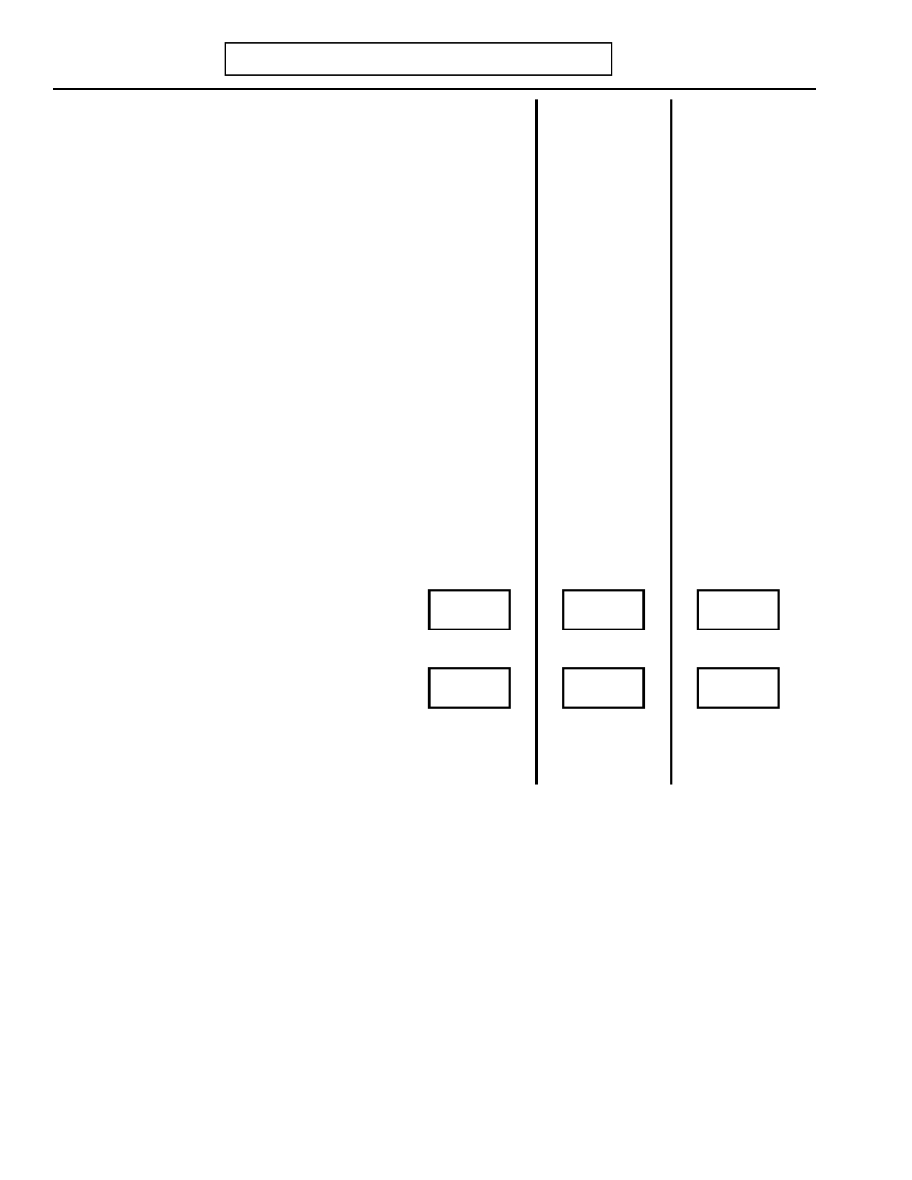
Page 114
P. ANXIETY DISORDERS

Agoraphobic
No Yes Unk

No

Social
Yes Unk
DIGS 4.0 / BP
21-Jul-2005

Simple/Specific No Yes Unk

35c. Simple/Specific Phobia only 0 1 9
INTERVIEWER: Code YES if the
symptoms are not better explained by
another disorder (e.g. OCD, PTSD,
Separation Anxiety, Panic Disorder).

36. Did you seek help from anyone, like a doctor 0 1 9 0 1 9 0 1 9
or other professional?

37. Did you take any medications? 0 1 9 0 1 9 0 1 9
If yes: Specify: ______________ ______________ ______________

______________ ______________ ______________

______________ ______________ ______________

______________ ______________ ______________

38. Did you ever have this problem at some time 0 1 9 0 1 9 0 1 9
other than two months before or after having
(Depression/Psychosis)?

Ons Age Ons Age Ons Age 39. How old were you the first time you had this
problem?

Rec Age Rec Age Rec Age 40. How old were you the last time you had this
problem?

41. Social Phobia only 0 1 9
If question 40 is 17 or less, Code YES if phobia lasted at least 6 months.

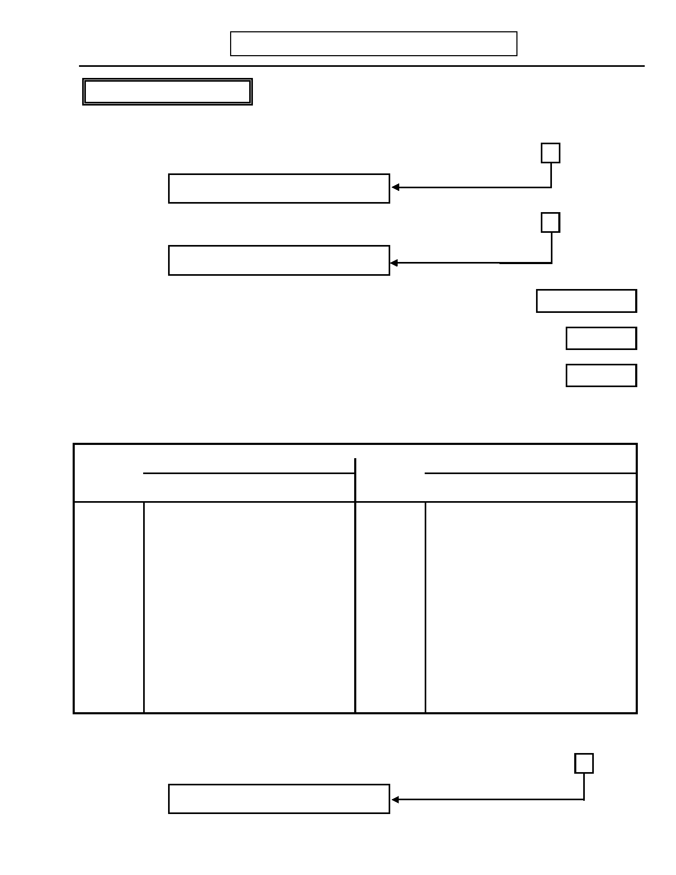
DIGS 4.0 / BP
21-Jul-2005

ANOREXIA NERVOSA
Q. EATING DISORDERS
Page 115

Now, I would like to ask you some questions about your eating habits and your weight.
No Yes Unk

1. Was there ever a time when you weighed much less than other people thought you 0 1 9
ought to weigh?
Skip to Bulimia (question 14, page 116)

2. At that time, had you lost a lot of weight on purpose or was it while you were growing 0 1 9
up and you kept your weight down on purpose?
Skip to Bulimia (question 14, page 116)
Pounds
3. What was your lowest weight at that time?
Inches
4. How tall were you? Record response:________________
Age
5. How old were you?
Sm Med Lrg

6. INTERVIEWER: Note body frame. 1 2 3

WEIGHT CRITERION FOR ANOREXIA (15% BELOW EXPECTED WEIGHT)
MEN WOMEN
Small Medium Large Small Medium Large
Height Frame Frame Frame Height Frame Frame Frame
5'2" 99 105 113 4'10" 80 86 95
5'3" 101 108 116 4'11" 83 88 97
5'4" 104 111 119 5'0" 85 91 100
5'5" 107 113 122 5'1" 87 94 102
5'6" 109 116 125 5'2" 91 96 104
5'7" 112 119 129 5'3" 93 99 108
5'8" 116 124 133 5'4" 95 102 110
5'9" 119 127 136 5'5" 97 104 113
5'10" 124 130 139 5'6" 101 109 117
5'11" 127 134 144 5'7" 104 112 120
6'0" 130 138 148 5'8" 108 116 124
6'1" 134 142 152 5'9" 111 119 127
6'2" 137 145 156 5'10" 114 122 131
6'3" 141 150 160 5'11" 118 126 135
6'4" 144 154 164 6'0" 121 129 138
* For women 18 to 25 years old, subtract one pound for each year under 25.
No Yes Unk

6.a) INTERVIEWER: Is lowest weight (question 3) more than table entry for height, 0 1 9
gender, and body?
Skip to Bulimia (question 14, page 116)

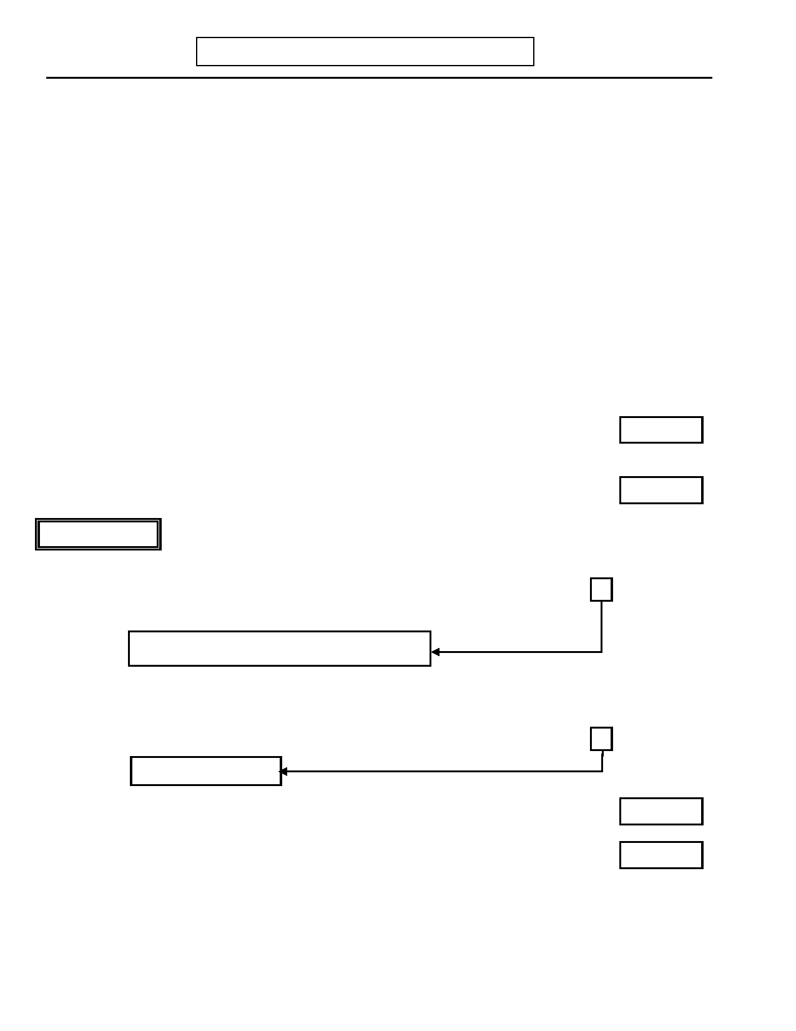
Page 116
Q. EATING DISORDERS
DIGS 4.0 / BP
21-Jul-2005

No Yes Unk

7. At that time did you still feel fat or did you see yourself as too fat in some ways? 0 1 9

8. Were you still very much afraid that you could become fat? 0 1 9

9. If female: Did your periods stop even when you were not pregnant? 0 1 9

9.a) If yes: Did you miss at least three cycles in a row? 0 1 9

10. Was there a medical disorder causing your weight loss? 0 1 9

If yes: Specify: ______________________________________________________

11. Did your lowered weight follow the use of diet pills, amphetamines, cocaine, or other 0 1 9
substances?

If yes: Specify: ______________________________________________________

12.

13.

How old were you the first time your weight was below __?
(See weight criterion table for loss of 15%.)

How old were you the last time your weight was below ___?
(See weight criterion table for loss of 15%.)

BULIMIA

Ons Age

Rec Age

No Yes Unk

14. Has there been a time in your life when you went on food binges (i.e., rapid 0 1 9
consumption of a large amount of food in a discrete period of time, usually less than
two hours)?
Skip to R. Pathological Gambling (page 119)

15. During these binges were you afraid you could not stop eating, or that your eating 0 1 9
was out of control?

16. Did you have eating binges as often as twice a week for at least three months? 0 1 9

Skip to question 19
Ons Age
17. How old were you when you first binged regularly?
Rec Age
18. How old were you the last time you binged regularly?

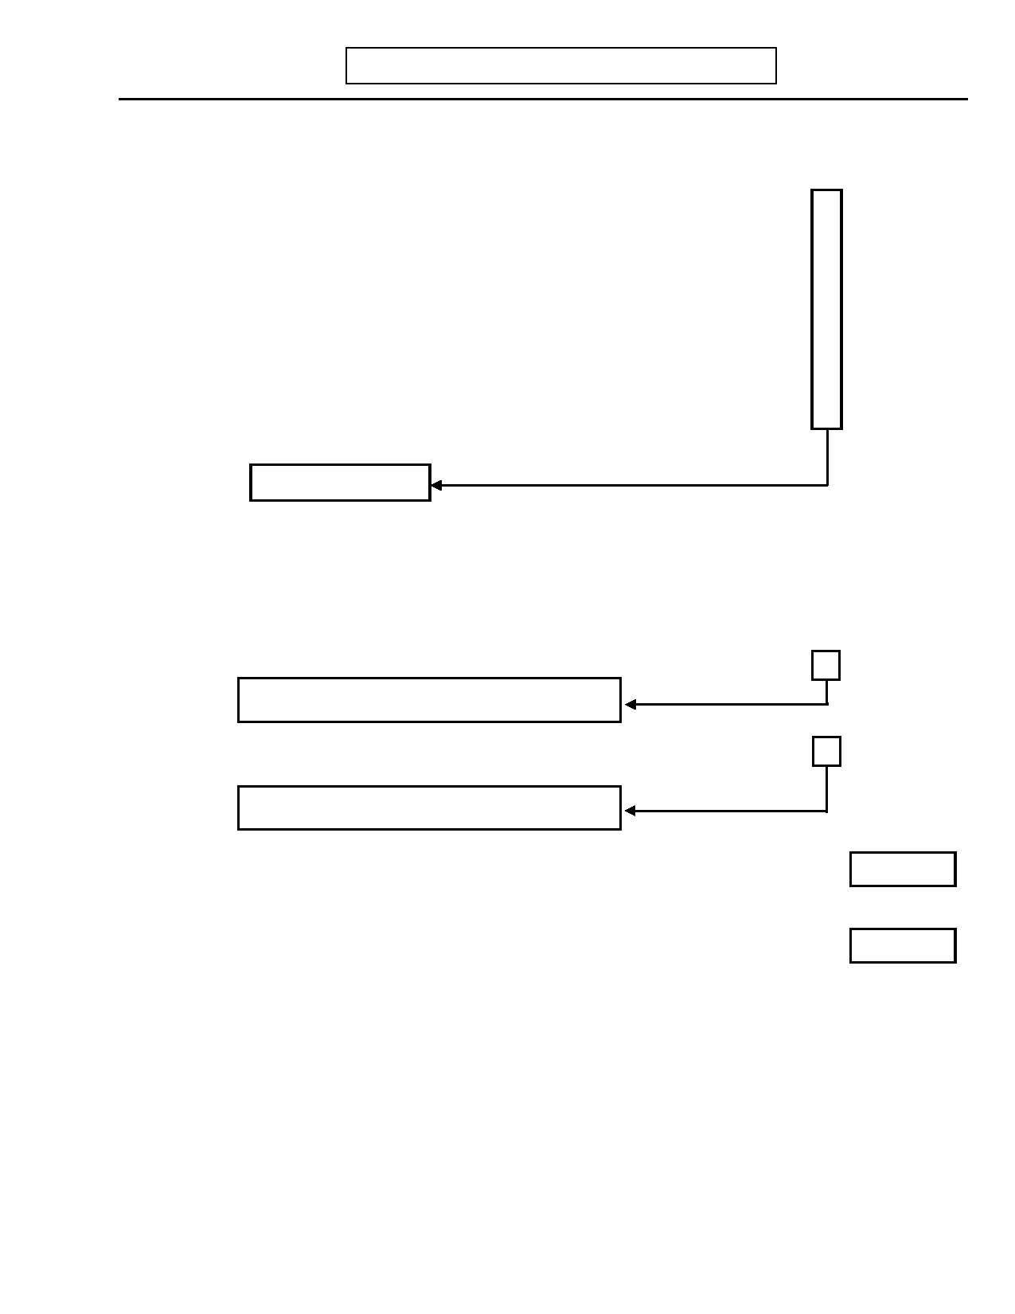
DIGS 4.0 / BP
21-Jul-2005
Q. EATING DISORDERS
Page 117

No Yes Unk
19. Compensatory Behavior
Did you do anything to make up for eating so much, perhaps like...

19.a) …making yourself vomit? 0 1 9

19.b) …taking laxatives or diuretics? 0 1 9

19.c) …strictly dieting? 0 1 9

19.d) …fasting? 0 1 9

19.e) …exercising a lot? 0 1 9

19.f) …other? 0 1 9
If yes: Specify: _______________________________________________

Skip to question 20

19.g) Did you do (Compensatory behavior/s) as often as twice a week for at least 3 0 1 9
months?

20. At this time when you went on food binges were you a lot more concerned about your 0 1 9
weight and/or shape than most people your age?

21. INTERVIEWER: Are questions 16 and 19g both YES? 0 1 9
Skip to R. Pathological Gambling (page 119)

22. Did these episodes of binge eating and (Compensatory behaviors) both occur on 0 1 9
average twice a week for at least 3 months?
Skip to R. Pathological Gambling (page 119)
Ons Age
23. How old were you when you first binged and (Compensatory behavior/s) regularly?

Rec Age
24. How old were you the last time you binged and (Compensatory behavior/s) regularly?

No Yes Unk

25. INTERVIEWER: If subject appears to meet criteria for Anorexia Nervosa, ask: Did 0 1 9
these episodes of binge eating and (Compensatory behaviors)
occur at any time other than during an anorexia episode?

Page 118 DIGS 4.0 / BP
21-Jul-2005

The page left intentionally blank

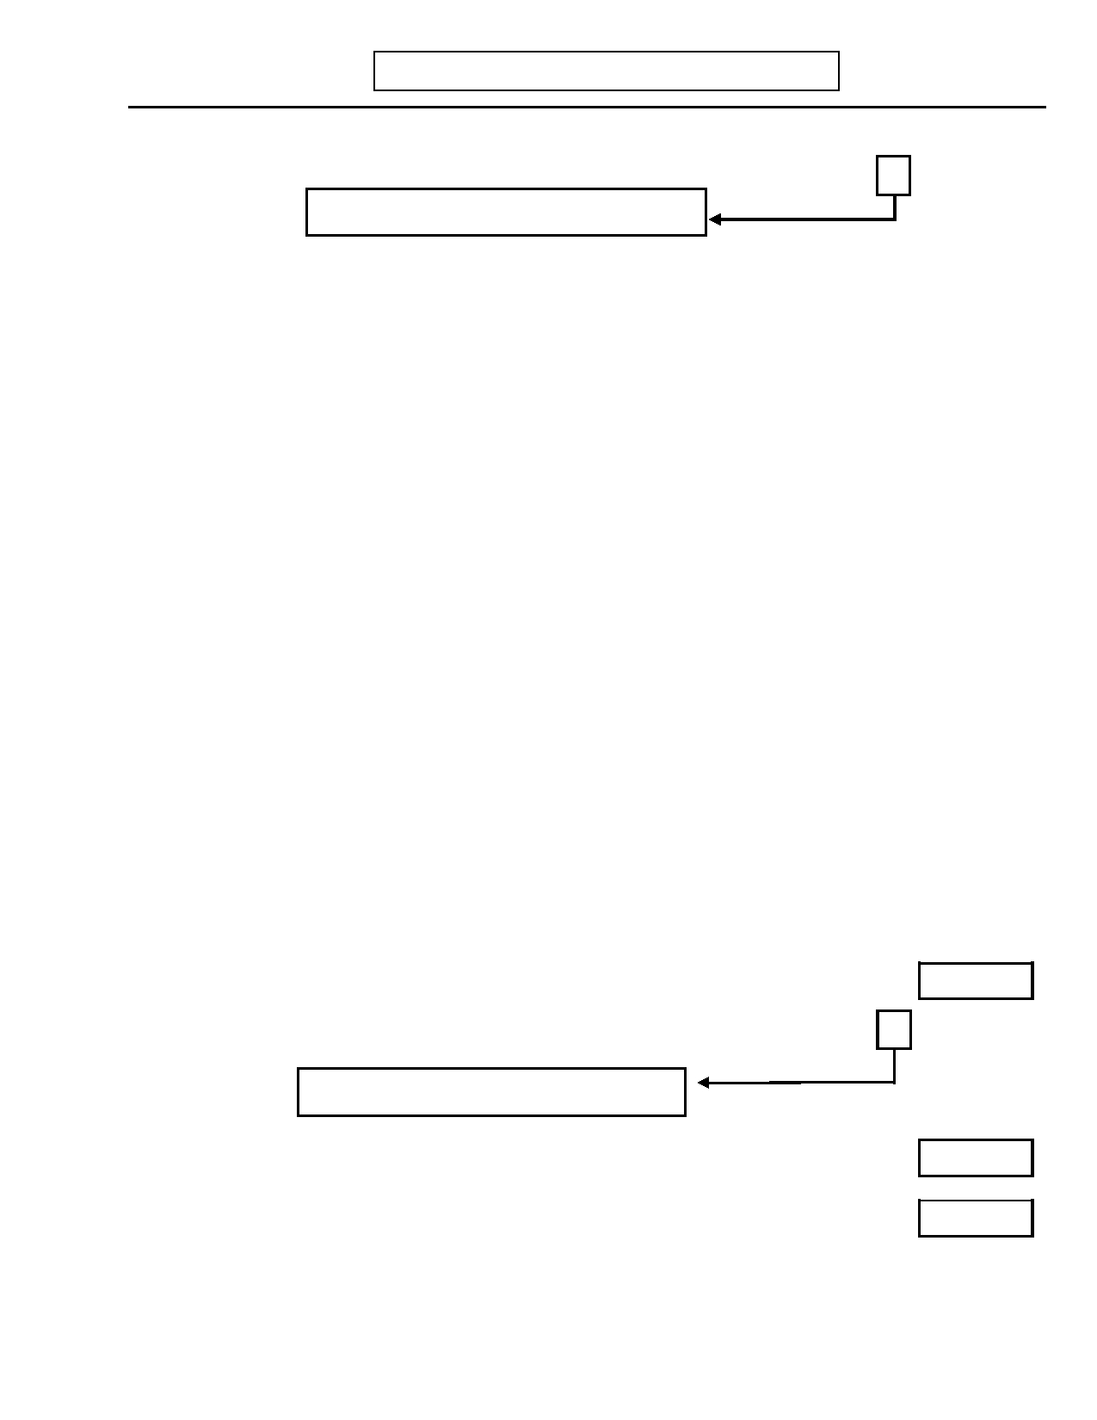
DIGS 4.0 / BP
21-Jul-2005
R. PATHOLOGICAL GAMBLING
Page 119

No Yes Unk

1. Have you ever gambled or bet too often or too much? 0 1 9
Skip to S. Antisocial Personality (page 121)

2. Did/do you frequently gamble larger amounts or over a longer period of time than 0 1 9
you intend?

3. Did/do you need to increase the size or frequency of the bets to achieve excitement? 0 1 9

4. Did/do you become restless or irritable if you are unable to gamble? 0 1 9

5. Did/do you sustain repeated losses by trying to win back losses? 0 1 9

6. Were/are you frequently preoccupied with gambling? 0 1 9

7. Have you made repeated attempts to stop or reduce your gambling? 0 1 9

8. Have you frequently neglected family, social, or job obligations when you gamble? 0 1 9

9. Has gambling ever caused you to skip important social, job, or recreational 0 1 9
activities?

10. Have you continued to gamble in spite of debts and/or other consequences? 0 1 9

11. Did/do you continue to gamble to escape from feelings such as sadness or depression, 0 1 9
helplessness, guilt, anxiety?

12. Have you committed illegal acts such as forgery, fraud, theft, or embezzlement to 0 1 9
finance gambling?

13. Did/do you rely on others to bail you out of financial crises caused by gambling? 0 1 9

14. Did/do you lie to family members, therapist or others to conceal the extent of your 0 1 9
gambling?
SX
15. INTERVIEWER: Count positive symptoms and enter here.

15.a) INTERVIEWER: Is question 15 four or more? 0 1 9

Skip to S. Antisocial Personality (page 121)
Ons Age
16. How old were you when you first gambled heavily?
Rec Age
17. How old were you the last time you gambled heavily?

18. Have you ever sought help for a problem with gambling? 0 1 9

19. Did you have these problems other than during a mania? 0 1 9

Page 120 DIGS 4.0 / BP
21-Jul-2005

This page left intentionally blank

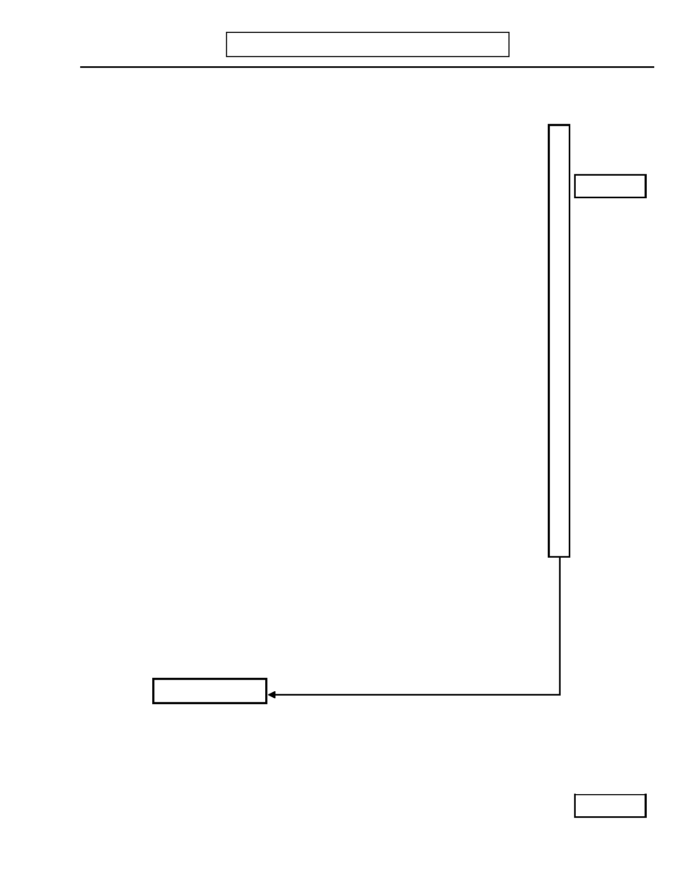
DIGS 4.0 / BP
21-Jul-2005
S. ANTISOCIAL PERSONALITY
Page 121

Now I would like to ask you some questions about when you were younger.
No Yes Unk
1. Before you were 15 years old...

1.a.1) …did you often skip school? 0 1 9

If yes: Ons Age
1.a.2) …how old were you the first time?

1.b) …did you run away from home overnight more than once or did you run away 0 1 9
from home without returning?

1.c) …did you often start physical fights? 0 1 9

1.d) …did you more than once use a weapon like a club, gun, or knife in a fight? 0 1 9

1.e) …did you more than once steal things or did you more than once forge anyone's 0 1 9
signature on a check or credit card?

1.f) …were you often mean to animals including pets or did you ever hurt an animal 0 1 9
on purpose?

1.g) …did you physically hurt another person on purpose (other than in a fight)? 0 1 9

1.h) …did you ever set fires when you were not supposed to? 0 1 9

1.i) …did you ever destroy someone's property on purpose (other than fire setting)? 0 1 9

1.j) …did you often bully, threaten, or intimidate others? 0 1 9

1.k) …did you ever break into someone's house, building or car? 0 1 9

1.l) …did you often tell lies? 0 1 9

If yes: Why did you tell a lot of lies? ___________________________________

_____________________________________________________________

INTERVIEWER: Code YES if intent was to obtain goods or favors or to
avoid obligations.
Code NO if subject lied to avoid physical or sexual abuse.

Skip to question 2

1.m) …did you ever force someone to have sex with you? 0 1 9

1.n) …did you ever take money or property from someone else by threatening them or 0 1 9
using force, like snatching a purse or robbing someone?
SX
2. INTERVIEWER: Count positive symptoms (1a-n) and enter here.


Page 122
S. ANTISOCIAL PERSONALITY
DIGS 4.0 / BP
21-Jul-2005

No Yes Unk

2.a) INTERVIEWER: Is question 2 three or more? 0 1 9

Skip to AA. ADHD (page 125)
Age
3. How old were you the first time you (list positive symptoms in question 1)?

4. Because of (positive behaviors) was there a difference in your social life or in how 0 1
you managed your school, work, or household chores?

If yes: Specify. ____________________________________________________

_________________________________________________________________

INTERVIEWER: For questions 5-15, probe as necessary for subjects with evidence of Mania,
Schizophrenia, or Substance Use Disorders:
"Was this (Behavior) always due to your use of alcohol/drugs?"
If yes: Code as 2
"Was this (Behavior) always during an episode of mania or psychosis?"
If yes: Do not count as positive episodes that are solely related to episodes of mania or psychosis.
Only
During
Alc/
No Yes Drugs
Now I am going to ask you questions about yourself after the age of 15.

5. In the last five years, have you been unemployed for six months or more, other than 0 1 2
when you were in school, sick, on strike, laid off, a full-time housewife, retired, or
in jail?

6. When you were working, were you often absent from work when you were not ill or 0 1 2
did you repeatedly miss work because you did not want to go?

INTERVIEWER: Code NO if absence due to illness in family.

7. Since you were 15, have you quit three or more jobs without having another job 0 1 2
lined up?

8. Since you were 15, have you repeatedly done things that you could have been 0 1 2
arrested for like stealing, or engaging in illegal occupations such as selling drugs
or stolen goods, destroying property, or harassing others?

9. Since you were 15, have you often thrown things, hit or physically attacked anyone 0 1 2
(including your wife/husband, partner, or children)?

10. Since you were 15, have you often failed to pay back debts that you owed like 0 1 2
credit card charges or loans, or have you failed to take care of other financial
responsibilities like child support or providing support for other dependents?

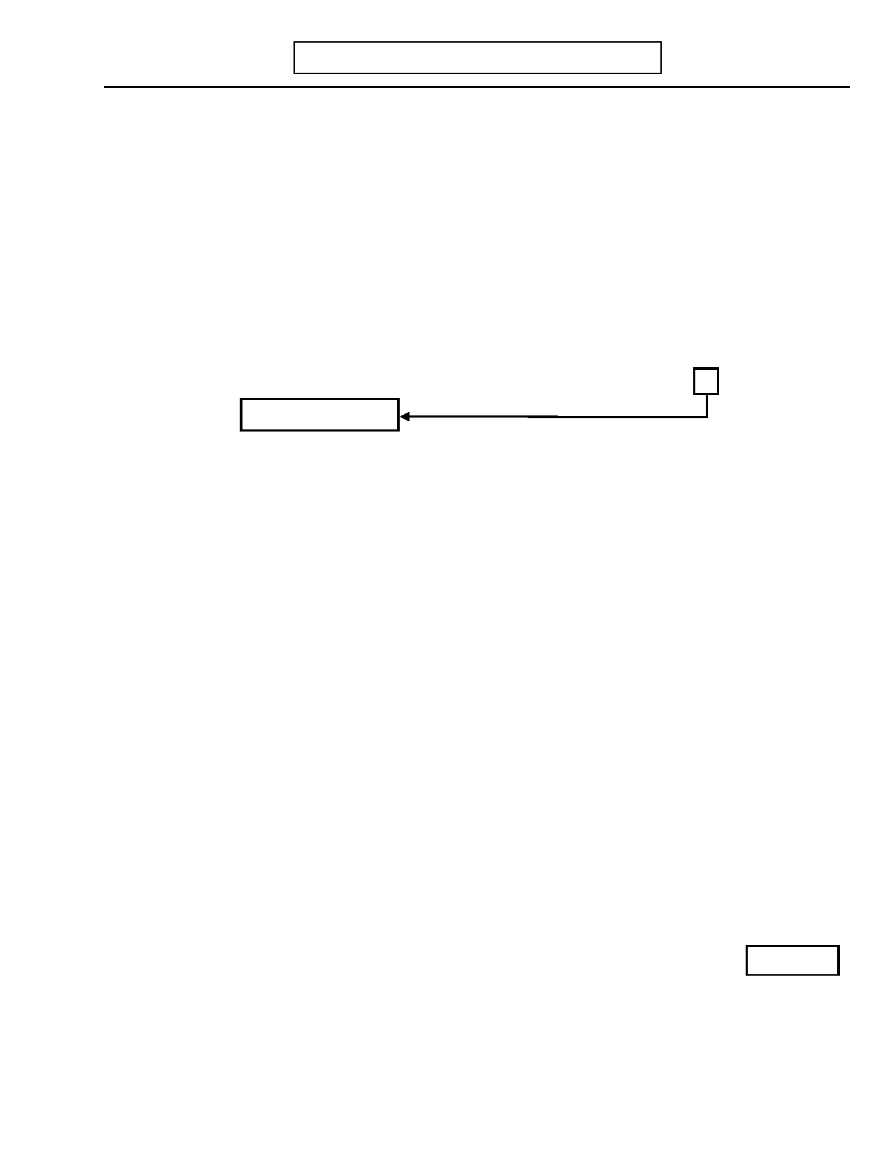
DIGS 4.0 / BP
21-Jul-2005
S. ANTISOCIAL PERSONALITY

No

Yes
Page 123

Only
During
Alc/
Drugs

11. Since you were 15, have you ever traveled from place to place without knowing 0 1 2
where you were going to stay or work or have you had no regular place to live for
a month or more?

12. Since you were 15, have you frequently lied, used an alias, or conned others for 0 1 2
personal profit or pleasure?

13. Since you were 15, have you received three or more speeding tickets or have you 0 1 2
often driven while intoxicated?

14. Since you were 15, have you ever been responsible for children? 0 1 2
Skip to question 16

15. Since you were 15, has anyone ever said that you were not taking proper care of a
child of yours (or a child you were responsible for) like...

15.a) …not giving the child enough food? 0 1 2

15.b) …not keeping the child clean resulting in his/her illness? 0 1 2

15.c) …not getting medical care when the child was seriously ill? 0 1 2

15.d) …leaving the child with neighbors because you were not able to take care of 0 1 2
the child at home (except for babysitting)?

15.e) …not arranging for anyone to take care of the child when you were away? 0 1 2

15.f) …running out of money to take care of the child more than once because you 0 1 2
spent the money on yourself?

16. Since you were 15, have you ever been faithful to one person in a romantic or love 0 1
relationship for one year or longer; that is, you did not have an affair or any
one-night stands during that time?

INTERVIEWER: Code YES (for positive symptom) if subject has never sustained
a totally monogamous relationship for more than one year.

17. Did you feel it was okay for you to have stolen, hurt, hit, destroyed, or (List other 0 1
antisocial acts from questions 8-13)?
Rec Age
18. How old were you the last time you did any of these things?

Page 124 DIGS 4.0 / BP
21-Jul-2005

This page left intentionally blank

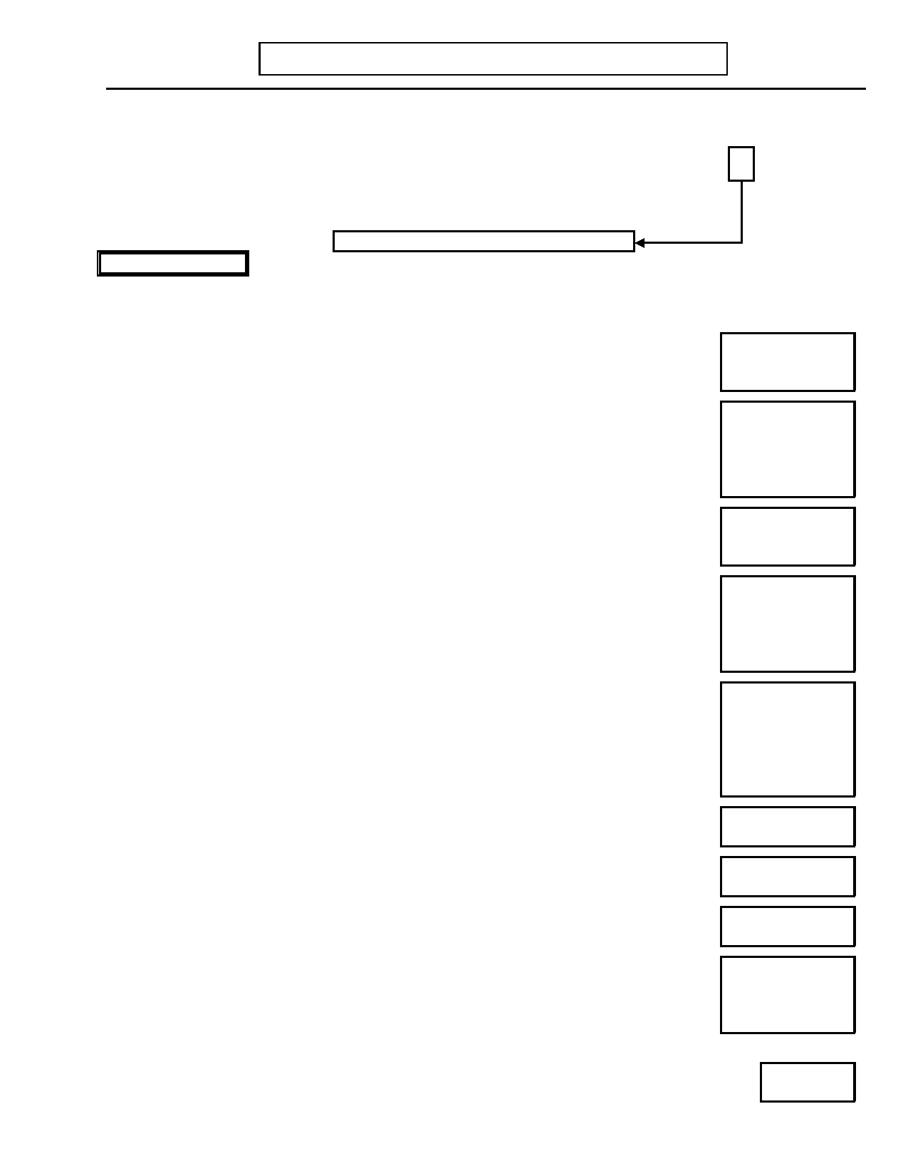
DIGS 4.0 / BP
21-Jul-2005
AA. ATTENTION DEFICIT / HYPERACTIVITY DISORDER
Page 125

Now I am going to ask you some questions about when you were younger.
No Yes Unk

1. When you were age 13 or younger, was there ever a time when you had a lot of 0 1 9
trouble paying attention in school or a time when little distractions made it very hard
for you to keep your mind on what you were doing?

Skip to question 12 (page 126)
INATTENTION
When you were age 13 or younger, was there ever a six month period when you often did
any of the following:

2.

3.

4.

5.

6.

7.

8.

9.

10.

Did you make a lot of careless mistakes at school, like not reading the instructions, or
leaving questions blank by accident?

Were you easily distracted when trying to complete a task or while playing a game?

3.a) Did you have trouble sticking to one activity or when you were playing or doing
one thing, did you often stop what you were doing because you'd think of
something else you'd rather do?
Did you "tune people out" or did your parents or teachers complain that you didn't
listen to them when they talked to you?

Did you often leave projects incomplete or did you have a hard time following
through on things?

5.a) Did your parents or teachers complain that you didn't follow instructions?

Did you often have trouble organizing tasks and activities or did other people tell you
that you were disorganized?

6.a) Was your desk or locker at school a mess, to the point you had difficulty finding
the things you needed or did your teachers complain that your assignments
were messy and disorganized?
Did you dislike tasks or activities that required a lot of attention?

Did you lose things a lot like homework assignments or things around your home?

Were you easily distracted by things going on around you?

Did you often leave your homework at home or leave things outside by accident?

10.a) Were you often forgetful throughout your day or did other people tell you that
you were forgetful?

0

0

0

0

0

0

0

0

0

0

0

0

0

1

1

1

1

1

1

1

1

1

1

1

1

1

SX

9

9

9

9

9

9

9

9

9

9

9

9

9

11. INTERVIEWER: Count number of boxes with at least one Yes response in questions 2-10
and enter here.

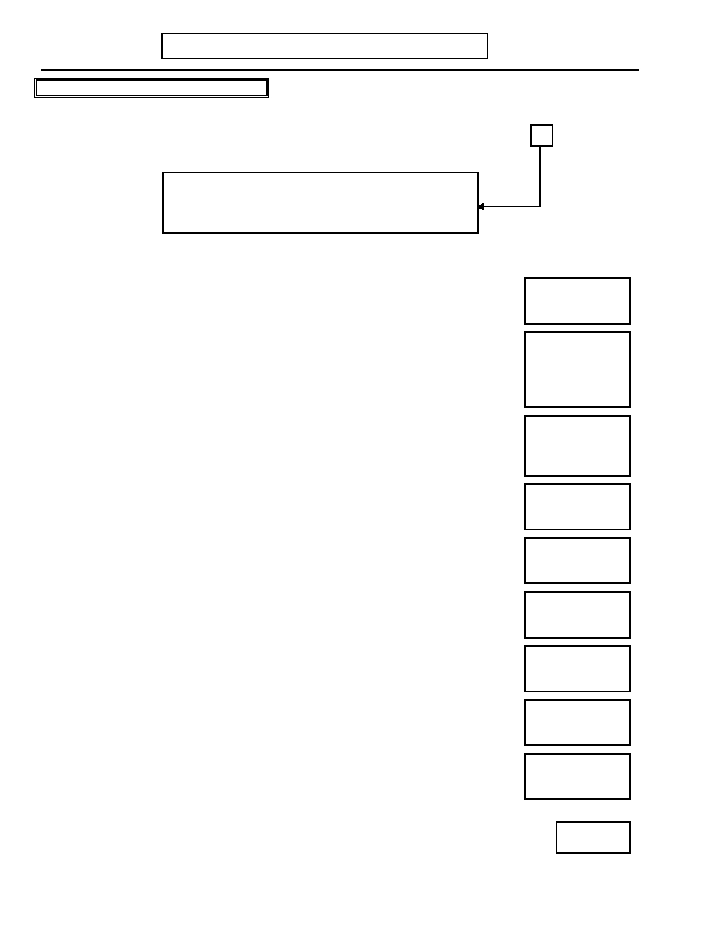
Page 126
AA. ATTENTION DEFICIT / HYPERACTIVITY
DIGS 4.0 / BP
21-Jul-2005

HYPERACTIVITY / IMPULSIVITY
No Yes Unk
12. When you were age 13 or younger, was there ever a time when you had a lot of
difficulty staying seated when you were supposed to or a time when you got into 0 1 9
trouble because you didn't think before you acted?

If BOTH Q.1 and Q.12 are NO, skip to T. Global
Assessment Scale (page 129).
If Q.1 is YES and Q.12 is NO, skip to question 23 (page
127.
When you were age 13 or younger, was there ever a six month period when you often did
any of the following:

13.

14.

15.

16.

17.

18.

19.

20.

21.

Did you have a hard time keeping your arms and legs still or did people often tell you
to sit still, to stop moving, or to stop squirming in your seat?

Did you often leave your seat when you were not supposed to in school or in other
places where being seated was required?

14.a) If yes: Did you often get into trouble for this?

Did your parents often have to remind you to walk instead of run when you were out
together or did your parents or teachers complain about you climbing things you
shouldn't?

Did you have a hard time playing quietly or did your parents or teachers often tell you
to quiet down when you were playing?

Was it hard for you to slow down or stay in one place for very long, or did people tell
you to slow down a lot?

Did people say you talked too much or did you get in trouble at school for talking
when you weren't supposed to?

Did you talk out of turn at home or did you sometimes call out the answers before you
were called on at school?

Was it hard for you to wait your turn in games or in line at the water fountain or in
the cafeteria?

Did your parents, teachers, or kids you knew complain that you cut them off when they
were talking?

0

0

0

0

0

0

0

0

0

0

1

1

1

1

1

1

1

1

1

1

SX

9

9

9

9

9

9

9

9

9

9

22. INTERVIEWER: Count number of boxes with at least one Yes response in questions 13-
21 and enter here.


DIGS 4.0 / BP
21-Jul-2005
AA. ATTENTION DEFICIT / HYPERACTIVITY DISORDER
Page 127

No Yes Unk

23. INTERVIEWER: Is the total for either question 11 or 22 six or more? 0 1 9

Skip to T. Global Assessment Scale (page 129)

24. Did you have any of these experiences to the point it caused problems for you and/or 0 1 9
your family before you were seven years old?

25. If yes: Did these behaviors cause problems for you in at least two areas of your life 0 1 9
(like at school and at home)?

25.a) INTERVIEWER: If NO to question 25, is there any other evidence of
clinically significant impairment in social, academic, or occupational 0 1 9
functioning?

26. How did these behaviors impact your functioning? Specify:____________________

_____________________________________________________________________

_____________________________________________________________________

_____________________________________________________________________

27. Did you seek or receive help from a doctor or other professional for these problems? 0 1 9

27.a) If yes: Did you receive medication? 0 1 9

Specify:_____________________________________________________________

Age
28. How old were you the last time you had any of these experiences to the point that it caused
problems for you and/or your family?


Page 128
AA. ATTENTION DEFICIT / HYPERACTIVITY

This page left intentionally blank.
DIGS 4.0 / BP
21-Jul-2005


DIGS 4.0 / BP
21-Jul-2005
T. GLOBAL ASSESSMENT SCALE (GAS)
Page 129

INTERVIEWER: Rate subject's lowest level of functioning during the past month (or at time of admission if hospitalized). Rate actual functioning regardless of treatment or prognosis.
No Yes

1. Is the subject hospitalized? 0 1
Current Episode GAS
2. GAS: At worst point during current episode
Past Month GAS
3. GAS: During past month
Score Criteria

100
|
91

90
|
81

80
|
71

70
|
61

60
|
51

50
|
41

40
|
31

30
|
21

20
|
11

10 |
1
Superior functioning in a wide range of activities, life's problems never seem to get out of hand, is sought out by others because of his warmth and integrity. No symptoms.

Good functioning in all areas, many interests, socially effective, generally satisfied with life. There may or may not be transient symptoms and "everyday" worries that only occasionally get out of hand.

No more than slight impairment in functioning, varying degrees of "everyday" worries and problems that sometimes get out of hand. Minimal symptoms may or may not be present.

Some mild symptoms (e.g., depressive mood and mild insomnia) OR some difficulty in several areas of functioning, but generally functioning pretty well, has some meaningful interpersonal relationships and most untrained people would not consider him "sick".

Moderate symptoms OR generally functioning with some difficulty (e.g., few friends and flat affect,
depressed mood and pathological self-doubt, euphoric mood and pressure of speech), moderately severe antisocial behavior.

Any serious symptomatology or impairment in functioning that most clinicians would think obviously
requires treatment or attention (e.g., suicidal preoccupation or gesture, severe obsessional rituals,
frequent anxiety attacks, serious antisocial behavior, compulsive drinking, mild but definite manic syndrome).

Major impairment in several areas, such as work, family relations, judgment, thinking or mood (e.g., depressed woman avoids friends, neglects family, unable to do housework), OR some impairment in reality testing or communication (e.g., speech is at times obscure, illogical, or irrelevant) OR single suicide attempt.

Unable to function in almost all areas (e.g., stays in bed all day) OR behavior is considerably
influenced by either delusions or hallucinations OR serious impairment in communication (e.g., sometimes incoherent or unresponsive) or judgment (e.g., acts grossly inappropriate).

Needs some supervision to prevent hurting self or others, or to maintain minimal personal hygiene
(e.g., repeated suicide attempts, frequently violent, manic excitement, smears feces), OR gross impairment in communication (e.g., largely incoherent or mute).

Needs constant supervision for several days to prevent hurting self or others or makes no attempt to maintain minimal personal hygiene or serious suicide act with clear intent and expectation of death.

Page 130 DIGS 4.0 / BP
21-Jul-2005

This page left intentionally blank


DIGS 4.0 / BP
21-Jul-2005
U. SANS

SITE OPTIONAL

SCALE FOR THE ASSESSMENT OF NEGATIVE SYMPTOMS
Page 131

See SANS Manual for detailed coding definitions (N. Andreason, 1984). INTERVIEWER: Ratings are to be based on the last 30 days.
None Severe Unk
AFFECTIVE FLATTENING OR BLUNTING

1. Unchanging Facial Expression 0 1 2 3 4 5 9
The patient's face appears wooden-changes less than expected as emotional content of discourse changes.

2. Decreased Spontaneous Movements 0 1 2 3 4 5 9
The patient shows few or no spontaneous movements, does not shift position, move extremities, etc.

3. Paucity of Expressive Gestures 0 1 2 3 4 5 9
The patient does not use hand gestures or body position as an aid in expressing his ideas.

4. Poor Eye Contact 0 1 2 3 4 5 9
The patient avoids eye contact or "stares through" interviewer even when speaking.

5. Affective Nonresponsivity 0 1 2 3 4 5 9
The patient fails to laugh or smile when prompted.

6. Inappropriate Affect 0 1 2 3 4 5 9
The patient's affect is inappropriate or incongruous, not simply flat or blunted.

7. Lack of Vocal Inflections 0 1 2 3 4 5 9
The patient fails to show normal vocal emphasis patterns, is often monotonic.

8. Global Rating of Affective Flattening 0 1 2 3 4 5 9
This rating should focus on overall severity of symptoms, especially
unresponsiveness, inappropriateness and an overall decrease in emotional intensity.

ALOGIA

9. Poverty of Speech 0 1 2 3 4 5 9
The patient's replies to questions are restricted in amount, tend to be brief, concrete, unelaborated.

10. Poverty of Content of Speech 0 1 2 3 4 5 9
The patient's replies are adequate in amount but tend to be vague, over concrete or over generalized, and convey little in information.

SANS CODES
0 = None/Not at all 2 = Mild 4 = Marked 9 = Unknown/Cannot be
1 = Questionable 3 = Moderate 5 = Severe assessed/Not assessed


Page 132
U. SANS

SITE OPTIONAL

None
DIGS 4.0 / BP
21-Jul-2005

Severe Unk

11. Blocking 0 1 2 3 4 5 9
The patient indicates, either spontaneously or with prompting, that his train of thought was interrupted.

12. Increased Latency of Response 0 1 2 3 4 5 9
The patient takes a long time to reply to questions, prompting indicates the patient is aware of the question.

13. Global Rating of Alogia 0 1 2 3 4 5 9
The core features of alogia are poverty of speech and poverty of content.

AVOLITION/APATHY

14. Grooming and Hygiene 0 1 2 3 4 5 9
The patient's clothes may be sloppy or soiled, and he may have greasy hair, body odor, etc.

15. Inpersistence at Work or School 0 1 2 3 4 5 9
The patient has difficulty seeking or maintaining employment, completing
school work, keeping house, etc. If an inpatient, cannot persist at ward activities, such as OT, playing cards, etc.

16. Physical Anergia 0 1 2 3 4 5 9
The patient tends to be physically inert. He may sit for hours and not initiate spontaneous activity.

17. Global Rating of Avolition/Apathy 0 1 2 3 4 5 9
Strong weight may be given to one or two prominent symptoms if particularly striking.
ANHEDONIA/ASOCIALITY

18. Recreational Interests and Activities 0 1 2 3 4 5 9
The patient may have few or no interests. Both the quality and quantity of interests should be taken into account.

19. Sexual Activity 0 1 2 3 4 5 9
The patient may show decrease in sexual interest and activity, or no enjoyment when active.

20. Ability to Feel Intimacy and Closeness 0 1 2 3 4 5 9
The patient may display an inability to form close or intimate relationships, especially with opposite sex and family.

SANS CODES
0 = None/Not at all 2 = Mild 4 = Marked 9 = Unknown/Cannot be
1 = Questionable 3 = Moderate 5 = Severe assessed/Not assessed


DIGS 4.0 / BP
21-Jul-2005
U. SANS

SITE OPTIONAL

None
Page 133

Severe Unk

21. Relationships with Friends and Peers 0 1 2 3 4 5 9
The patient may have few or no friends and may prefer to spend all his time isolated.

22. Global Rating of Anhedonia/Asociality 0 1 2 3 4 5 9
This rating should reflect overall severity, taking into account the patient's age, family status, etc.

ATTENTION

23. Social Inattentiveness 0 1 2 3 4 5 9
The patient appears uninvolved or unengaged. He may seem "spacey".

24. Inattentiveness During Mental Status Testing 0 1 2 3 4 5 9
Refer to tests of "serial 7s" (at least five subtractions) and spelling "world" backwards.

25. Global Rating of Attention 0 1 2 3 4 5 9
This rating should assess the patient's overall concentration, both clinically and on tests.

SANS CODES
0 = None/Not at all 2 = Mild 4 = Marked 9 = Unknown/Cannot be
1 = Questionable 3 = Moderate 5 = Severe assessed/Not assessed

Page 134 DIGS 4.0 / BP
21-Jul-2005

This page left intentionally blank


DIGS 4.0 / BP
21-Jul-2005
V. SAPS

SITE OPTIONAL

SCALE FOR THE ASSESSMENT OF POSITIVE SYMPTOMS
Page 135

See SANS Manual for detailed coding definitions (N. Andreason, 1984).
None Severe Unk

HALLUCINATIONS

1. Auditory Hallucinations 0 1 2 3 4 5 9
The patient reports voices, noises, or other sounds that no one else hears.

2. Voices Commenting 0 1 2 3 4 5 9
The patient reports a voice which makes a running commentary on his behavior or thoughts.

3. Voices Conversing 0 1 2 3 4 5 9
The patient reports hearing two or more voices conversing.

4. Somatic or Tactile Hallucinations 0 1 2 3 4 5 9
The patient reports experiencing peculiar physical sensations in the body.

5. Olfactory Hallucinations 0 1 2 3 4 5 9
The patient reports experiencing unusual smells which no one else notices.

6. Visual Hallucinations 0 1 2 3 4 5 9
The patient sees shapes or people that are not actually present.

7. Global Rating of Hallucinations 0 1 2 3 4 5 9
This rating should be based on the duration and severity of the hallucinations and their effects on the patient's life.

DELUSIONS
8. Persecutory Delusions 0 1 2 3 4 5 9
The patient believes he is being conspired against or persecuted in some way.

9. Delusions of Jealousy 0 1 2 3 4 5 9
The patient believes his spouse is having an affair with someone.

10. Delusions of Guilt or Sin 0 1 2 3 4 5 9
The patient believes that he has committed some terrible sin or done something unforgivable.

11. Grandiose Delusions 0 1 2 3 4 5 9
The patient believes he has special powers or abilities.

12. Religious Delusions 0 1 2 3 4 5 9
The patient is preoccupied with false beliefs of a religious nature.

SAPS CODES
0 = None/Not at all 2 = Mild 4 = Marked 9 = Unknown/Cannot be
1 = Questionable 3 = Moderate 5 = Severe assessed/Not assessed


Page 136
V. SAPS

SITE OPTIONAL

None
DIGS 4.0 / BP
21-Jul-2005

Severe Unk

13. Somatic Delusions 0 1 2 3 4 5 9
The patient believes that somehow his body is diseased, abnormal, or changed.

14. Delusions of Reference 0 1 2 3 4 5 9
The patient believes that insignificant remarks or events refer to him or have special meaning.

15. Delusions of Being Controlled 0 1 2 3 4 5 9
The patient feels that his feelings or actions are controlled by some outside force.

16. Delusions of Mind Reading 0 1 2 3 4 5 9
The patient feels that people can read his mind or know his thoughts.

17. Thought Broadcasting 0 1 2 3 4 5 9
The patient believes that his thoughts are broadcast so that he himself or others can hear them.

18. Thought Insertion 0 1 2 3 4 5 9
The patient believes that thoughts that are not his own have been inserted into his mind.

19. Thought Withdrawal 0 1 2 3 4 5 9
The patient believes that thoughts have been taken away from his mind.

20. Global Rating of Delusions 0 1 2 3 4 5 9
This rating should be based on the duration and persistence of the delusions and their effect on the patient's life.

BIZARRE BEHAVIOR

21. Clothing and Appearance 0 1 2 3 4 5 9
The patient dresses in an unusual manner or does other strange things to alter his appearance.

22. Social and Sexual Behavior 0 1 2 3 4 5 9
The patient may do things considered inappropriate according to usual social norms (e.g., masturbating in public).

23. Aggressive and Agitated Behavior 0 1 2 3 4 5 9
The patient may behave in an aggressive, agitated manner, often unpredictably.

SAPS CODES
0 = None/Not at all 2 = Mild 4 = Marked 9 = Unknown/Cannot be
1 = Questionable 3 = Moderate 5 = Severe assessed/Not assessed


DIGS 4.0 / BP
21-Jul-2005
V. SAPS

SITE OPTIONAL

None
Page 137

Severe Unk

24. Repetitive or Stereotyped Behavior 0 1 2 3 4 5 9
The patient develops a set of repetitive actions or rituals that he must perform over and over.

25. Global Rating of Bizarre Behavior 0 1 2 3 4 5 9
This rating should reflect the type of behavior and the extent to which it deviates from social norms.

POSITIVE FORMAL THOUGHT DISORDER

26. Derailment 0 1 2 3 4 5 9
A pattern of speech in which ideas slip off track onto ideas obliquely related or unrelated.

27. Tangentiality 0 1 2 3 4 5 9
The patient replies to a question in an oblique or irrelevant manner.

28. Incoherence 0 1 2 3 4 5 9
A pattern of speech that is essentially incomprehensible at times.

29. Illogicality 0 1 2 3 4 5 9
A pattern of speech in which conclusions are reached that do not follow logically.

30. Circumstantiality 0 1 2 3 4 5 9
A pattern of speech that is very indirect and delayed in reaching its goal idea.

31. Pressure of Speech 0 1 2 3 4 5 9
The patient's speech is rapid and difficult to interrupt; the amount of speech produced is greater than that considered normal.

32. Distractible Speech 0 1 2 3 4 5 9
The patient is distracted by nearby stimuli which interrupt his flow of speech.

33. Clanging 0 1 2 3 4 5 9
A pattern of speech in which sounds rather than meaningful relationships govern word choice.

34. Global Rating of Positive Formal Thought Disorder 0 1 2 3 4 5 9
The frequency of this rating should reflect the frequency of abnormality and degree to which it affects the patient's ability to communicate.

SAPS CODES
0 = None/Not at all 2 = Mild 4 = Marked 9 = Unknown/Cannot be
1 = Questionable 3 = Moderate 5 = Severe assessed/Not assessed

Page 138 DIGS 4.0 / BP
21-Jul-2005

This page left intentionally blank

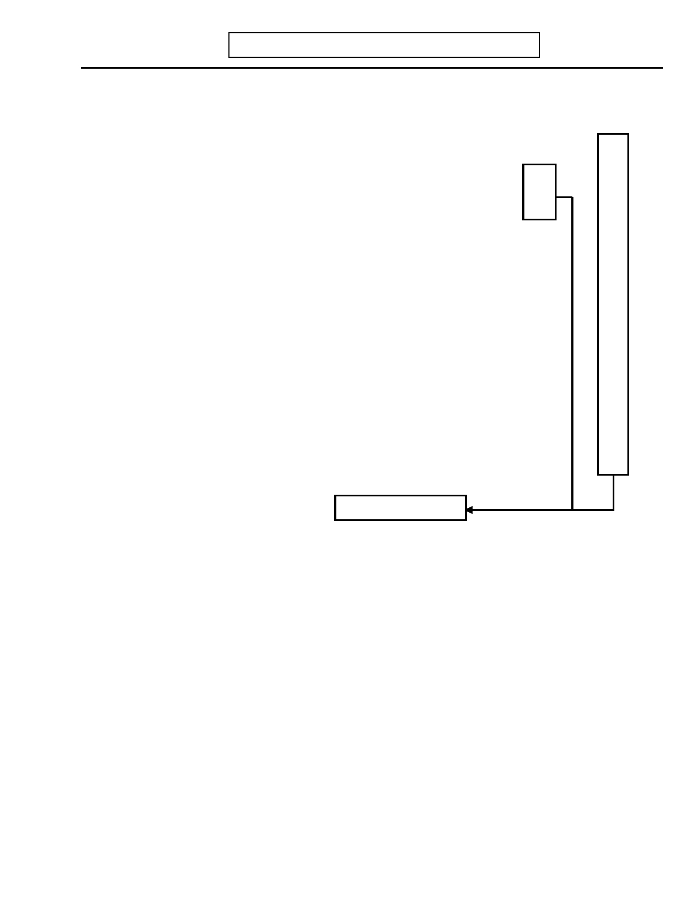
DIGS 4.0 / BP
21-Jul-2005
X. INTERVIEWER'S RELIABILITY ASSESSMENT
Page 139

INTERVIEWER: Indicate how reliable you think the information provided by the subject is in the following areas.
Good Fair Unreliable

1. SOMATIZATION 1 2 3

2. MAJOR DEPRESSION 1 2 3

3. MANIA 1 2 3

4. ALCOHOL ABUSE 1 2 3

5. TOBACCO, MARIJUANA AND DRUG ABUSE 1 2 3

6. PSYCHOSIS 1 2 3

7. SUICIDAL BEHAVIOR AND VIOLENT BEHAVIOR 1 2 3

8. ANXIETY DISORDERS 1 2 3

9. EATING DISORDERS 1 2 3

10. ANTISOCIAL PERSONALITY 1 2 3

11. ADHD 1 2 3

12. OVERALL RELIABILITY 1 2 3

Please explain below

Page 140 DIGS 4.0 / BP
21-Jul-2005

This page left intentionally blank


DIGS 4.0 / BP
21-Jul-2005
Y. NARRATIVE SUMMARY
Page 141


Page 142
Y. NARRATIVE SUMMARY
DIGS 4.0 / BP
21-Jul-2005

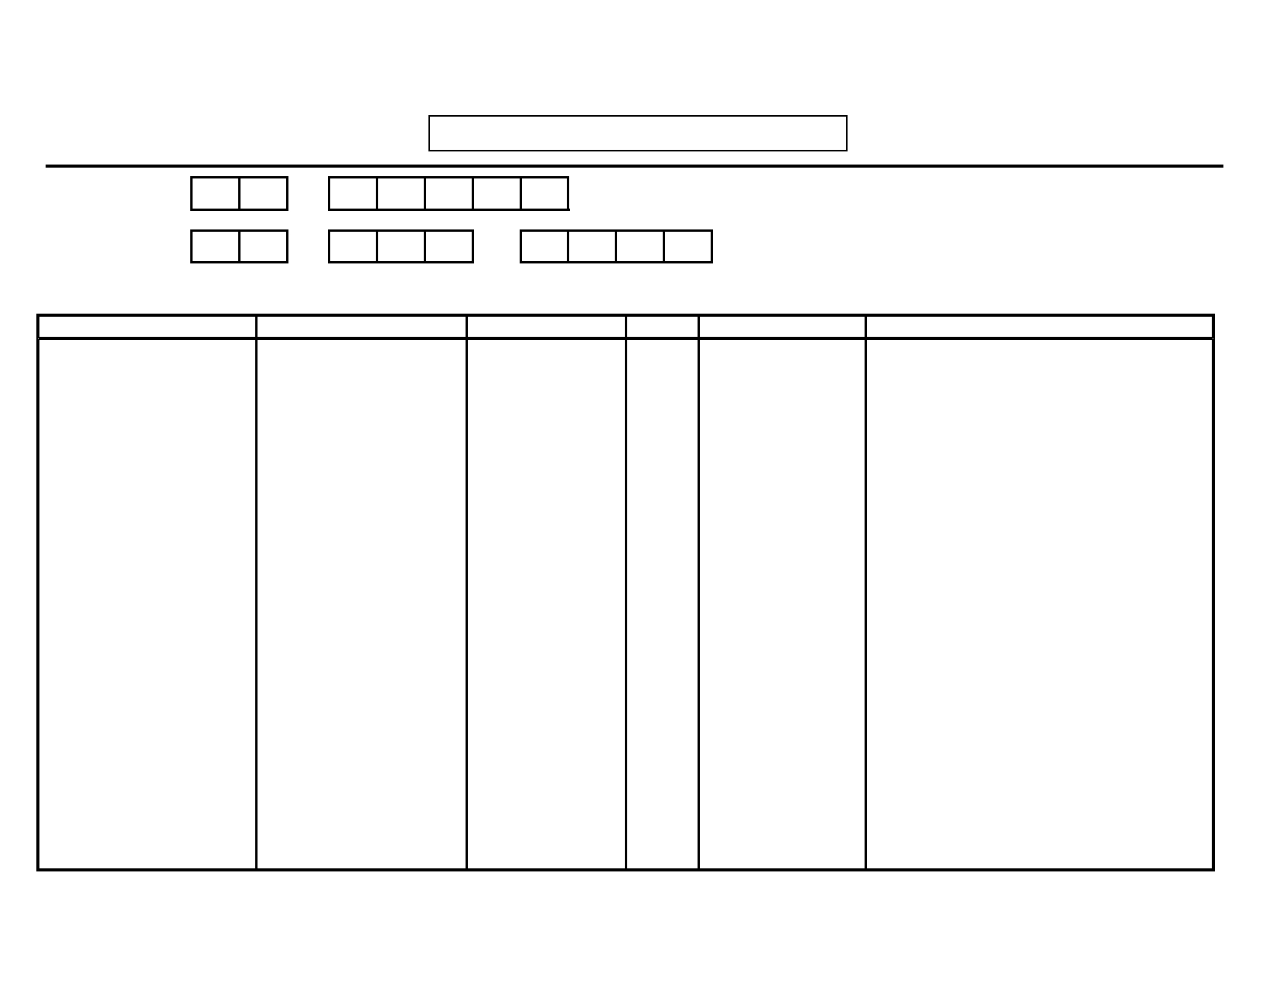
DIGS 4.0 / BP
21-Jul-2005

Subject ID:

-
Z. MEDICAL RECORDS INFORMATION

Subject Name: __________________ ____
Page 143

__________________

First name MI Last name
Date of Birth: - -
Day Month Year

Physician Name Hospital/Clinic Name City State Treatment Dates Condition


Page 144 DIGS 4.0 / BP
21-Jul-2005

This page left intentionally blank


DIGS 4.0 / BP
21-Jul-2005

Ethnicity
ETHNICITY CARD

* 210 = European - Peoples West of the Urals and North of the Black Sea
220 = African, sub-Saharan - Most African-Americans and Afro-Caribbeans ("Black Hispanics"), as
well as Sub-Saharan Africans (incl. South Sudanese).
230 = African, northeastern - Mediterranean and Saharan Africans (incl. Algerians, Egyptians, North
Sudanese, Libyans, Moroccans, and Tunisians)
240 = Southeast Asian - Malaysian, Balinese, Viet Hmong, Thai, South Chinese, Indonesian, and
indigenous people of the Philippines.
250 = All Other Asian - All peoples East of the Urals and South of the Black Sea except Southeast
Asians (e.g., North Chinese, Indians, Koreans, Japanese, Turks, Armenians)
260 = Native Americans - Indigenous peoples of North, Central, and South America
* 270 = Admixed - All recent mixtures of the above groups (incl. "Hispanics," non-indigenous Central and
South Americans, Filipinos, etc.)
* 280 = Special Populations - Genetic isolates and outliers (e.g., Old Order Amish, Sardinian, Ashkenazi,
Sephardic)
290 = Other - (e.g., Pacific Islanders, indigenous Australians, etc.)
999 = Unknown

SITE OPTIONAL

* Use third digit specifiers for sub-groups:

210 = European - Peoples West of the Urals and North of the Black Sea
211 = Anglo-Saxon
212 = Northern European (e.g., Norwegian).
213 = West European (e.g., French, German)
214 = East European, Slavic
215 = Russian
216 = Mediterranean
270 = Admixed - All recent mixtures of the above groups (incl. "Hispanics," non-indigenous Central and
South Americans, Filipinos, etc.)
271 = Hispanic (not Puerto Rican)
272 = Puerto Rican Hispanic
273 = Mexican Hispanic
280 = Special Populations - Genetic isolates and outliers (e.g., Old Order Amish, Sardinian, Ashkenazi,
Sephardic)
281 = Ashkenazi Jew 282 = Sephardic Jew


DIGS 4.0 / BP
21-Jul-2005

This page left intentionally blank


DIGS 4.0 / BP
21-Jul-2005
MODIFIED MMS CARD

CLOSE YOUR EYES

DIGS 4.0 / BP
21-Jul-2005

This page left intentionally blank

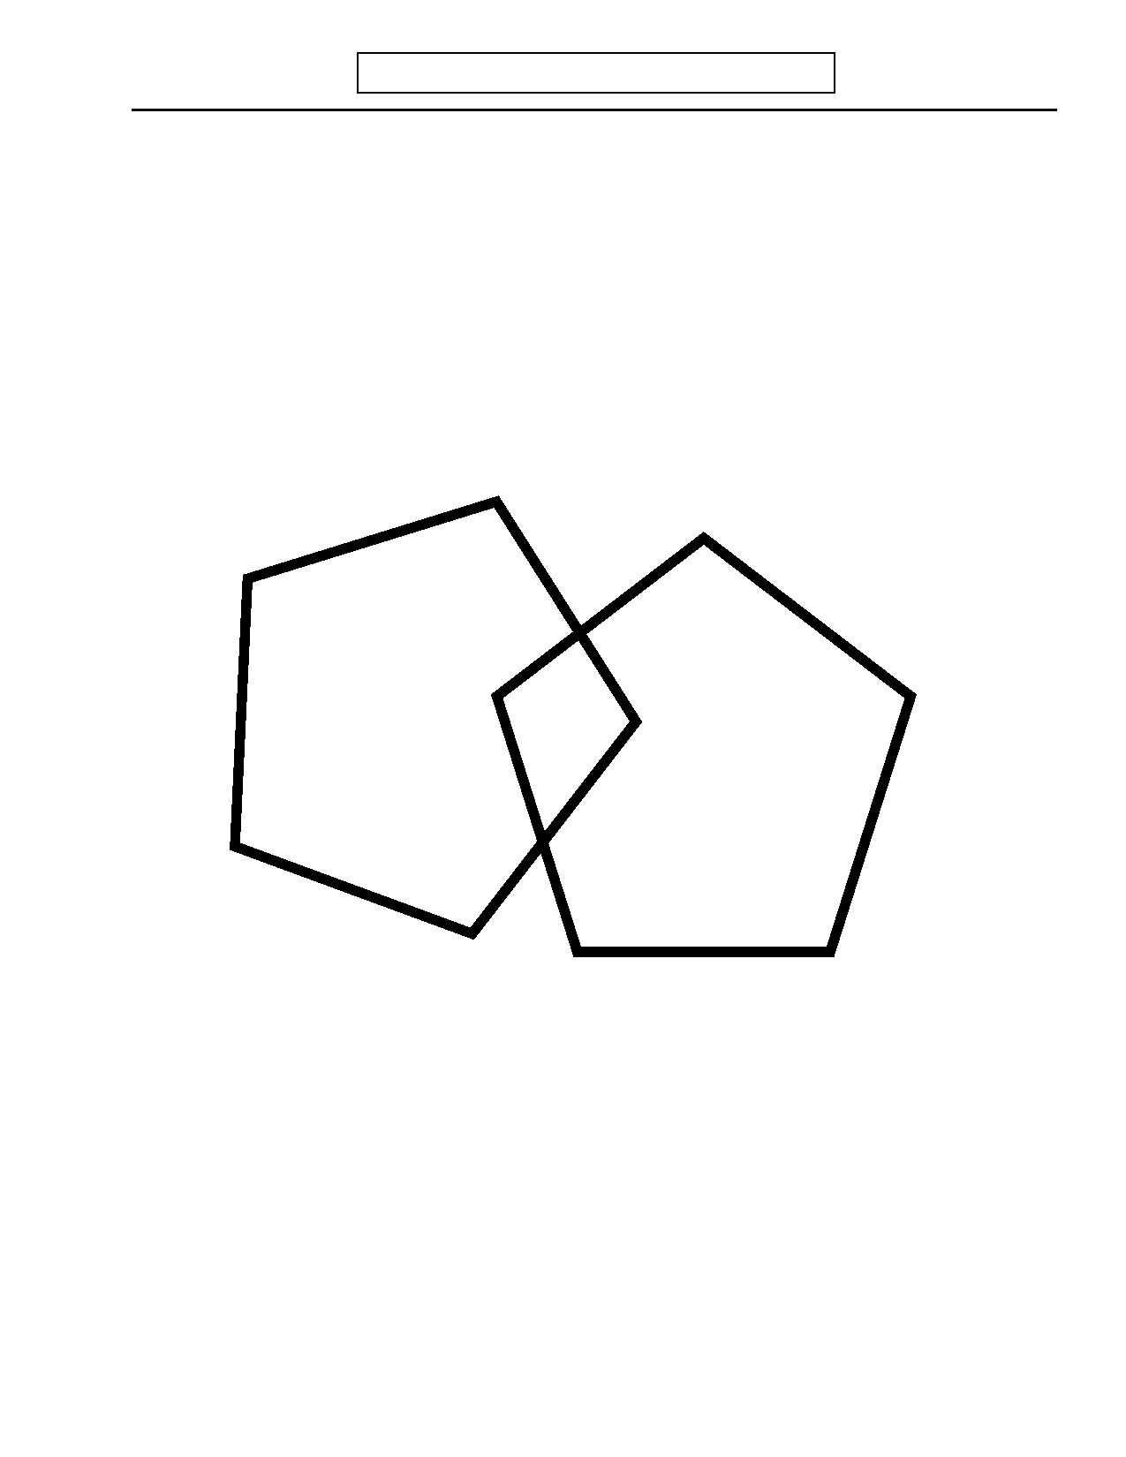
DIGS 4.0 / BP
21-Jul-2005
MODIFIED MMS CARD

DIGS 4.0 / BP
21-Jul-2005

This page left intentionally blank


DIGS 4.0 / BP
21-Jul-2005

Depressed
DEPRESSION TALLY SHEET

Box 1:

Most
Severe
_______

Other
_______

______ F.4.c, 38.e Felt depressed
______ F.4.d/e, Felt irritable/anxious
38.f/g

Appetite/Weight Box 2: _______ _______
______ F.6, 39 Change in appetite
______ F.6.a, 39.a Change in weight

Sleeping Box 3: _______ _______
______ F.7, 40 Trouble sleeping
______ F.7.b, 40.b Unable to fall asleep for at least an hour
______ F.7.c, 40.c Trouble sleeping through the night
______ F.7.e, 40.e Waking up an hour earlier than usual
______ F.7.f, 40.f Slept more than usual

Restless/Slowed Down Box 4: _______ _______
______ F.8, 41 Was fidgety or restless
______ F.9, 42 Moved or talked slower

Loss of Interest Box 5: _______ _______
______ F.10, 43 Loss of interest in sex/other pleasurable activities
______ F.10.a, Loss of interest in nearly all usual activities
43.a

Tired Box 6: _______ _______
______ F.11, 44 Loss of energy or more tired than usual

Guilt Box 7: _______ _______
______ F.12, 45 Felt guilty or bad about self
______ F.13, 46 Felt was a failure or worthless

Thinking Box 8: _______ _______
______ F.14, 47 Had difficulty thinking, concentrating or making
decisions

Thoughts of Dying Box 9: _______ _______
______ F.15, 48 Thought about dying/wishing was dead
______ F.16, 49 Tried to harm self

DIGS 4.0 / BP
21-Jul-2005

This page left intentionally blank

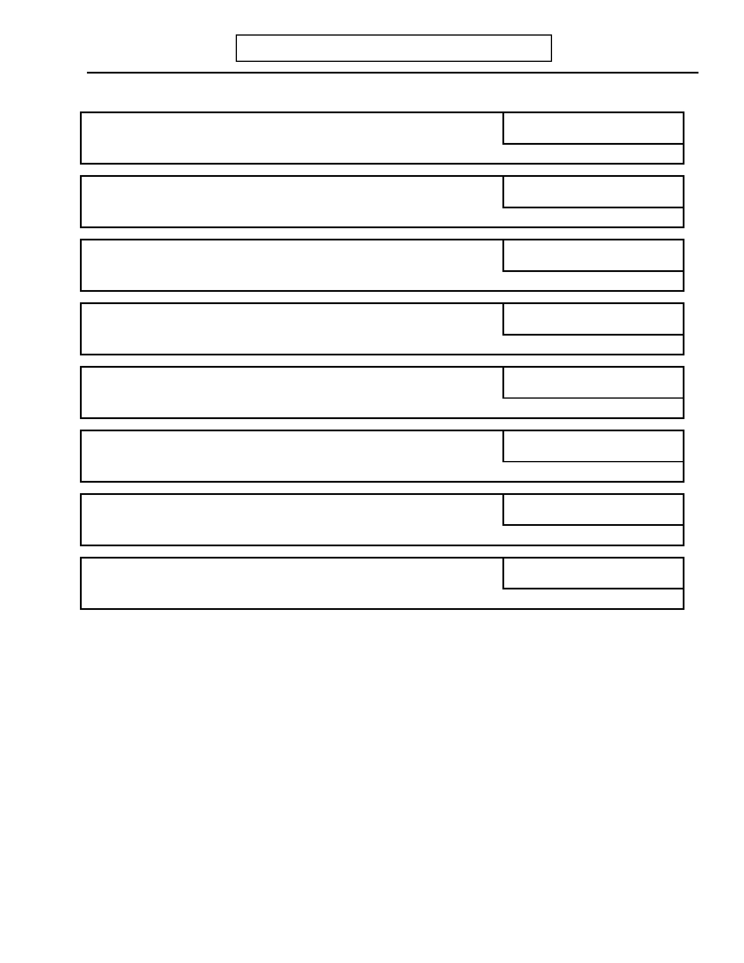
DIGS 4.0 / BP
21-Jul-2005

Mania
MANIA/HYPOMANIA TALLY SHEET

Box 1:

Most
Severe
_______

Other
_______

______ G.5, 33 Irritable/elated

More Active Box 2: _______ _______
______ G.6, 34 More active than usual or restless

More Talkative Box 3: _______ _______
______ G.7, 35 More talkative than usual

Racing Thoughts Box 4: _______ _______
______ G.8, 36 Thoughts raced/talked too fast to follow

Grandiosity Box 5: _______ _______
______ G.9, 37 Felt very important or that you had special powers

Sleeping Box 6: _______ _______
______ G.10, 38 Needed less sleep than usual

Concentration Box 7: _______ _______
______ G.11, 39 Attention kept jumping from one thing to another

Reckless Behavior Box 8: _______ _______
______ G.12, 40 Did things that could have gotten you into trouble

DIGS 4.0 / BP
21-Jul-2005

This page left intentionally blank


DIGS 4.0 / BP
21-Jul-2005

A. Cocaine

Cocaine (girl) Coca Leaves
Crack
Freebase
Rock Toot

B. Stimulants

Amphetamine
Methamphetamine Meth. Speed Crank
Crystal
Beauties (Black Beauties)
Diet Pills
Whitecrosses

C. Sedatives, Hypnotics, Tranquilizers

Quaaludes (Ludes)
Valium Librium
Xanax
Barbiturates
Barbs
Seconal Ativan
Sleeping Pills

D. Opiates

Heroin
Boy
Smack Opium Darvon Codeine
Morphine Percodan Demerol
Methadone
Dilaudid Vicodan
Lorcet
Oxycontin
DRUG USE CARD

List of Drugs

E. PCP

Hog
Angel Dust (Dust)
Seryl
Dip
Wack Water

F. Hallucinogens

LSD (Acid)
Purple Microdot
Blotters
Mescaline
Peyote
Mushrooms (Magic Mushrooms)
Psilocybin
Psychedelics
DMT

G. Solvents

Glue
Toluene Gasoline
Paint
Paint Thinner
White-Out

H. Other

Nitrous Oxide
Amyl Nitrite
Poppers
Butyl Nitrite
Khat
Betel Nut
Ecstasy (MDMA)

I. Combination

Speedball
T's and Blues
Ice

DIGS 4.0 / BP
21-Jul-2005

This page left intentionally blank

DIGS 4.0 / BP
21-Jul-2005
COMORBIDITY CARD

1 = Emotional/thinking difficulties always occurred first.

2 = Alcohol/drug abuse always occurred first.

3 = Emotional/thinking difficulties and alcohol/drug abuse
always occurred at the same time.

4 = No strict pattern (sometimes emotional/thinking
difficulties first, sometimes alcohol/drugs first).

5 = Emotional/thinking difficulties and alcohol/drug abuse
always occurred independently.

6 = Not clear.

