ACCELEROMETRY

Table of Contents

1. Background and rationale 2
2. ActiGraph setup 2
2.1 Epoch period 4
2.2 Start/stop time 5
2.3 Subject name (Participant ID#) 6
2.4 Complete the Actigraph Distribution form 8
3. Placement of Actigraph 8
4. Prepping the participant for monitoring free-living activity 9
5. Interim telephone contact 9
6. Next appointment (7 to 14 days) 9
6.1 Complete the Actigraph Return and Reading form 9
6.2 Download the data using the following methods 9
7. Description of equipment 12
7.1 Actigraph technical specification 12
8. Data backup 15
9. Quality assurance 15
9.1 Training and certification 15
9.2 Certification requirements 16
9.3 Quality assurance checklist 16
Appendix 1 Participant waist monitor instructions and diary 17
Appendix 2 Accelerometry Tracking Forms 26
Appendix 3 Data Backup 28

Note: Minor changes were made to make this manual less specific to the Health ABC Study.

ACCELEROMETRY

1. Background and rationale

Physical inactivity is an important health risk factor and strongly related to disability, morbidity, and increased risk of mortality. Therefore, accurate estimates of physical activity are crucial for both clinical and public health applications. In epidemiological studies, physical activity data are typically collected through self-report. The commonly used methods of survey and self-report frequently yield physical activity data that are inaccurate and limited. Self-reported physical activity suffers from significant reporting bias attributable to a combination of social desirability bias and estimating frequency and duration of physical activity is cognitively challenging, especially among older adults. The development of accelerometry as an objective measure of physical activity has opened up new possibilities for studying all intensity levels of physical activity levels from completely sedentary to vigorous activity over a number of days. An accelerometer measures the existence and intensity of motion in terms of “counts.” Data can be collected in short epochs (e.g., 1, 15, 30, or 60 seconds). The devices are small, easy to use, and can store data for multiple days. The accelerometer counts can be used to classify motion as sedentary, low intensity, moderate intensity, and high intensity based on cutoff points derived from validation studies. Rather than applying these cutoff points the data can be used to evaluate patterns of physical activity.

2. ActiGraph setup

The initial set up of the ActiGraph has to be done before the participant comes in for the first clinic visit. Start the ActiLife software.



Plug the ActiGraph GT3X into the USB Port using the USB cable.
The ActiGraph GT3X connected to the USB cable.

Press the Initialize Device button (NOTE: The ActiGraph must be plugged into the USB Port before clicking this button).

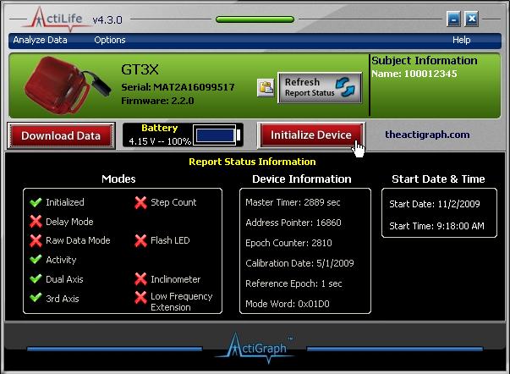

The Initialize GT3X screen shown below will appear. Ensure that the following settings are checked: Epoch Period—1 second; Filter Option—Normal; Activity (Default Mode); and 3rd Axis (which will automatically also check Dual Axis).

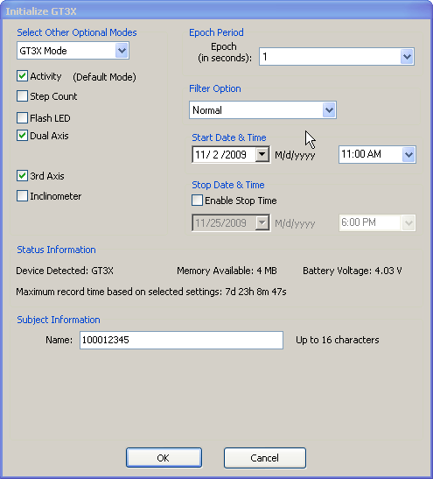

2.1 Epoch period

The ActiGraph collects and reports physical activity in “counts” and then can be used to estimate time spent at different intensity levels. Counts are simply the summation of the accelerations measured during the epoch period. The GT3X ActiGraph measures changes in acceleration 30 times each second. When one-minute cycles are used, 1,800 measurements are summed and that value is written to memory at the end of the one-minute interval.

Activity counts represent a quantitative measurement of activity over time. Think of epochs as the resolution of the recorded data. The lower the epoch the greater resolution of data you will get.

The following epoch lengths are available: Raw, 1, 2, 5, 10, 15, 30, 60, 120, 180, and 240 seconds.

Lower epoch periods provide greater resolution, but also produce more data that must be recorded and stored on the device per day. Therefore, epoch periods dictate the number of days of continuous recording that can be stored. For one-second epoch periods and three-axis acceleration monitoring, approximately seven days and twenty-three hours of continuous data can be recorded.

Use 1 second epochs for free-living conditions.

2.2 Start/stop time

The GT3X supports user configurable start and stop times. This allows the user to program the monitor to start recording at a specific time. This should be used to check that the monitor will begin recording at the correct time. Use tomorrow’s date, i.e., the date the participant will come into clinic, as the start date.

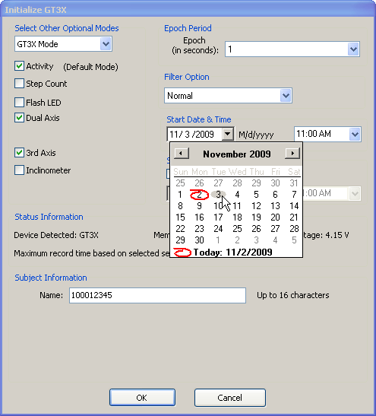

Choose 12:00 PM (noon) for start time.

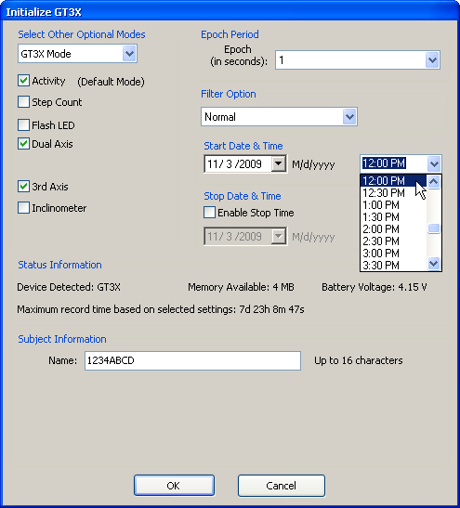

2.3 Subject name (Participant ID#)

Enter the subject’s ID Number in the Subject Name prompt.
Once you have entered the appropriate information, click OK.

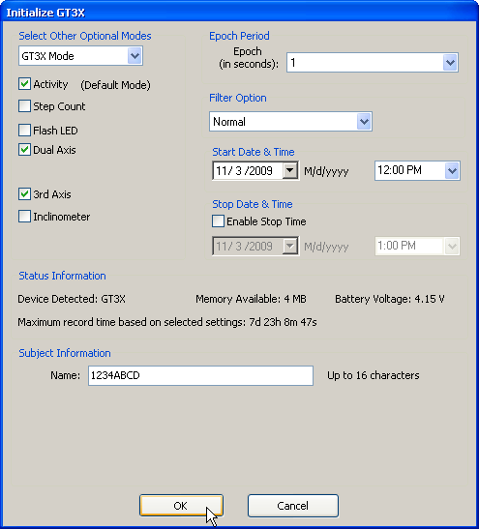

Please be patient while the computer sends the commands to the ActiGraph unit.

Once the ActiGraph has been successfully started, it will report when the ActiGraph will start collecting data.

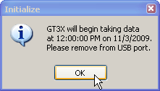

Disconnect the ActiGraph immediately from the USB Cable and click OK. The monitor will flash intermittently until the monitor starts recording data, then the light will cease to flash; i.e., no flashing when the GT3X is not connected to the computer via a USB indicates that the monitor is collecting data.

Congratulations! You are now ready to place the ActiGraph on the participant and collect activity data!

2.4 Complete the Actigraph Distribution form

At the first visit, when you give the participant the ActiGraph, complete the ActiGraph Distribution form. Record the person’s full name on the form, whether or not the participant received an ActiGraph and the serial number of the ActiGraph.

3. Placement of Actigraph

The Actigraph comes with a waistband that will be worn around the hip. It should be worn on the hip (as close as possible to the iliac crest). It is important that the accelerometer is fastened tightly to the belt or measurements will be inaccurate. The accelerometry can be worn either over or under clothing.

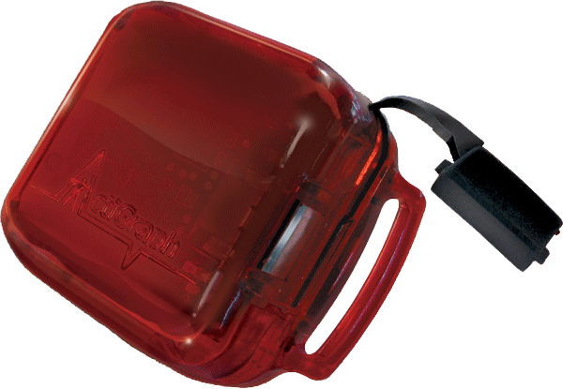

4. Prepping the participant for monitoring free-living activity

Participants with poor cognitive function will not be asked to wear the accelerometer.
Be sure to set up the Actigraph for free-living monitoring. See instructions in section 2.

The participant will be responsible for wearing and removing the monitor. Show the participant how to use the ActiGraph (directions in section 3. “Placement of ActiGraph” and in Appendix 1). Provide the necessary instructions and contact information to the participant (Appendix 1). Review the instructions with the participant and ask them to wear to monitor for at least 7 days. Specifically point out that they take off the accelerometer before going to sleep and put it on again in the morning and to take it off before a shower or swim. Ask the participant to keep a record of activities when the monitor is taken off. Review the instructions and example diary with the participant before giving them the packet that includes the diary pages. Remind participants of the upcoming visit.

5. Interim telephone contact

Participants should be reminded to wear the ActiGraph, complete the diary, and to bring the diary and ActiGraph to their next appointment with project staff. This reminder will be done over the telephone at the same time as the call to remind them about the appointment.

6. Next appointment (7 to 14 days)

6.1 Complete the Actigraph Return and Reading form

At the next appointment, 7 to 14 days after the first appointment, the participants will return the ActiGraphs. Record the person’s full name on the form and the date the ActiGraph was returned.

6.2 Download the data using the following methods

During the second visit the accelerometer data will be downloaded.

Follow these steps to download your collected data from the ActiGraph:

Start the ActiLife software. Plug in the Actigraph USB cable.

The ActiGraph GT3X connected to the USB cable.

Press the Download Data button (NOTE: The ActiGraph must be plugged into the USB Port before clicking this button).

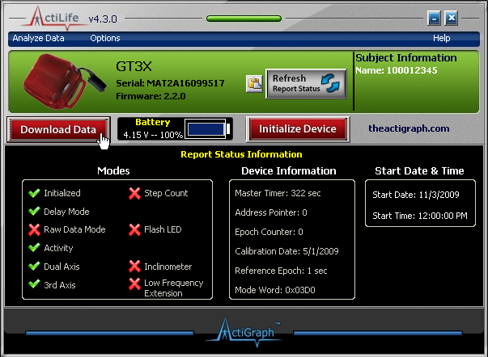

This message is displayed to indicate the status of the execution of the Download command. The ActiLife Lifestyle Software will begin to download the data from the ActiGraph GT3X.

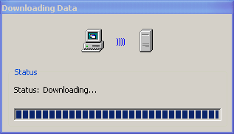

Once the data is downloaded it must be saved on the computer for analysis. Please save using the Participant ID (ABCD1234) and the file extension *.dat.

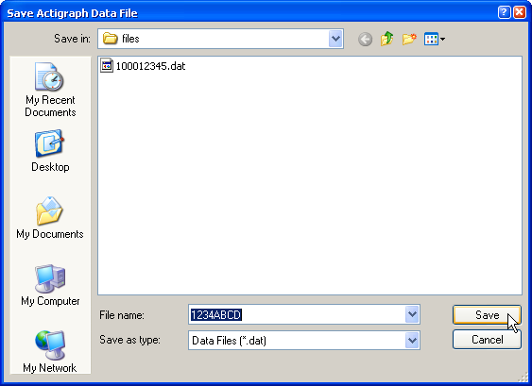

After clicking save, you will be asked whether you want to graphically preview the data. Click No.

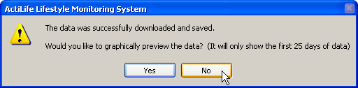

Note: If you get an error message with “File already exists. Do you want to replace it?” Click “No.” This means that the file extension was not correct. Change file name to what you wish to save it as, then click save. Otherwise data will be overwritten.

Now that the data has been successfully downloaded, it can be imported into your own statistical analysis programs or you can choose any of the Analysis functions available within the ActiLife Lifestyle Software.

7. Description of equipment

7.1 Actigraph technical specification

The Actigraph (model GT3X ) is a solid-state accelerometer which collects and records physical activity data. It weighs 27 grams and its dimensions are 1.5” x 1.44” x 0.70” (3.8 x 3.7 x 1.8 cm). It can store the number of times it moves x the rate of movement change (acceleration) on a continuous basis for a period of up to 20 days in the “pedometer mode.” [ActiGraph, www.theactigraph.com]. The ActiGraph is housed in a tamper-proof water-resistant case. The ActiGraph collects and records this information in its memory where it is then transferred from the GT3X and a Microsoft Compatible PC via a standard USB 2.0 interface. This connection also serves as the battery charger.

The GT3X activity monitor accurately and consistently measures and records time varying accelerations ranging in magnitude from approximately 0.05 to 2 G's. The acceleration signal, represented by an analog voltage, is sampled and digitized by a twelve-bit (12) Analog to Digital Converter (ADC) at a rate of thirty times per second (30 Hertz). Once digitized, the signal passes through a digital filter that band-limits the accelerometer to the frequency range of 0.25 to 2.5 Hz. This frequency range has been carefully chosen to detect normal human motion and to reject motion from other sources. The digital filter yields an output signal that responds linearly to changing accelerations within the pass band. Each sample is summed over a user specified interval of time called an ‘epoch’.

The primary hardware components of the GT3X include a 16-bit microcontroller with on chip 12 bit ADC, 4 Megabyte (MEG) of NON VOLATILE FLASH memory, a solid-state accelerometer, voltage regulator, and a battery charger. A rechargeable 3.7V single prismatic cell Lithium Ion/Lithium Polymer battery supplies power. Battery life, defined as the time between battery charges, is in excess of fourteen days.

The GT3X is capable of collecting activity data from three axes. With triple axis mode enabled the unit collects acceleration data in the vertical axis, horizontal axis right-left, and horizontal front back.
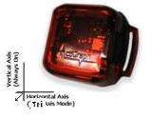
Battery
The GT3X’s rechargeable Lithium Ion battery is capable of providing power for twenty (20) days without a recharge. Recharging is automatic and is accomplished by connecting the GT3X to any standard USB port. Charging time will depend on the battery life, but will typically not exceed three hours for a fully depleted battery. Once the battery is completely charged, the red LED light inside the ActiGraph will remain lit.

Note: If a PC is not available or if multiple ActiGraph’s need to be recharged, a self-powered USB hub can be used. By using this method, it is possible to daisy chain hubs such that 127 GT3Xs can be recharged at once.

*If charging multiple GT3Xs by way of a USB hub, it is recommended that the hub not be connected to the computer. If connected to the computer, each GT3X connected will attempt to communicate with the computer and could potentially cause instability issues with the computer.

Data Storage
The ActiGraph GT3X contains 4 MB (four megabyte) of non-volatile FLASH memory for data storage. The number of days that data can be collected during continuous wear time depends on various parameters, including epoch period and number of axes (single, dual, or three). For the settings used in this study, defined in 3 ActiGraph setup, approximately seven days and 23 hours of data can be recorded.
USB connection
The GT3X utilizes an industry standard USB 2.0 interface for both data transfer and battery charging. Data transfer rate is set to 115,200 bps with no parity, one (1) stop bit, eight (8) data bits and no handshaking.

MINIMUM SYSTEM REQUIREMENTS
Operating System: Windows 2000 Professional with SP4 / XP Home or Professional Edition
Internet Access
FULL ADMINISTRATOR RIGHTS (see your IT Department)
Microsoft Office with Excel 2000/XP in English US or English UK in order to analyze data
Graphics: at least 256 colors; Small Fonts
Screen Resolution: 800x600 or 1024x768
Serial Port or USB Connection (Adapter Required)
Processor Speed: 300MHz Pentium
Memory: at least 32MegaBytes
Hard Drive: at least 32Mb available

The GT3X has five distinct operational modes. They consist of Active, Low Battery, Halt, Recovery, and USB/Charging.

Active
Active mode is the normal operating mode of the GT3X. During this mode, the device is on, collecting data.

Low Battery
The GT3X enters the Low Battery mode automatically when the battery voltage drops below a factory programmed threshold. It is identical in behavior and action to the Active mode, except the LED flashes two times every three seconds1. Once the device has entered this mode, a battery charging sequence must be initiated within three and a half (3 ½) hours or the GT3X will enter the Halt mode.

Halt
In this mode, the GT3X will preserve the previously collected data, quit taking subsequent data, flash the LED three times every three seconds, and will enter a very low power state. The GT3X will enter Halt mode 3 ½ hours after Low Battery mode is entered if a battery recharge is not initiated. The device must be either re-initialized or restarted after Halt mode is entered if the user wishes to continue use of the GT3X. Note that if a recharge is not initialized in a timely manner, the battery will completely discharge. In this scenario, the device is rendered unusable until the battery is recharged.

USB/Charging
The USB/Charging mode is entered each time the GT3X is connected to a PC by way of the USB port. When in this mode, the GT3X will automatically stop taking data, and the battery will automatically begin charging (if needed). Assuming the ActiGraph drivers for the GT3X have been installed on the PC the user may communicate with the device via the application. If the GT3X is placed in Halt mode by the user (see “pushbutton” section) it will remain in Halt mode even after it is disconnected from the PC.

LED Reference Chart
GT3X LED Flashing Reference
GT3X Connected to PC
1 Flash | LiOn Battery is Charging
2 Flashes | LiOn Battery is Faulty
Steady On | Battery Charged
GT3X Not Connected to PC
No Flashes  (LED Off) | Actively Taking Data ("Flash Mode" Disabled)/User Turned Off/Battery Dead
1 Flash | Actively taking data ("Flash Mode" Enabled)
2 Flashes | Delay Mode/Battery is Low (check application for remaining battery life)
3 Flashes | Recovery Mode (Must be re-initialized)
Note: The LED will ALWAYS flash to indicate LOW BATTERY (2 or 3 flashes as indicated in the table above) regardless of whether "Flash Mode" is enabled.

Installing Actigraph software: Exit all programs and restart your computer. Log into your computer as normal. After your computer has started again, insert the CD into your CD-ROM drive. The installation screen opens automatically if you have Autorun enabled on your system. If you have Autorun disabled or the installation menu does not start automatically, go to your Desktop on your computer and double click on "My Computer" Icon. Click on your CD Drive and then double click on the file “actiloader.exe”.

1. Click on the Install Drivers Button. Follow the onscreen instructions for installing the necessary drivers for the ActiGraph.

2. Once the drivers have been successfully installed, click on the Install Software button and follow the onscreen directions.

3. Click on the Exit Button to close the Installation program.

8. Data backup

Data should be backed up to a CD after downloading it from the accelerometer.

9. Quality assurance

9.1 Training and certification

The examiner requires no special qualifications or experience to perform this assessment. Training should include:

• Read and study manual
• Attend the project training session on techniques (or observe administration by experienced examiner)
• Practice on other staff or volunteers
• Discuss problems and questions with local expert or QC officer

9.2 Certification requirements
• Complete training requirements
• Conduct exam on two volunteers while being observed by QC officer:
- According to protocol, as demonstrated by completed QC checklist

9.3 Quality assurance checklist

Before giving ActiGraph to participant
ActiGraph is connected to USB cable
ActiGraph set up for free-living
Participant ID# entered at “Subject Name” prompt
ActiGraph disconnected from USB cable and “OK” clicked

Placement of ActiGraph on participant
Participant instructed about how to wear ActiGraph
ActiGraph placed as close to iliac crest as possible
Procedure for completing 7-day activity diary explained to participant
Procedure for returning ActiGraph explained to participant
Participant asked if they have any questions
Fills out ActiGraph Distribution Form
Reviews forms for completeness

After return of Actigraph
ActiGraph properly connected to USB cable
Download button clicked on ActiWeb Client Software
Data saved properly
Reviews activity diary to see if completely filled out, partially filled out, or not filled out at all
Correctly enters activities on computer
Records how many days the ActiGraph was worn on ActiGraph Return and Reading Form
Records how many valid days the ActiGraph was worn on ActiGraph Return and Reading Form
Records whether diary was completed partially, fully, or not at all on the ActiGraph Return and Reading Form
Reviews forms for completeness

Appendix 1 Participant waist monitor instructions and diary


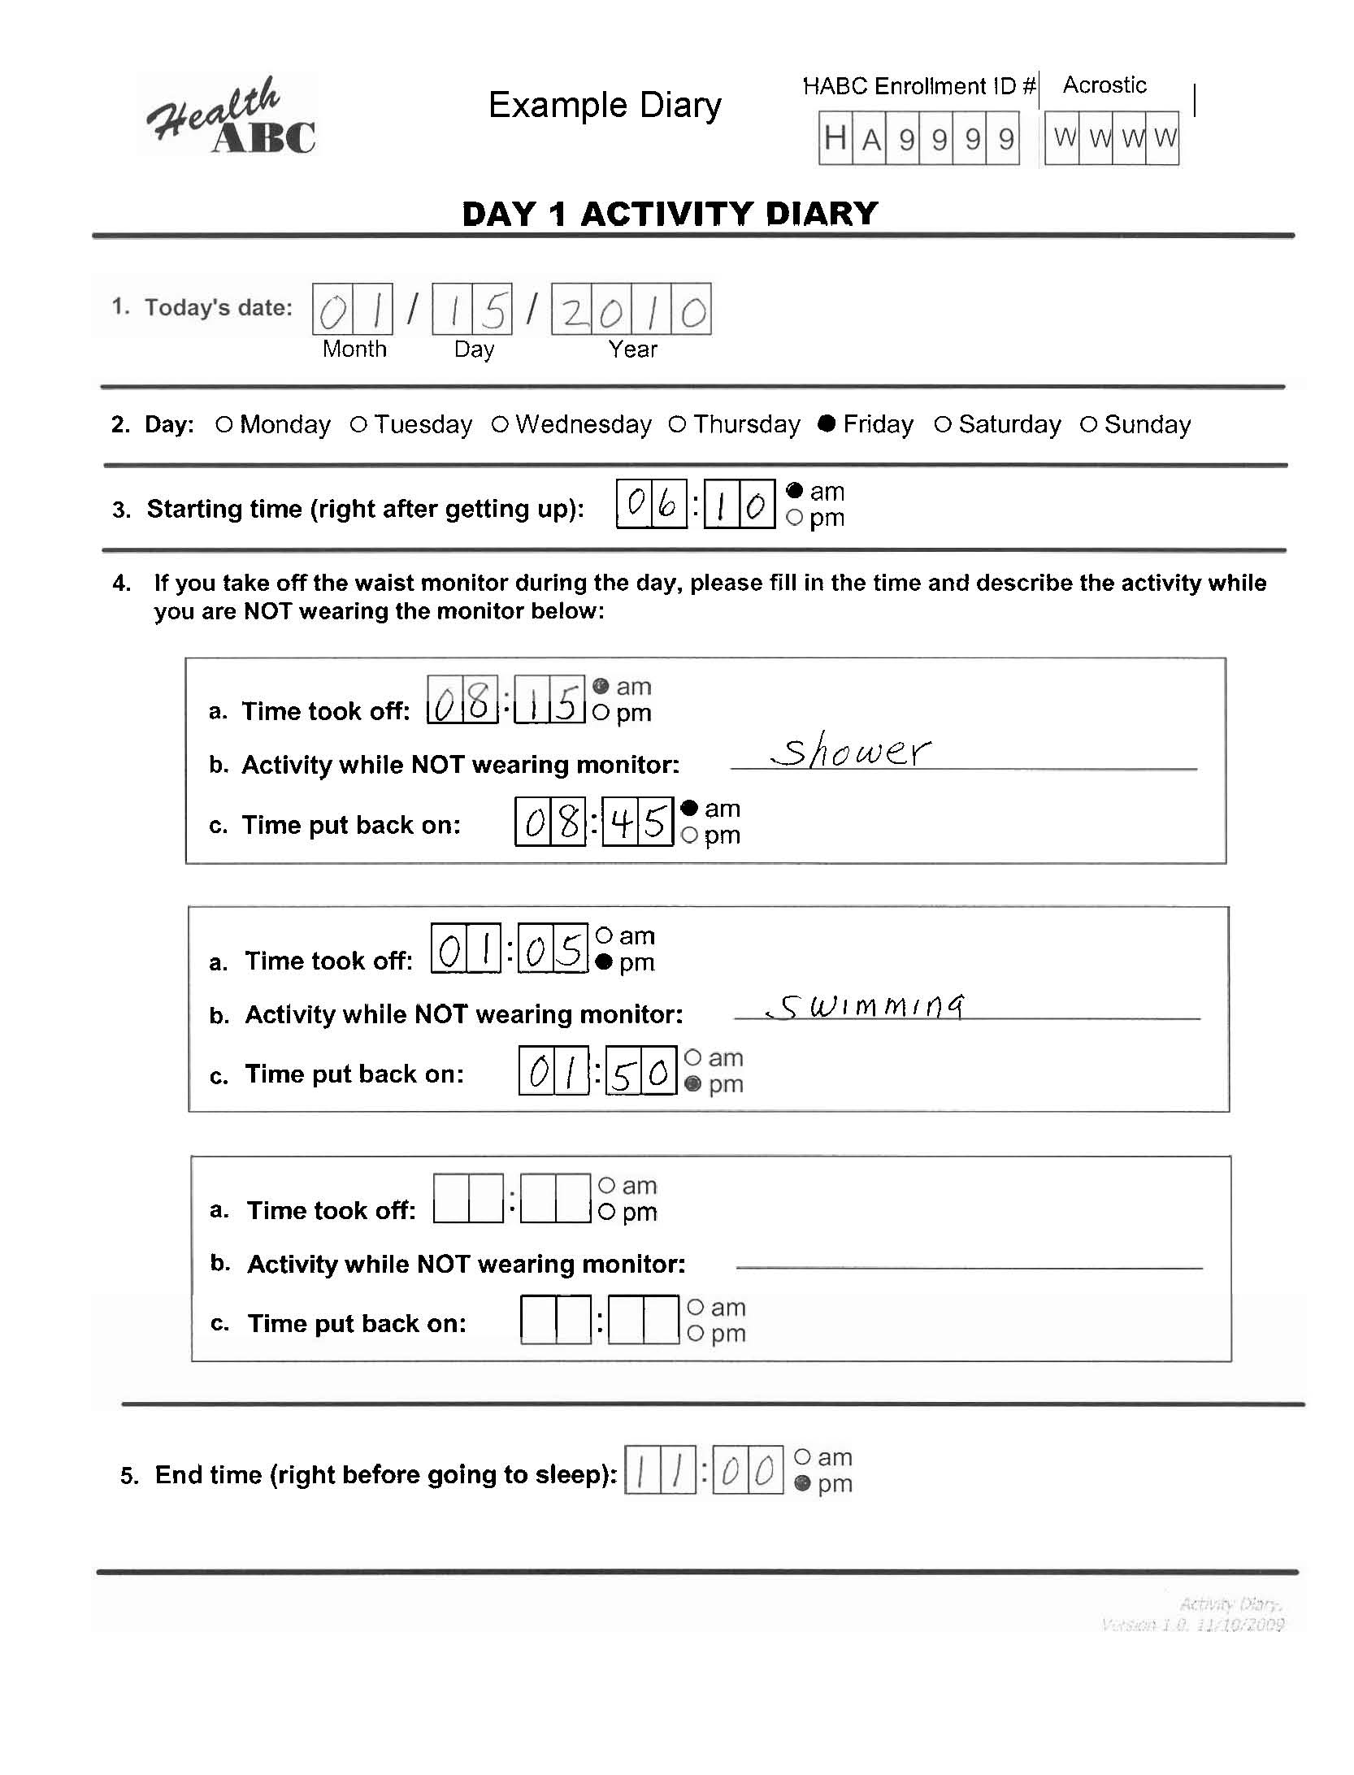
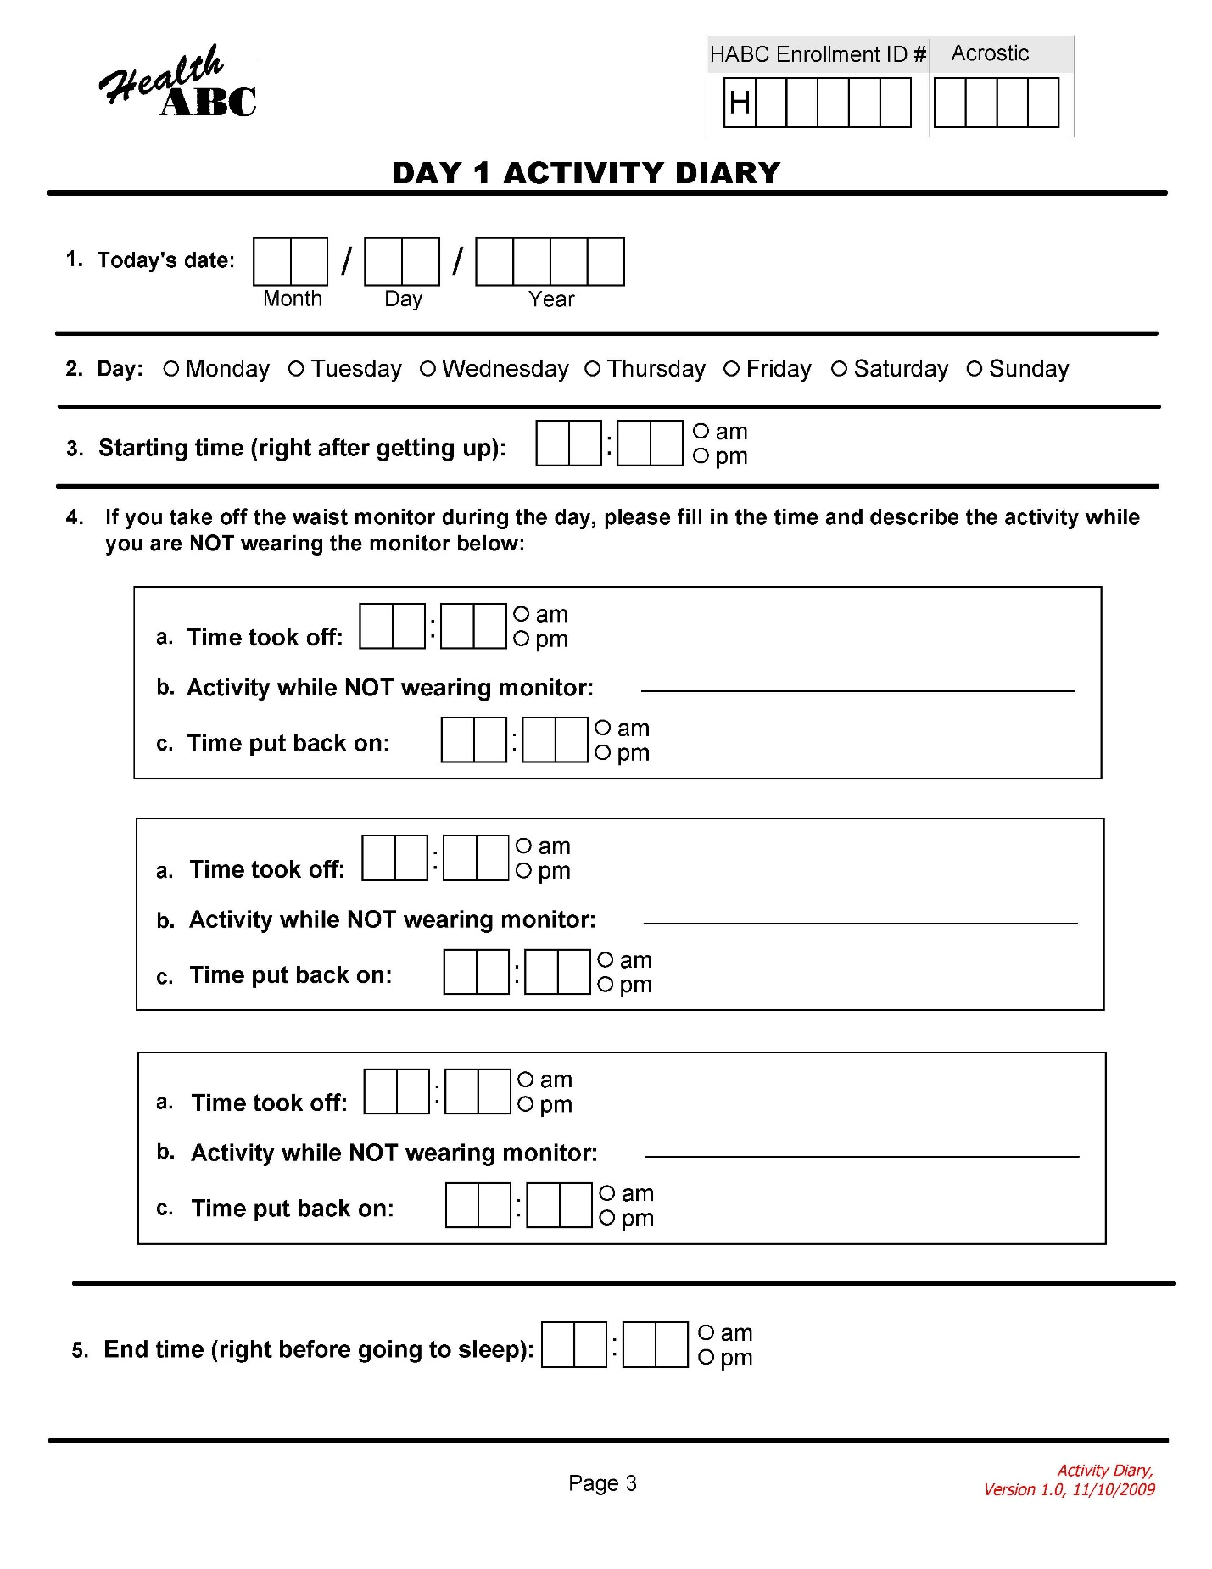
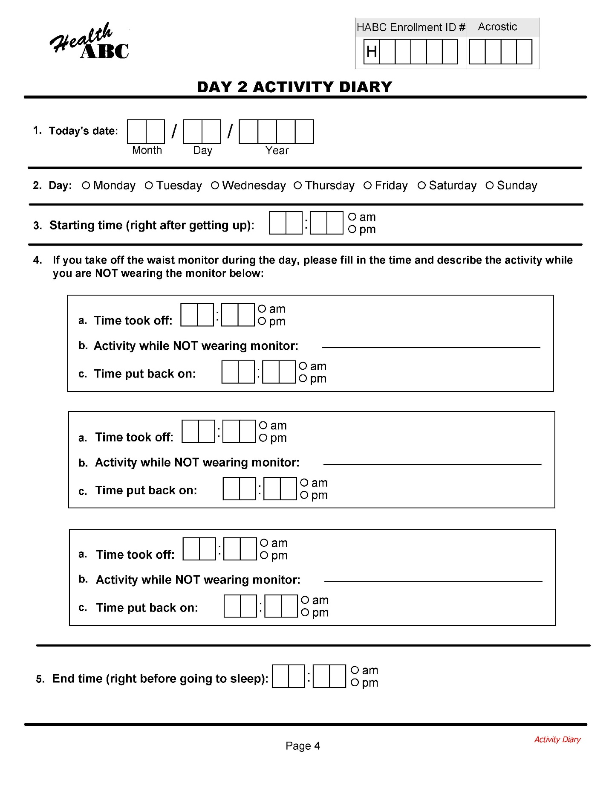
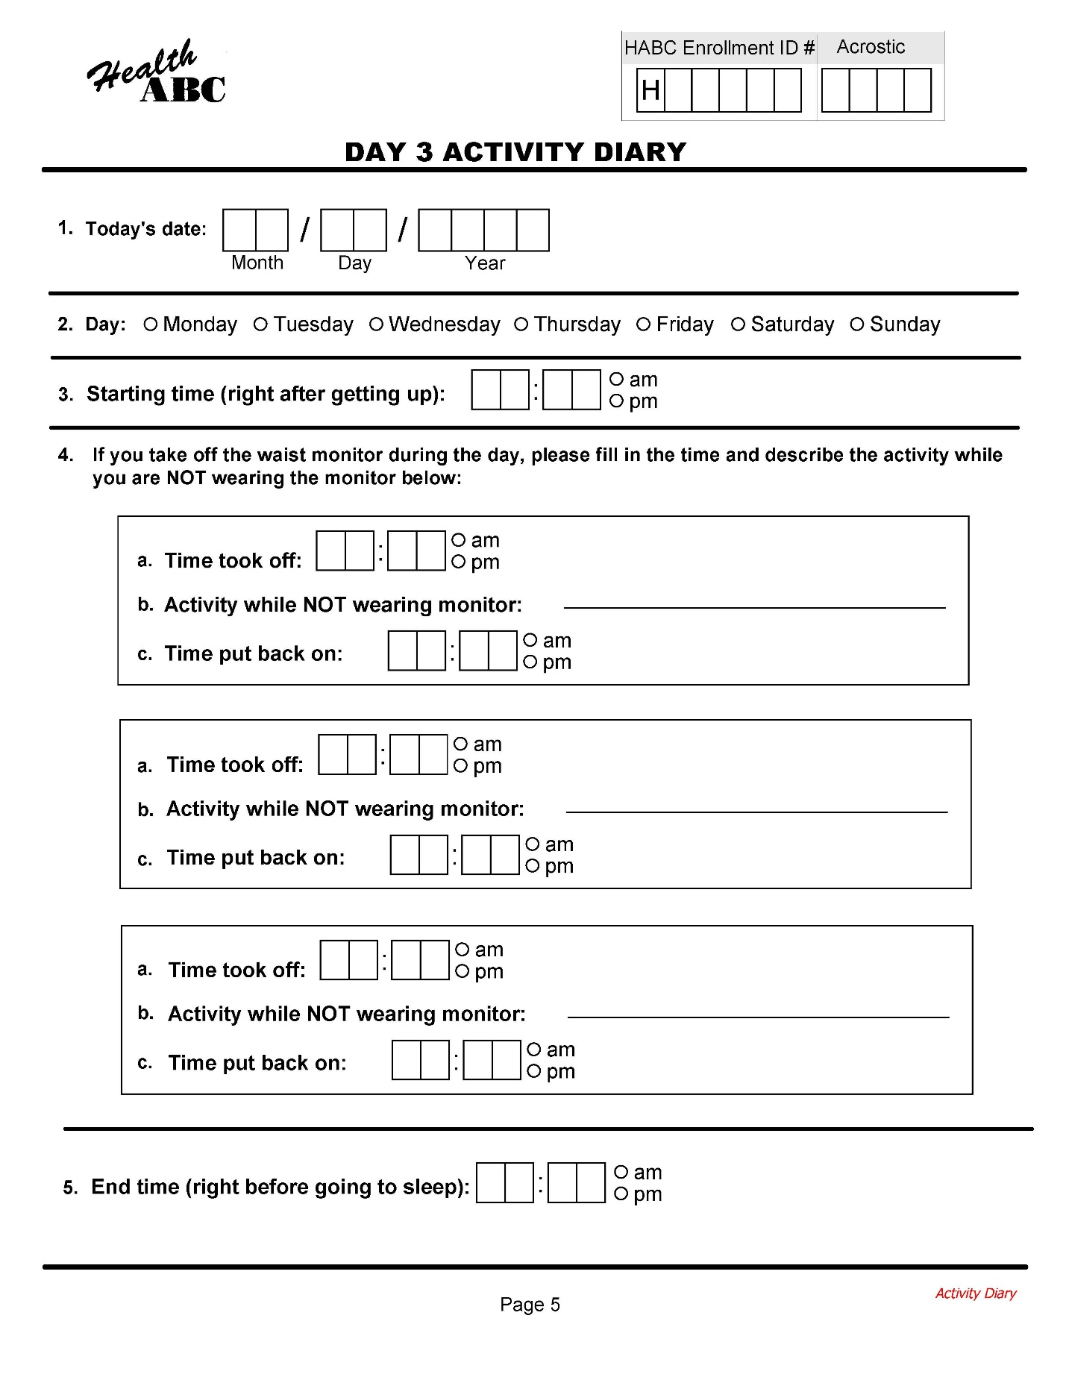
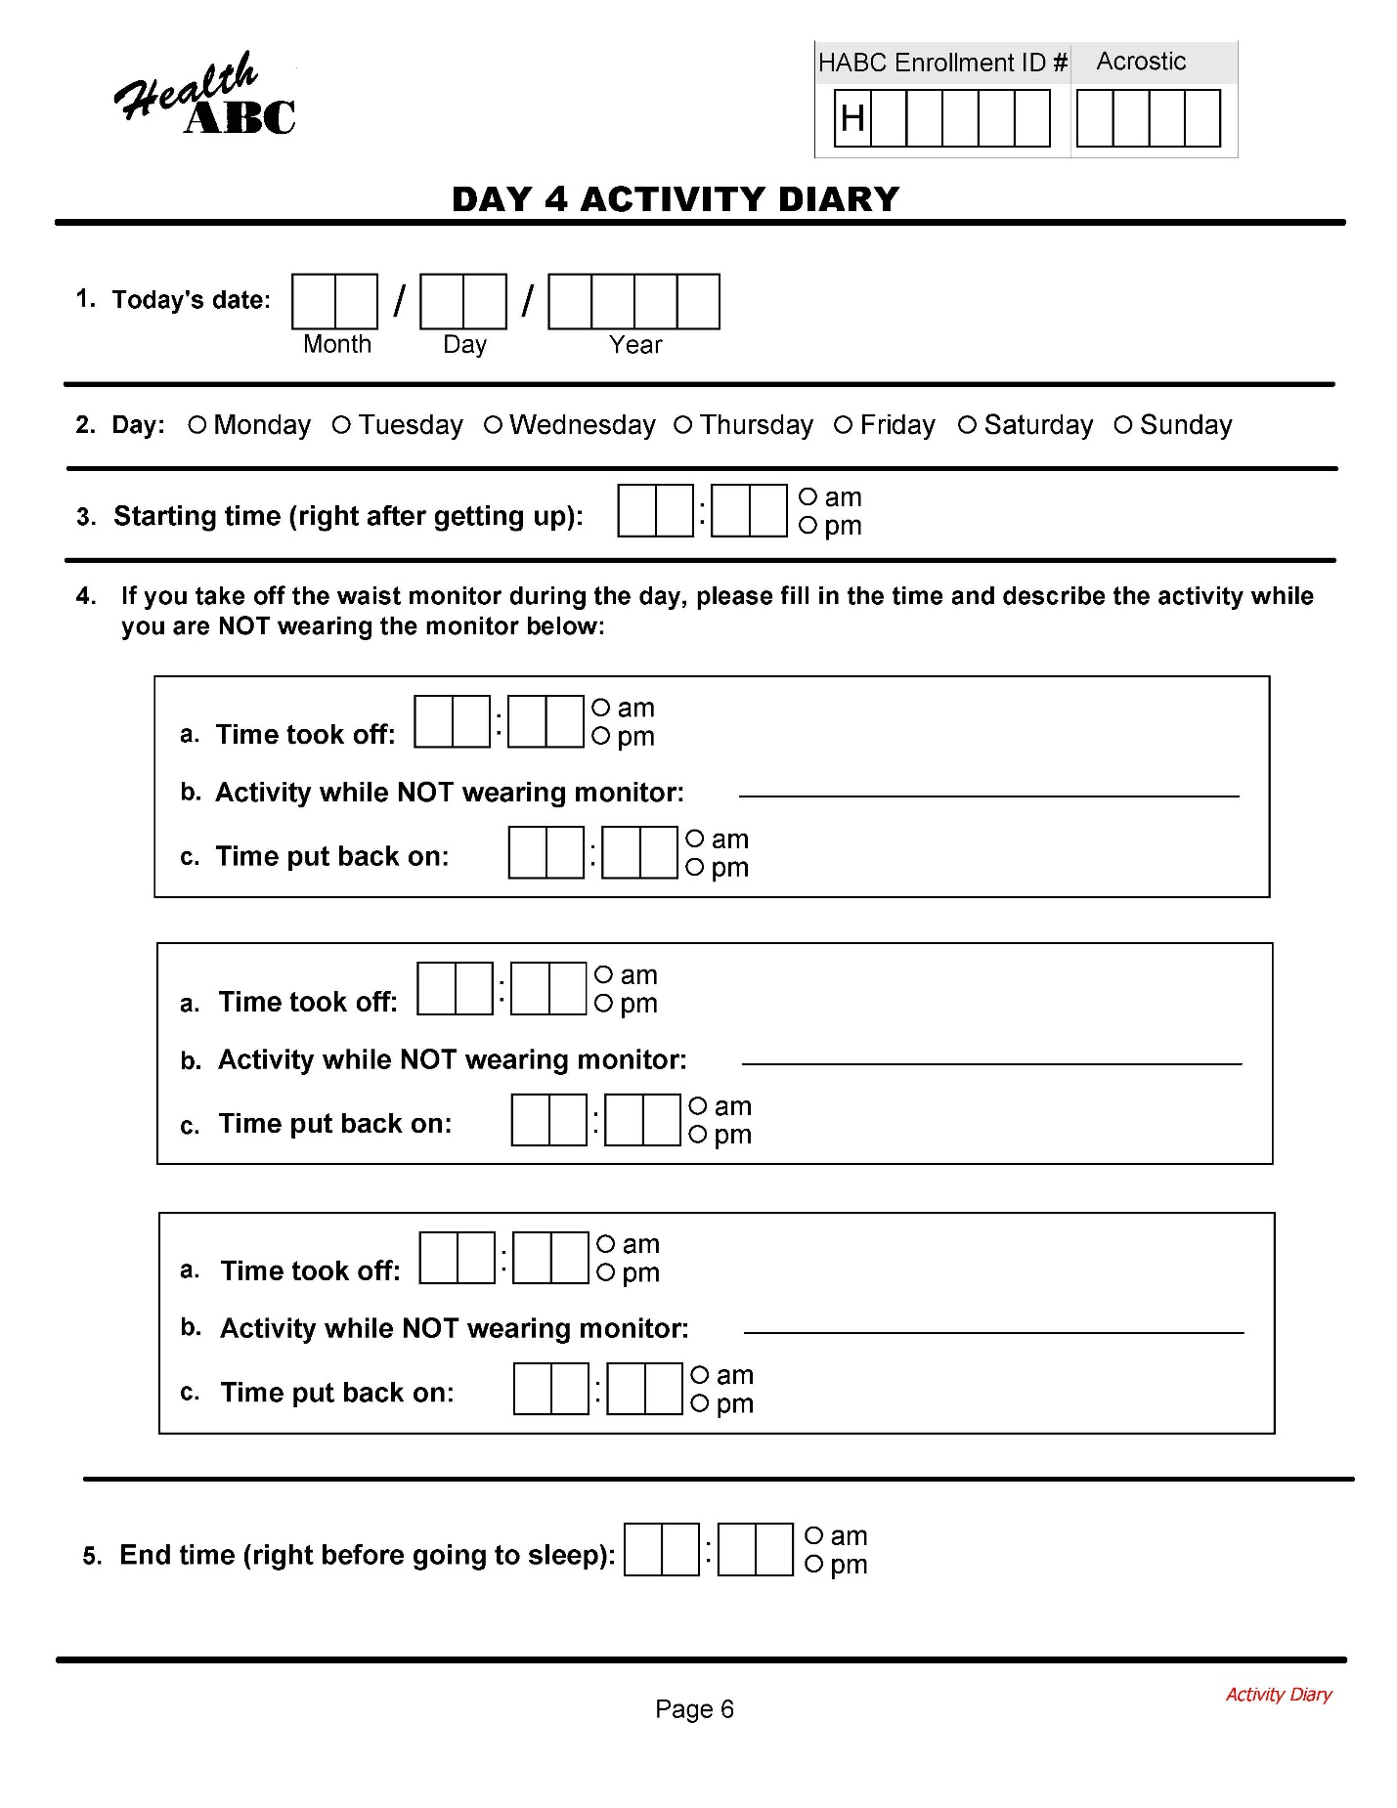
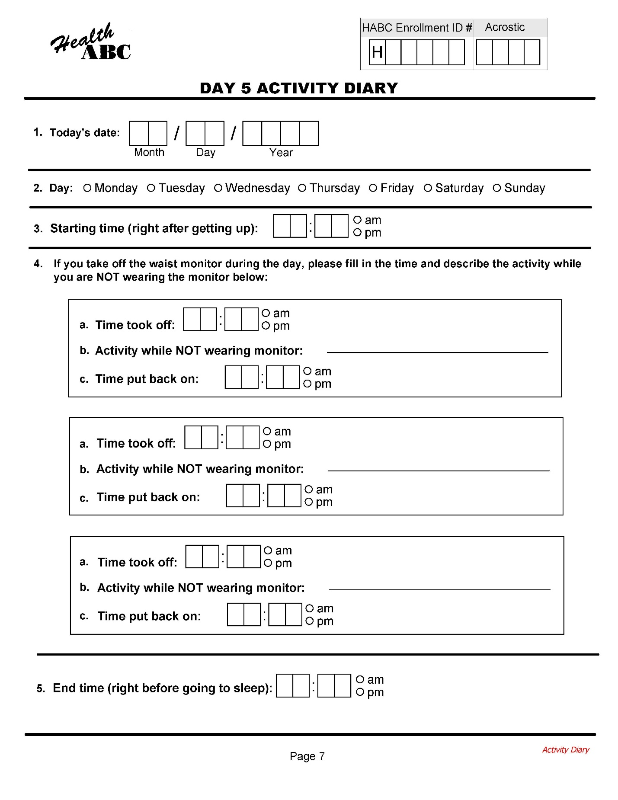
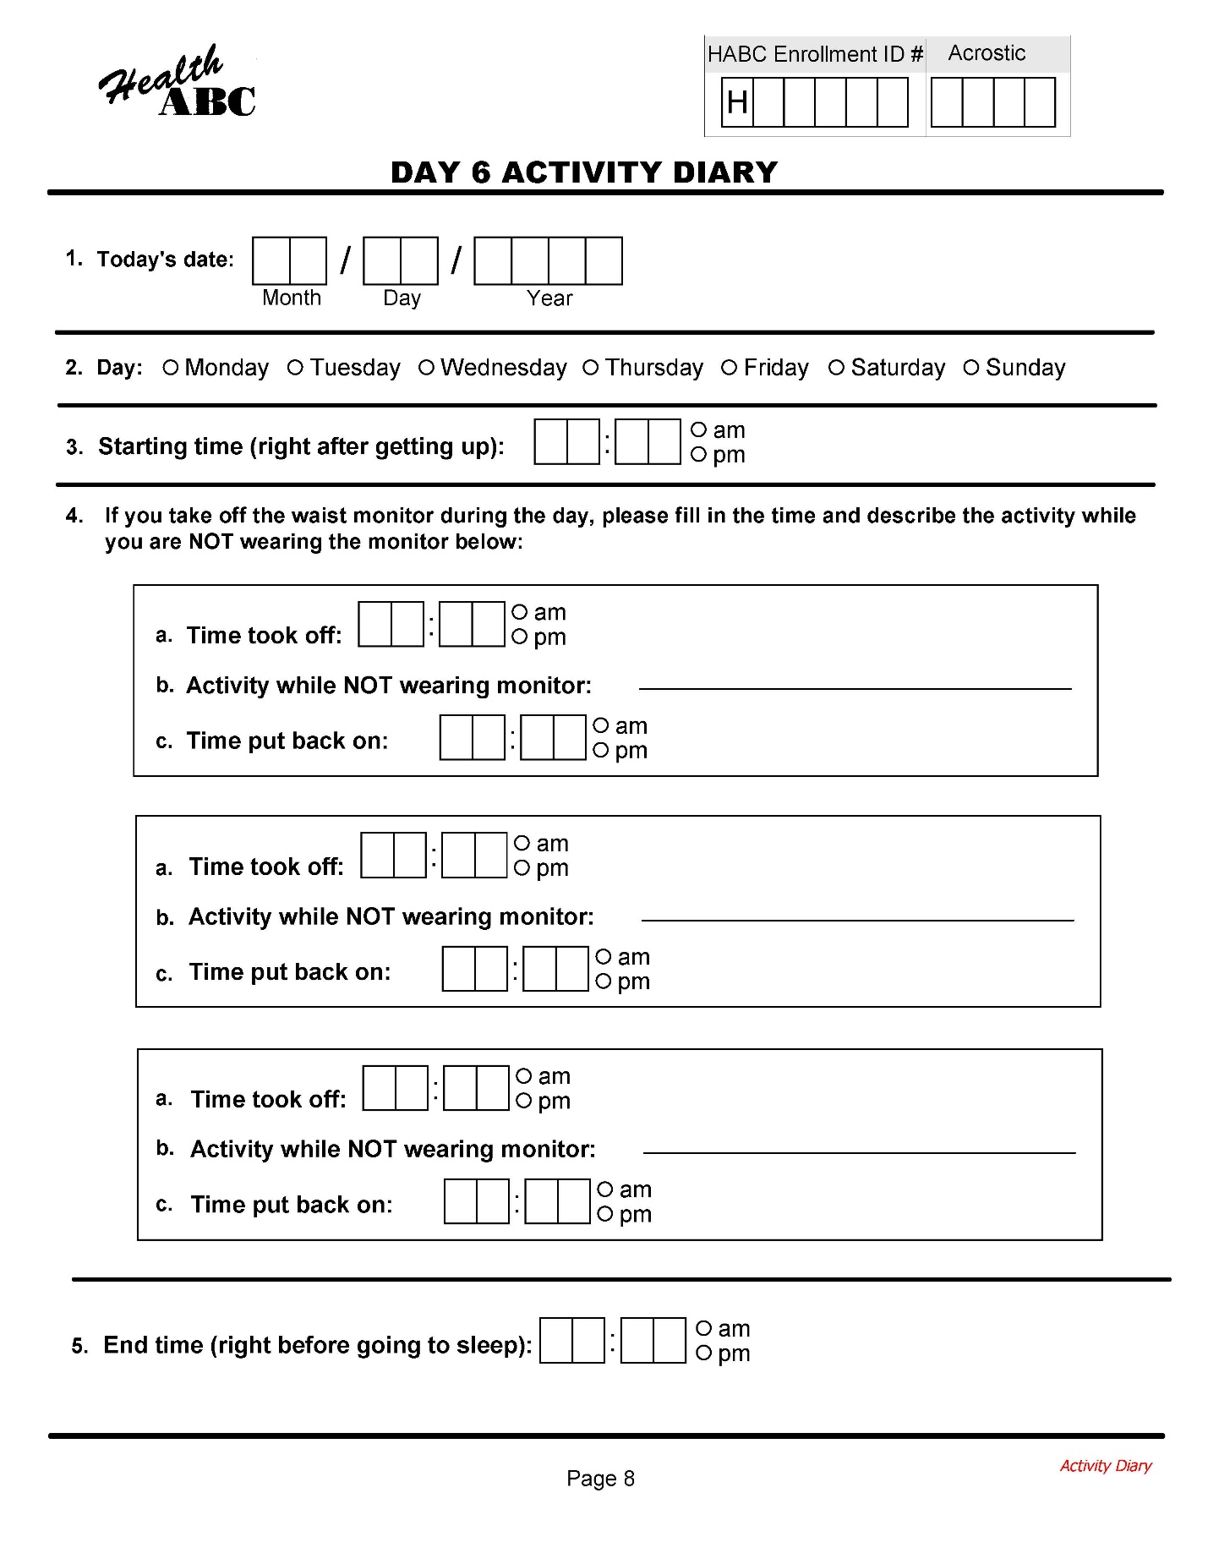
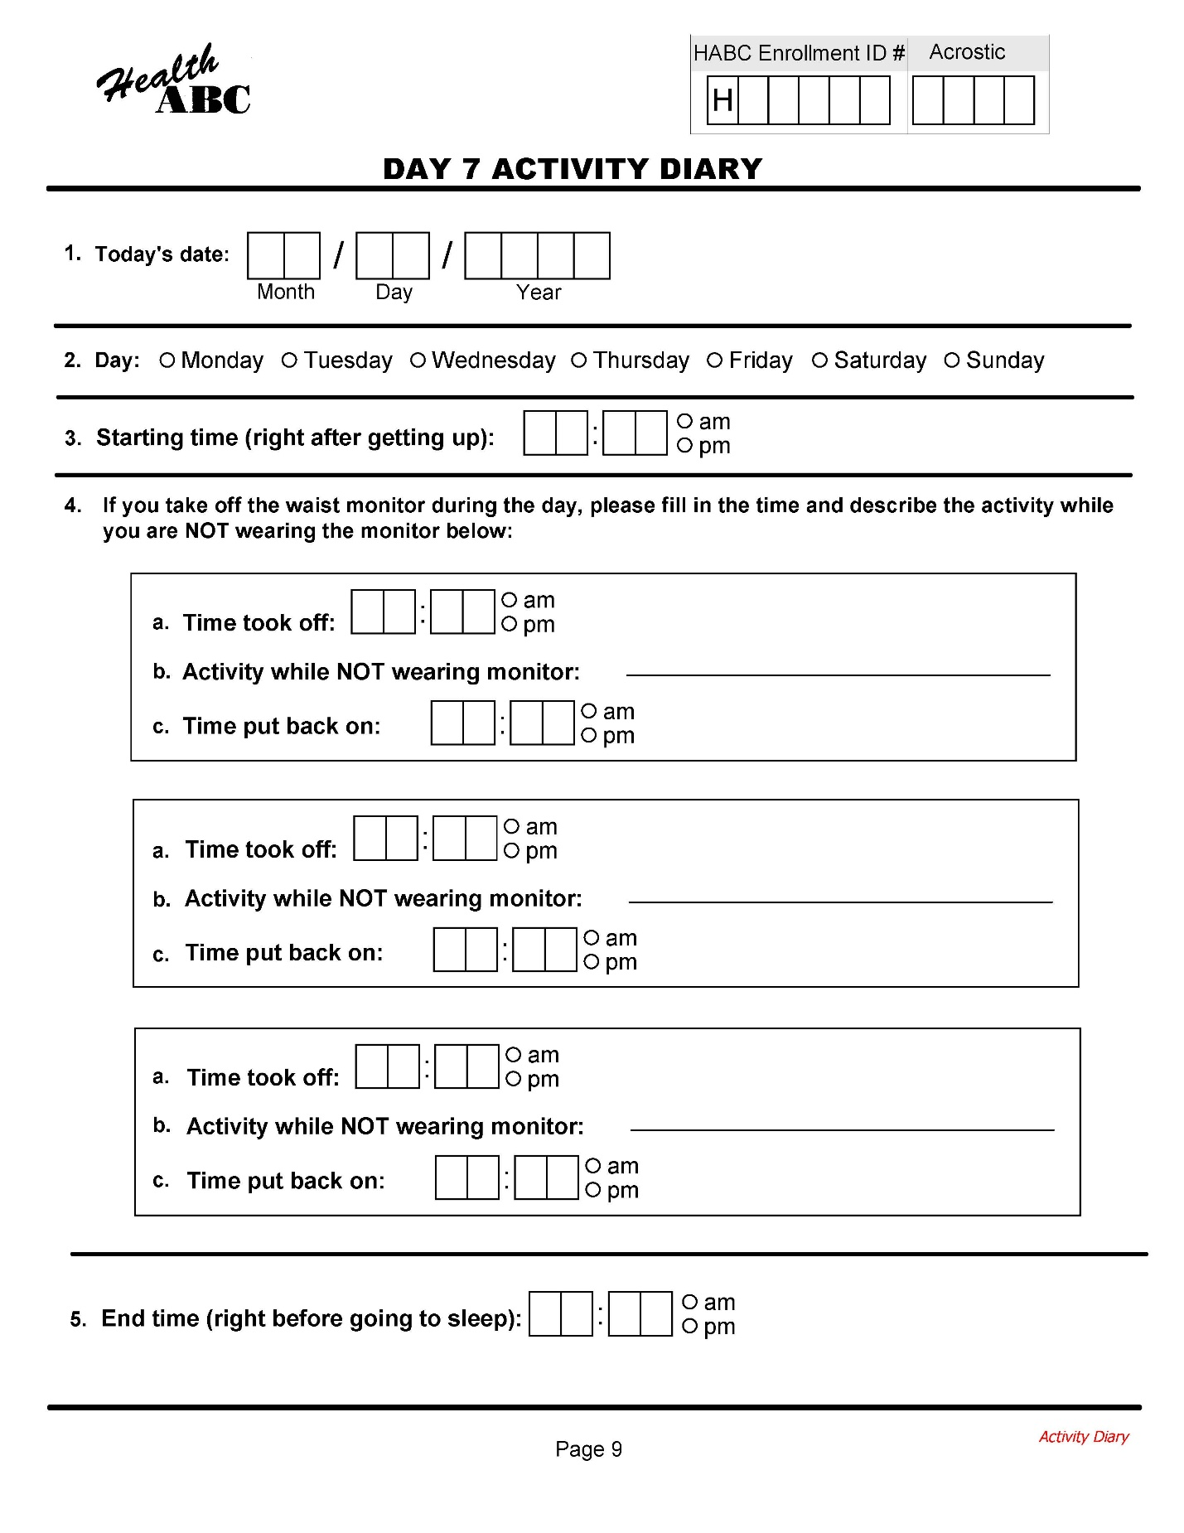

Appendix 2 Accelerometry Tracking Forms

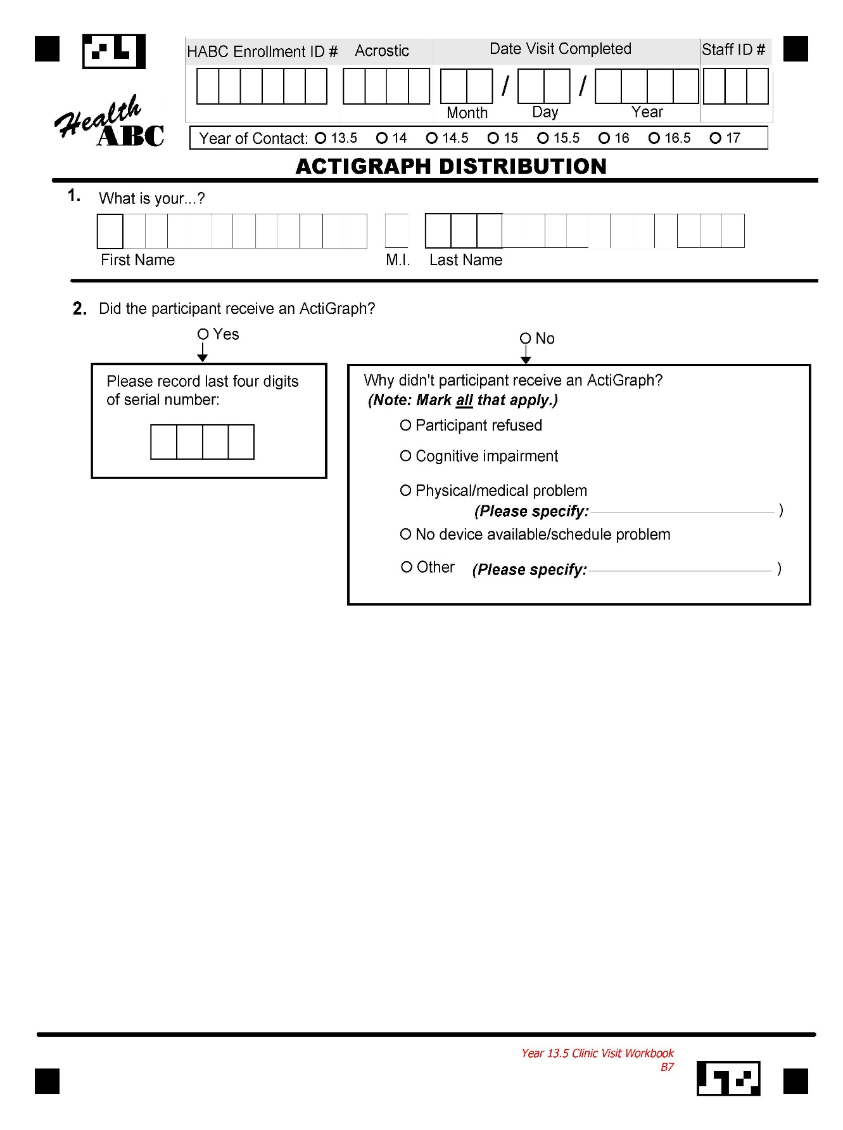
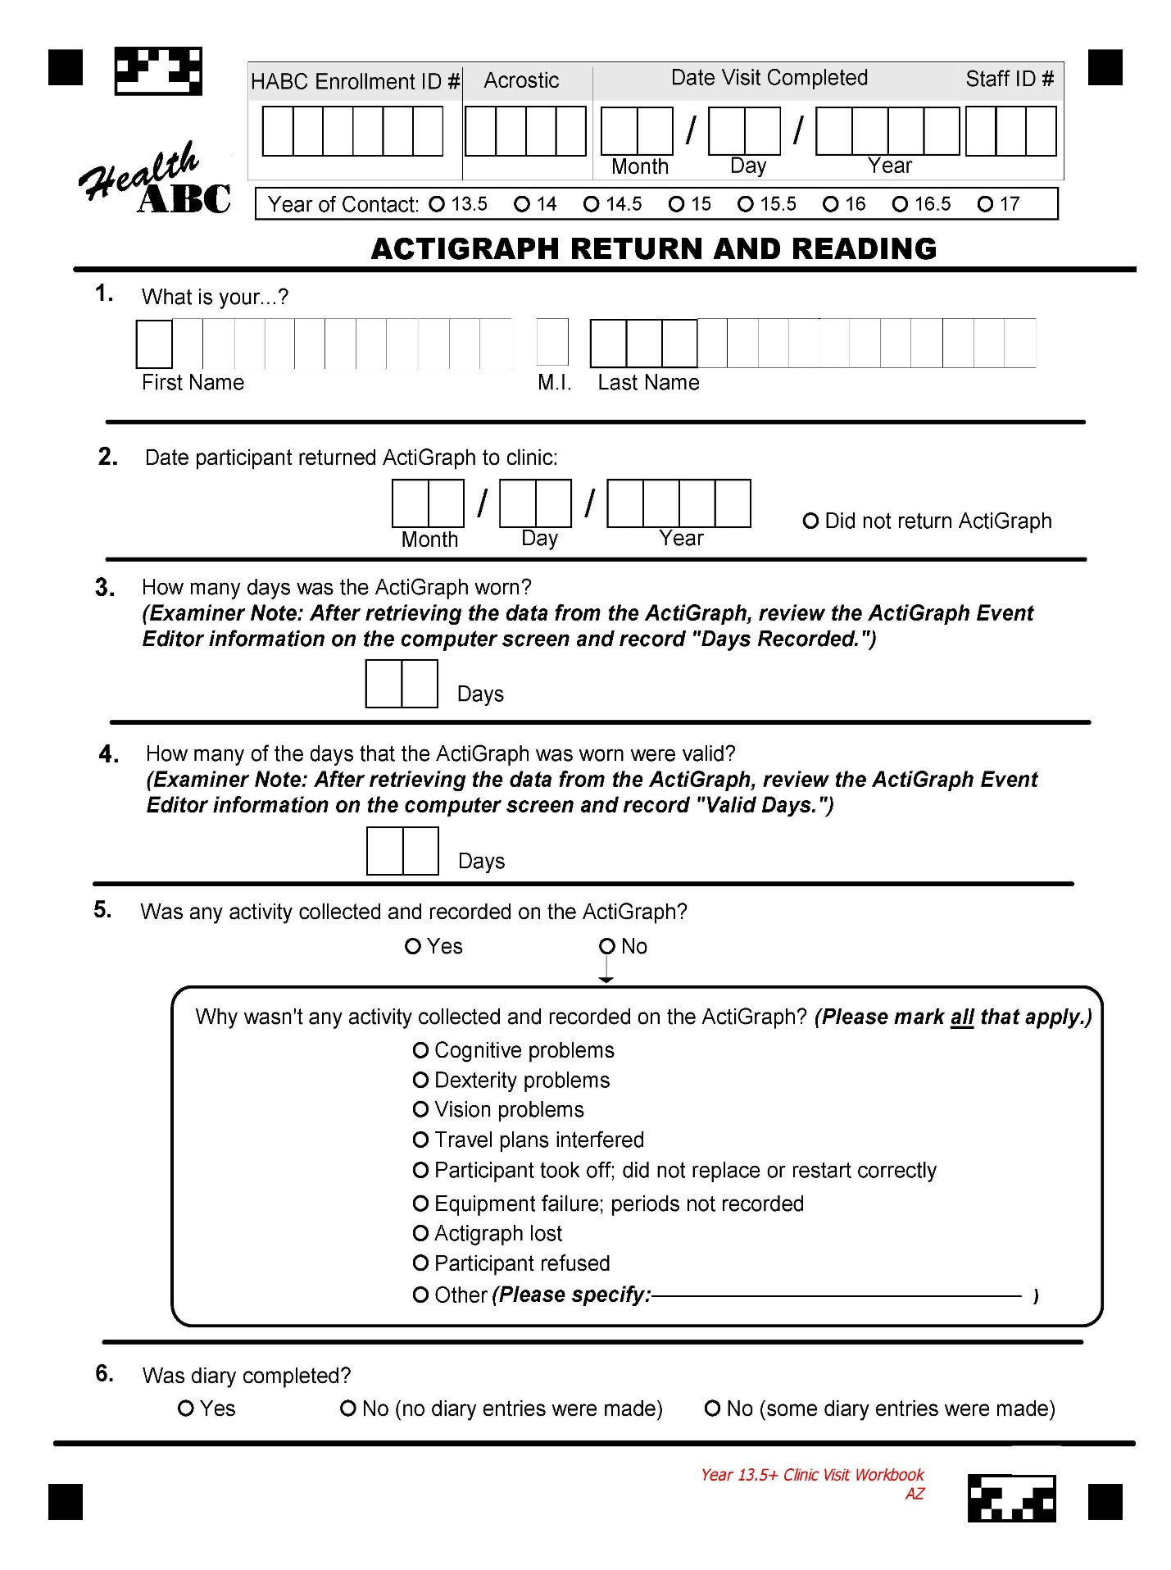

Appendix 3 Data Backup

Data should be backed-up onto a CD at the end of every day.

For each participant, there are three files with three extensions: .dat .csv, and .cmnt. These are stored in C:\Program Files\ActiGraph\ActiLife\files. These must be copied individually onto a CD.

