THIRD NATIONAL HEALTH AND NUTRITION EXAMINATION SURVEY

GALLBLADDER ULTRASONOGRAPHY PROCEDURE MANUAL

Westat, Inc.
1650 Research Boulevard
Rockville, MD 20850
(301) 251-1500

September 1988

TABLE OF CONTENTS

Chapter Page

1 INTRODUCTION . . . . . . . . . . . . . . . . . . . . . . . . . . . . . . . . . . . . . . . . . . 1-1
  - 1 Overview of the Ultrasound Component . . . . . . . . . . . . . . . . . . . . . . 1-1
  - 2 Overview of Anatomy and Physiology . . . . . . . . . . . . . . . . . . . . . . . . 1-2
    - 1 Normal Structure and Function . . . . . . . . . . . . . . . . . . . . . . 1-2
    - 2 Abnormalities of the Gallbladder . . . . . . . . . . . . . . . . . . . . . 1-4
1. 3 Principles of Operation . . . . . . . . . . . . . . . . . . . . . . . . . . . . . . . . . . 1-5
2 EQUIPMENT . . . . . . . . . . . . . . . . . . . . . . . . . . . . . . . . . . . . . . . . . . . 2-1
2. 1 Description of Equipment and Supplies . . . . . . . . . . . . . . . . . . . . . . . 2-1
2. 2 Ultrasound Area . . . . . . . . . . . . . . . . . . . . . . . . . . . . . . . . . . . . . . 2-2
2. 3 Equipment Setup Procedure . . . . . . . . . . . . . . . . . . . . . . . . . . . . . . . 2-2
2. 3. 1 Beginning of Stand Procedures . . . . . . . . . . . . . . . . . . . . . . . 2-2
2. 3. 2 Calibration Procedures . . . . . . . . . . . . . . . . . . . . . . . . . . . . 2-5
2. 3. 3 Daily Operating Procedures . . . . . . . . . . . . . . . . . . . . . . . . . 2-9
2. 4 Care and Maintenance of Equipment . . . . . . . . . . . . . . . . . . . . . . . . . 2-10
2. 4. 1 Cleaning . . . . . . . . . . . . . . . . . . . . . . . . . . . . . . . . . . . . . 2-10
2. 4. 2 Maintenance . . . . . . . . . . . . . . . . . . . . . . . . . . . . . . . . . . . 2-11
2. 4. 3 Malfunctions . . . . . . . . . . . . . . . . . . . . . . . . . . . . . . . . . . 2-12
2. 5 End of Stand Procedures . . . . . . . . . . . . . . . . . . . . . . . . . . . . . . . . . 2-13
3 EXAMINATION PROTOCOL . . . . . . . . . . . . . . . . . . . . . . . . . . . . . . . . . . 3-1
3. 1 Eligibility Criteria . . . . . . . . . . . . . . . . . . . . . . . . . . . . . . . . . . . . . 3-1
3. 2 Pre-examination Procedures . . . . . . . . . . . . . . . . . . . . . . . . . . . . . . 3-1
3. 3 Examination Procedures . . . . . . . . . . . . . . . . . . . . . . . . . . . . . . . . . 3-2
3. 3. 1 Protocol Procedures . . . . . . . . . . . . . . . . . . . . . . . . . . . . . . 3-2
3. 3. 2 Examination Form . . . . . . . . . . . . . . . . . . . . . . . . . . . . . . . 3-13
3. 3. 3 Questionnaire Specifications . . . . . . . . . . . . . . . . . . . . . . . . 3-20
3. 4 Post Examination Procedures . . . . . . . . . . . . . . . . . . . . . . . . . . . . . . 3-30
TABLE OF CONTENTS (continued)
Chapter Page
4 LOGS AND RECORDS . . . . . . . . . . . . . . . . . . . . . . . . . . . . . . . . . . . . . . 4-1
4. 1 Hard Copy Forms . . . . . . . . . . . . . . . . . . . . . . . . . . . . . . . . . . . . . 4-1
4. 1. 1 Ultrasound Daily Log Sheet . . . . . . . . . . . . . . . . . . . . . . . . . 4-1
4. 1. 2 Calibration Log Sheet . . . . . . . . . . . . . . . . . . . . . . . . . . . . . 4-3
4. 2 Automated Forms . . . . . . . . . . . . . . . . . . . . . . . . . . . . . . . . . . . . . 4-3
4. 2. 1 Ultrasound Daily Log . . . . . . . . . . . . . . . . . . . . . . . . . . . . . 4-3
4. 3 Shipment of Logs and Records . . . . . . . . . . . . . . . . . . . . . . . . . . . . . 4-4
4. 3. 1 Logs . . . . . . . . . . . . . . . . . . . . . . . . . . . . . . . . . . . . . . . . 4-4
4. 3. 2 Calibration Forms . . . . . . . . . . . . . . . . . . . . . . . . . . . . . . . 4-4
5 QUALITY CONTROL . . . . . . . . . . . . . . . . . . . . . . . . . . . . . . . . . . . . . . . 5-1
5. 1 Examination Forms . . . . . . . . . . . . . . . . . . . . . . . . . . . . . . . . . . . . 5-1
5. 1. 1 Automated System Forms . . . . . . . . . . . . . . . . . . . . . . . . . . 5-1
5. 1. 2 Hard Copy Data Collection Forms . . . . . . . . . . . . . . . . . . . . 5-1
5. 2 Daily Log Sheets . . . . . . . . . . . . . . . . . . . . . . . . . . . . . . . . . . . . . . 5-2
5. 3 Review Center Activities . . . . . . . . . . . . . . . . . . . . . . . . . . . . . . . . 5-2
5. 3. 1 Standard Review . . . . . . . . . . . . . . . . . . . . . . . . . . . . . . . . 5-2
5. 3. 2 Rapid Reviews . . . . . . . . . . . . . . . . . . . . . . . . . . . . . . . . . 5-2
5. 3. 3 Emergency (Level 1) Referral Situations . . . . . . . . . . . . . . . . 5-3
5. 4 Reporting Exam Findings . . . . . . . . . . . . . . . . . . . . . . . . . . . . . . . . 5-4
5. 5 Equipment Calibrations . . . . . . . . . . . . . . . . . . . . . . . . . . . . . . . . . 5-7
5. 6 Observation and Replication . . . . . . . . . . . . . . . . . . . . . . . . . . . . . . 5-7
5. 7 Refresher Sessions . . . . . . . . . . . . . . . . . . . . . . . . . . . . . . . . . . . . . 5-8
6 SAFETY . . . . . . . . . . . . . . . . . . . . . . . . . . . . . . . . . . . . . . . . . . . 6-1
6. 1 Equipment Precautions . . . . . . . . . . . . . . . . . . . . . . . . . . . . . . . . . . 6-1
6. 2 Sample Person Considerations . . . . . . . . . . . . . . . . . . . . . . . . . . . . . 6-1
6. 2. 1 Screening for Eligibility . . . . . . . . . . . . . . . . . . . . . . . . . . . 6-1
6. 2. 2 SP Movement and Positioning . . . . . . . . . . . . . . . . . . . . . . . 6-1
    - 3 SPs Unable to Physically Cooperate . . . . . . . . . . . . . . . . . . . 6-2
TABLE OF CONTENTS (continued)
Chapter Page
    - 4 Confused or Uncooperative Sample Persons . . . . . . . . . . . . . . 6-2
6. 2. 5 Upset or Ill Sample Persons . . . . . . . . . . . . . . . . . . . . . . . . . 6-2
6. 3 Medical Emergencies . . . . . . . . . . . . . . . . . . . . . . . . . . . . . . . . . . . 6-3

List of Exhibits
Exhibit Page

1-1 Anatomic Views . . . . . . . . . . . . . . . . . . . . . . . . . . . . . . . . . . . . . . . . . . . 1-3
2-1 Calibration Form . . . . . . . . . . . . . . . . . . . . . . . . . . . . . . . . . . . . . . . . . . . 2-7
3-1 Lateral and Transverse Views . . . . . . . . . . . . . . . . . . . . . . . . . . . . . . . . . . . 3-5
3-2 Gallstones with Acoustic Shadowing . . . . . . . . . . . . . . . . . . . . . . . . . . . . . . 3-6
3-3 Small Gallstones . . . . . . . . . . . . . . . . . . . . . . . . . . . . . . . . . . . . . . . . . . . 3-7
3-4 Gallbladder with Stones . . . . . . . . . . . . . . . . . . . . . . . . . . . . . . . . . . . . . . . 3-9
3-5 Reverberation . . . . . . . . . . . . . . . . . . . . . . . . . . . . . . . . . . . . . . . . . . . 3-11
3-6 Sludge . . . . . . . . . . . . . . . . . . . . . . . . . . . . . . . . . . . . . . . . . . . 3-12
3-7 Logic Flow . . . . . . . . . . . . . . . . . . . . . . . . . . . . . . . . . . . . . . . . . . . 3-14
3-8 Landmark Questions . . . . . . . . . . . . . . . . . . . . . . . . . . . . . . . . . . . . . . . . . 3-17
3-9 Loop Questions . . . . . . . . . . . . . . . . . . . . . . . . . . . . . . . . . . . . . . . . . . . 3-18
3-10 Ultrasound Data Collection Form . . . . . . . . . . . . . . . . . . . . . . . . . . . . . . . . 3-21
4-1 Ultrasound Daily Log Sheet . . . . . . . . . . . . . . . . . . . . . . . . . . . . . . . . . . . . 4-2
5-1 Report of Findings Letter . . . . . . . . . . . . . . . . . . . . . . . . . . . . . . . . . . . . . . 5-5
  - Normal and Gallstone Findings Paragraphs . . . . . . . . . . . . . . . . . . . . . . . . . . 5-6

INTRODUCTION

Overview of the Ultrasound Component

Ultrasonography of the gallbladder is included as part of the digestive diseases component of the NHANES III. In addition to ultrasonography, the digestive diseases component will also obtain information from interviews with sample persons. The ultrasound procedure will be performed to detect abnormalities of the gallbladder, especially the presence of gallstones, in adults aged 20 to 74 years. Reliability of the diagnostic ultrasound procedure is reported to be 95% when basic criteria for diagnosis of gallstones are present.

Digestive diseases represent the third largest economic burden of illness in the United States. Gallbladder disease is the most costly digestive illness, generating more than a billion dollars per year in direct costs for medical care. Gallstones occur in approximately 15% of the population, and with higher incidence in women and the elderly. In 1984, approximately 776,000 patients were discharged from short- stay hospitals with a diagnosis of gallstones, 485,000 of those patients received a cholecystectomy.

Information from the NHANES III studies should yield a better understanding of the prevalence and risk factors of gallbladder disease, and lead to the development of improved primary prevention measures. This manual has been designed to serve as a reference for the performance and interpretation of the ultrasound examination. Standardized procedures have been developed to insure that each examination is performed in a consistent manner and that the results of each examination are accurate and reliable. Consequently, it is imperative that these procedures always be observed in the performance of ultrasound examinations.

All ultrasound personnel will receive training in the standardized procedures and will be tested for proficiency. In addition, supervisors will periodically accompany personnel in the field to observe and confirm the accuracy of the procedures, assist with any problems and conduct refresher sessions as needed. These measures are intended to assure the consistent, accurate performance of the examination, and the collection of reliable information.

Overview of Anatomy and Physiology

Normal Structure and Function

The gallbladder is part of a network of structures known collectively as the biliary tree, which drains bile from the liver into the duodenum to facilitate digestion. The biliary tree also includes the cystic duct, the right and left hepatic ducts, and the common hepatic and common bile ducts, as well as a series of microscopic biliary vessels.

A small, pear-shaped sac located on the underside of the liver, the gallbladder varies in size, but rarely exceeds 4cm in diameter and 10cm in length. It consists of a rounded fundus, smooth body and tapering neck, which becomes contiguous with the cystic duct and attaches to the porta hepatis. The cystic duct ultimately joins the right side of the common hepatic duct to form the common bile duct (see Exhibit 1-1).

Circulation to the gallbladder is supplied primarily by the cystic artery, a branch of the right hepatic artery, and the cystic veins, which drain directly into the portal vein.

The function of the gallbladder is to provide a reservoir for the storage and concentration of bile. Secreted by the liver, bile is composed largely of bile salts, bile pigments and small amounts of organic materials such as cholesterol, lecithin, fatty acid and mucin. Bile salts are produced by the liver and are essential for the digestion and absorption of fat in the small intestine. Bile pigments are the end product of the breakdown of hemoglobin during the destruction of old red blood cells. Most of the bile secreted between meals is diverted to the gallbladder.

Production of bile ranges from 250-1,000 mls per day, and is regulated by the concentration of bile salts in the blood, and the secretion of fluids in which bile salts are dissolved. The gallbladder is capable of storing approximately 50 mls of bile, and can increase the concentration of bile by five to ten- fold.
Exhibit 1-1. Anatomic Views

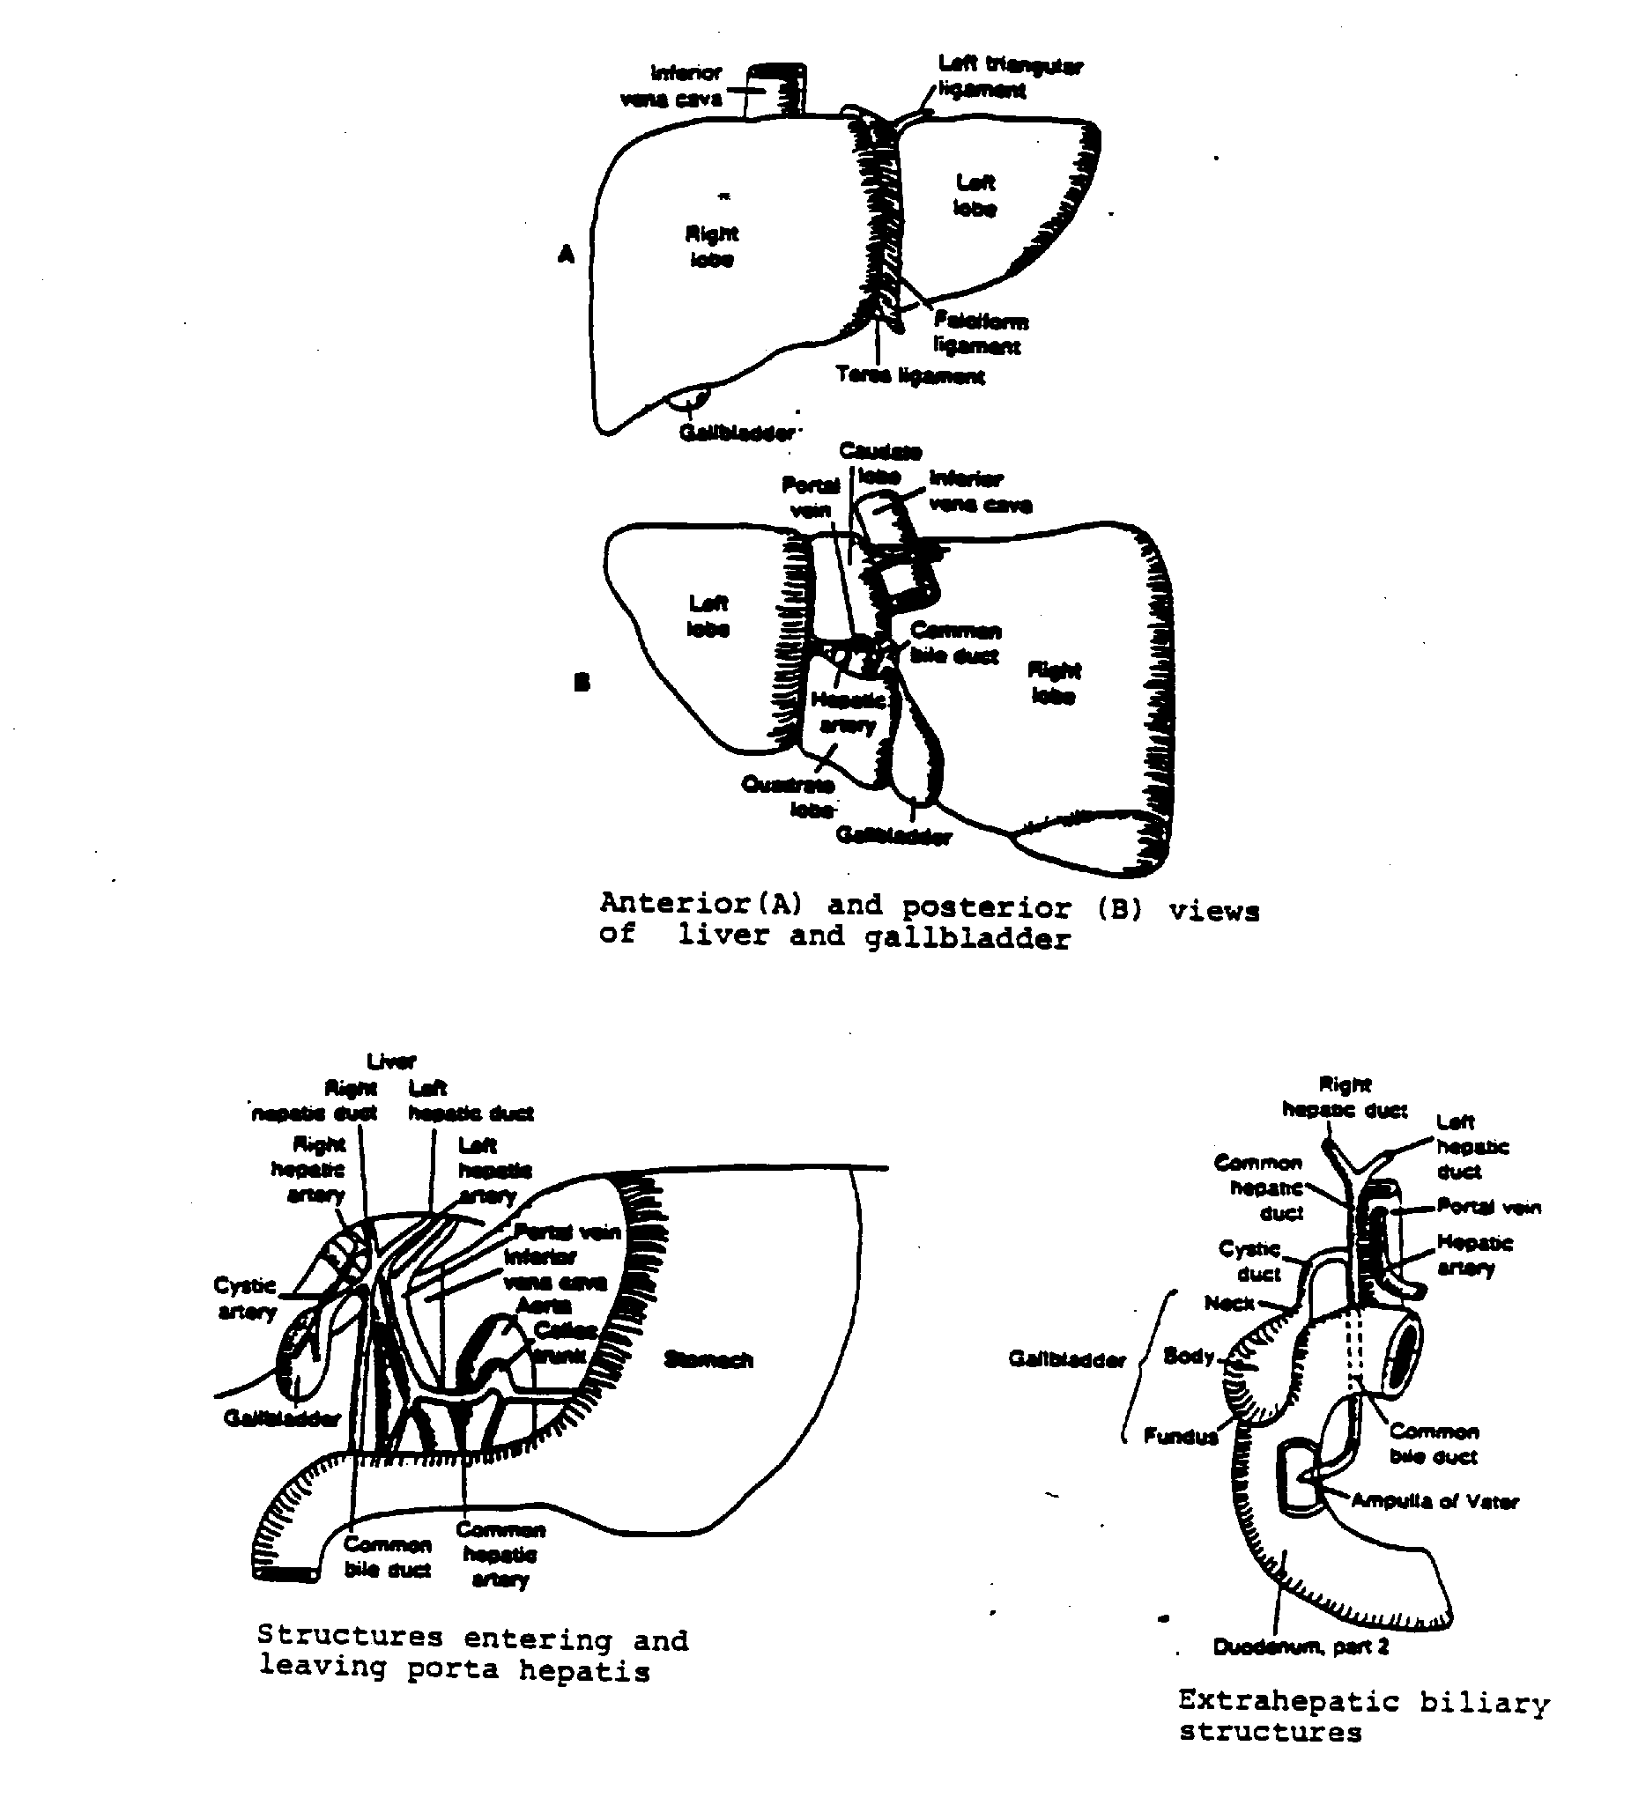
Release of bile from the gallbladder is stimulated by the presence of food, especially fat, in the digestive tract. Reflexive contractions of the gallbladder wall and secretion of a hormone from the duodenum, cholecystokinin, which further stimulates contraction of the gallbladder, are triggered in response to the presence of food. The contractions, in conjunction with relaxation of the neck of the gallbladder, force bile out into the duodenum. Most of the bile salts are reabsorbed from the intestinal tract and returned to the liver to be used again.

Abnormalities of the Gallbladder

Unusual or abnormal findings in the gallbladder include both anatomic irregularities as well as pathologic conditions. Anatomic peculiarities of the gallbladder may include extremely large or small- sized organs, misalignment of vessels or ducts, absence of the gallbladder (not due to surgery) or in some rare instances, the presence of two gallbladders. These findings are of interest mainly because of their influence on the ultrasound examination, but documentation of evidence of disease in the gallbladder is the main objective of the exam for NHANES III.

The presence of gallstones in the gallbladder or bile ducts, or cholelithiasis, and inflammation of the gallbladder, or cholecystitis, are the most common problems affecting the gallbladder. The NHANES III is primarily concerned with the detection of gallstones, but evidence of cholecystitis or other abnormalities will be reported as well. The ultrasound examination is extremely reliable for the diagnosis of gallstones, reportedly as high as 95% when specific criteria are present, and has exceeded the oral cholecystogram as the diagnostic procedure of choice.

Gallstones result from changes in the concentration of bile, specifically, of bile salts, lecithin and cholesterol. Alterations in the balance of these concentrations causes cholesterol, which is normally dissolved by lecithin and bile salts, to precipitate out of solution and form a stone. Small amounts of calcium salts and other elements may also be included in the stone as pure cholesterol stones are rare.

Small gallstones may slip through the gallbladder and ducts, and into the small intestine where they are expelled without incident. However, large stones become lodged in the gallbladder, usually at the neck (Hartmann's pouch), causing painful muscle spasms, or in the bile duct, preventing bile from entering the intestine and blocking the digestion and absorption of fat. As the liver continues to secrete bile,
pressure rises in the occluded duct and bile pigments are forced into the blood and tissues, where they accumulate, causing jaundice, a deep yellow coloring of the skin. Stones may also lodge at the juncture of the bile and pancreatic duct in the duodenum, blocking the flow of both bile and pancreatic juices, and resulting in the complete cessation of digestion and absorption of food.

Cholecystitis is an inflammation of the gallbladder usually triggered by a stone in the gallbladder itself or in the bile duct. Acute cholecystitis results form the sudden obstruction of a gallbladder outlet, and, if severe, may warrant immediate medical attention. Chronic cholecystitis persists over a long period of time and may be manifested as a series of attacks or as vague abdominal pain. Thickening of the gallbladder wall may be present in both conditions but is seen in other disorders and therefore is not diagnostic in these instances. Fluid collections, representing small abscesses, may be seen around the gallbladder in acute cholecystitis. A more reliable diagnostic sign is the "sonographic Murphy's sign," which is pain in the right upper quadrant when the ultrasound probe is pressed directly over the gallbladder.

Right upper quadrant pain, especially following the ingestion of greasy or fatty foods is the classic symptom of gallbladder disease. In most instances, however, gallbladder disease is completely asymptomatic.

Principles of Operation

Diagnostic ultrasound uses high frequency sound waves to produce visual images of internal body structures and is considered a safe and effective diagnostic tool.

The basic principle underlying sonography is the piezoelectric effect, which is the electrical stimulation of a quartz crystal to propagate high frequency, or "ultra sound" waves. These ultrasound waves exceed the frequency range of sound for the human ear, 20-20,000 Hz, and thus are inaudible. The ultrasound beam generated by the crystal is transmitted to human tissue, reflected, and converted into a visual image, which can be studied for evidence of disease or abnormality.

Ultrasound waves require a medium for transmission, since matter must be present for sound to travel. Ultrasound travels in longitudinal waves, alternately compressing and decompressing (rarifying) molecules and producing a to-and-fro motion that is passed between molecules along the direction of the
wave. The distance between molecules, and thus the composition of the medium, is important to the propagation of ultrasound.

Dense materials, such as water or solids, facilitate the transmission of ultrasound, while materials with greater distances between molecules, such as air, have difficulty propagating waves. The ability of the materials to be compressed and rarified is also a major determinant of propagation. Materials that resist compression are less effective in transmitting waves. Consequently, the velocity of the ultrasound wave (or beam) is dependent on the density and compressibility of the medium. Velocity is important as it must be known accurately for proper calibration of equipment.

The frequency of the wave also affects the transmission of ultrasound. As the frequency increase, the wavelengths decrease and molecules in the medium have a more difficult time forming compressions and rarifications. With higher frequencies, the resolution is better but penetrability (or depth) decreases. Conversely, with lower frequencies, image resolution is not as good but penetrability of the beam improves.

Biologic materials have the ability to reflect sound waves at tissue interfaces, which varies with the density and compressibility of the material, and the velocity of the wave. This ability, or property of reflection, is known as acoustic impedance. Changes in the impedance of tissues cause reflections of the ultrasound waves, and the greater the change between tissues, the greater the amount of reflection of the wave. These changes in impedance at tissue interfaces make it possible to see tissue structures, particularly soft tissue, with ultrasonic beams.

Some structures are poorly imaged with ultrasound equipment. Lungs and bowel containing air reflect sound waves and do not image well. Structures behind them cannot be seen accurately due to the amount of reflection, so neighboring soft-tissue or fluid-filled organs must be used as a window to visualize structures obscured by air. Bone also reflects a large proportion of the sound waves directed towards it and that does not image well.

Ultrasound beams aimed at body tissues should be directed at right angles to the surface, otherwise the waves are refracted, (deviated) and the amount of reflection is reduced. At a point known as the critical angle, total reflection occurs at the interface and reflected waves cannot be detected.
A transducer, which houses the piezoelectric crystal, converts electrical energy to sonic energy, and returning echoes back to electrical energy. In a pulse-echo system, such as that used in the NHANES III, the crystal is pulsed electrically to omit sound for a brief time, then transmission stops and the crystal waits for the return echo. As echoes return, the crystal again vibrates, generating another electrical signal. If real-time imagining is used, as it is in NHANES III, this signal can be converted into a dynamic visualization of internal structures.

Resolution of an image is obtained with a transducer or probe that combines the right frequency and proper focal zone. The near field, or that area nearest the transducer face, is called the Fresnel zone. Probes can be focused for specific zones and should be used appropriately. Outside the focal zone, information that appears to be present may actually be an artifact, and structures are distorted and poorly visualized.

EQUIPMENT

Description of Equipment and Supplies

The Toshiba Sonolayer SSA-90A is designed specifically for abdominal and OB/GYN examinations. It consists of a main console, a two-channel digital processor, three transducers, and a matrix camera. A videocassette recorder has been added to the unit, and is connected to the auxiliary power supply and VCR input/output outlets on the main unit.

All of the equipment in the examination room is secured to minimize damage during transportation.

The equipment and supplies provided are listed below:

Equipment

Toshiba Sonolayer SSA-90A, with digital control panel and two-channel digital scan processor.

9" video monitor

3.75 MHz phased array sector transducer

3.75 MHz electronic linear/trapezoid transducer

5.0 MHz phased array sector transducer

Calibration phantom

Toshiba videocassette recorder

Matrix camera

2 8 x 10 film cassettes

Footswitch for freeze frame

Supplies

Ultrasound Sonostat acoustic gel

4 x 4 gauze pads (nonsterile)

2 hr VCR tapes

Isopropyl alcohol (70%)

Vinyl examination gloves

Paper drapes (chucks, 30 x 50 cms)

Ultrasound x-ray film

Film envelopes for hard copies

Mailing envelopes for VCR tapes

Ultrasound Area

The ultrasound examination room in the MEC is located in the second trailer of the MEC. It contains the SSA-90A unit, the MEC automated system terminal (VT 320), an examining table, and a limited amount of supplies. No other procedures are conducted in the room.

Equipment Setup Procedure

Beginning of Stand Procedures

      - Complete an inventory of all supplies and submit inventory to the MEC manager. Note any supplies needed for the stand.

      - Unpack new supplies received from Westat and stock examination room or store in belly compartment as needed.

      - Perform preliminary checks and set up equipment.

        - Confirm with the MEC manager that incoming voltage is appropriate for the operation of the SSA-90A.
        - Remove tie-down material from the SSA-90A.

        - Remove transducer storage cases from under the examination table storage area. Check all probes for cracks or breaks in the casing or cables. Inform the MEC manager of any problems.

        - Check the connection plugs on the 3.75 MHz and 5.0 MHz phased array sector probes. Connect both probes to the right side of the unit. All connections should be tight. The 3.75 MHz trapezoid/linear probe is stored in its case in the exam table storage area.

        - Plug the main power cable into the wall outlet on the left side of the room. Clip the cable through the U-clip near the wall outlet. Attach the grounding wire (three pin plug) to appropriate connection, if required by local regulations.

        - Check the connections to and from the VCR on the VCR rear panel and on the rear panel of the main unit. Both should be secure. VCR should be attached to top of the SSA-90A unit.

      - Turn on main power switch, upper left side of control panel. Wait one minute. The system will automatically be placed in the PRESET A conditions and display those conditions on the screen.

      - Compare on screen Menus 1 and 2 to the hard copy films kept on file. Make sure settings are correct.

      - Review and adjust the following controls are necessary:

Preset the following controls to mid-position:

- Observation monitor - Brightness and Contrast controls should be set. Controls should not be changed as video tape settings are matched to these controls and alterations will affect videotape image of exams.

- Gain (80dB)

- All STC slide controls

- M Mode CH1

The timer will display the correct time on the television monitor.

Adjust television monitor.

- Check the gray scale bar displayed on the monitor, and adjust the brightness and contrast controls so that each gradation can be identified, and image is fairly flat.
      - Check the following controls to be sure they are set as indicated:

a. | Top Left
 | Control | Setting
 | PRESET | A ON, all others OFF
 | PROBE | A
 | SCANNING | OFF (Sector scanning is automatic)
b. | Top Right
 | Control | Setting
 | MENU 1 | OFF
 | MENU 2 | OFF
 | FETAL GROWTH | OFF
 | BODY MARK | OFF
 | FOCUS | VARIABLE
 | SCALE | x 0.75 ON or Variable
c. | Below, Left to Right
 | Control | Setting
 | RECORDER | OFF
 | DISPLAY | Exit Video OFF
 | ECG SYNC | OFF (Not used)
 | CAMERA | OFF (Not used)
 | R. DELAY | OFF
 | CHAR | Variable
 | DIST | Variable (Trackball function)
 | AREA | Variable * *
 | CH 1 | OFF
 | CH 2 | OFF
 | STC | All scales set at mid-point
 | M MODE | All OFF
 | POSITION | Not used
 | B MODE | Single ON, all others OFF
 | GAIN | Variable, 80 dB recommended
 | FREEZE | OFF

      - Measurement
The digital scan processor calculates and displays distances between any two points on a displayed anatomical sector. The trackball and distance button are used to obtain measurements. To measure areas on the image:

        - Press [DIST]; [DIST] and [CH1] lamps will indicate, and a mark will be displayed in the center of the screen.

        - Use the trackball to move the mark to the first point of measurement.

        - Press [CH1] to fix the first position indicated by the marker.

        - Use the trackball to move the marker to the next point of measurement.

        - Press [CH1] again to fix the second position. The measurement of distance between the first and second points will display for Channel 1.

        - After measurements are finished, press [DIST] to erase marks and measurements. Press [CHAR] to proceed to another trackball function without disturbing distance display.

      - Perform a calibration of the unit. Calibration procedures are described in Section 2.3.2.

Calibration Procedures

The sonographer performs a calibration of the unit, as described in Section 2.3.2.2, at the start of every stand, and after the unit is serviced by Toshiba.

Calibration by Service Representatives

Toshiba service representatives will perform technical calibrations at regular intervals determined by NCHS biomedical engineers. These calibrations do not replace the calibrations performed by the sonographer, however, the sonographer's calibrations should be performed after the service representative has completed all servicing or technical calibrations.

Start of Stand Calibration Procedures

        - Document all calibration checks on the Calibration Form, shown in Exhibit 2-1, and on hard copy images taken on film and kept on file.
        - Enter the date, examiner identification, machine number, stand number and location area on the form.

        - Both the 3.75 MHz and 5.0 MHz transducers should be used to scan the phantom for the calibration procedures. Use full field focus for the calibrations. Try to use as few sheets of film as possible for the hard copy images.

        - Place the calibration phantom on the examination table and select the 3.75 MHz transducer. Apply small amount of sonostat gel to the transducer.

        - Horizontal Angle Check

Use the caliper markers and measure the distance from the outside of pin C to the outside of pin D. With the second set of calipers, measure from the inside of pin D to the outside of pin E. Obtain a hard copy image.

        - Horizontal Calipers

Using the first set of calipers, measure the calipers against the centimeter markers along the horizontal axis. Use the second set of calipers to measure the horizontal Row B pins. Obtain a hard copy image.

        - Axial resolution

Scan the three different sets of five pins arranged in a diagonal line. Each set represents a different depth. For each depth, identify the two closest pins visible and record the distance between these pins. Obtain a hard copy image of each pin group. REMINDER: Pins will appear as dashes. Be sure to measure at correct side of dash.

        - Lateral resolution

Use the same pin groups described in the axial resolution check. Measure the width in millimeters of the topmost pin in each group with the caliper markers. Obtain a hard copy image showing the caliper markers and measurement.

        - Visual Calipers

Using the vertical centimeter markers along the vertical axis and the vertical Row A pins, follow the same procedure described in step 8.
Exhibit 2-1. Calibration Form
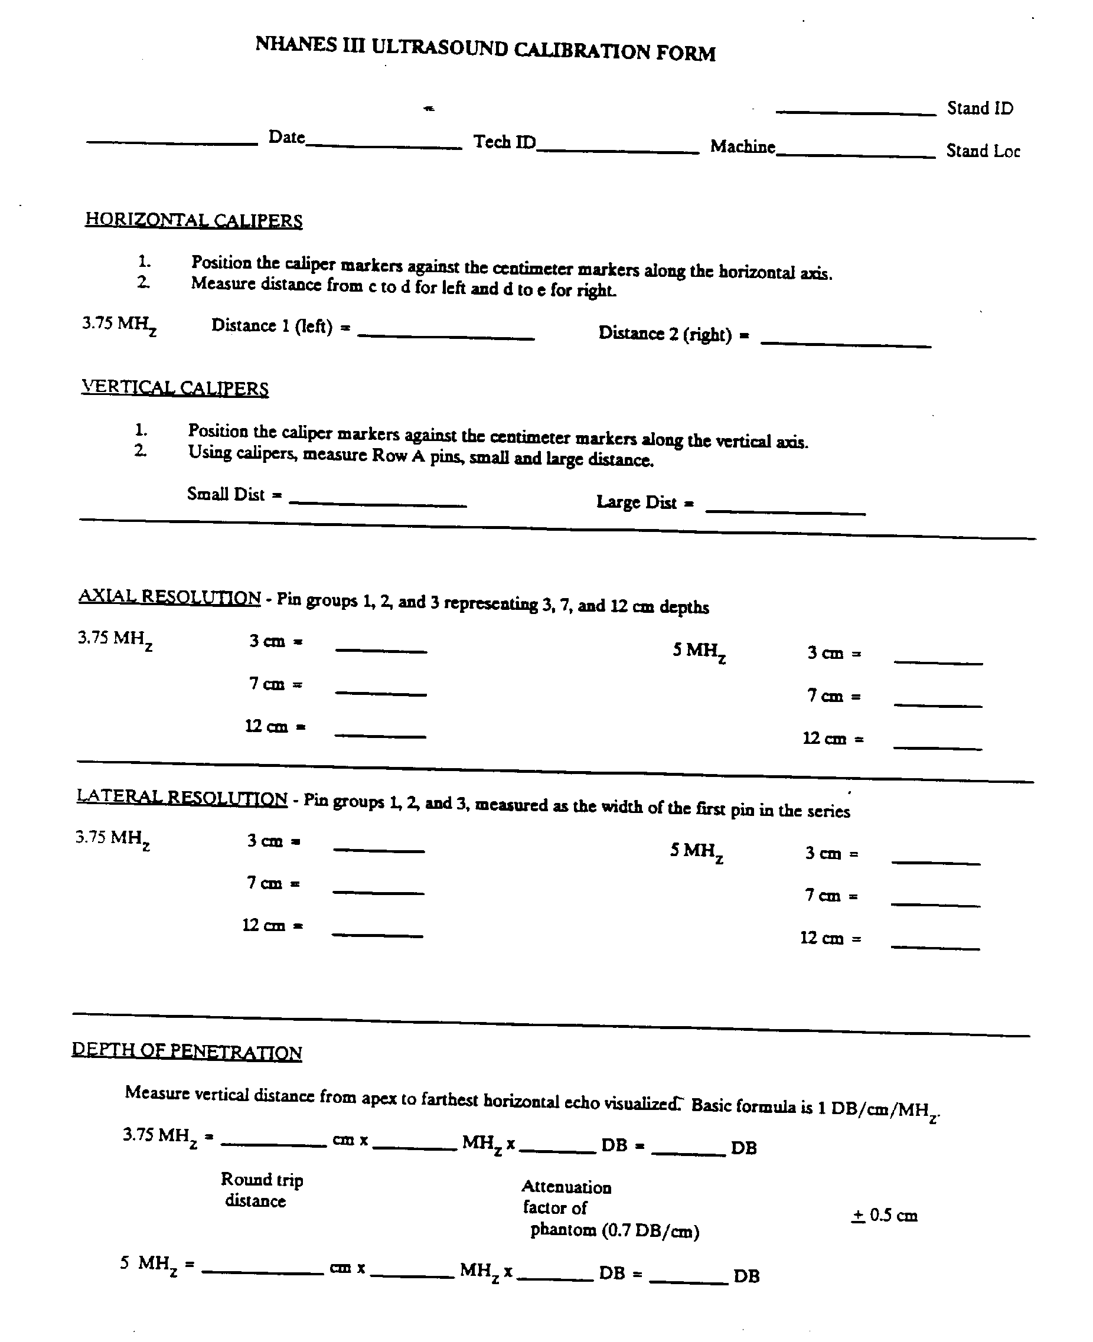
Exhibit 2-1. Calibration Form (continued)
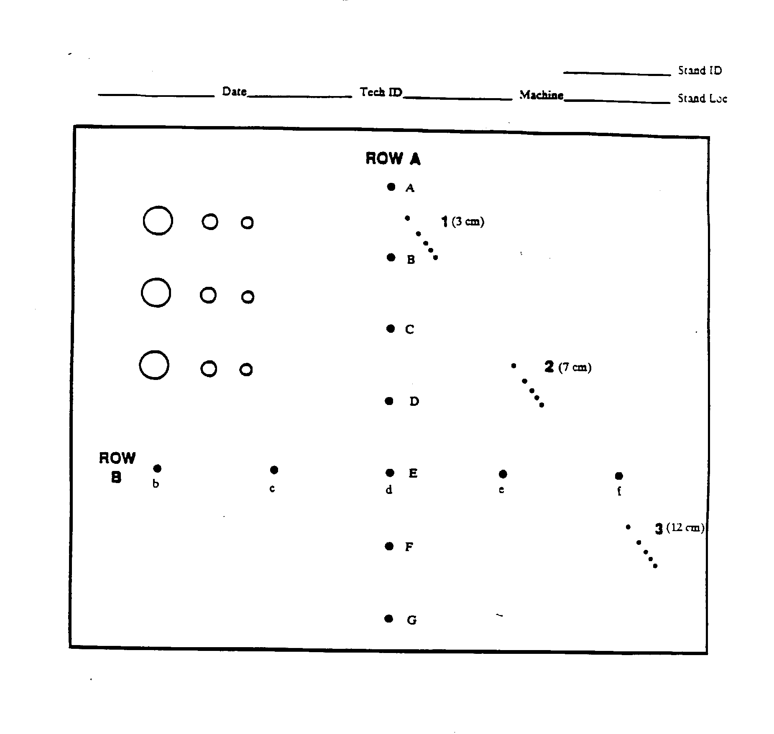
        - Depth of Penetration

Using the caliper markers, measure the distance from the apex of the pin image to the farthest horizontal echo visualized. Obtain a hard copy image.

        - Repeat Steps 5, 6 and 10 with 5.0 MHz transducer.

        - Confirm that all entries on the calibration form are correct and attach hard copy films. File form and hard copy films in Calibration Notebook.

Daily Operating Procedures

      - Turn on the main power switch on the upper left side of the control panel of the Toshiba SSA 90A. Wait one minute. The system will automatically be placed in the PRESET A conditions and will display these conditions on the screen. Check settings as described under start of stand procedures.

      - Start a Ultrasound Daily Log Sheet, if hard copy logs are required.

      - Turn up VT320 screen.

      - Make sure the VCR is operating properly and prepared for use during examination. Each VCR recording should consist of an examination from beginning to end, and include relevant typed annotations by the technician.

        - Make sure the VCR power switch is on. The VCR should be turned on separately from the Toshiba unit.

        - The VCR timing mechanism is set to run continuously, but the VCR clock should be set to correlate with the clock time on the Toshiba screen.

        - Label a clean cassette on the top and side with:

stand identification and location,

tape identification number (sequential numbers beginning with one),

start and end dates, with session number if needed.

EXAMPLE: 3/15/88 PM Session - 3/17/88. The tape begins with the PM session on 3/15 and continues through both sessions performed on 3/17.

        - Place tape in the cassette slot.
        - Press RESET to return counter digits to 0000. The counter number should be reset to 0000 whenever a new tape is begun.

        - Advance the tape approximately six digits by pressing FF (fast forward).

        - Press STOP to stop movement of the tape.

      - Twenty sample person examinations should be recorded on each tape.

      - Each examination day should begin with a sign-on message and end with a sign-off message on the monitor screen, which is recorded to tape. Messages need not be written between the morning and afternoon or the morning and evening sessions.

        - The message should include the status of the day (beginning or end), the day of the week and the date. EXAMPLE: Begin Tuesday, 3/15/88.

        - At the end of the day, advance the tape after the sign-off message at least 15 counters to allow a sufficient gap between examination days for the reviewer to notice the change in days.

      - At the end of each session, print a copy of the session log from the automated system.

      - Always place the probe back in its holding bracket after each exam. Be careful not to bump or drop the probe. Do not lay it across the main unit.

      - Do not spill any liquid on the control panel. If liquid is spilled on the panel, shut off the power immediately. Notify the MEC manager. The only liquids permissible in the ultrasound area are alcohol and acoustic gel. Keep coffee and all other liquids out of the examining room.

Care and Maintenance of Equipment

Cleaning

      - Toshiba SSA-90A

The SSA-90A requires no daily cleaning, other than the removal of any acoustic couplant from the unit. Liquids should not be kept near the unit.

Approximately once per month, the air filter should be removed from the rear panel of the main unit, dusted, and returned to its position.

Toshiba Video Cassette Recorder

The cabinet of the recorder may be dusted or cleaned with a soft damp cloth. Make sure that no liquid spills or drips into the cabinet or onto the controls.

After approximately every 50 examinations, the ultrasonographer should clean the video cassette recorder tape heads with the tape head cleaner. Note the date that the tape heads were cleaned on the VCR log in the Calibration Notebook so that the next date of cleaning can be estimated.

Matrix Camera Imager

Camera should be kept free of dust but regular cleaning is not required.

Maintenance

      - Toshiba SSA-90A

Adjustments to the SSA-90A should be made by service repairmen approved by NCHS. Periodic maintenance of equipment will be performed by authorized service repairmen. If the machine is not functioning properly, the MEC manager should be notified immediately.

Start of stand calibration of the SSA-90A will be performed by the ultrasonographer. Calibrations will be checked at designated intervals by consultants to assure proper operation of equipment and confirm technician procedures. No other maintenance procedures are required for this equipment.

Toshiba Video Cassette Recorder

Every four weeks, the ultrasonographer should demagnetize the VCR tape heads using a demagnetizing cassette. Note on the VCR log the date the procedure was performed so that the date of the next demagnetizing procedure can be estimated.
The cassette recorder should not be operated immediately if condensation is present, unless the power cord has been plugged into an AC outlet. Condensation will most likely occur when the equipment is moved from a cold place to warm place, upon heating a cold room or in extremely humid environments. The VCR has a moisture condensation prevention circuit which operates when the power cord is plugged into a live AC outlet. However, if the unit has not been plugged in, wait two hours after plugging in the cord to operate the recorder.

Operation of the unit with condensation on the heads will result in damage to the tape.

Matrix Camera

No maintenance of the camera will be performed by the sonographers.

Malfunctions

Improper functioning of any equipment should be reported immediately to the MEC manager. Other than the limited guidelines provided below for troubleshooting, no attempt should be made by health technicians to adjust or repair equipment.

Toshiba SSA-90A

Several basic checks may be performed when the equipment appears to be malfunctioning. No other alterations or adjustments should be attempted.

The following actions may be taken:

        - When the power switch is turned on but power is not supplied, check for:

          - Correct connection of the power cable to the outlet.

          - Breakdown of the power fuse on the rear panel of the equipment.

CAUTION: Always disconnect power cable from outlet before inspecting fuse.
        - If power is supplied but no raster appears on the monitor, check for correct settings of monitor ([CONTRAST], [BRIGHTNESS]).

        - If rasters are displayed but no echo appears ont he monitor, check for:

          - Correct probe connection.

          - Correct settings of [GAIN] and [STC].

CAUTION: Never connect or disconnect a probe from the unit when the main power is on. Due to high electrical conductance, electrical shock may result.

Video Cassette Recorder

If the cassette recorder is not functioning properly, the following procedures may be performed:

        - Make sure power cord is plugged in.

        - Make sure cassette is inserted.

        - If the tape will not return to its beginning, make sure that the MEMORY switch is turned off.

        - If the cassette is rejected soon after insertion, the safety function that protects the VCR and tape is activated. Remove the cassette and reinsert it.

        - If cassettes are inserted too soon after the EJECT button is pushed, the cassette will be rejected. Take the cassette out and try to insert it again.

If these procedures are unsuccessful, the MEC manager should be informed of the problem immediately.

End of Stand Procedures

- Conduct an end of stand inventory and submit list of supplies needed for the next stand to the MEC manager.

- Pack supplies for transportation to the next stand.
- Check that all VCR tapes have been removed from the VCR and labeled. Make sure power to the unit is off.

- Turn off the main power switch on the control panel.

- Replace each probe into its individual storage case and store it under the examination table.

- Unplug the main power cord and the VCR cord. Disconnect the ground wire. Move the unit into the corner up against the left wall.

- Strap the Toshiba unit to the wall using the tie-down brackets.

- Prepare last VCR examination tapes, with transmittal forms and copies of logs for shipment and give to MEC manager for mailing.

- Give copies of transmittal forms used during the stand to MEC manager to send to Westat.

- Clean the ultrasound table pad.

3. EXAMINATION PROTOCOL

Eligibility Criteria

All sample persons between the ages of 20 and 74 years are eligible for ultrasonography of the gallbladder. Sample persons will be asked to fast for at least six hours prior to arriving at the MEC in preparation for the NHANES III exam, but will not be excluded from the exam if they have not fasted.

There are no other exclusion criteria for the ultrasound examination.

Pre-examination Procedures

    - Check that the VCR is on and that the VCR tape has been inserted and advanced by six digits since previous exam. Make sure [DISPLAY] on the control panel of the main unit is off.

    - If using a hard copy Ultrasound Daily Log, place the SP identification label in the appropriate column and record the following items: Stand number and location, date and session (AM, PM or EVE), examiner number, VCR ID number, beginning VCR counter number, and start time of exam.

    - Code pertinent information into the identification portion of the ultrasound screen. Press [CHAR] twice or move cursor into upper left portion of screen. Use keyboard on control panel to type in SP identification number and examiner number. Press [CHAR] once to move back to scale on screen.

    - Assist the SP onto the exam table and into a supine position.

    - Ask the SP to fold up the gown top to expose the upper right quadrant of the abdomen. Drape the SP with two chucks to protect the gown top and pants.

    - Enter the SP identification number into the automated system and bring up the first screen of the Ultrasound Data Collection Form.

    - Identify the SP's anatomical position and transducer plane (longitudinal or transverse) and type abbreviations of these directions onto main screen. Re-identify position as necessary throughout exam.

Examination Procedures

Protocol Procedures

      - Ask the SP the screening questions for the examination from the automated Ultrasound Data Collection Form. Specifications for the Ultrasound Data Collection Form are provided in Section 3.3.3.

      - Place disposable glove on the hand that will operate the probe.

      - Apply acoustic gel to the SP's upper right quadrant, and begin the scan. Survey the gallbladder area and identify the anatomical landmarks. Once the gallbladder is located, begin the VCR to record the examination.

      - Scan longitudinally through the gallbladder showing thorough examination of the gallbladder neck and fundus as well as demonstrating a clear and sharp posterior gallbladder wall. Scanning may be performed subcostally and/or intercostally, which ever procedure provides the best view of the gallbladder.

      - After the longitudinal scans are performed, stop the VCR tape, and change the transducer position annotation on the main screen. Start the VCR tape and begin scanning transversely through the gallbladder making clean sweeps from the fundus of the gallbladder to the neck.

      - When satisfactory wall definition is obtained in the transverse view, freeze the image and measure the thickness of the gallbladder wall. This is a single measurement and may be obtained in either the supine of LLD (left lower decubitus) position.

      - When the supine screening is complete, stop the VCR tape, change the transducer and SP position annotations on the main screen. Ask the SP to turn into a LLD position and start the VCR tape. Repeat steps 4-6.

      - If views of the gallbladder are unobtainable in the supine position, the sonographer may move directly to the LLD scanning position. Note the omitted position in the appropriate section of the Ultrasound Data Collection Form.

      - If gallstones are noted, follow the procedures for confirming and documenting the presence of gallstones described in Section 3.3.2.3. Matrix films are not required.

      - If non-gallbladder findings are noted, follow procedures described in Section 3.3.1.1.

      - If the VCR does not function properly, the sonographer should take hard copy films of the key portions of every exam to document the findings. In the event that a rapid review is needed, the films should be forwarded to the review center.
      - Mark the scans to identify key findings and to assist reviewers. Us the following codes for scans and logs:
Codes for Toshiba Screen Annotations: SAG Sagittal
SUP Supine
TRV Transverse
LLD Lower Lateral Decubitus
RUQ Right Upper Quadrant
EPI Epigastrium
RT REN Right Renal
UPP Upper Pole
MID Mid Pole
LOW Lower Pole
WT Wall Thickness
SD Stone Dimension
C Cyst
PRONE same
ERECT same

Positive Findings Annotations for Logs:

+gb Stones
+polyps same
+LM Liver Mass
+RM Renal Mass
+AA Aortic Aneurysm
+AM Abdominal Mass

+LIV*
Liver Abnormality

Visualization of Gallbladder Normal Appearance
The normal gallbladder appears as an oval, echo-free structure, and should be easily located on the inferior aspect of the liver by following the right coastal margin or the main lobar fissure. A sonographic landmark for the gallbladder, the main lobar fissure is an echogenic line leading from the bifurcation of the right portal vein to the gallbladder. Normal anatomic relationships of the gallbladder to abdominal structures is shown in longitudinal and transverse views in Exhibit 3-1.

*This code can be adapted to signify an abnormality in any organ, i.e., + REN would represent a renal abnormality, +PAN would represent a pancreatic abnormality, etc.

Pathologic Appearance

        - Gallstones - Gallstones are seen in acute and chronic cholecystitis but may also be seen in symptom-free patients. There are six different appearances.

          - Shadowing - A stone surrounded by bile appears as an exhogenic structure within fluid. If the stone is larger than 2mm, it will absorb and reflect sound, and cast an acoustic shadow posterior to the stone (see Exhibit 3-2).

          - Stones without shadowing - Small stones may not cause acoustic shadows. If an echogenic focus can be shown to move when the SP is repositioned, it is probably a stone (see Exhibit 3-3).

          - Gravel - If there are many small stones present, they will settle out in the most dependent portion of the gallbladder. It will not be possible to determine individual stones, and an irregular pattern of echoes will be displayed along the posterior aspect of the gallbladder. Shadowing may or may not be present.
Exhibit 3-1. Lateral and Transverse Views

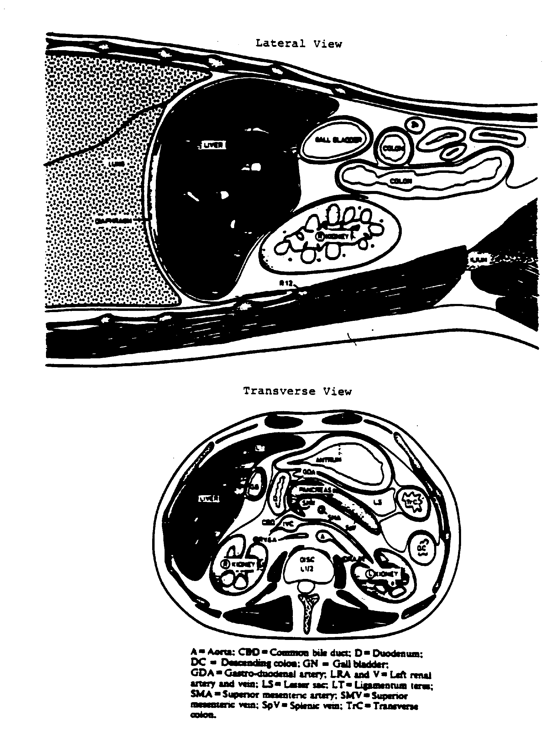
Exhibit 3-2. Gallstones with Acoustic Shadowing

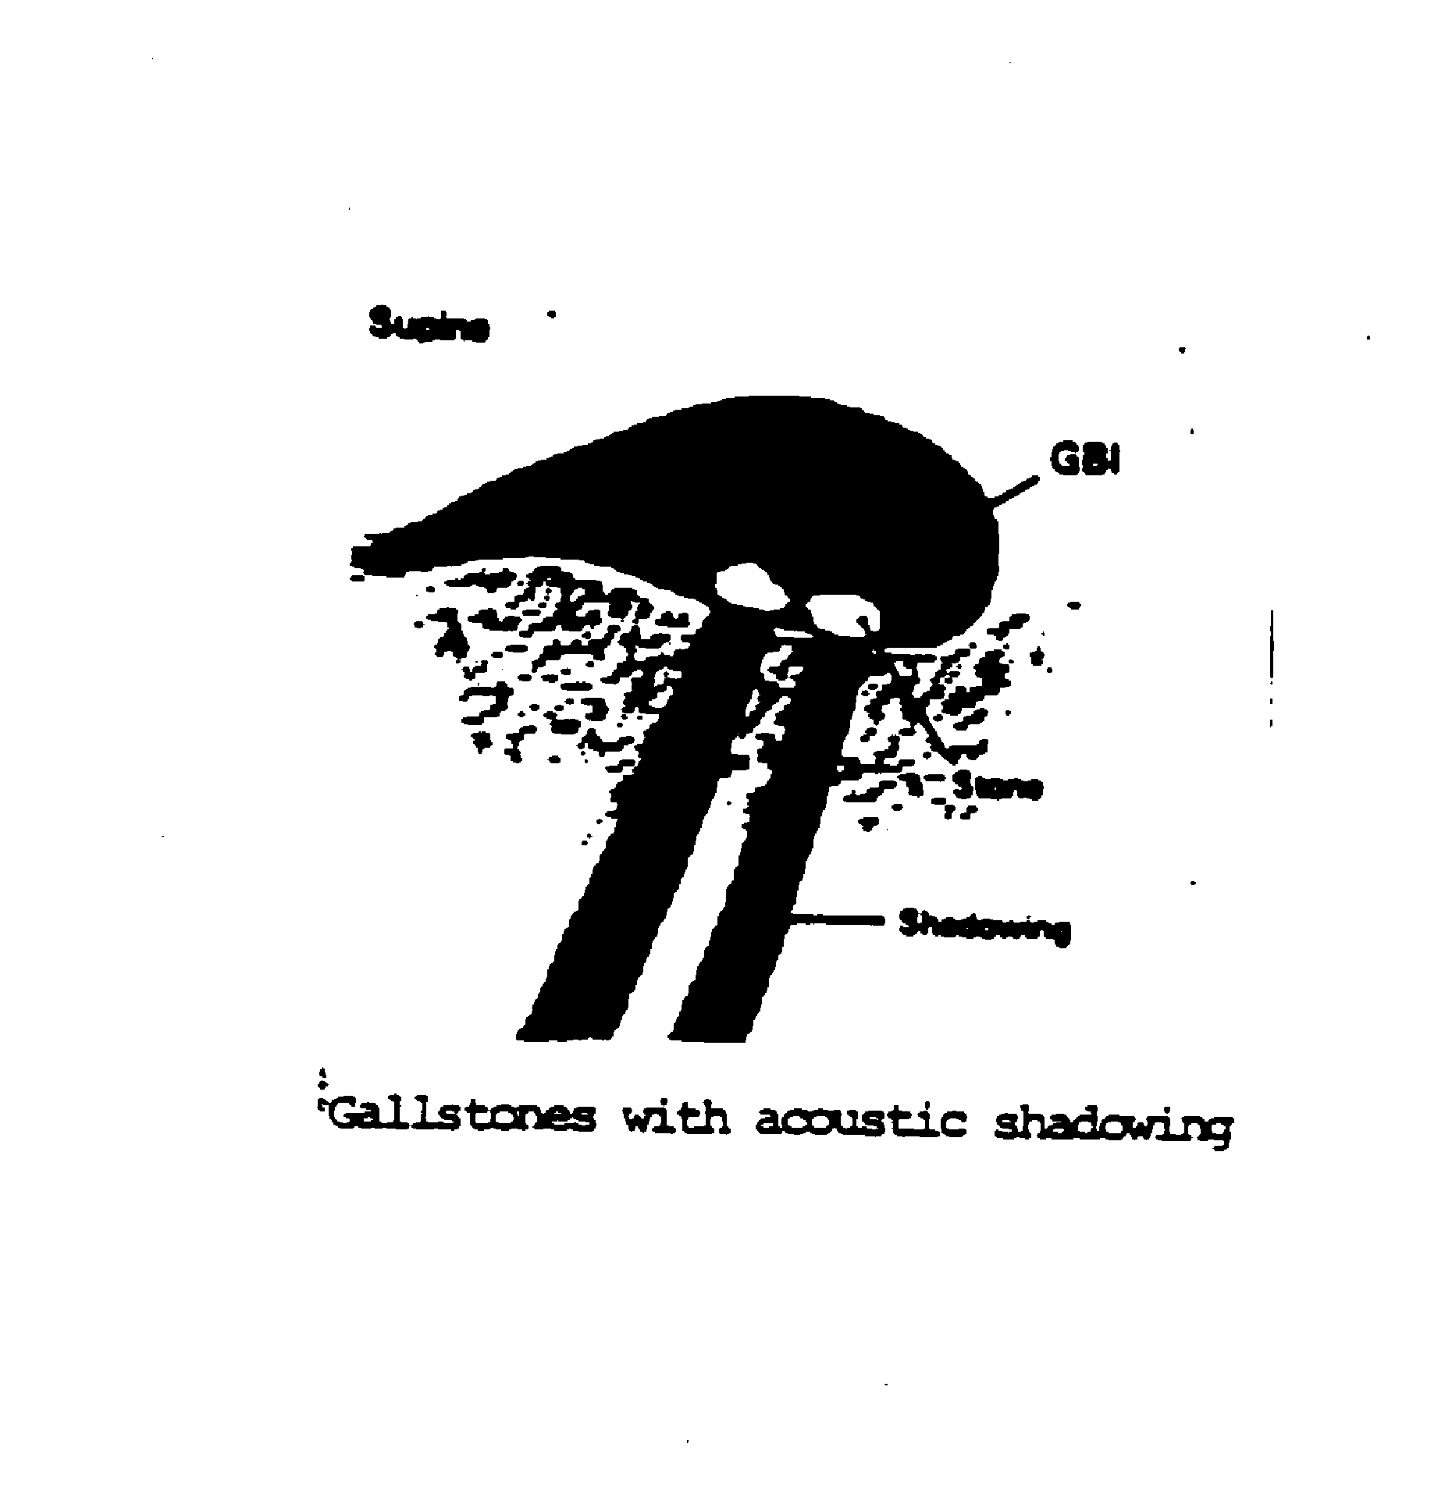
Exhibit 3-3. Small Gallstones

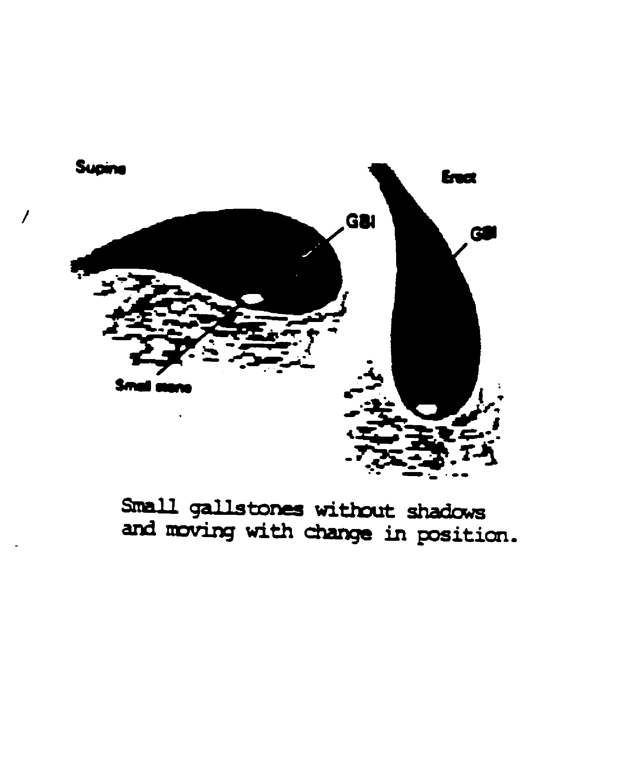
          - Gallbladder Filled with Stones - When the gallbladder is filled with stones, no echo-free bile may be noted and the stones appear as a group of dense echoes with acoustic shadowing located near the liver edge (see Exhibit 3-4).

          - Stones as a Fluid Level - Stones sometimes float and can be seen as a fluid level within the gallbladder. These stones appear as an echogenic line.

          - Adherent Stones - Adherent stones may be seen as echoes in the gallbladder without shadowing. If the echoes do not move when the SP changes position, they may be adherent stones or polyps.

        - Wall Thickening - Gallbladder wall thickening can be seen as a line of decreased echogenicity. The gallbladder wall should not be more than 3mm wide.

        - Diagnostic criteria for gallstones.

          - Two criteria must be present for the diagnosis of gallstones:

Echogenic region within the gallbladder

Acoustic shadowing reproducible in two views (longitudinal and transverse)

These views may be obtained within the supine or LLD position.

          - After the criteria have been met, the largest gallstone should be measured. This is a single measurement in any position, and should be obtained wherever the stone is best imaged. If the measurement is unobtainable, make the appropriate selection on the Ultrasound Data Collection Form.

          - While scanning, obtain longitudinal and transverse views of the positive finding in both SP positions and record the images on the videotape.

          - In the case of all non-shadowing stones and/or polyps, the sonographer will switch to a 5 MHz probe to rule out shadowing. Also, the focal zone may be improved to better delineate shadowing.

          - All positive findings should be carefully documented on the Ultrasound Data Collection Form.

        - Non-gallbladder Pathologic Findings

          - All non-gallbladder incidental findings will be briefly recorded on the VCR tape.
Exhibit 3-4. Gallbladder with Stones

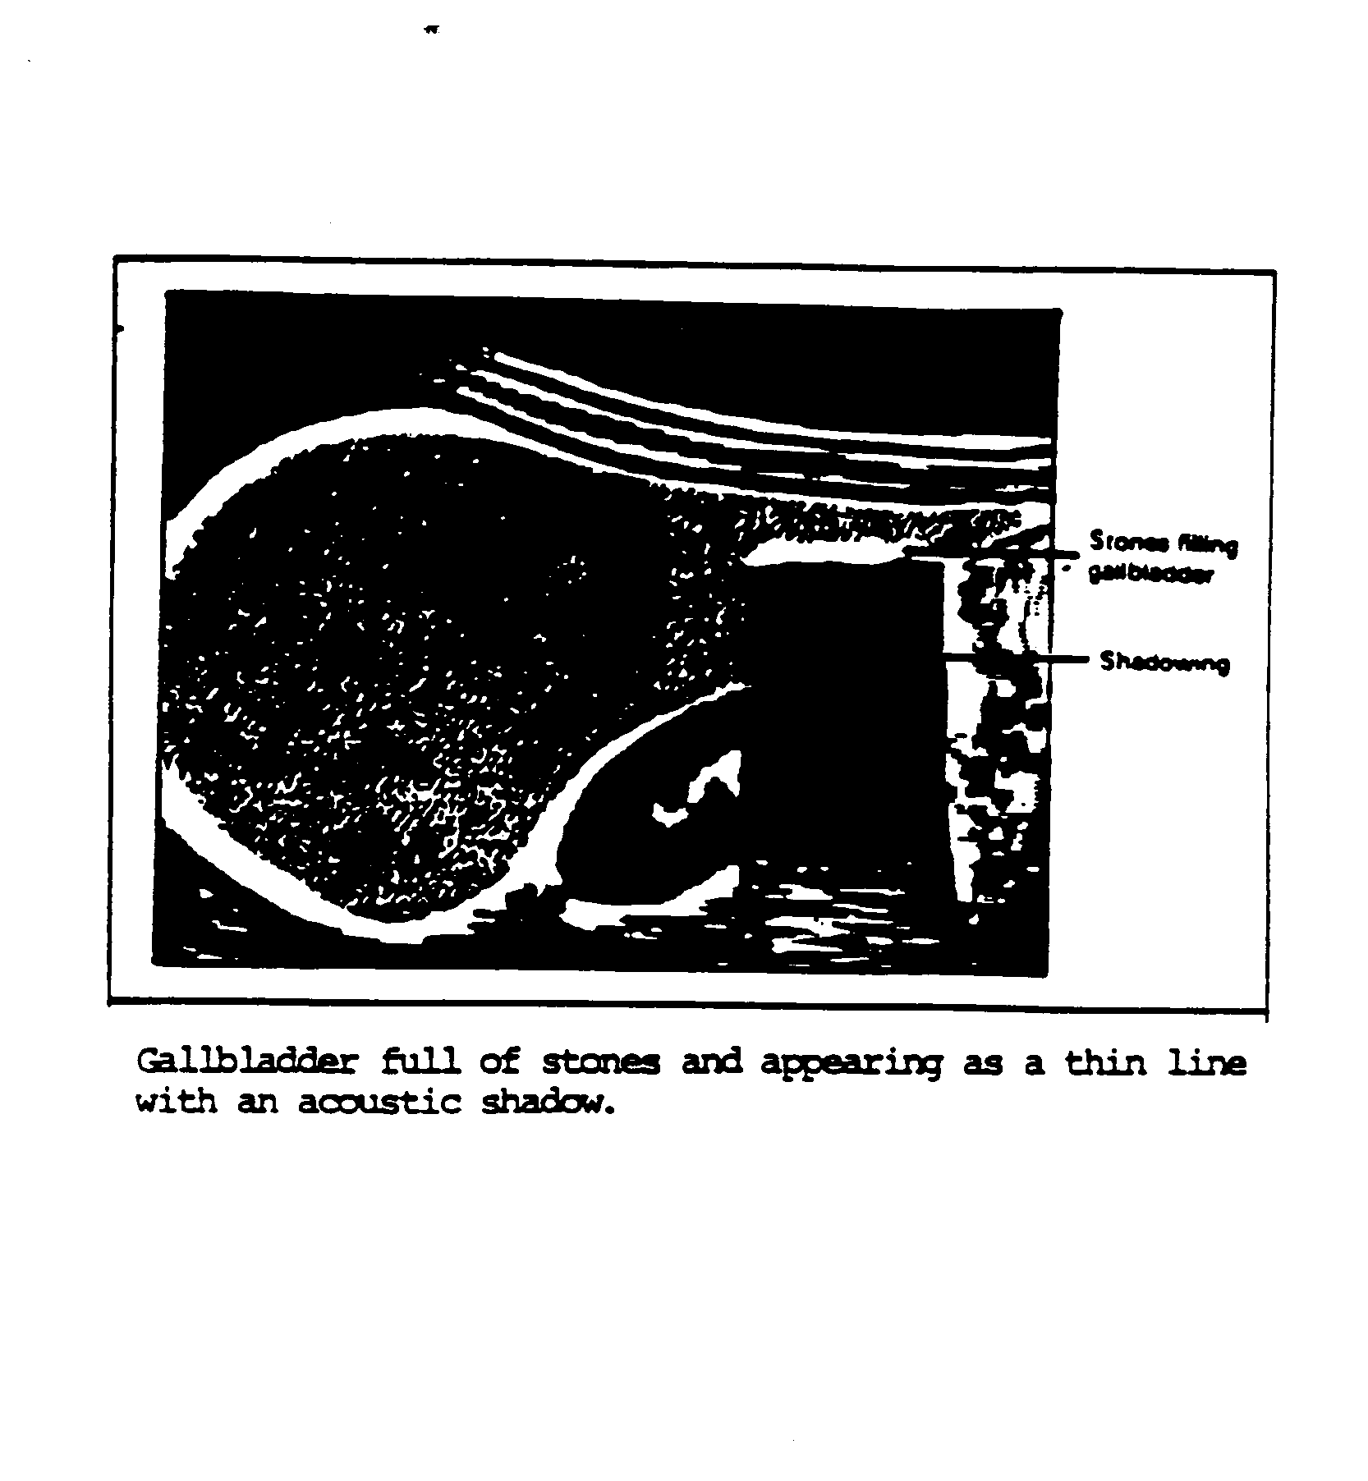
          - Documentation of the finding will be made on two sheets of hardcopy film. One sheet will be forwarded, with the VCR tape, for review as described in Section 5.0, Quality Control. The second sheet will be kept on location until the end of the stand, at which time it will be forwarded to NCHS.

          - Based on the sonographer's impression, any finding requiring rapid review will be sent to radiologists at the review center. Also, the radiologist may be consulted by telephone for referral recommendations. All cases requiring emergent review will be discussed with the MEC physician, who will discuss any referral recommendations with the SP. The sonographer should not report findings to the SP.

          - All non-gallbladder findings should be coded properly on the Ultrasound Data Collection Form.

Problems in Visualization

        - Reverberation - Echogenic areas near the anterior wall of the gallbladder may be due to reverberation. Similar areas near the posterior aspect of the organ may be caused by partial volume (see Exhibit 3-5).

        - Kink or Septum - Occasionally the gallbladder folds over or contains a septum, usually near the area where the neck and body meet. If only a portion is seen, it may look like a gallstone or polyp.

        - Small or Absent Gallbladder - Small gallbladders can be missed entirely. In rare instances, the gallbladder is congenitally absent, but the gallbladder may contract due to a meal if the SP did not fast. Inability to locate the gallbladder may also suggest a diseased organ.

        - Sludge - Viscid bile usually causes low-level echoes in the dependent portion of the gallbladder, similar to those seen with many small stones. However, if the SP changes position, sludge will reaccumulate slowly while stones will settle immediately. Also known as "sand" or "mud", sludge is seen in individuals with jaundice, liver disease, hyperalimentation or sepsis (see Exhibit 3-6).

        - Bowel Gas - Gas in the duodenum may produce an acoustic shadow in the vicinity of the gallbladder. The colon too, when filled with air, may cast a shadow which must be distinguished from that caused by a stone.

        - Non-visualized Gallbladder - If the gallbladder is not visualized during the exam, make sure the surgery and fasting questions have been answered completely. The anatomical landmarks must be recorded on videotape if they can be visualized. If the specific landmarks are not imaged, a brief recording of the RUQ (right upper quadrant) should be taken.
Exhibit 3-5. Reverberation

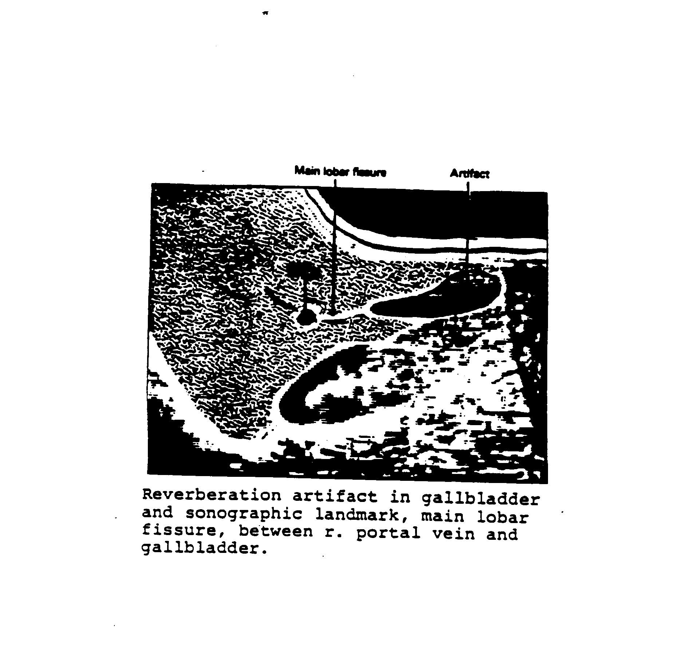
Exhibit 3-6. Sludge

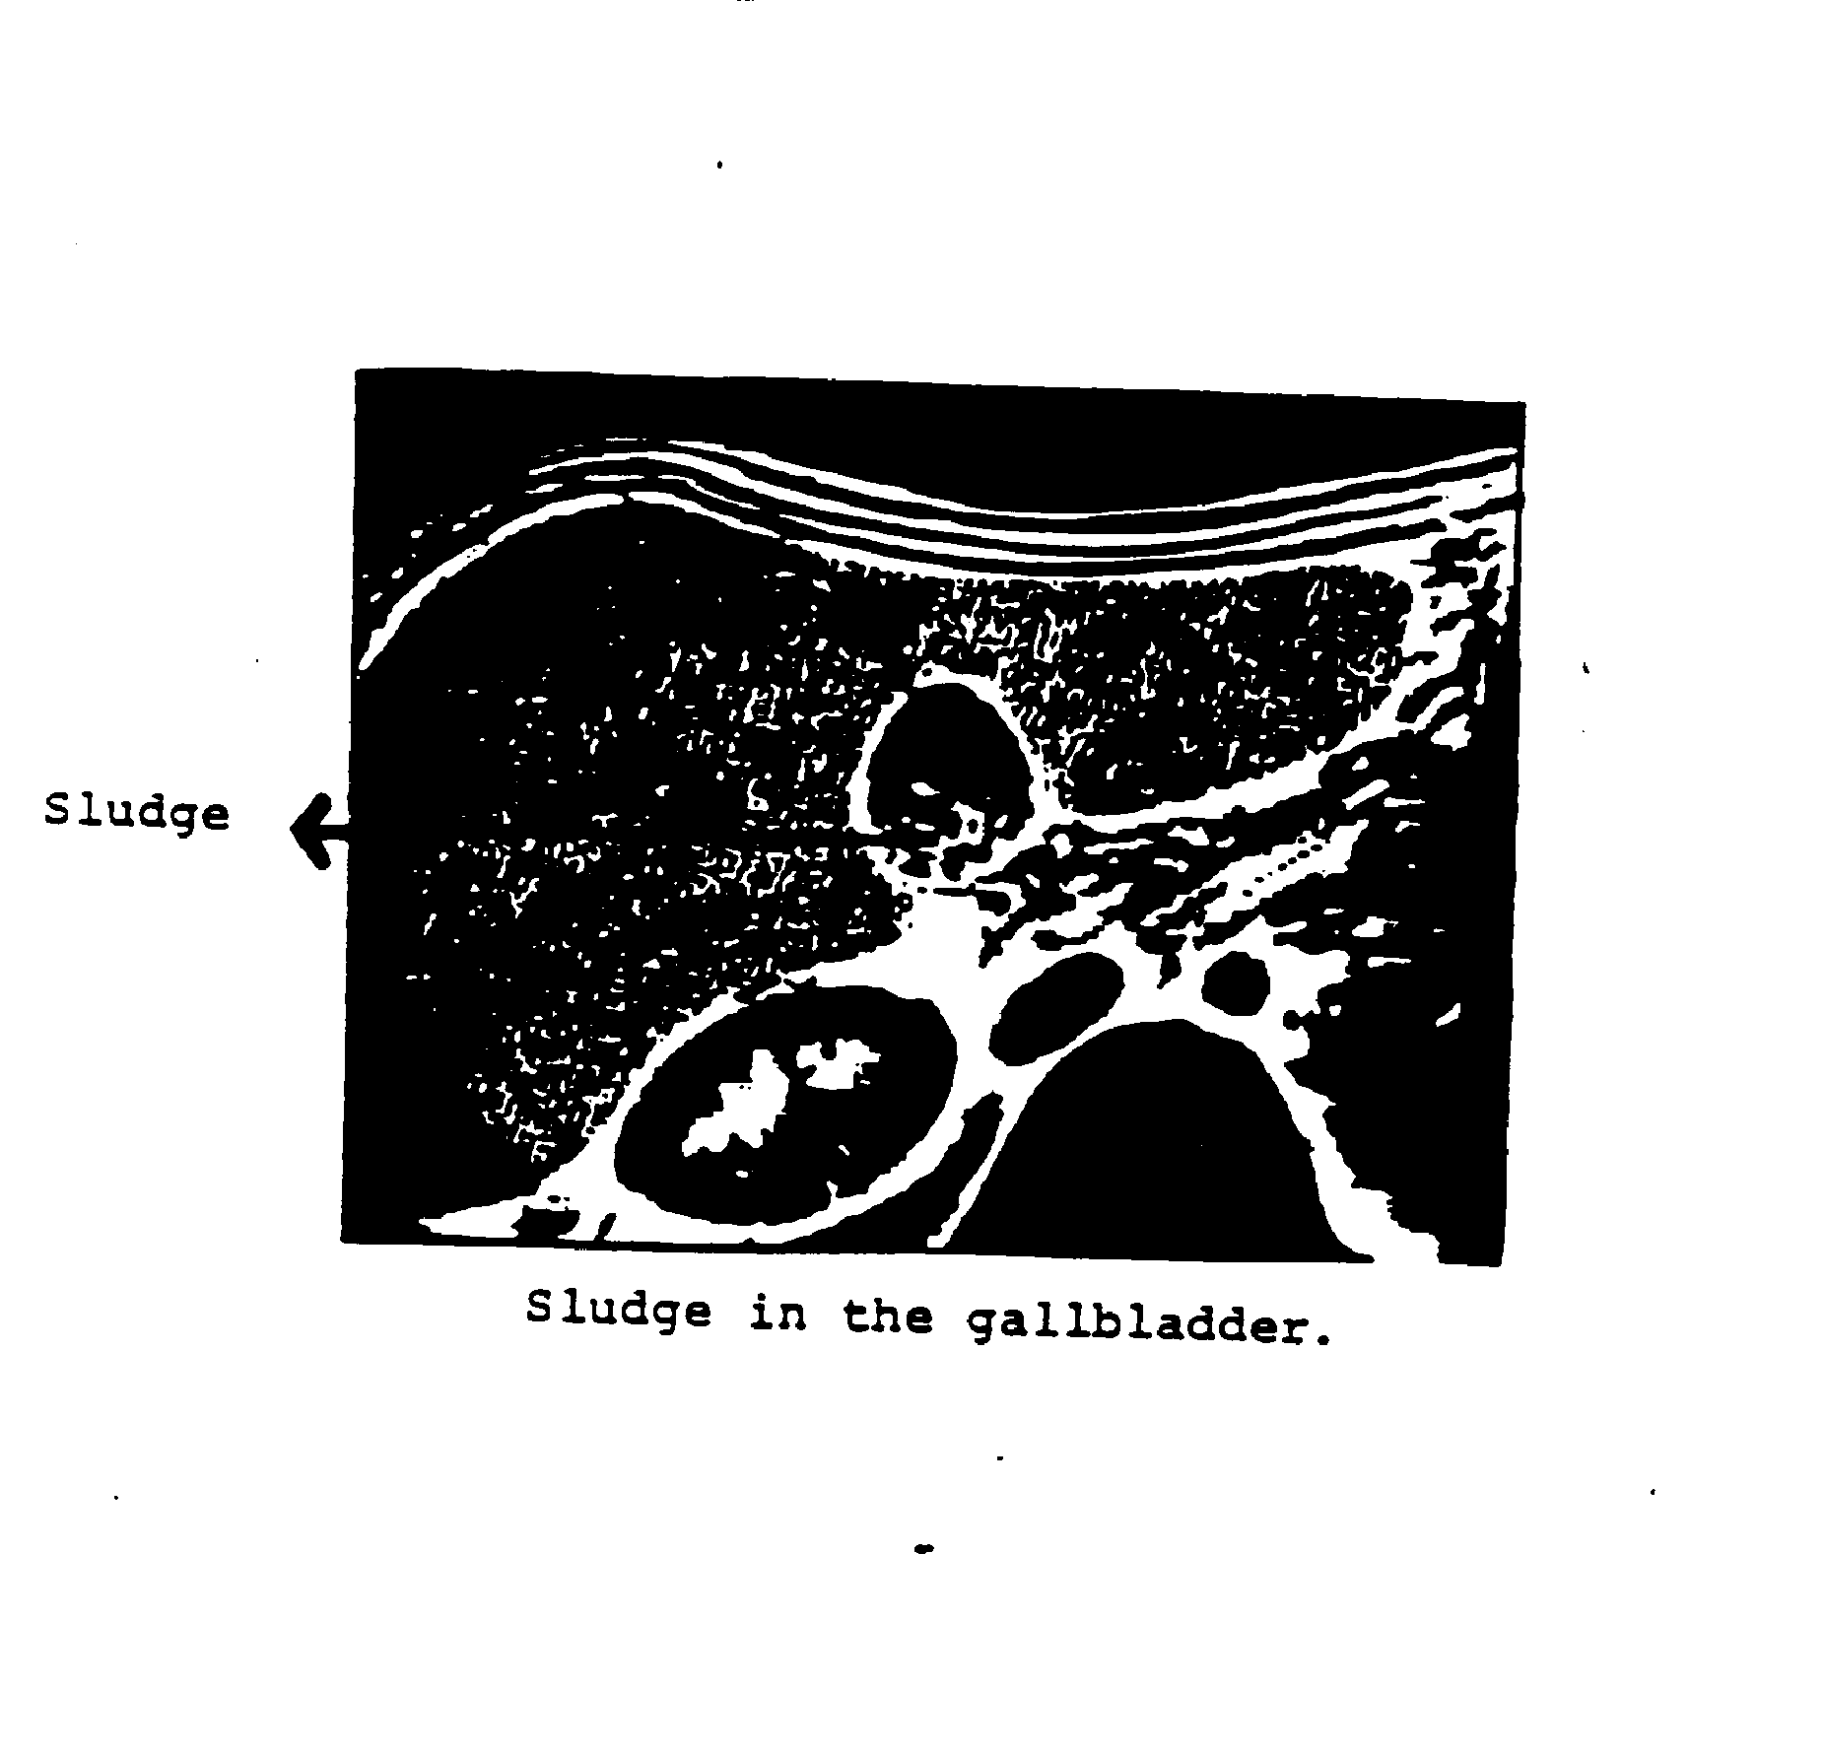
        - Switching Transducers

The 5.0 MHz sector probe should be used whenever the sonographer requires improved superficial resolution.

The transducers must be changed from the 3.75 MHz to the 5.0 MHz whenever the distance from the anterior abdominal wall to the posterior gallbladder wall is greater than five centimeters.

        - Sludge vs. Posterior Wall - Demonstrating a clear posterior gallbladder wall is an important requirement of the ultrasound exam. With the Toshiba SSA-90A, the focus controls allow the sonographer to choose the depth at which the focal zone can be improved. Additional options for proving a non-sludge filled gallbladder versus a sludge- filled gallbladder are the STC controls, overall gain control and switching to different frequencies of transducers.

Examination Form

      - Automated System

The automated version of the Ultrasound Data Collection Form is designed to be identical to the hard copy form, discussed in Section 3.3.2.2, so that the information collected will be the same with both instruments. All of the questions and observations recorded on the hard copy form are included in the automated system in the same sequence, however, the skip patterns are performed by the program. This allows the sonographer to record information in the pertinent fields, and to skip those areas that do not apply to the sample person being examined. The logic used to design the program is shown in Exhibit 3-7.

As part of the skip pattern programming, the automated system also calculates portions of the form that the sonographer must determine when using the hard copy version. For example, the system computes the number of hours since the sample person last ate, and compares the presence of any scars with the anatomic landmarks observed and automatically directs the sonographer to the next appropriate field of information.
Exhibit 3-7. Logic Flow

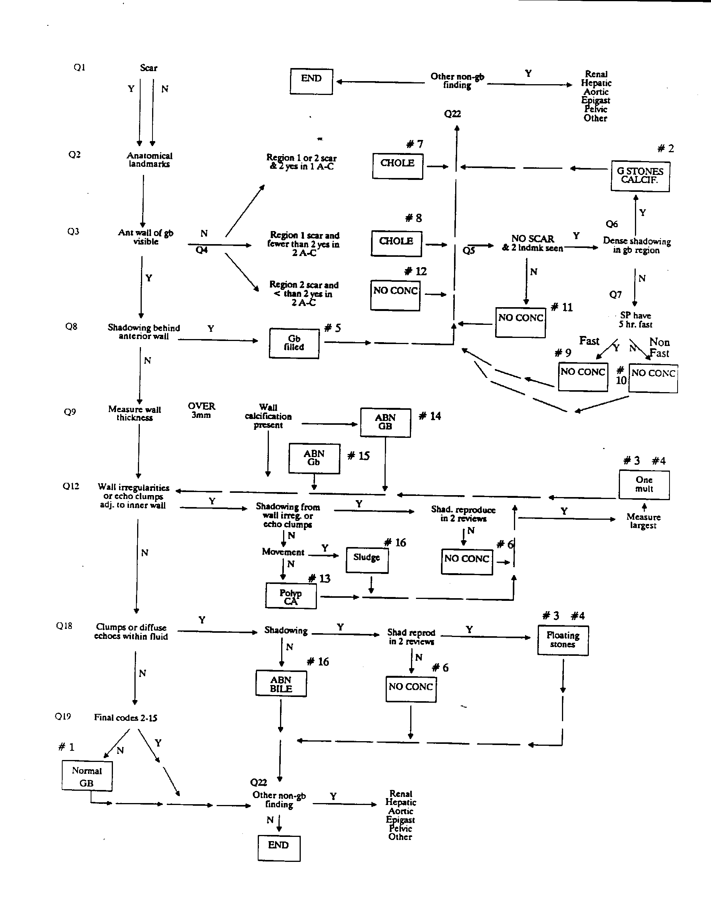
Information on the automated system is grouped into four major areas: identification information, screening and anatomic landmark questions, findings noted in the gallbladder and other organs, and interpretation of findings, which is derived automatically from the data recorded by the sonographer. For each sample person, a final summary of findings, such as Normal Gallbladder, is recorded.

The information requested by the automated system is identical to that included in the hard copy form, as described in Section 3.3.2.3, Questionnaire Specifications. Refer to this section for specifications for questions and items of information included on the Ultrasound Data Collection Form.

A description of the flow of the automated form is provided below.

Identification Information

The sonographer will first be required to enter the sample person identification number and examiner ID number into the entry screen, and to select the data collection option to obtain the ultrasound form.

At the first ultrasound screen, the cassette number and counter number will be requested. The cassette number is the number of the videotape inserted in the VCR, which will be derived from preprinted labels with sequential numbers provided by NCHS. The counter number is the number showing on the VCR that indicates the current position on the VCR tape. This number is used to locate SP exams on the tape, and is useful when trying to retrieve a specific exam, such as during review of the tape.

The cassette number may be changed by using the ultrasound program, or, if the tape needs to be changed in the middle of a session, by selecting the change tape option on the initial menu and typing in the new number.

Screening and Anatomic Landmarks

The next group of questions include the fasting and landmark questions. The sonographer will ask the SP what time they last ate a meal or snack, and will enter the time into the system. The program will compute the number of hours fasted.

Next, the sonographer will record the location of any scars observed on the abdomen by placing a "1" in the region of the abdomen in which the scar appears. The numbers of the abdomen correspond to the numbers shown in the diagram on the hard copy form.

Following the questions regarding scars, the program will prompt the sonographer with several questions on the anatomic landmarks observed (Exhibit 3-8). The sonographer should replay "YES" or "NO" to each question as the findings dictate. The system will then compare the scars observed with the landmarks noted and move to the next appropriate question. If appropriate, such as when the SP has had a cholecystectomy, it will skip to a final box selection and then continue with the remaining questions for non-gallbladder findings.

Questions regarding the anterior wall of the gallbladder and shadowing will appear next (Exhibit 3-9). This portion of the program is the beginning of a loop that will require the sonographer to proceed through the questions twice. The first time through the questions, the sonographer will record findings relating to the gallbladder. After completing the first series of questions, the sonographer will be returned to the start of the loop to record any additional findings for the gallbladder. This allows the sonographers to record findings that would otherwise conflict and require that a choice be made, thus losing some information. When there are no further gallbladder findings to record, the program will proceed to prompt for non-gallbladder findings. At the end of each pass through the loop questions, the program will display a result code so the sonographer can make sure the conclusion is correct. If it is not, it is possible at this point to return through the loop and edit the information.

If there are non-gallbladder findings, the sonographer will indicate the organ in which the findings appear. The program will then request information about videotaping and still films, as part of the inventory and shipping records. If there are non-gallbladder findings, a comment regarding the findings should be made in the Comment section.
Exhibit 3-8. Landmark Questions

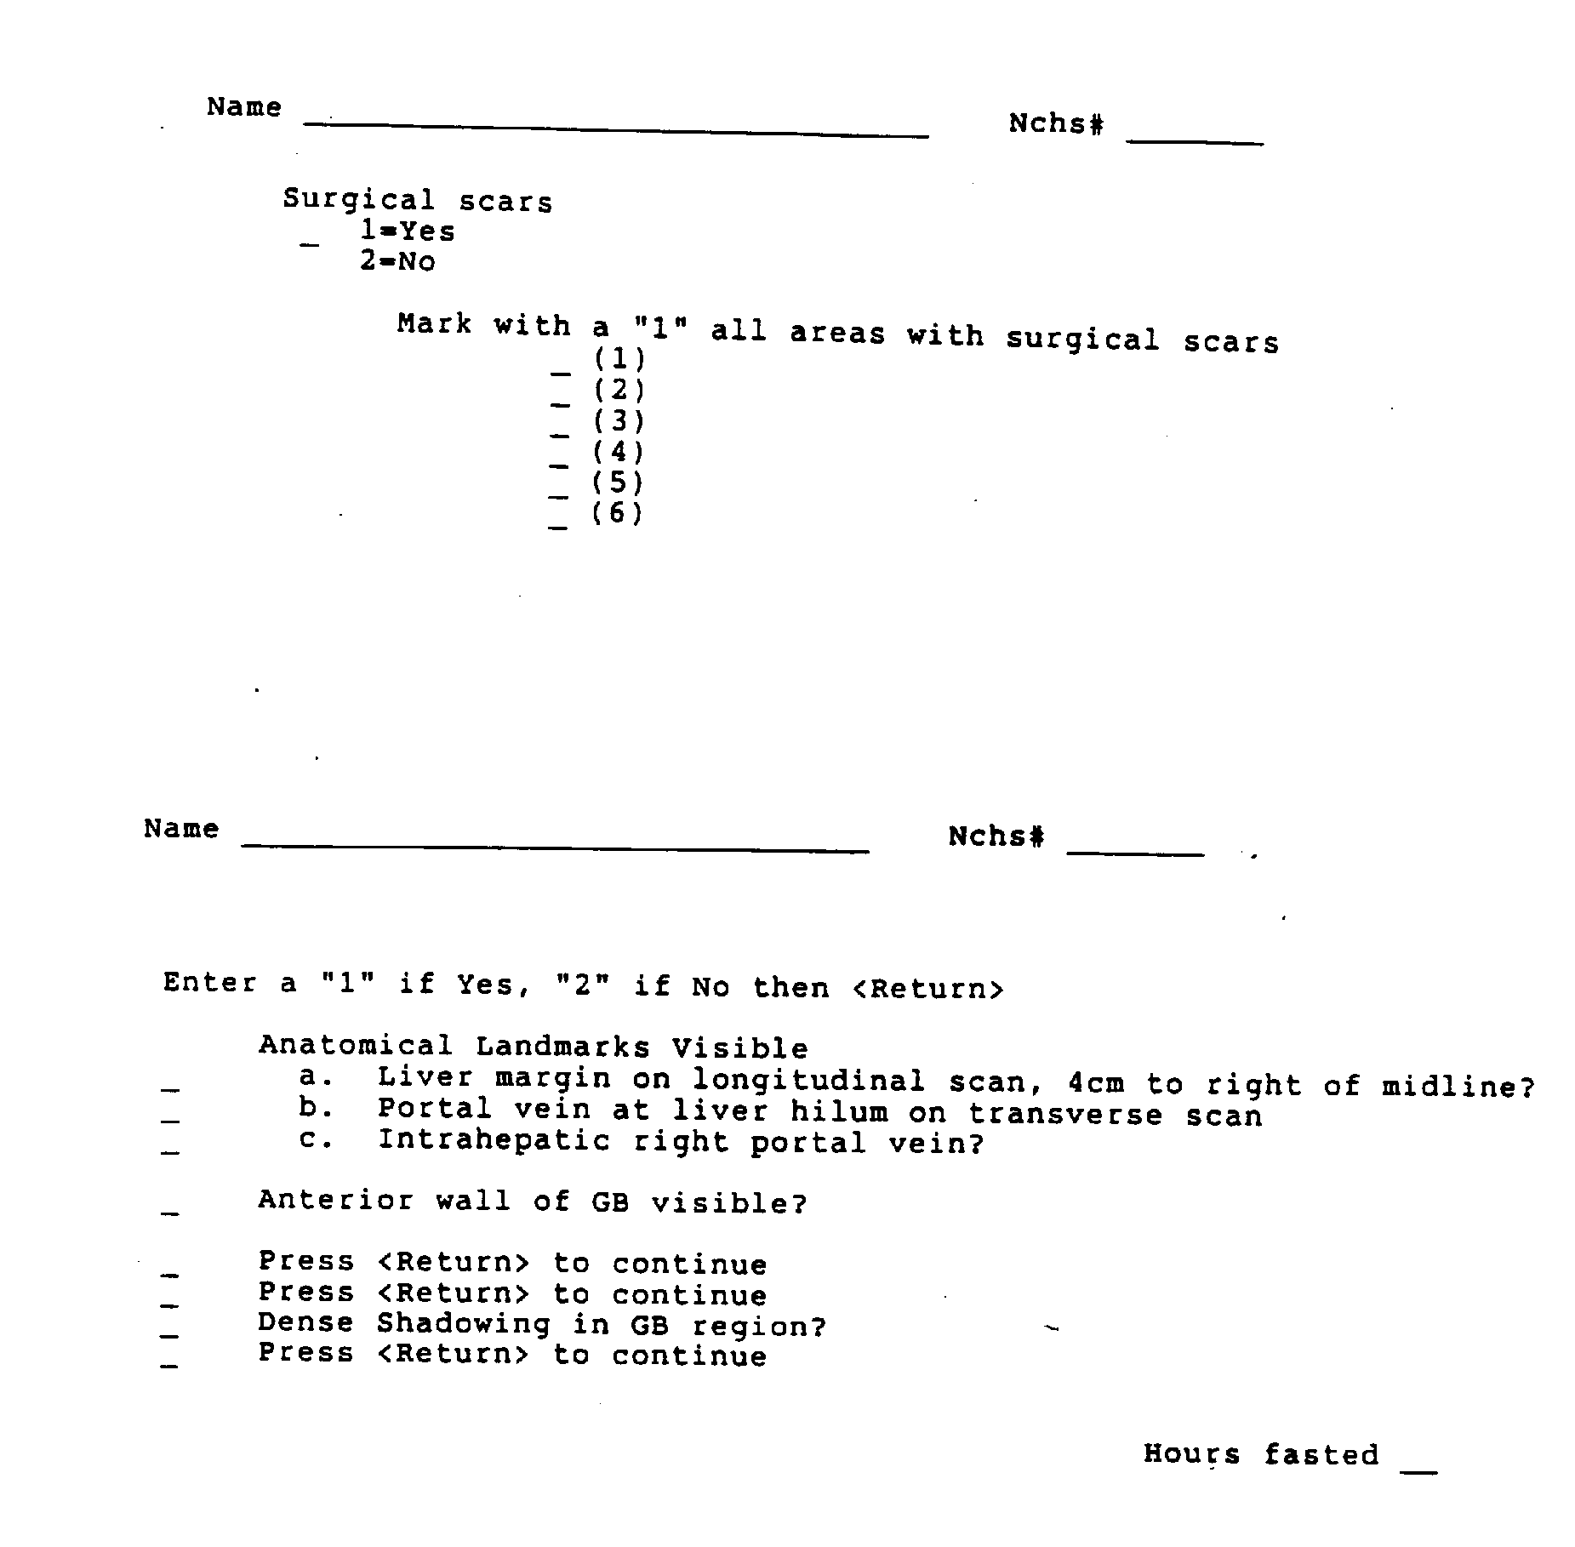
Exhibit 3-9. Loop Questions

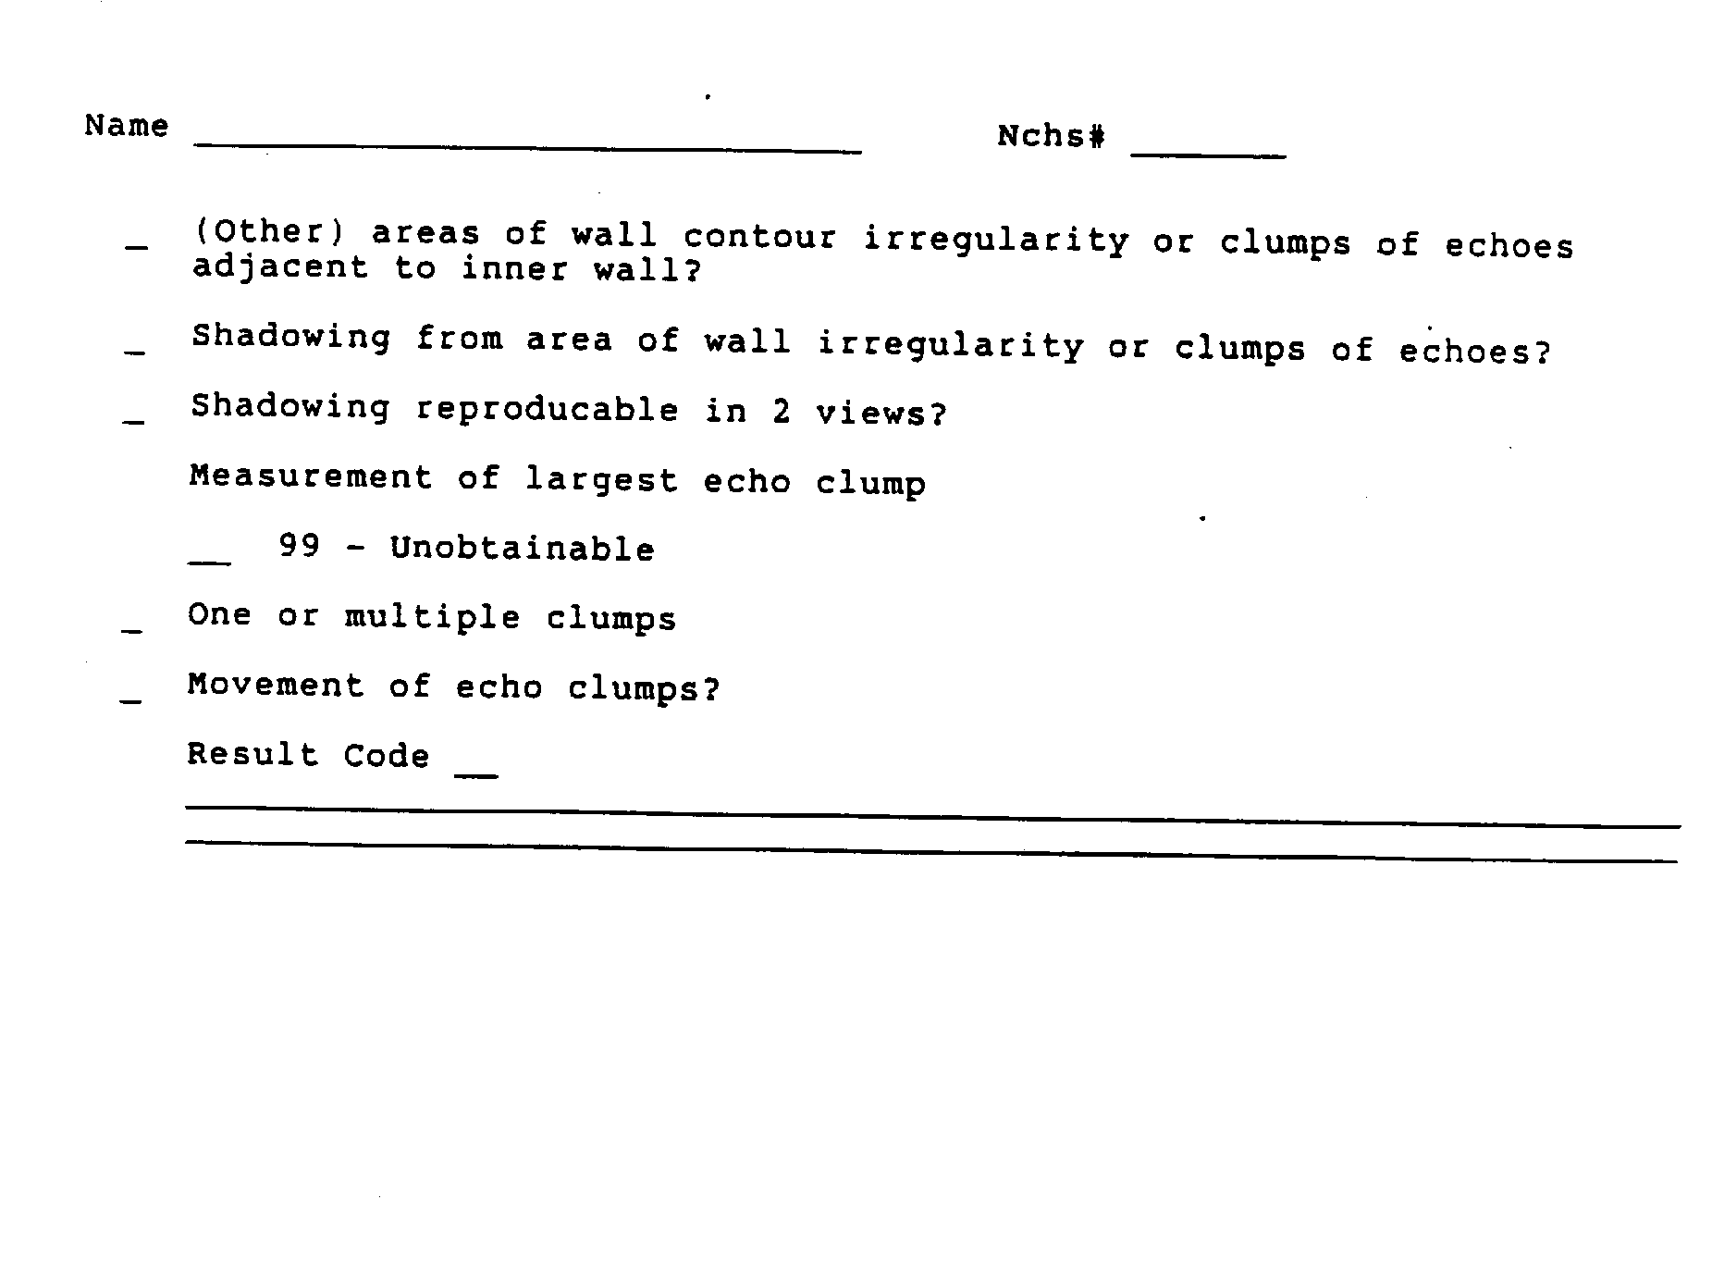

Results of Examination

At the conclusion of the questions, the program will display a screen, Result of Test, that will ask the sonographer to indicate if the test was done, incomplete, or not done. If the exam performed, and all materials were obtained, such as videotape and still films, the exam should be considered complete. If the exam was performed, but some portion of the required information could not be obtained, such as the VCR was down and no tape was made, the response Test Incomplete should be marked. If no exam could be performed, such as when there is too little time available, or the Toshiba SSA-90A is down, the respond Test Not Done should be recorded.

After completing this section, the program will move to the Comments section if the exam was complete, and the Reasons section if the exam was incomplete or not done. A reason must always be recorded if test incomplete or not done is selected.

Reasons for Test Incomplete, Not Done

The reasons for incomplete or unperformed exams displayed in the program are the same as those listed on the hard copy ultrasound form and described in Section 3.3.2.3. Selection of a reason should be based on the definitions provided in that section.

After a reason has been selected, the cursor will move the Comments section.

Comments

Any remarks pertinent to the test should be entered in this section. If a problem was noted, or if the test was incomplete or not done, an explanatory comment must be provided to clarify the situation.

If the exam was complete, the sonographer has the option to make comments if there was something unusual about the exam that should be noted. Comments are extremely helpful during review of the data and tapes.
The words "Fast Track" will be printed in this section on the automated system log sheet whenever the sonographer selects a result code between 13 and 22 that requires an expedited review.

Upon completion of the Comments section, the sonographer should push "next screen", return to the first ultrasound screen, and then push "remove" twice to clear the screen for the next SP.

Hard Copy Form

The hard copy version of the Ultrasound Data Collection Form will be used whenever the automated system is not available. A copy of the form is shown in Exhibit 3-10.

A supply of hard copy forms will be kept on the MEC and should be instituted immediately after the automated system goes down. At the end of the exam session, or whenever the automated system is again available, the data collected on the hard copy forms will be entered into the system.

Specifications for the questions and items of information included on the Ultrasound Data Collection Form are provided in Section 3.3.2.3.

Questionnaire Specifications Identification Information
The sonographer should first complete the identification portion of the form.

- Staff No. - Enter examiner identification number.

- NCHS No. - Apply the sample person label with the NCHS identification number.

- Cassette No. - Enter the number of the videotape cassette in the VCR. The number will be obtained from the printed "box" label provided by NCHS.

- Tape Counter - Enter the counter number showing on the VCR, as a guide for the reviewer.
Exhibit 3-10. Ultrasound Data Collection Form

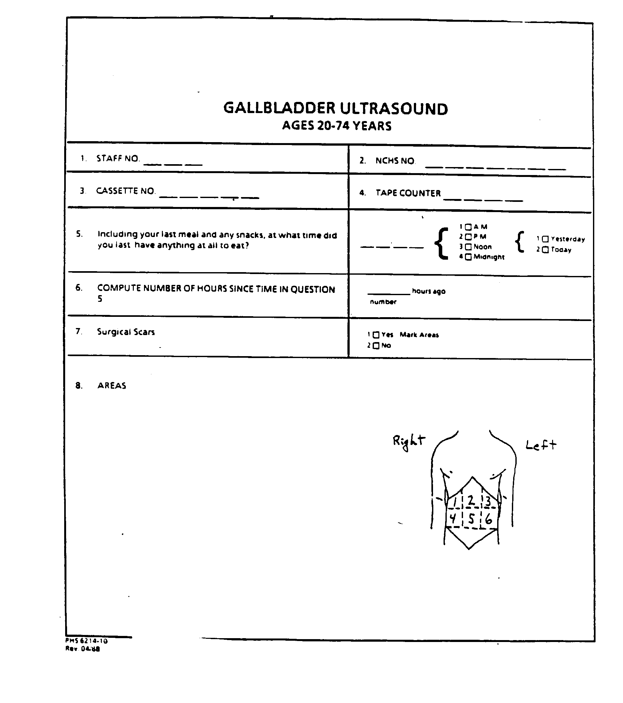
Exhibit 3-10. Ultrasound Data Collection Form (continued)

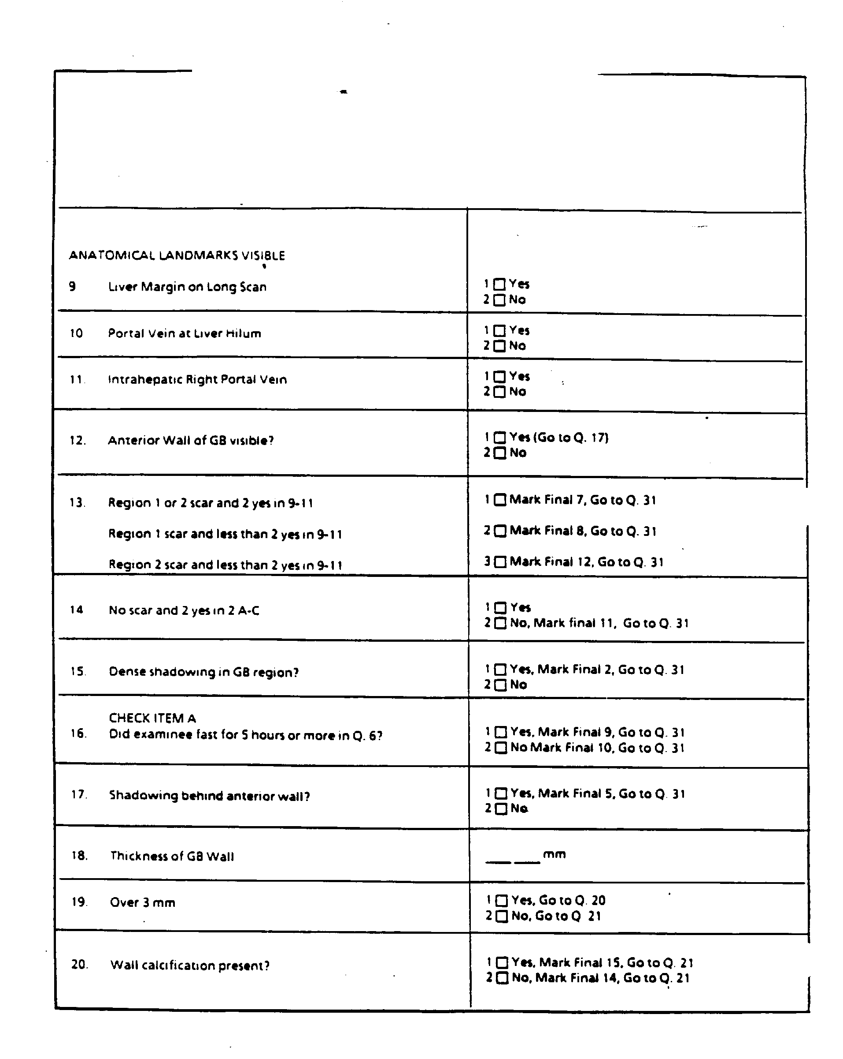
Exhibit 3-10. Ultrasound Data Collection Form (continued)

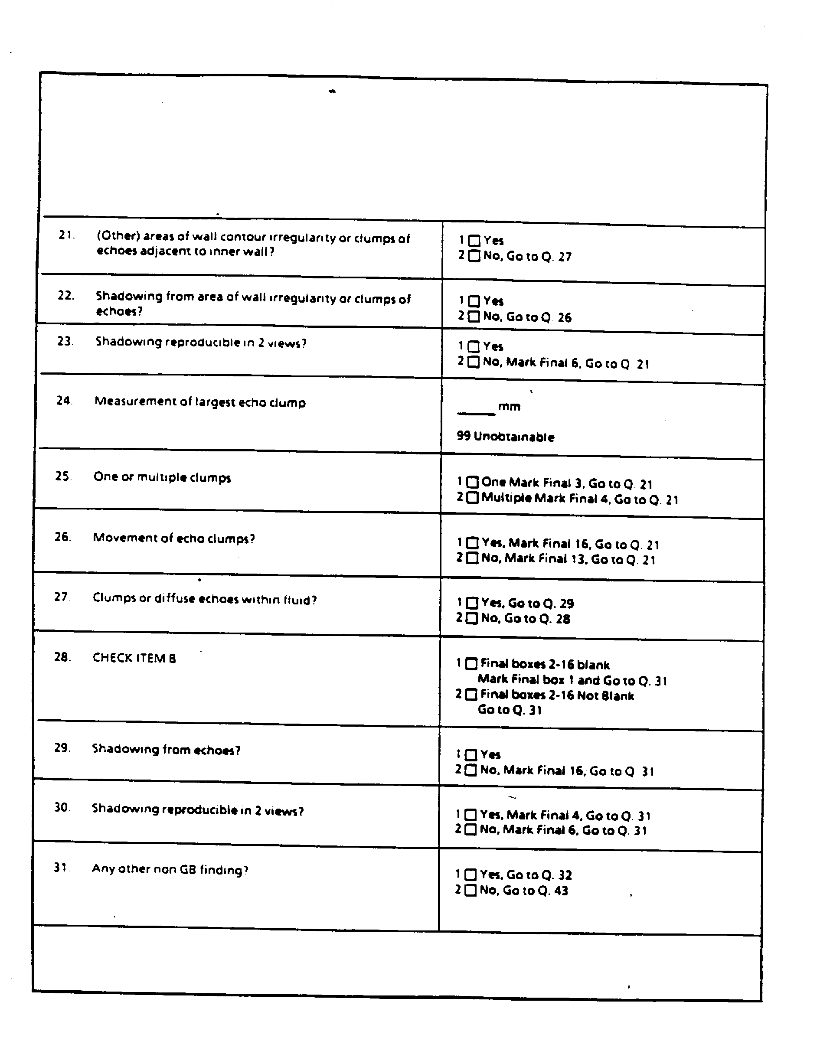
Exhibit 3-10. Ultrasound Data Collection Form (continued)

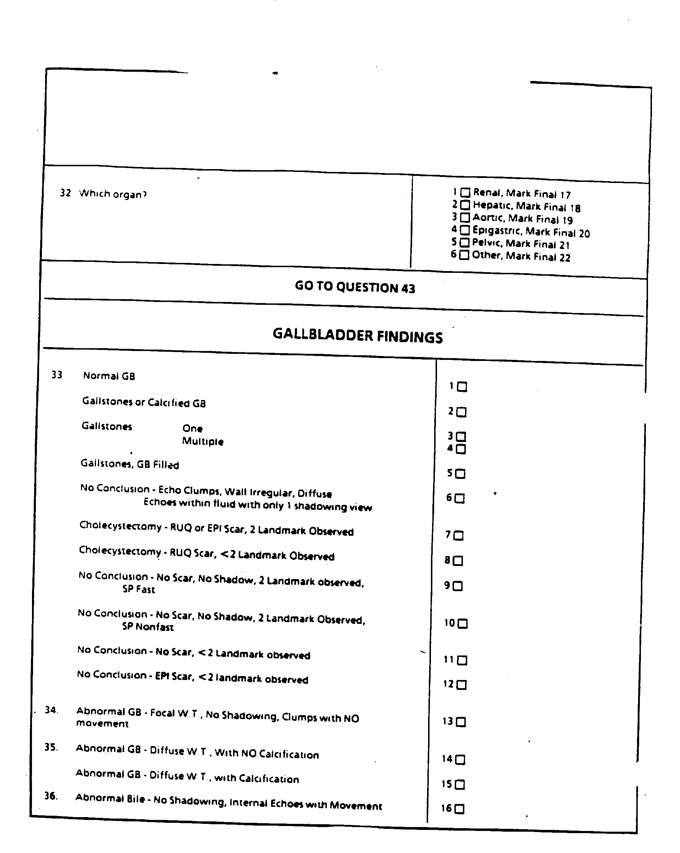
Exhibit 3-10. Ultrasound Data Collection Form (continued)

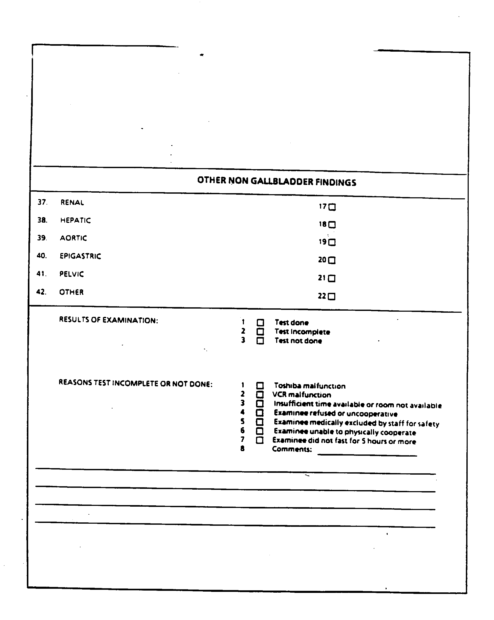

Screening Question

Q5 Read the screening question to the SP exactly as it is written, and record the time of day the SP last ate a meal or snack.

Q6 Compute the number of hours since the time the SP last ate. (The automated system will automatically compute this time).

Recording Findings

Q7 If surgical scars are present on the abdomen, mark "YES", and indicate the location on the abdominal diagram. Otherwise, mark "NO".

Q8 Diagram of scars

Q9 If liver margin is visualized, mark "YES". Q10 If portal vein is visualized, mark "YES".
Q11 If intrahepatic right portal vein is visualized, mark "YES".

Q12 If any portion of the anterior wall of the gallbladder is visible, mark "YES" and skip to Q17.

Q13 Select the correct combination of landmarks visible and scars present on the abdomen.

Region 1 or 2 scar and "YES" in Q9-11

If a scar is present in Region 1 or 2, and any two anatomical landmarks are visible, mark box 1, skip to and mark Final Box 7 and skip to Q31.

Region 1 scar and less than 2 "YES" in Q9-11

If scar is present in Region 1 and less than two anatomical landmarks are visible, select box 2, skip to Final Box 8 and skip to Q31.

Region 2 scar and less than 2 "YES" in Q9-11

If scar is present in Region 2 and less two anatomical landmarks are visible, mark box 3, skip to Final Box 12 and skip to Q31.

Q14 No scar and 2 "YES" in Q9-11

If no scar is present and any two landmarks are visible, mark "YES" and continue to Q15. If no scar is present but less than two landmarks can be visualized, mark box 2, "NO", skip to Final Box 11, and skip to Q31.
Q15 Dense shadowing in gallbladder region

If dense shadowing is visible in the area of the gallbladder, mark "YES", skip to Final Box 2 and skip to Q31. If no shadowing is present, mark "NO" and continue to Q16.

Q16 Check Item A - Did examinee fast for five hours or move in Q6?

If examinee fasted five hours or more, mark "YES", skip to and mark Final Box 9 and skip to Q31. If examinee fasted for less than five hours, skip to and mark Final Box 10, then skip to Q31.

Q17 Shadowing behind anterior wall

If shadowing is visible behind the anterior wall of the gallbladder, mark "YES", skip to Final Box 5 and proceed to Q31. If no shadowing is present, mark "NO" and go to Q18.

Q18 Thickness of gallbladder wall

Enter measurement, in millimeters, of gallbladder wall thickness.

Q19 Over 3mm

If the thickness of the gallbladder wall is greater than 3mm, select the "YES" option and continue to Q20. If thickness is less than 3mm, mark the "NO" option and skip to Q21.

Q20 Wall calcification present?

If calcification of the gallbladder wall are visible, mark "YES", skip to Final Box 15 and go to Q21. If none are present, mark "NO", skip to Final Box 14 and go to Q21.

Q21 Other areas of wall contour irregularity or clumps of echoes

If any areas of irregularity in the contour of the organ or clumps of echoes near the inner wall are visible, mark "YES" and go to Q22. If no irregularities or echo clumps are observed, mark "NO" and skip to Q27.

Q22 Shadowing from area of wall irregularity or clumps of echoes

If shadowing is observed near areas of irregularity or in the form of clumps, mark "YES" and go to Q23. If no shadowing is observed, mark "NO" and skip to Q26.

Q23 Shadowing reproducible in two views

If the shadowing present in Q22 can be reproduced in both the longitudinal and transverse views, mark "YES" and go to Q24. If the shadowing cannot be reproduced in two views, mark "NO", skip to Final Box 6 and go to Q21. Check answer.
Q24 Measurement of largest echo clump

Enter in millimeters the dimension of the largest visible echo clump. If measurement is not obtainable, enter "99". Proceed to Q25.

Q25 One or multiple clumps

Mark appropriate box depending on the number of echo clumps present and proceed to Q21. Check answer.

Q26 Movement of echo clumps

If movement is observed from the echo clumps, mark "YES". If no movement is observed, mark "NO". Go to Q21 and check answer.

Q27 Clumps or diffuse echoes within fluid

If clumps of echoes or diffuse echoes are observed within the fluid in the gallbladder, mark "YES" and skip to Q29. If no clumps or diffuse echoes are observed, go to Q28.

Q28 Check item 33

Check Q33. If Final Boxes 2-16 blank, mark box 1 and skip to Q31. If Final Boxes 2-16 not blank, mark box 2 and skip to Q31.

Q29 Shadowing from echoes

If shadowing is observed from the echoes reported in Q27, mark "YES" and go to Q30. If no shadowing is seen, mark "NO", skip to and mark Final Box 16 and skip to Q31.

Q30 Shadowing reproducible in two views

If the shadowing seen in Q29 is reproducible in both the longitudinal and transverse views, mark "YES" and skip to and mark Final Box 4. If the shadowing cannot be reproduced, mark "NO", skip to and mark Final Box 6. Go to Q31.

Q31 Any other non-gallbladder findings

If any other pathological non-gallbladder findings are observed, mark "YES" and go to Q32. If no other non-gallbladder findings are observed, skip to Q43.

Q32 Which organ

Mark the appropriate box to indicate the organ in which non-gallbladder findings were noted. Follow the skip pattern directions provided after the response box.

Q33 Questions 33-42 should already have been encountered and asked by this point in the form.

Results of Examination

Select one response which best describes the outcome of the examination:

Test done - Mark this box if the test was completed.

Test incomplete - Mark this box if the test was begun but could not be completed. A reason must be marked in Reasons Test Incomplete or Not Done if this answer is selected.

Test not done - Mark this box if the exam was not performed. A reason must be marked in Reasons Test Incomplete or Not Done if this answer is selected.

Reasons Test Incomplete or Not Done

A reason must be marked in this section if the ultrasound exam was not completed or obtained. Select the reason based on the following descriptions:

Toshiba malfunction - Exam could not be completed or performed due to a Toshiba SSA- 90A malfunction. Be sure to describe the malfunction in the Comments section.

VCR malfunction - Exam could not be recorded due to a VCR failure.

Insufficient time available - Exam could not be completed or obtained because of lack of time available in the exam session.

Examinee refused or uncooperative - SP was not cooperative and interfered with completion of the exam, or refused the exam.

Examinee medically excluded - Although there are no exclusion criteria for this exam other than age, it may be necessary to occasionally exclude an SP because they are confused, cannot follow directions or feel ill. Check with the MEC manager before excluding an SP.

Examinee unable to physically cooperate - If the examinee cannot lie on the table because of a physical problem, or is otherwise unable to assume the physical positions needed to perform the exam, mark this option.

Examinee did not fast for five hours or more - The exam should always be performed regardless of the length of the fast, but if the exam was incomplete or unobtainable because of an insufficient fast, select this option.

Comments

Any pertinent remarks concerning the exam or the SP should be recorded in this section. Brief descriptions of equipment problems, SP problems or other unusual circumstances of the exam are helpful during analysis of the data.

Post Examination Procedures

    - Stop the VCR at the end of the examination, then advance the VCR counter at least seven numbers to prepare for the next exam.

    - Have the examinee return to a supine position. Use gauze pads and alcohol to remove the excess scanning couplant from the SP's abdomen.

    - Complete entry of findings onto the Ultrasound Data Collection Form. Return to the introductory screen and prepare for the next SP.

    - Assist the SP in getting off the table.

    - If an emergent review is required, discuss the findings with the MEC physician and if necessary, contact the radiologist from the review center for referral recommendations. The MEC physician should discuss the interpretation of findings and recommendation for referral with the sample person.

    - Notify MEC coordinator that the room is ready for the next SP.

LOGS AND RECORDS

The ultrasound technician will be required to complete or record information on several forms for the ultrasound exam, other than the Ultrasound Data Collection Form. Though one of the forms is automated, it is important that you be familiar with the hard copy versions of all forms as you will be required to use hard copy forms if the automated system becomes unavailable.

Hard copy versions of all forms will be available on the MEC if needed.

Hard Copy Forms

    - Ultrasound Daily Log Sheet

A hard copy version of the Ultrasound Daily Log Sheet which will be used whenever the automated version of the log is not available. The log, shown in Exhibit 4-1, will be used by the sonographer to record the Sample Person NCHS identification number, examiner number, date, start and end of exam and VCR tape ID and counter numbers. The log will also be used to record unusual occurrences or circumstances, and reasons for uncompleted or unsatisfactory exams. A barcoded label with the SP identification number should be placed on the log sheet with each SP entry.

The log is used as hard copy backup record for the videotaped examinations, so it is important that all categories of information are accurate and completed. SP entries should be made on the log in the order in which they receive the exam. Be sure that the tape number and counter numbers are included, so the log can be linked with the videotapes. If the log is sent with a tape for a rapid review, write "FAST TRACK" in the Comments section of the exam to be reviewed to flag the exam for reviewers.

Unusual occurrences or reasons for unsatisfactory or uncompleted exams should be recorded in the log. In particular, events that may affect the results or interpretation of data should be noted, such as equipment malfunctions or ill SPs. Incidents should be recorded as they happen, otherwise the exact order of events may be difficult to reconstruct at a later date.
Exhibit 4-1

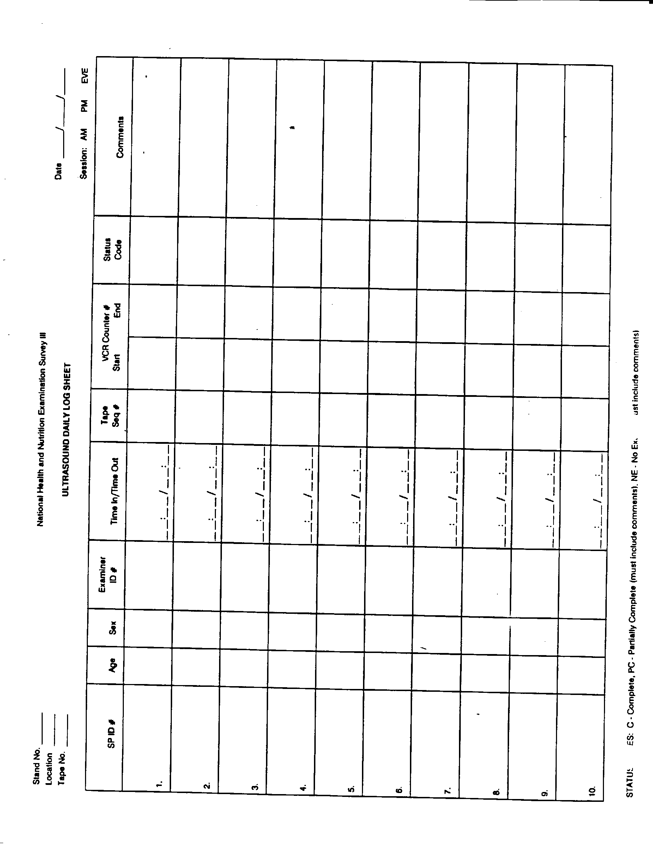

Calibration Log Sheet

The Calibration Log Sheet, shown previously in Exhibit 2-1, will be used to record the start of stand calibrations, and any post-servicing calibrations performed by the sonographer. A diagram of the locations and depths of the pins, and a record of the depths obtained will be included in the log.

The logs for each SSA-90A will be kept in a Calibration Notebook in the ultrasound examination room in each MEC.

Automated Forms

    - Ultrasound Daily Log

The Ultrasound Daily Log will not appear as a separate form on the automated system, however, the information entered into the automated system can be retrieved in a hard copy log format by using the laser printer on the MEC. A copy of the daily log should be printed out after each session and kept in the ultrasound exam room for reference.

It will not be necessary to enter information into the automated system separately to create the daily log. The date and time of the session (AM, PM or EVE) will be loaded into the system at another station. A clock in the system will keep track of examination times by logging the entry and exit of each data collection form. SP identification numbers, and examiner numbers will be recorded from the entry screen which appears prior to every data collection form. The videotape ID number and counter numbers will be requested and entered during use of the data collection form. Therefore, it is not necessary to maintain a separate daily log when using the automated system.

Exams that require a rapid review from the review center, which are designated by result codes of 13-22, will be flagged by the automated system. The words "FAST TRACK" will be printed in the Comments section of the log of all exams coded 13-22.
Remember, when using the data collection form, the system begins timing your procedures as soon as you access the form, and continues until you return to the introductory screen and clear it for the next SP. Any delay in completing the data collection form on the system will increase the record of your examination time.

Shipment of Logs and Records

    - Logs

A complete set of the Ultrasound Daily Logs printed from the automated system (or hard copy forms, if used) should be kept in the ultrasound examination room until the end of the stand, at which time they should be forwarded to the Director of MEC Operations at Westat. No transmittal forms are required for the logs.

A copy of the daily logs should also accompany each videotape that is sent to the review center. The logs should correspond to the examinations that are recorded on the tape. If a tape is sent to the review center by overnight delivery for an expedited review, a complete set of logs corresponding to the exams on the tape should also be sent at that time.

Calibration Forms

Copies of the Calibration Forms should be sent to NCHS at the end of the stand. The original copy of the Calibration Form should remain in the notebook in the exam room as a continuing reference for the sonographers. No transmittal forms are required for the Calibration Forms.

QUALITY CONTROL

A variety of quality control procedures have been chosen to ensure the accurate collection and documentation of reliable data, and to provide a review process to facilitate early detection and referral of abnormalities detected during the ultrasound exam.

Examination Forms

    - Automated System Forms

Automated versions of the Ultrasound Data Collection Forms and daily logs will be reviewed at NCHS by staff responsible for the gallbladder ultrasound component. Feedback from reviews of the forms will be forwarded to the Director of MEC Operations at Westat.

Copies of the Ultrasound Daily Logs will be available for review on a weekly basis at NCHS from the automated system. Tapes from the automated systems in each MEC will be sent to NCHS each week.

Hard Copy Data Collection Forms

Normally, the Ultrasound Data Collection Forms will be recorded on the automated system. If the system is not available, the hard copy version of the data collection form is available on the MEC for use as backup data collection record. After the automated system function is restored, information collected on the hard copy forms will be entered by the sonographers into the automated system.

If hard copy versions of the Ultrasound Data Collection Form are used and not entered into the automated system, these forms should be collected and sent to NCHS for review at the end of the stand. The forms should be accompanied by a completed Transmittal Form as outline in Part 1, Section 2.0, Standardized Procedures.

Daily Log Sheets

Ultrasound Daily Logs will be retrieved from the automated system tape at NCHS and reviewed by NCHS and Westat staff at regular intervals. Feedback regarding the logs will be reported to the Director of MEC Operations at Westat.

If hard copy logs are used during the stand, the original copies of the logs should be sent to Westat, and a copy of the logs should be sent to NCHS. A Transmittal Form should accompany the logs sent to NCHS.

Review Center Activities

The review center will provide reviews of all taped ultrasound examinations by a radiologist specializing in abdominal ultrasonography. The radiologist will view the tapes, complete an evaluation form and forward copies of the tapes, evaluations and any logs or hard copy films to NCHS within three week of receipt.

Standard Review

Videotapes containing examination findings that do not require rapid review, including the presence of gallstones, will be forwarded to the review center as every second tape is completed. Copies of corresponding daily logs will accompany the tapes.

Still films of abnormal findings, corresponding to the findings recorded on the tape, that do not require expedited review will also be included in the shipment of tapes to NCHS.

Rapid Reviews

If during the ultrasound examination the sonographer notes any abnormal pathology that deserves more rapid review than the standard review process provides, the sonographer will send the tape and a log flagged "FAST TRACK" to the review center for an expedited review. The tape should be sent
on the same schedule as a standard review. A copy of the Transmittal Form accompanying the tape should be sent to Dr. Kurt Maurer at NCHS.

The automated system will flag the exam in question by printing "FAST TRACK" in the comments section. If a hard copy log is in use the sonographer should write "FAST TRACK" in the Comments section.

Sonographers will also include with the tape and logs any still films taken of the abnormality. Radiologists at the review center will view the tapes and report the finding of the review to NCHS within one week of receipt of the expedited tape. NCHS will then prepare an appropriate letter to the sample person and their physician, or the Medical Director will contact the sample person or physician directly.

Emergency (Level 1) Referral Situations

In the event the sonographer notes an abnormality that is believed to pose an imminent threat to the health of the sample person, such as a suspected abdominal aneurysm, a radiologist at the review center may be contacted to offer advice regarding appropriate assessment of the situation and referral recommendations.

The sonographer should alert the MEC physician as soon as the pathology is observed, and the physician should be present when the call if placed to the review center radiologist. If the MEC physician and review center radiologist agree that a Level 1 or emergency referral is indicated, the MEC physician will discuss the findings of the exam and the recommendations of the review center with the sample person. The sonographer should not report the findings or referral recommendations to the sample person.

The videotape tape and still films of the examination should be sent to the review center as soon as possible (overnight delivery) for a rapid review.

Reporting Exam Findings

The National Center for Health Statistics (NCHS) is responsible for reporting findings for the gallbladder ultrasound examination to sample persons. After videotapes of the examinations are reviewed by the review center, NCHS will send a letter to the sample person explaining the findings of the exam.

If important abdominal pathology is discovered, with or without gallstones, the exam videotape will be sent for an expedited review and a letter describing the findings will be sent to the sample person, or to the sample person's physician, within one week following the review by the review center. Result codes of 13-15, and 17-22 will initiate the expedited review of the exam and the rapid report to the SP. A copy of the letter that will be sent to the sample person (or their physician) is shown in Exhibit 5-1.

If the examination revealed normal or inconclusive findings (result codes 1, 6, and 9-12), or gallstones, cholecystectomy or abnormal bile (result codes 2-5, 7-8, and 16), a similar letter without mention of abdominal pathology, will be sent to the sample person or their physician within two months of the data of examination. A paragraph explaining the findings will be inserted in place of the paragraph describing the abdominal pathology. Examples of these paragraphs are shown in Exhibit 5-2.

Findings considered to be of an emergent nature will be handled as Level 1 referrals, as described in Section 5.3.3. In addition, the videotapes of these exams will be sent to the review center for expedited review, and the findings reported to the sample person or their physician within one week of review.
Exhibit 5-1. Report of Findings Letter

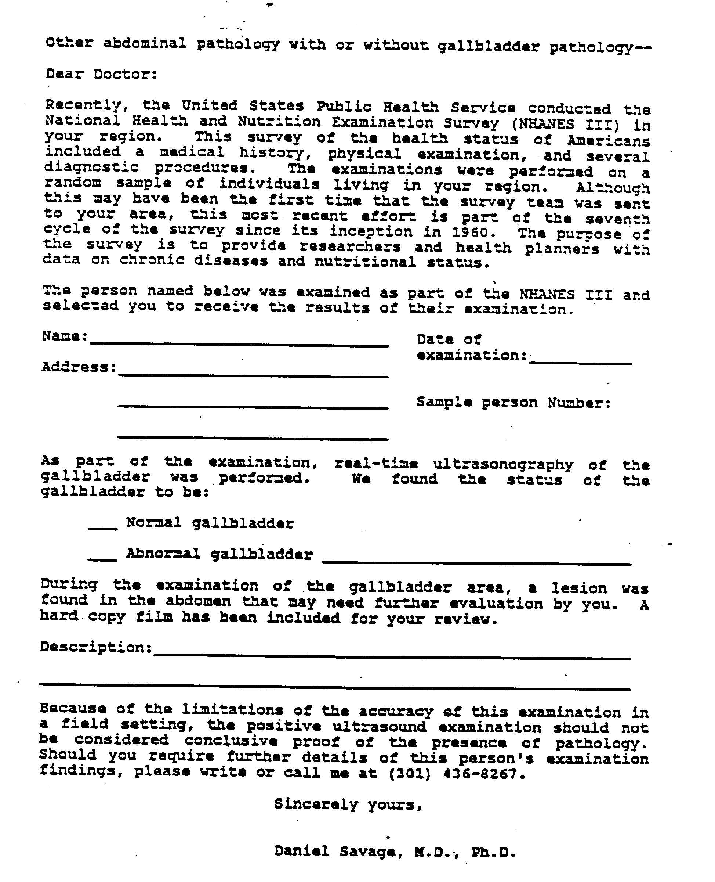
Exhibit 5-2. Normal and Gallstone Findings Paragraphs

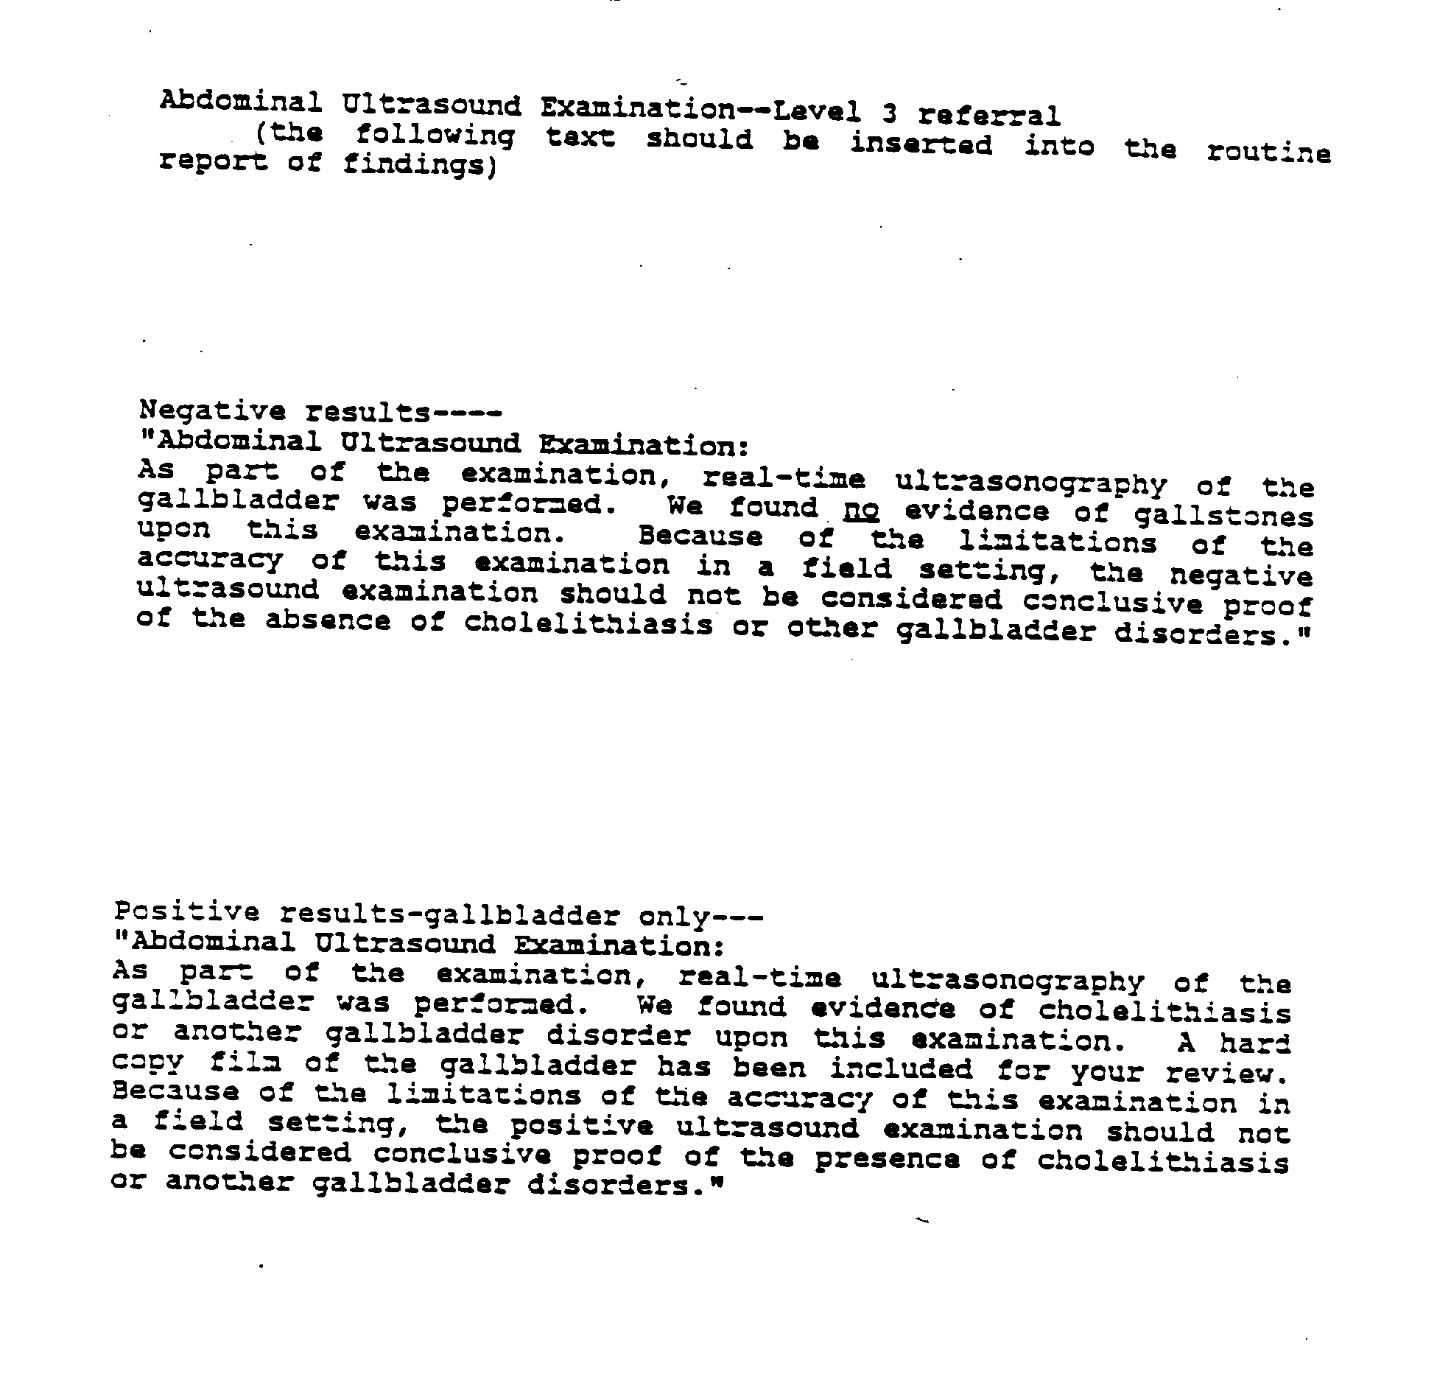

Equipment Calibrations

Regular calibrations and equipment checks will be conducted on the Toshiba SSA-90A and on the videocassette recorder by the sonographers.

A full calibration of the Toshiba SSA-90A will be completed at the start of every stand, and after repairs or maintenance is performed by Toshiba personnel. Calibration of the VCR will consist primarily of videotaping the start of stand calibrations. Results of calibrations will be recorded in the Calibration Log and on matrix film. Problems should be reported promptly to the MEC manager.

Observation and Replication

On a quarterly basis, ultrasound consultants will be responsible for observing a sample (approximately 20) of examinations performed in the field by MEC ultrasonographers. The consultant will observe the protocol procedures and techniques, and any deviation from standard procedures will be noted.

Consultant radiologists will also review the examination video-tapes to insure that findings are properly identified and documented. A sample of ultrasound data collection forms will also be reviewed for completeness and accuracy.

Feedback regarding the performance of exams and examination findings will be reported to NCHS, and then forwarded to the Director of MEC Operations.

In addition to consultant observation, full examination replicates will be performed on a small number of sample person near the end of each stand. Replication of some exams by ultrasound consultants may also be instituted. If replication of exams by consultants is determined to be feasible, replications will be conducted near the end of the stand.

Refresher Sessions

Several times per year, refresher sessions will be scheduled for all ultrasonographers to provide an opportunity for review of procedures as well as to confirm the consistency of procedures performed in the field.

SAFETY

  - Equipment Precautions

The Toshiba SSA-90A is approved by the Underwriter's Laboratory and insulated to guard against the possibility of electrical shock.

Other than the authorized system checks, no attempts should be made to adjust or repair the SSA-90A equipment or the VCR.

The MEC manager should be notified immediately of any equipment problems.

Sample Person Considerations

6.21 Screening for Eligibility

Sample persons will be screened for eligibility to participate in the ultrasound examination, however, there are no risks posed to sample persons during this exam.

SP Movement and Positioning

Sample persons are required to sit and then lie on the exam table in a supine and left lateral decubitus position for this exam. The sonographers will assist SPs to step onto a foot stool and then sit on the table, however sonographers will not lift any SP onto the table.

Wheelchair-bound sample persons, or SPs on stretchers must be able to support their weight on at least one foot and transfer to the exam table with minimal assistance from the sonographer. If SPs cannot transfer without significant support, they should not be removed from the wheelchair or stretcher to receive the exam.

SPs Unable to Physically Cooperate

Sample persons who are unable to lie in the positions required to perform the ultrasound exam may receive the exam while standing, however, visualization of all structures or abnormalities may not be possible. If positioning of the SP is extremely difficult or impossible the SP should be excluded from the exam and the reason documented on the data collection form and log. Sonographers should check with the MEC manager before excluding the sample person.

Confused or Uncooperative Sample Persons

Sample persons who are unable or unwilling to follow instructions for positioning may need to be excluded from the ultrasound exam. Sonographers should consult the MEC manager for assistance in gaining cooperation from the SP, or in excluding the sample persons if necessary.

Sample persons who do not understand English and prefer to converse in Spanish may be assisted through the exam by a bilingual staff member. The screening question for the ultrasound exam has been translated into Spanish to assist in screening sample persons.

Upset or Ill Sample Persons

Persons who feel or appear too ill to continue an examination should be referred to the MEC physician for assessment. Although the ultrasound exam poses no risks to sample persons, individuals who feel ill should experience no delay in being evaluated by the MEC physician. If there is any question about the health or well-being of a sample person, the sonographer should consult the MEC physician as soon as possible.

6.3 Medical Emergencies

The MEC physician should be notified immediately in the event of any emergency. Assessments can then be made regarding the SP's imminent condition and the type of emergency care required.

In all cases, emergency procedures established for the MEC, as described in Part I, Section 3.0 Emergency Procedures, should be followed.

